IEEE P802.11
Wireless LANs
Proposed Resolution for REVme CID 6022 and 6027
Date: 2024-01-12
Author:
Name | Affiliation | Address | Phone | Email
Emily Qi | Intel Corporation | 2111 NE 25th Ave.  Hillsboro OR 97124 |  | Emily.h.qi@intel.com

This submission present proposed resolutions for CID 6022 and 6027.

The proposed changes are based on REVme/D4.2.

Revision history:

R0 – initial version
R1 – incorporate the feedback from TGMe on 1/16.

CID | Page | Clause | Resn Status | Comment | Proposed Change | Resolution | Owning Ad-hoc
6022 | 607.30 | 9.2.4.63 |  | MDR comment: The bit position should always start with B0. | See as comment. |  | MAC

Discussion:

Cited text:

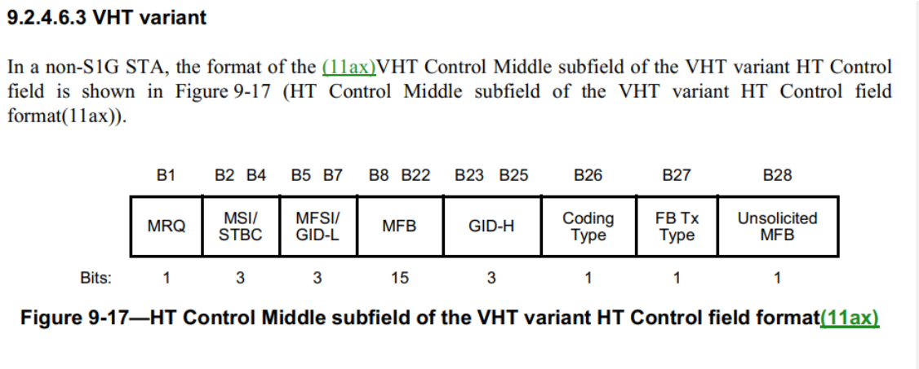

Proposed Resolutions:
Revised.
Update the Figure 9-17 (HT Control Middle subfield of the VHT variant HT Control field format(11ax)) with following changes:

B0 | B1 B3 | B4 B6 | B7 B21 | B22 B24 | B26 | B26 | B27
MRQ | MSI/STBC | MFSI/  GID-L | MFB | GID-H | Coding Type | FB Tx Type | Unsolicited MFB
1 | 3 | 3 | 15 | 3 | 1 | 1 | 1

CID | Page | Clause | Resn Status | Comment | Proposed Change
6027 | 2505.1 | 11.9.3.2 |  | "When the AP sets the Channel Switch Count field of the Extended Channel Switch Announcement element to 0, it shall not include a Max Channel Switch Time element in a Beacon or Probe Response frame.". Why shall the max channel switch time not be used when the Channel Switch Count field is 0? Under this scenario, STA can still use the Max Channel Switch Time element, as it will help the STA know in advance when the AP is expected to start beaconing on the new channel after if “disappeared” on the old one (for the same reasons that it helps for the case where the Channel Switch Count > 0). | Clarify it and allow the max channel switch time to be included when the Channel Switch Count field is 0. Change the cited sentence to "When the AP sets the Channel Switch Count field of the Extended Channel Switch Announcement element to 0, it may include a Max Channel Switch Time element in a Beacon or Probe Response frame. When the Channel Switch Count field is 0, the Max Channel Switch Time element indicates the estimated time where AP will start beaconing on the new channel."

Discussion:

Cited text and Proposed Changes in the comment:
When the AP sets the Channel Switch Count field of an Extended Channel Switch Announcement element to a nonzero value in a Beacon or Probe Response frame, it should include a Max Channel Switch Time element in that frame. When the AP includes the Max Channel Switch Time element, the AP shall transmit the first Beacon frame in the new channel no later than the time indicated in the Switch Time field of the Max Channel Switch Time element after the last Beacon frame transmitted in the current channel, unless the AP determines that it is unable to operate on the new channel.
When the AP sets the Channel Switch Count field of the Extended Channel Switch Announcement element to 0, it shall not may include a Max Channel Switch Time element in a Beacon or Probe Response frame. When the Channel Switch Count field is 0, the Max Channel Switch Time element indicates the estimated time where AP will start beaconing on the new channel.

When we discussed in the TGme teleconference, the feedback from the teleconference is to combine those two paragraphes together.

Proposed Resolutions:

Revised.

At 2563.56 (of D4.2), make the following changes:

When an AP transmits a frame containing an Extended Channel Switch Announcement element, it should include a Max Channel Switch Time element in the frame if the Channel Switch Count field is nonzero and it may include the element if the field is 0. When the AP sets the Channel Switch Count field of a Channel Switch Announcement element to a nonzero value in a Beacon or Probe Response frame, it should include a Max Channel Switch Time element in that frame. When the AP includes the Max Channel Switch Time element, the AP shall transmit the first Beacon frame in the new channel no later than the time indicated in the Switch Time field of the Max Channel Switch Time element after the last Beacon frame transmitted in the current channel, unless the AP determines that it is unable to operate on the new channel.
NOTE---An Extended Channel Switch Announcement frame does not contain an Extended Channel Switch Announcement element (see 9.6.7.7).

At 2572.38 to 2572.48 (of D4.2), make the following changes:
When an AP transmits a frame containing an Extended Channel Switch Announcement element, it should include a Max Channel Switch Time element in the frame if the Channel Switch Count field is nonzero and it may include the element if the field is 0. When the AP sets the Channel Switch Count field of an Extended Channel Switch Announcement element to a nonzero value in a Beacon or Probe Response frame, it should include a Max Channel Switch Time element in that frame. When the AP includes the Max Channel Switch Time element, the AP shall transmit the first Beacon frame in the new channel no later than the time indicated in the Switch Time field of the Max Channel Switch Time element after the last Beacon frame transmitted in the current channel, unless the AP determines that it is unable to operate on the new channel.
NOTE---An Extended Channel Switch Announcement frame does not contain an Extended Channel Switch Announcement element (see 9.6.7.7).
When the AP sets the Channel Switch Count field of the Extended Channel Switch Announcement element to 0, it shall not include a Max Channel Switch Time element in a Beacon or Probe Response frame.

