IEEE P802.11
Wireless LANs
Transmit Power Envelope Subelement
Date: 2024-01-08
Author(s):
Name | Affiliation | Address | Phone | email
Christian Berger | NXP | 350 Holger Way, San Jose, CA |  | christian.berger@nxp.com

Abstract
This submission proposes a change of to indicate support for mandatory/optional puncturing patterns, changes are relative to Draft P802.11be_D4.0, IEEE802.11az-2022 and Draft P802.11bk D1.0.

Revisions:

Interpretation of a Motion to Adopt

A motion to approve this submission means that the editing instructions and any changed or added material are actioned in the TGax Draft. This introduction is not part of the adopted material.

Editing instructions formatted like this are intended to be copied into the TGbk Draft (i.e. they are instructions to the 802.11 editor on how to merge the text with the baseline documents).

TGbk Editor: Editing instructions preceded by “TGbk Editor” are instructions to the TGbk editor to modify existing material in the TGaz draft. As a result of adopting the changes, the TGbk editor will execute the instructions rather than copy them to the TGbk Draft.

The text preceded by “Discussion” is not part of the adopted changes.

CID | P.L | Clause | Comment | Proposed Change | Resolution
1044 | 4.14 | 9.4.2.298 | "The Transmit Power Envelope subelement has the same definition as the Transmit Power Envelope element" - how can a subelement be an element? The table specifies subelement ID 3, but this element has ID 195 - In my mind this needs at least a wrapper. | Create a wrapper with ID 3 and length that hold this Transmit Power Envelope element inside; alternatively remove this from Ranging Parameters element and include as a separate element in the frame(s) in question. | Revised  TGbk editor, see changes in document:

- Discussion:

- Table 9-322h23fd—Ranging Subelement IDs for Ranging Parameters
Subelement ID | Name | Extensible
0 | Non-TB Specific subelement | Yes
1 | TB-specific subelement | Yes
2 | Secure HE-LTF subelement | Yes
3 | Transmit Power Envelope subelement | Yes
4 | 320 MHz Ranging subelement | Yes
5-220 | Reserved
221 | Vendor Specific
222-255 | Reserved

… …

The Transmit Power Envelope subelement has the same definition as the Transmit Power Envelope element (see 9.4.2.161 (Transmit Power Envelope element)).
The format of the 320 MHz Ranging subelement is as shown in Figure 9-7xx (320 MHz Ranging subelement format).

 | B0 B7 | B8 B15 | B16 B18 | B19 B21 | B22 | B23 | B24 B39
 | Subelement ID | Length | Max R2I  Nss =320 MHz | Max I2R  Nss =320 MHz | Puncturing Pattern  Support | Reserved | Puncturing Pattern
Bits: | 8 | 8 | 3 | 3 | 1 | 1 | 16
Figure 9-7xx—320 MHz Ranging subelement format
The Subelement ID and Length fields are defined in 9.4.3 (Subelements).

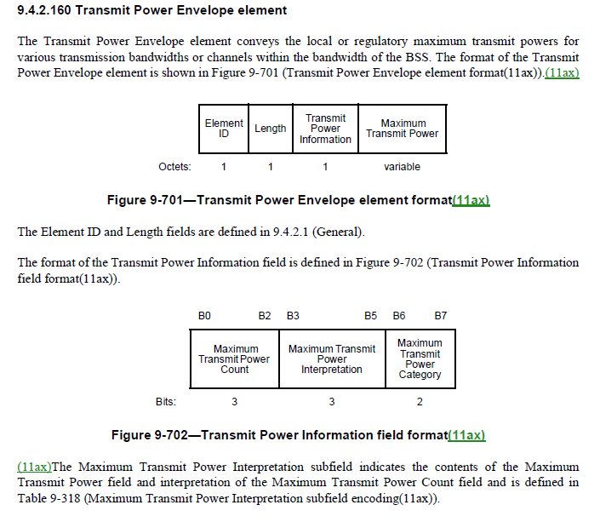

Option 1:
Create a wrapper:

 | Subelement ID | Length | Transmit Power Envelope
Octets: | 1 | 1 | variable
Figure 9-7xx—Transmit Power Envelope subelement format

The Subelement ID and Length fields are defined in 9.4.3 (Subelements).
The Transmit Power Envelope field contains a Transmit Power Envelope element (see 9.4.2.160 (Transmit Power Envelope element)).

Option 2:

Move to FTM frame level:

 | Category |  | Public Action |  |  | Dialog Token |  | Follow Up Dialog Token |  | TOD |  |  |  | TOA
Octets: | 1 |  | 1 |  |  | 1 |  | 1 |  |  | 6 |  |  |  |  |  |  |  | 6
 | TOD Error |  | TOA Eror |  |  | LCI Report  (optional) |  | Location Civic Report  (optional) |  | Fine Timing  Measurement  Parameters  (optional) |  |  |  |  | FTM  Synchronization information  (optional)
Octets: | 2 |  | 2 |  |  | variable |  | variable |  | variable |  |  |  |  |  |  | variable
 |  | Ranging Parameters (optional) |  | Secure HE-LTF Parameters (optional) | Channel Measurement Feedback Type (optional) |  | Channel Measurement Feedback (optional) |  | Direction Measurement Results  (optional) |  |  | Multiple Best AWV ID  (optional) | Multiple AOD Feedback (optional) |  |  | LOS Likelihood (optional) |  | Transmit Power Envelope (optional)
Octets: |  | variable |  | 14 | 2 |  | variable |  | 9 |  |  | variable | variable |  |  | 4 |  | variable

- Figure 9-896—Fine Timing Measurement (FTM) Action field format

… …

The Transmit Power Envelope field is optionally present. If present, it contains a Transmit Power Enveople element as defined 9.4.2.160 (Transmit Power Envelope element).

