IEEE P802.11
Wireless LANs
Fixing error
Date: 2024-01-04
Author(s):
Name | Affiliation | Address | Phone | email
Jeongki Kim | Ofinno |  |  | jkim@ofinno.com
Leonardo Lanante | Ofinno
Abstract
This submission proposes to fix the error in 10.23.2.2.

Revisions:
R0: Initial version.

Editing instructions formatted like this are intended to be copied into the TGme Draft (i.e. they are instructions to the 802.11 editor on how to merge the text with the baseline documents).

TGme Editor: Editing instructions preceded by “TGme Editor” are instructions to the TGme editor to modify existing material in the TGme draft. As a result of adopting the changes, the TGme editor will execute the instructions rather than copy them to the TGme Draft.

Discussion:

In TGax draft, an error happened in 10.23.2.2 when making new revision from TGax D4.3 to D5.0. The error still exists in REVme draft.

TGax D4.3
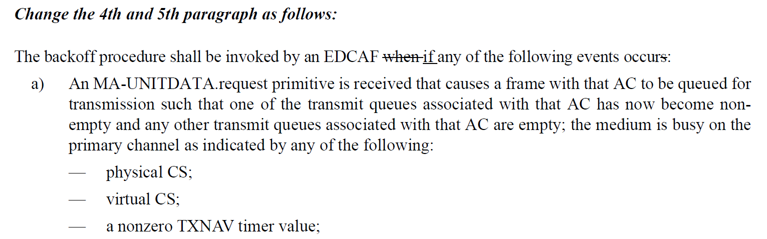
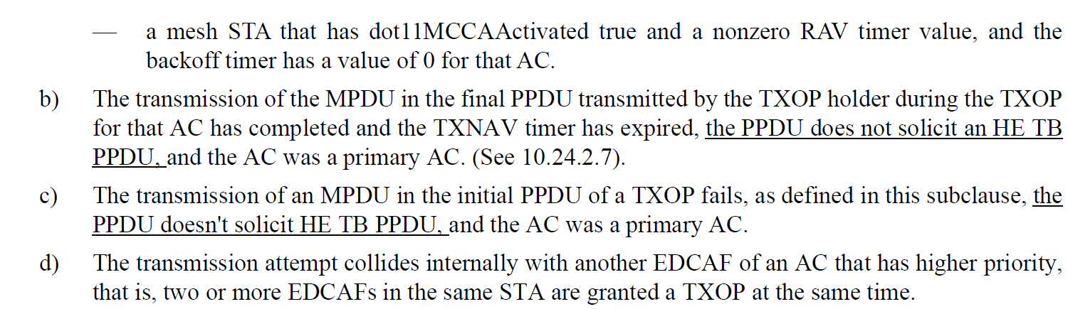
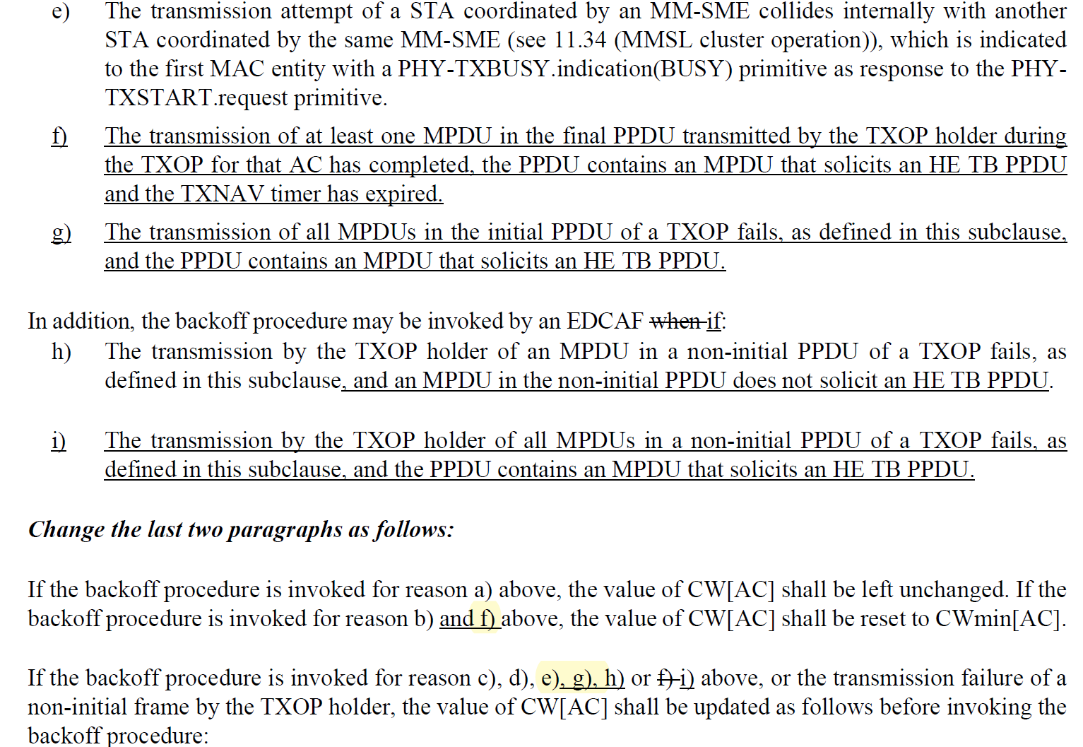

TGax D5.0
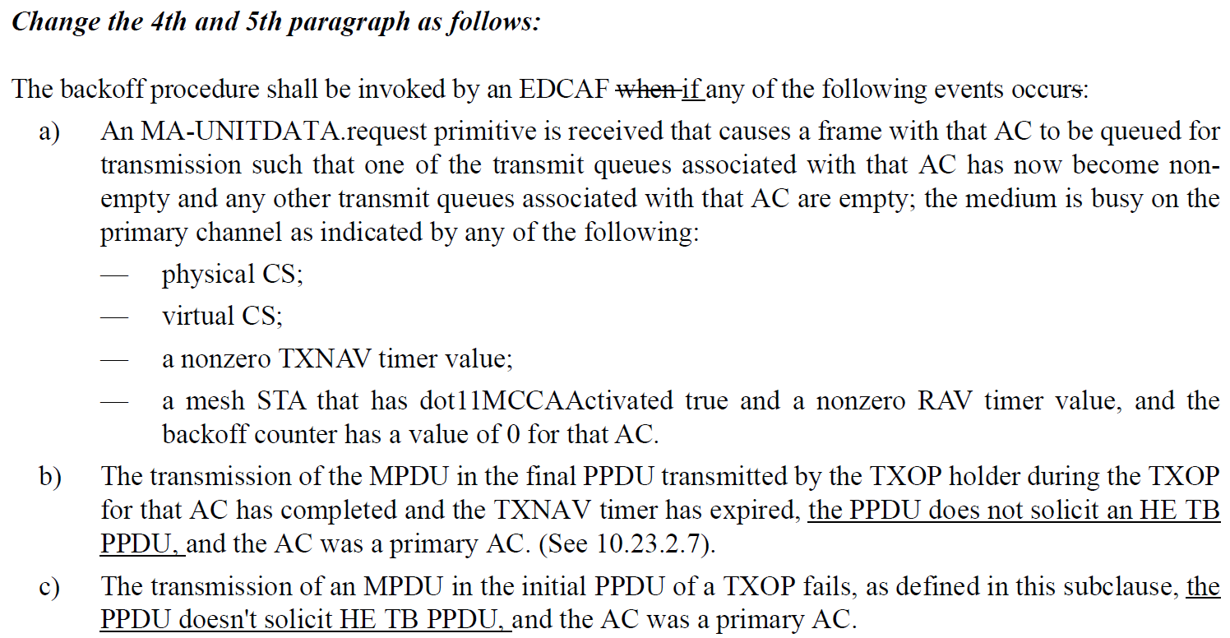
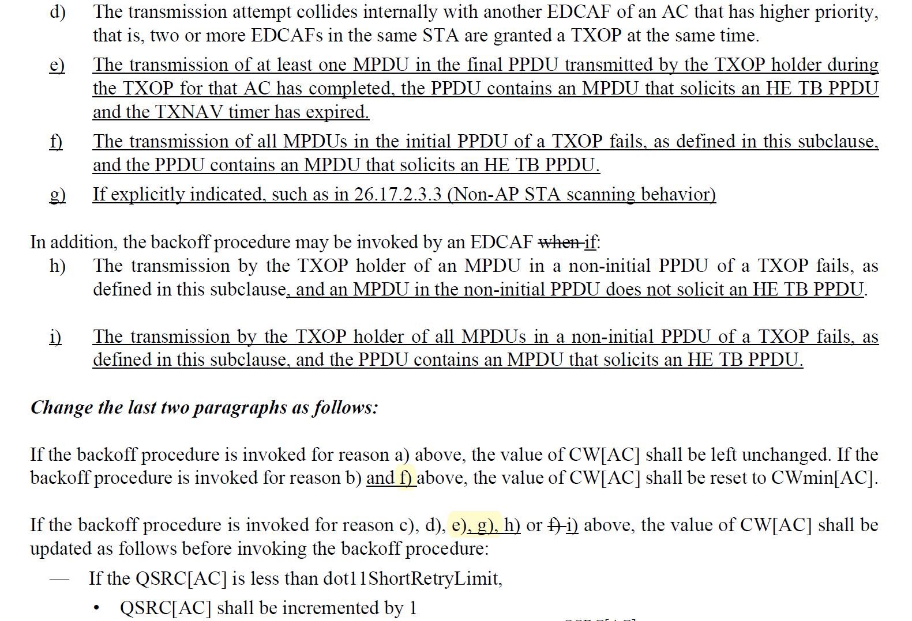
Proposed resolution: In current TGREVme Draft,
- “f)” should be changed to “e)” because the related text is about successful case.
- “e)” should be changed to “f)” because the related text is about failure case.
- “g)” should be moved to unchanged cases because it’s similar with h) in REVme draft.

Proposed text:

TGme Editor: Please make the following changes in the subclause 10.23.2.2.
10.23.2.2 EDCA backoff procedure
….

The backoff procedure shall be invoked by an EDCAF (11ax)if any of the following events occurs:
a) An MA-UNITDATA.request primitive is received that causes an MPDU corresponding to the EDCAF’s AC to be queued for transmission such that all of the following are true:
1) One of the transmit queues associated with that AC has now become nonempty(#2222)
2) Any other transmit queues associated with that AC are empty
3) The backoff counter has a value of 0 for that AC
4) The medium is busy on the primary channel as indicated by any of the following:
— Physical CS
— Virtual CS
— A nonzero TXNAV timer value
— For a mesh STA that has dot11MCCAActivated true, a nonzero RAV timer value
b) For the EDCAF that is the TXOP holder, the transmission of the final PPDU transmitted by the TXOP holder during the TXOP has completed, the final PPDU does not solicit an HE TB PPDU, and the TXNAV timer has expired.(11ax)
c) For the EDCAF that is the TXOP holder, the transmission of an MPDU in the initial PPDU of a TXOP fails, as defined in this subclause, and the initial PPDU does not solicit an HE TB PPDU.(11ax)
d) A transmission attempt by the EDCAF collides internally with another EDCAF of an AC that has higher priority, that is, two or more EDCAFs in the same STA are granted a TXOP at the same time.
e) The transmission of at least one MPDU in the final PPDU transmitted by the TXOP holder during
the TXOP for that AC has completed, the PPDU contains an MPDU that solicits an HE TB PPDU
and the TXNAV timer has expired.(11ax)
f) The transmission of all MPDUs in the initial PPDU of a TXOP fails, as defined in this subclause,
and the PPDU contains an MPDU that solicits an HE TB PPDU.(11ax)
g) If explicitly indicated, such as in 26.17.2.3.3 (Non-AP STA scanning behavior).(11ax)
h) The EDCAF is permitted to initiate a TXOP (see 10.23.2.4 (Obtaining an EDCA TXOP)) but
chooses not to.(#3653)
In addition, the backoff procedure may be invoked by an EDCAF if:
i) For the EDCAF that is the TXOP holder, the transmission by the TXOP holder of an MPDU in a non-initial PPDU of a TXOP fails, as defined in this subclause and an MPDU in the non-initial
PPDU does not solicit an HE TB PPDU.(11ax)
j) For the EDCAF that is the TXOP holder, the transmission by the TXOP holder of all MPDUs in a non-initial PPDU of a TXOP fails, as defined in this subclause, and the PPDU contains an MPDU
that solicits an HE TB PPDU.(11ax)

NOTE 1—If the transmission by the TXOP holder of an MPDU in a non-initial PPDU of a TXOP failed, the STA can perform either a PIFS recovery, as described in 10.23.2.8 (Multiple frame exchange sequences in an EDCA TXOP(#109)), perform a backoff as described in item i) (#1107)above, or wait for the TXNAV timer to expire and invoke the backoff procedure per item b) above. How it chooses among these options is implementation dependent.

A STA that performs a backoff within its existing TXOP per item i) (#1108)above shall not extend the
TXNAV timer value (see 10.23.2.8 (Multiple frame exchange sequences in an EDCA TXOP(#109))).

NOTE 2—In other words, the backoff is a continuation of the TXOP, not the start of a new TXOP.

If the backoff procedure is invoked for reason a), g) or h) above, CW[AC] and QSRC[AC] shall be left
unchanged.(#3653)
If the backoff procedure is invoked for reason b) or e)(11ax) above, CW[AC] shall be set to CWmin[AC], and QSRC[AC] shall be set to 0.(#3653)
If the backoff procedure is invoked for reason c), d), f), i), or j)(11ax) above, CW[AC] and QSRC[AC]
shall be updated as follows:(#3653)
— If QSRC[AC] is less than dot11ShortRetryLimit,
— QSRC[AC] shall be incremented by 1.
— CW[AC] shall be set to the lesser of CWmax[AC] and 2QSRC[AC] × (CWmin[AC] + 1) – 1.
— Else
— QSRC[AC] shall be set to 0.
— CW[AC] shall be set to CWmin[AC].
….

