IEEE P802.11 Wireless LANs
Misc GEN MAC comments
Date: 2023-12-05
Author(s):
Name | Affiliation | Address | Phone | email
Michael Montemurro | Huawei |  |  | montemurro.michael@gmail.com
Background
This contribution proposes comment resolutions to selected GEN and MAC comments from initial SA Ballot. CIDs 6136-40.

R0 – Initial version.
R1 –

Comment
CID | Page | Clause | Duplicate of CID | Resn Status | Comment | Proposed Change
6140 |  |  |  |  | This draft is inconsistent in representation of hex digits A through F in terms of capitalization. We see that uses of lower case a-f are grouped in page ranges and thus may have been introduced by now merged amendment projects. | Replace lower case a-f hex digits with upper throughout including (searching on 0x or found with a quick scan): p. 2658, l. 13 p. 2661, l. 47 p. 2806, l. 33 p. 2802, l. 22, 36-46 p. 2911, l. 43, 49 p. 2912, l. 50 p. 3002, l. 61 p. 5645, l. 18-64 p. 5657. l. 53 p. 5658, l. 58 p. 5659, l. 29 p. 5661, l. 30, 42, 53 p. 5662, l. 5 p. 5663, l. 12-45 p. 5667-5697 (it is not clear if the mix of upper case and lower case is required by syntax rules) p. 5722, l. 19 p. 5723, l. 52

Discussion: (GEN)
- The comment is requesting to replace lower case with upper case letters in HEX digits.
- There are no occurrences in 11az, which means the list should be up to date with the latest draft.
- p. 2658, l. 13 - 0x1234567890abcdef
- p. 2661, l. 47 – line 46 as well: “the Service Information Response ANQP-element is “bfd39037d25c,” and the service hash used as input to compute the Bloom Filter Bit Array field is “0xbfd39037d25c.”.
- p. 2806, l. 33 – 0x7f.
- p. 2802, l. 22, 36-46 – 0xff one on each line
- p. 2911, l. 43, 49 – 0xdd
- p. 2912, l. 50 – 0xdd
- p. 3002, l. 61 – 0xdd
- p. 5645, l. 18-64 – this is a reference implementation in C – best not to change
- p. 5657. l. 53 – this is a reference implementation in C – best not to change
- p. 5658, l. 58 – this is a reference implementation in C – best not to change
- p. 5659, l. 29 - this is a reference implementation in C – best not to change
- p. 5661, l. 30, 42, 53 – this is a reference implementation in C – best not to change
- p. 5662, l. 5 – this is a reference implementation in C - best not to change
- p. 5663, l. 12-45 – these are test vectors – best not to change
- p. 5667-5697 (it is not clear if the mix of upper case and lower case is required by syntax rules) – these are test vectors – best not to change
- p. 5722, l. 19 – this is a reference implementation in C - best not to change
- p. 5723, l. 52 – this is a reference implementation in C - best not to change

Proposed Resolution: (6140)
REVISED. Make the changes proposed by the commenter with the exception of the locations that reference C code or test vector output.
Change the hex values at the following locations from lower to upper case:
p. 2658, l. 13 - 0x1234567890abcdef
p. 2661, l. 46-47 – “the Service Information Response ANQP-element is “bfd39037d25c,” and the service hash used as input to compute the Bloom Filter Bit Array field is “0xbfd39037d25c.”.
p. 2806, l. 33 – 0x7f.
p. 2802, l. 22, 36-46 – 0xff one on each line
p. 2911, l. 43, 49 – 0xdd
p. 2912, l. 50 – 0xdd
p. 3002, l. 61 – 0xdd

Comment
CID | Page | Clause | Duplicate of CID | Resn Status | Comment | Proposed Change
6136 | 1760.00 | 9.9.2.2.2 |  |  | It is not clear what "OUI1" means, or whether it is a typographical error. Does the first column of the table represent a name of the ID field type? Where are those named defined? Since the "type of identifier depends on the type of WUR frame" and since those types are listed in Table 9-644, the Type from Table 9-644 should be added to each row. | In Table 9-644, change the header of the first column to "WUR frame type". In Table 9-645, add a new first column with the header "WUR frame type", and in each cell insert a WUR frame type. Consider deleting the existing "IF field" column. If not, replace "OUI1" with something more meaningful; e.g. “OUI-based”.
6137 | 1760.00 | 9.9.2.2.2 |  |  | The last row of Table 9-645 refers to "OUI (see 9.4.1.29 (Organization Identifier field))". But 9.4.1.9 refers to an Organization Identifier field that can contain a 24-bit OUI, a 24-bit CID, or a 36-bit OUI-36. This is confusing, because it's not clear if the OUI in Table 9-645 is referring to all three options. If the field is restricted to 24 bits, then CID should be included because it coexists with OUI as an organizational identifier. | Replace reference to "OUI" with a list of what’s allowed. If the field is restricted to 24 bits, then include 24-bit OUI and 24-bit CID. This comment also applies to the last line of p 1764 and the first line of p 1765.
6138 | 1764.00 | 9.9.3.4 |  |  | It's not clear whether OUI-36 is allowed for "OUI". If so, then there is a problem because, while 12 bits are conveyed in the ID field and another 12 bits are (per the next page) conveyed in the Type Dependent Control field, the middle 12 bits are not conveyed, so conflicts with 24-bit OUI could occur. | Either explicity exclude OUI-36 or modify the draft to allow transmittal of all 36 bits. |  | MAC |  | Submission Required | MAC: 2023-11-10 23:40:01Z - status set to: Submission Required
6139 | 1764.00 | 9.9.3.4 |  |  | Whlle the text here (and in the first line of the next page) refers to “the OUI”, it doesn’t say WHICH OUI or WHOSE OUI. | Since this is for a Vendor Specific format, specify an OUI (or CID...) assigned to the vendor responsible for specifying the Vendor Specific frame format. |  | MAC |  | Submission Required | MAC: 2023-11-10 23:39:44Z - status set to: Submission Required

Discussion:
- The text referenced in CIDs 6136 and 6137 is
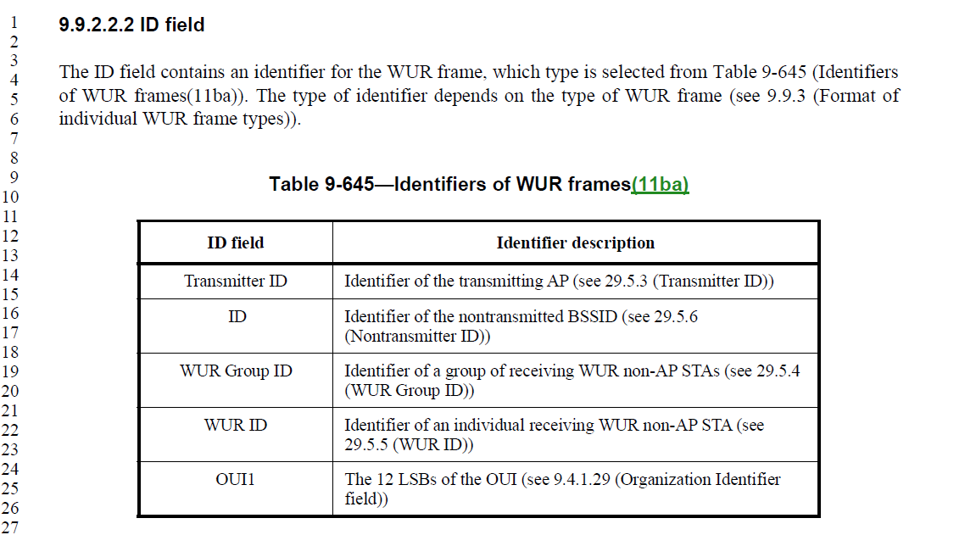
- The text cited in CIDs 6138 and 6139 is
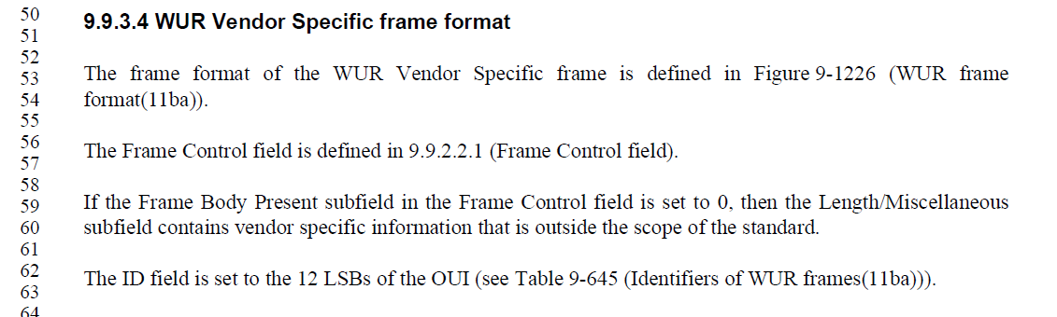
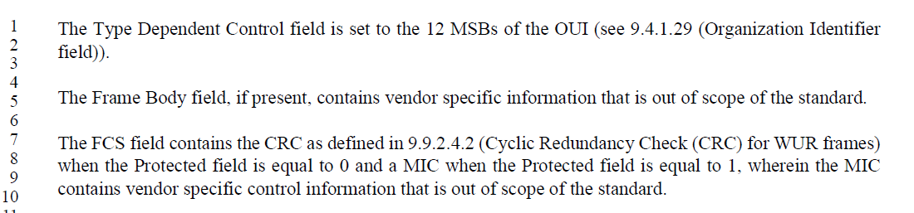
- The WUR Vendor Specific frame format assumes an OUI with the 12 LSB in the ID field and the 12 MSB in the Type Dependent Control field.
- Agree with the commenter that in table 9-645, the entry “OUI1” is confusing
- The reference to 9.4.1.29 is also misleading because the field formats are significantly different.

Proposed Resolution: (6136, 6137, 6138, 6139)
REVISED. Clarify the format of a WUR Vendor Specific frame format with the following changes:

In the last row of table 9-645 (1760.9) replace the first column, changing
“OUI1” to “WUR Vendor Specific”

And replace the second column, changing
“The 12 LSBs of the OUI (see 9.4.1.29 (Organization Identifier field))
to
“The identifier is a public unique identifier assigned by the IEEE Registration
Authority as a 24-bit OUI, or a 24-bit CID (see [B15] and [B16]). The ID field contains the 12 LSB of the OUI and the Type Dependent Control field contains the 12 MSB of the OUI.”

Update the description of the Type Dependent Control field to reference Table 9-645:
At 1765.1, replace
“The Type Dependent Control field is set to the 12 MSBs of the OUI (see 9.4.1.29 (Organization Identifier field)).
With
“The Type Dependent Control field is set to the 12 MSBs of the OUI (see Table 9-645).”

