IEEE P802.11
Wireless LANs
Changes to Clause 6 for 11az-2022
Date: 2023 - October
Author(s):
Name | Affiliation | Address | Phone | email
Graham SMITH | SR Technology | Sunrise, FL, USA. | 916 799 9563 | gsmith@srtrl.com
Abstract
Clause 6 edits in 802.11az-2022 are amended so as to agree with the new Clause 6 format that is now being used in 802.11me
Background

Clause 6 has been overhauled in 802.11me. The basic concept was that Clause 6 was doimated by boilerplate text and the details therein, in the vaste majority of cases obvious from the main text.
It was also noted that in some cases, details had been added to the MLME descriptions that should not be there in the understandng that Clause 6 is “conceptual”.

The method adopted was to first identify the different MLME-SAP interfaces, Clause 6.3, and then to create a Table 6-1, Clause 6.4 that listed all the MLMEs with type of interface and references. In the vaste majority of cases thia was considered adequate.

In Clause 6.5, however, certain MLMEs are listed in their full detail. The introduction explains why:

“MLME SAP primitives are detailed in this clause when they do not directly correspond to frame exchanges described in subsequent clauses, where the primitive parameters differ significantly from the fields in the respective frames, or when the primitives may not be clear from the descriptions in those clauses.”

Hence, there are listed in Clause 6.5 several of the fundamental MLMEs, e.g, Authenticate. Thus, the 11az edits to the Authentication are retained, with a change to the Clause number.

When the 11me team looked at the FTM MLMEs, the Table entry is
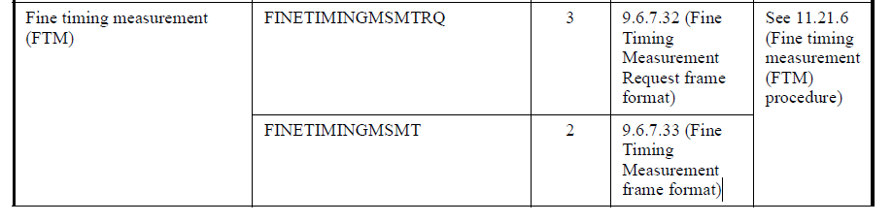
It is considered that this is still valid.

At the time we did the Table and considered what to maintain in Clause 6.5, it was considered that the details given in the original Clause 6.3.56 Fine timing measurement, was not the right place for such detailed instructions and that the text in Clause 11.21.6 should be sufficient. It was considered that there was a danger of duplication or worse still differences. Remember Clause 6 is “conceptual”. Hence, I it was decided nt to include FTM in the details Clause 6.5.

Hence, the changes proposed for 802.11az-2022 are as follows.

Note: Changes to the Clause 9 and Clause 11 references in Table 6-1 will be automatically corrected.

Editorial Instructions to 802.11az - 2022

Page 29

Change clause references as shown: (was 6.3, now 6.5)

6.35 MLME SAP interface

6.35.5 Authenticate

6.35.5.2 MLME-AUTHENTICATE.request

6.35.5.2.2 Semantics of the service primitive

Change the text of 6.35.5.2.2 as follows

6.35.5.3 MLME-AUTHENTICATE.confirm

6. 35.3.2 Semantics of the service primitive

Change the text of 6. 35.5.3.2 as follows:

Page 30

6.35.5.4 MLME-AUTHENTICATE.indication

6.35.5.4.2 Semantics of the service primitive

Change the text of 6.35.5.4.2 as follows:

Page 31

6.35.5.5 MLME-AUTHENTICATE.response

6.35.5.5.2 Semantics of the service primitive

Change the text of 6.35.5.5.2 as follows:

Delete

6.3.56 Fine timing measurement (FTM)

6.3.56.2 MLME-FINETIMINGMSMTRQ.request

6.3.56.3 MLME-FINETIMINGMSMTRQ.indication

6.3.56.4 MLME-FINETIMINGMSMT.request

6.3.56.5 MLME-FINETIMINGMSMT.confirm

6.3.56.6 MLME-FINETIMINGMSMT.indication

