IEEE P802.11  
Wireless LANs

|  |  |  |  |  |
| --- | --- | --- | --- | --- |
| LB276 - Comment resolutions for DMG part 3 | | | | |
| Date: 2023-11-15 | | | | |
| Author: | | | | |
| Name | Affiliation | Address | Phone | Email |
| Yan Xin | Huawei Technologies | Ottawa, ON, Canada |  | yan.xin@huawei.com |
|  |  |  |  |  |
|  |  |  |  |  |
|  |  |  |  |  |
|  |  |  |  |  |

This submission includes the resolutions for the following three comments to P802.11bf D2.0:

##### 3331, 3332, 3333

##### Revision history:

##### R0 – initial version

R1 – revise the proposed text

**CID: 3331, 3332, 3333**

|  |  |  |  |  |  |  |
| --- | --- | --- | --- | --- | --- | --- |
| CID | Clause | Page | Line | Comment | Proposed Change | Proposed resolution |
| 3331 | 11.55.3.4 | 171 | 34 | This paragraph describes a solution for the sounding phase in the parallel mode in coordinated monostatic sensing to aviod interference across multiple sensing responders, i.e., using the transmit beams assigned by the sensing initiator by setting the TX Beam List subelement in the DMG Sensing Measurement Session element in the DMG Sensing Measurement Request frame. This solution cannot gurantee to fully avoid interference across multiple sensing responders for all scenarios. | Need to further consider other solutions that can avaid interference across sensing responders in parallel sounding in coordinated monostatic sensing. | REVISED  TGbf editor: please revise th text in 802.11bf D2.1 as proposed in 11-23/2008r1. |
| 3332 | 11.55.3.6.2.3 | 181 | 42 | As specified in subclause 28.9.4, "the TRN field in EDMG SC PPDUs may be used as the waveforms of the TRN field of a coordinated DMG monostatic sensing PPDU. Each responder in the parallel mode of coordinated DMG monostatic sensing may be assigned with a unique TRN subfield waveform for EDMG SC PPDUs." Those TRN subfields assinged to different sensing responders are orthogonal. However, Figure 11-75o shows that monostatic sounding PPDUs may not be fully aligned in time. How to maintain the orthogonality of sounding signals in the parallel mode for accurate sensing mesurement? | Need to further consider the sounding signals trasnmission in the parallel mode of coordinated monstatic DMG sensing. | REVISED  TGbf editor: please revise th text in 802.11bf D2.1 as proposed in 11-23/2008r1. |
| 3333 | 11.55.3.6.2.3 | 181 | 42 | Transmissions of sounding PPDUs by multiple sensing responders simutaneously over a single channel in the parallel mode in coordinated monostatic sesning may impact on the synchronization of the PPDUs and/or TRN field, and the subsequent measurement results in the measurement phase. | Further consider transmission of sounding PPDUs over different channels for different sensing responders. | REVISED  TGbf editor: please revise th text in 802.11bf D2.1 as proposed in 11-23/2008r1. |

*Discussion:*

All CID#3331, 3332, 3333 address a potential issue that the procedure of parallel coordinated DMG monostatic sensing specified in the subclause 11.55.3.6.2.3 in 802.11bf D2.0 cannot gurantee to fully avoid interference across multiple sensing responders by using the different transmit beams assigned by the sensing initiator which sets the TX Beam List subelement in the DMG Sensing Measurement Session element in the DMG Sensing Measurement Request frame. As shown in Figure 11-75o, in the sounding phase, multiple Monostatic sensing PPDUs are transmitted in parallel over a single channel.

Since in EDMG, multichannel operations can be scheduled for an either SP or a CBAP allocation in DTI, to minimize the cross-interference between sensing PPDUs simultaneously transmitted by different sensing responders in parallel coordinated monostatic sounding, in 11-23/1247r0 it is proposed that in parallel coordinated monostatic sensing, different monostatic responders use different channels to transmit respective Monostatic PPDUs.

This contribution provides resolutions to the comments CID#3331, 3332, 3333 by addressing the channel access and the indication of channels to be used in the the sounding phase for parallel coordinated monostatic DMG sensing over multiple channels, which are discussed in 11-23/2025r2 in details.

TGbf editor: please modify the text in P43L45 in the following subclause in 802.11bf D2.1 as follows

**9.3.1.25.5 DMG Sensing Request frame**

The EDMG TRN Length, RX TRN-Units per Each TX TRN-Unit, EDMG TRN-Unit P, EDMG TRN-Unit

M, EDMG TRN-Unit N, TRN Subfield Sequence Length, Sense Multiple Golays, and Sense Golay

Index fields contain the values of the corresponding header fields in the EDMG multistatic sensing PPDU.

These fields are reserved if the Sensing Type is set to Coordinated Monostatic or Coordinated Bistatic.

The Monostatic Sounding Mode field indicates whether the sounding phase of the coordinated monostatic

DMG sensing measurement exchange is performed in sequential or parallel mode. A value of 1 indicates the

sequential mode, a value of 0 indicates the parallel mode. This field is reserved if the Sensing Type is not set

to Coordinated Monostatic.

The BW field is set to a non-zero value, in which ‘one’ indicates the channel over which in the sounding phase, a Monostatic PPDU is transmitted if the Sensing Type is set to Coordinated Monostatic with the Monostatic Sounding Mode field set to 0. The operating channel indicated in the BW field is one of primary, secondary, secondary1 or secondary2 channels as specified in the BSS Operating Channels field and Primary Channel field within the EDMG Operation element (see 9.4.2.266 EDMG Operation element(11ay)) transmitted by an EDMG AP or an EDMG PCP (see 10.23.2.14 (EDCA channel access in an EDMG BSS(11ay))). The BW field is set to all ‘zeros’ if the Sensing Type is set to Coordinated Monostatic with the Monostatic Sounding Mode field set to 0 to indicate that in the sounding phase Monostatic PPDUs are transmitted solely on the primary channel. The BW field is reserved if the Sensing Type is set to Coordinated Bistatic or Coordinated Monostatic with the Monostatic Sounding Mode field set to1.

TGbf editor: please add a note after the last paragraph of 9.3.1.25.5 DMG Sensing Request frame

**9.3.1.25.5 DMG Sensing Reponse frame**





NOTE – Both the Sounding Duration field and the Report Duration field are set to zeros in a DMG Sensing Response frame when the Responder is unable to participate in parallel coordinated monostatic DMG sensing over multiple channels.

TGbf editor: please modify the text in subclause 11.55.3.6.2.3 in 802.11bf D2.1 as follows



— In the sounding phase over single channel, sensing responders shall start to send one or more DMG monostatic sensing PPDUs in parallel on the primary channel no later than a SIFS after the last DMG Sensing Response frame. DMG monostatic sensing PPDUs transmitted by each sensing responder shall be separated by a SBIFS. If the Sensing Exchange SN field of the TDD Beamforming Information field in the DMG Sensing Request frame is equal to 1, the DMG monostatic sensing PPDUs transmitted by each sensing responder shall cover the number of transmitting AWV indicated by the Number TX Beams Per Exchange field and the times of repetition indicated by the Repeat Per Exchange field within the DMG Sensing Scheduling subelement within the DMG Sensing Measurement Session element. The duration of the transmission of the DMG monostatic sensing PPDUs including the SBIFS shall be equal to the Sounding Duration field within the DMG Sensing Measurement Exchange Duration element delivered by the sensing responder in the DMG Sensing Measurement Response frame. If the Sensing Exchange SN field of the TDD Beamforming Information field within the DMG Sensing Request frame is set to *i* (*i* > 1), the DMG monostatic sensing PPDUs shall cover the number of transmitting AWV indicated by the Num of TX Beams in Exchange field and the times of repetition indicated by the Num of Repeat in Exchange field within the TDD Beamforming Information field of the DMG Sensing Request frame with Sensing Exchange SN field set to *i* - 1. The duration of the transmission of the DMG monostatic sensing PPDUs including the SBIFS shall be equal to the Sounding Duration field of the DMG Sensing Response frame of the DMG sensing measurement exchange with the Sensing Exchange SN field set to *i* - 1.

…

**Figure 11-75o(a)—Coordinated monostatic DMG sensing measurement exchanges, parallel sounding mode over single channel**

Figure 11-75o (a) (Coordinated monostatic DMG sensing measurement exchanges, parallel sounding mode over single channel) gives an example of two parallel coordinated monostatic DMG sensing measurement exchanges. The PCP/AP is the sensing initiator and the two non-AP STAs (STA A and STA B) are sensing responders. The SP is not used and the measurement results need to be reported. In the DMG sensing measurement session phase, STA A and STA B deliver the Sounding Duration 0a, Report Duration 0a, Sounding Duration 0b, and Report Duration 0b of the first DMG sensing measurement exchange to the sensing initiator by the DMG Sensing Measurement Exchange Duration element within the DMG Sensing Measurement Response frames.

TGbf editor: please modify the text in the paragraph of P183L32 in subclause 11.55.3.6.2.3 in 802.11bf D2.1 as follows

In the following sounding phase, STA A and STA B transmit DMG monostatic sensing PPDUs and receive the reflected signal in parallel on the primary channel. The duration of the transmission of the DMG monostatic sensing PPDUs of STA A including the SBIFS is equal to the Sounding Duration 0a. The duration of the transmission of the DMG monostatic sensing PPDUs of STA B including the SBIFS is equal to the Sounding Duration 0b. The measurement in DMG monostatic sensing PPDUs covers the number of transmit AWVs indicated by the Number TX Beams Per Exchange field and the times of repetition indicated by the Repeat Per Exchange field within the DMG Sensing Scheduling subelement of the DMG Sensing Measurement Session element.

TGbf editor: please add the following text after last the paragraph subclause 11.55.3.6.2.3 in 802.11bf D2.1 as follows

— In the sounding phase over multiple channels, sensing responders shall start to send one or more DMG monostatic sensing PPDUs in parallel over respective channels as indicated in 9.3.1.25.5 (DMG Sensing Request frame) no later than a SIFS after the last DMG Sensing Response frame.

Figure 11-75o (b) (Coordinated monostatic DMG sensing measurement exchanges, parallel sounding mode over multiple channel) illustrates an example of one parallel coordinated monostatic DMG sensing measurement exchange over the primary channel and the secondary channel within a TXOP which is obtained based solely on activity of the primary channel (see 10.23.2.14 EDCA channel access in an EDMG BSS(11ay)).

The sensing responder (shown as Responder 2 in Figure 11-75o(b)), which is with the assigned highest STA ID and receives the last Request frame in order, shall transmit a monostatic sensing PPDU over the primary channel no later than a SIFS after transmitting the DMG Sensing Response frame without performing CCA. The sesning responder shall be polled first by the Initiator (no channel switching is needed).

By following the EDMG channel access rule over multiple channels (see 10.38.12.2 Channel access over multiple channels), the sensing responder (shown as Responder 1 in Figure 11-75o(b)) that receives a DMG Sensing Request frame which is not the last one shall perform CCA on one of the secondary channels indicated in the BW field in the DMG Sensing Request frame during an interval of PIFS immediately preceding the start of the monostatic sounding PPDU transmission. If CCA for that channel is determined to be idle, i.e., no PHY-CCA.indication(BUSY) occurs during an interval of PIFS that ends at the start of transmission (see 10.23.3.14 (EDCA channel access in an EDMG BSS)), the sensing responder shall transmit a Monostatic PPDU over one of the secondary channels.

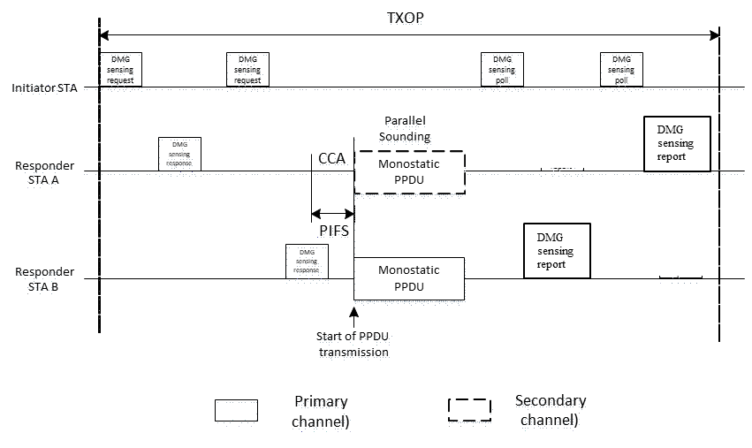

Figure 11-75o (b) Coordinated monostatic DMG sensing measurement exchanges, parallel sounding mode over multiple channel

If SP channel access is applied to parallel coordinated monostatic DMG sensing over multiple channels, different SP allocations with different Allocation IDs, which overlap in time but operate over different channels, are specified in the Extended Schedule element (see 9.4.2.130 Extended Schedule element) and EDMG Extended Schedule element (9.4.2.267 EDMG Extended Schedule element(11ay)) to respective Responders for transmissions of corresponding monostatic PPDUs in parallel. Both the Source AID and the Destination AID in the Extended Schedule element and in the EDMG Extended Schedule element for each SP with a unique Allocation ID are set to be the corresponding Responder AID. For each SP allocation, the BW subfield in the Channel Allocation subfield in the EDMG Extended Schedule element is set to different values to specify that different Responders perform sounding using different channels during the sounding phase in parallel coordinated monostatic DMG sounding over multiple channels.

The responder that receives the last DMG Sensing Request frame in order shall transmit monostatic sensing PPDU over the primary channel no later than a SIFS after transmitting the DMG Sensing Response frame without performing CCA. The responder shall be polled first by the initiator (no channel switching is needed).