IEEE P802.11
Wireless LANs
Name inconsistency – Sensing Responder Role Bitmap field
Date: 2023-10-17
Author(s):
Name | Affiliation | Address | Phone | email
Narengerile | Huawei | Shenzhen, China |  | narengerile@huawei.com
Rui Du
Mengshi Hu
Zhuqing Tang
Yiyan Zhang

Abstract
This document addresses an editorial inconsistency in the name of the Sensing Responder Role Bitmap field in the SBP Parameters element.

R0: initial version on Oct 17, 2023.

Discussions:
- In the SBP Parameters element, the field to indicate the sensing transmitter/receiver of each given sensing responder is the Sensing Responder Role Bitmap field. This follows the same naming principle as other fields in the SBP Parameters element, which is “Sensing Responder XX”.
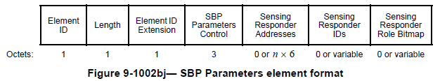
- In the SBP Parameters Control field, the field that controls the presence of the Sensing Responder Role Bitmap field is the Preferred Responder Role Bitmap Present field. This follows a similar naming logic as other fields in the SBP Parameters Control field, which is “Preferred Responder XX” or “XX Preferred Responder”.
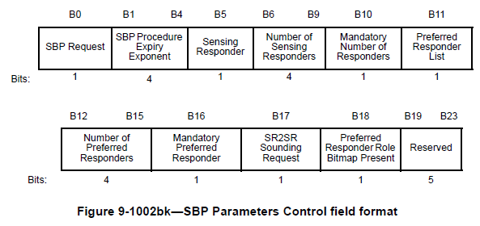
- However, in the text, “the Preferred Responder Role Bitmap field” is mistakenly used as “the Sensing Responder Role Bitmap field”. The former does not exist in the 11bf spec. So, we should make a global change to replace “the Preferred Responder Role Bitmap field” with “the Sensing Responder Role Bitmap field”.

Modifications:
To TGbf Editor: Please make a global change throughout D2.1 to replace “Preferred Responder Role Bitmap field” with “Sensing Responder Role Bitmap field”.

SP:
Do you agree to include the proposed draft text in DCN 23/1970r0 in the latest 11bf Draft?
Y/N/A

