IEEE P802.11Wireless LANs
Proposed Resolutions to 11be LB275 CID-19523
Date: 2023-11-02
Author(s):
Name | Company | Address | Phone | email
Qi Wang | Apple Inc. |  |  | qi_wang2@apple.com
Yong Liu | Apple Inc.

Abstract
This submission proposes the resolution to 11be LB275 CID-19523.

The page and line numbers refer to those in 11be_D4.1 [1].

- Introduction

This submission proposes the resolution to 11be LB275 CID-19523.

Comment:
19523 | Qi Wang | 566.04 | 35.3.17 | "b) On the EMLSR link(s), the group addressed frame(s) that are expected to be received by the non-AP MLD shall be buffered and delivered following the rules defined in 35.3.15 (Multi-link operation group addressed frames)." When a EMLSR non-AP MLD receives on one EMLSR link, it is incapable of receiving either individually or group addressed frames on another EMLSR link, and it takes time to switch its radio resource between two links. An AP MLD has the knowledge of the DTIM beacon TBTTs and group addressed frame delivery time. The 11be spec needs to specify additional rules that an AP MLD completes a TXOP on one EMLSR link in time to allow sufficient time for the non-AP EMLSR STA to switch the radio resource and receive the DTIM beacons and group addressed frames on another link. | As in comment. Please specify additional rules at the AP MLD on the group addressed frame delivery for EMLSR. | Revised.  Agree with the commenter that an AP MLD shall ensure the unicast DL transmission on one EMLSR link completes in time before the group addressed (broadcast/multicast) frame transmission on another EMLSR link so that the non-AP MLD has sufficient time to switch its radio resource from one link to another link to prevent data loss.  TGbe editor: Please incorporate the proposed text change tagged with 19523 in this document.

The page and line numbers refer to those in 11be_D4.1 [1].

- Discussion

As noted in CID-19523, when an non-AP MLD operates in the EMLSR mode, it can receive data frames only on one of the EMLSR links at a time, and it takes time for the non-AP MLD to move its main radio from one of the EMLSR links to another. The latest 11be spec lacks the rule that requires an AP MLD to complete a unicast DL TXOP on one EMLSR link in time to allow sufficient time for the non-AP MLD to switch its radio resource to another EMLSR link to receive the group addressed (broadcast/multicast) frames. Without such a rule, the non-AP MLD operating in the EMLSR mode cannot receive the group addressed frames from time point A to time point B, as illustrated in Figure 1 below.

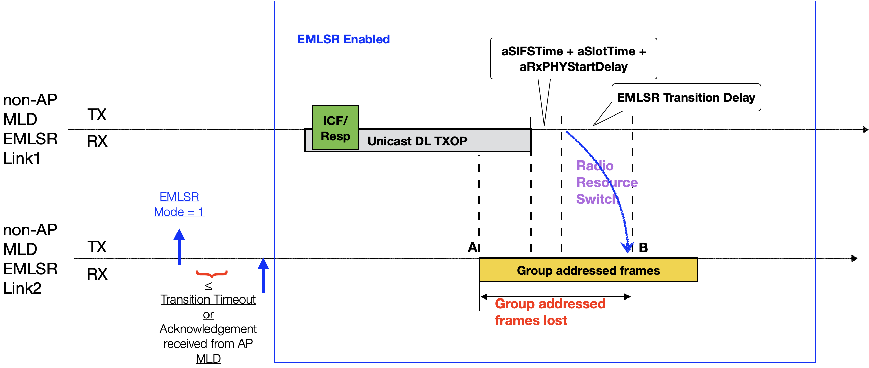
Figure 1. Illustration of a problem of the EMLSR protocol in 11be_D4.0/4.1

As a result, we propose the 11be text modification to solve the problem, and the correct EMLSR protocol behavior is illustrated in Figure 2 below.

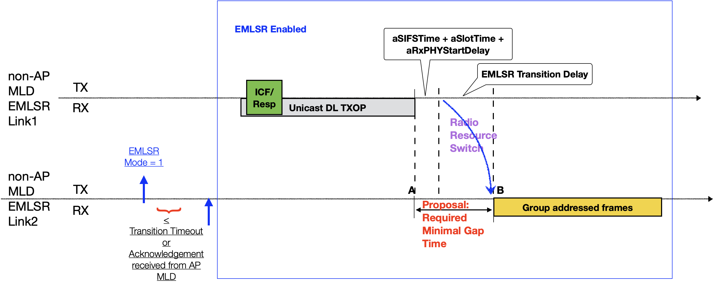
Figure 2. Proposal to fix the problem in EMLSR protocol

- Proposed resolution
TGbe editor: Please change the 11be spec as shown below. The reference version is 11be_D4.1 (#19523)
35.3.17 Enhanced multi-link single radio operation
TGbe editor:11be_D4.1, page 576 line 34 – P578, line 33 (#19523)
When a non-AP MLD is operating in the EMLSR mode with an AP MLD supporting the EMLSR mode, the following applies:
a) The non-AP MLD shall be able to listen on the EMLSR link(s), by having its affiliated non-AP STA(s) corresponding to those links in the awake state. The listening operation includes CCA and receiving the initial Control frame of frame exchanges that are initiated by the AP MLD.
NOTE 2—A non-AP STA operating on one of the EMLSR links can change its power management mode and follows the procedure in 11.2 (Power management). A non-AP STA can listen on one of the EMLSR links in active mode or in PS mode when it is in the awake state.
b) On the EMLSR link(s), the group addressed frame(s) that are expected to be received by the non-AP MLD shall be buffered and delivered following the rules defined in 35.3.15 (Multi-link operation group addressed frames).
c) An AP affiliated with the AP MLD that initiates frame exchanges that are neither group addressed Data nor group addressed Management frames with the non-AP MLD on one of the EMLSR links shall begin the frame exchanges by transmitting the initial Control frame to the non-AP MLD with the limitations specified below.
- The initial Control frame of frame exchanges shall be sent in the non-HT PPDU or non-HT duplicate PPDU format using a rate of 6 Mb/s, 12 Mb/s, or 24 Mb/s.
- The non-AP MLD shall indicate the EMLSR padding delay, which is the minimum MAC pad- ding duration of the initial Control frame, in the EMLSR Padding Delay subfield of the EML Capabilities subfield in the Common Info field of the Basic Multi-Link element carried in a (Re)Association Request frame that it transmits.

- The non-AP MLD may update the EMLSR padding delay by including an updated EMLSR Padding Delay duration in the EMLSR Parameter Update field in the EML Operating Mode Notification frame.
- The AP affiliated with the AP MLD shall set the length of the Padding field of the initial Control frame based on the rules defined in 35.5.2.2.3 (Padding for a triggering frame) to ensure that the MAC padding duration of the initial Control frame is greater than or equal to the EMLSR padding delay last indicated by the non-AP MLD either in the EMLSR Padding Delay subfield of the EML Capabilities subfield in the Common Info field of the Basic Multi-Link element or in the EMLSR Padding Delay subfield of the EMLSR Parameter Update field in the last successfully transmitted EML Operating Mode Notification frame.

- The AP affiliated with an AP MLD should end an DL TXOP for individually addressed frames on one EMLSR link at least aSIFSTime + aSlotTime + aRxPHYStartDelay + EMLSR Transition Delay, where aRxPHYStartDelay is equal to 20 μs, before the transmission of the group addressed frames on another EMLSR link, where the non-AP MLD is an intended receiver of the group addressed frames. The end of an DL TXOP is either the time the AP affiliated with the AP MLD receives the PPDU transmitted by the non-AP STA affiliated with the non-AP MLD as a response to the most recently received frame from the AP affiliated with the AP MLD, or at the end of the transmission of an PPDU containing a frame for the non-AP STA from the AP affiliated with the AP MLD that does not require an immediate acknowledgement. (#19523)

- The initial Control frame shall be an MU-RTS Trigger frame or a BSRP Trigger frame. A non-AP STA affiliated with a non-AP MLD that is in the listening operation and that receives an MU- RTS Trigger Frame or BSRP Trigger frame addressed to it shall respond as defined in 35.5.2.3 (Non-AP STA behavior for UL MU operation) except when the frame exchanges initiated by the initial Control frame on one of the EMLSR links overlap with group addressed frame transmissions on the other EMLSR link where the non-AP STA intends to receive the group addressed frames. The number of spatial streams for the response to the BSRP Trigger frame shall be limited to one, which shall be indicated in the BSRP Trigger frame.
NOTE 3—Whether to use the MU-RTS Trigger frame or the BSRP Trigger frame as the initial Control frame to initiate the frame exchanges is implementation specific and out of scope of this standard.
NOTE 4—If an AP MLD has received an EML Operating Mode Notification frame with the In-Device Coexistence Activities subfield of the EML Control field set to 1 from a non-AP MLD, and the AP MLD does not receive a response to an initial Control frame that it transmits to the non-AP MLD, then the AP can consider the nonresponse as a result of the in-device coexistence events at the non-AP MLD on the link where the frame was transmitted. The AP is recommended to consider the in-device coexistence indication and select appropriate transmission parameters and methods for the non-AP MLD
d) After receiving the initial Control frame of frame exchanges and transmitting an immediate response frame as a response to the initial Control frame, a non-AP STA affiliated with the non-AP MLD that was listening on the corresponding link shall be able to transmit or receive frames on the link on which the initial Control frame was received and shall not transmit or receive on the other EMLSR link(s) until the end of the frame exchanges, and subject to its spatial stream capabilities, operation mode, and the minimum MAC padding duration of the Padding field of the initial Control frame, the non-AP STA affiliated with the non-AP MLD shall be capable of receiving a PPDU that is sent using more than one spatial stream on the link on which the initial Control frame was received a SIFS after the end of its response frame transmission solicited by the initial Control frame. During the frame exchanges, the other AP(s) affiliated with the AP MLD shall not transmit frames to the other non-AP STA(s) affiliated with the non-AP MLD on the other EMLSR link(s).

- The non-AP MLD shall indicate its EMLSR transition delay in the EMLSR Transition Delay subfield of the EML Capabilities subfield in the Common Info field of the Basic Multi-Link element carried in a (Re)Association Request frame that it transmits. The non-AP MLD may update its EMLSR transition delay by including the EMLSR Parameter Update field in an EML Operating Mode Notification frame.

- When the EMLSR Parameter Update field is present in an EML Operating Mode Notification frame, the EMLSR Link Bitmap subfield of the EML Control field shall contain a different value than the EMLSR Link Bitmap value contained in the most recent EML Operating Mode Notification frame successfully transmitted by the non-AP MLD.

- The non-AP MLD shall be switched back to the listening operation on the EMLSR links after the EMLSR transition delay time most recently indicated by the non-AP MLD), if any of the following conditions is met and this is defined as the end of the frame exchanges:
- The MAC of the non-AP STA affiliated with the non-AP MLD that received the initial Control frame does not receive a PHY-RXSTART.indication primitive during a timeout interval of aSIFSTime + aSlotTime + aRxPHYStartDelay, where aRxPHYStartDelay is equal to 20 μs, starting at the end of the PPDU transmitted by the non-AP STA affiliated with the non-AP MLD as a response to the most recently received frame from the AP affiliated with the AP MLD or starting at the end of the reception of the PPDU containing a frame for the non-AP STA from the AP affiliated with the AP MLD that does not require immediate acknowledgement.
- The MAC of the non-AP STA affiliated with the non-AP MLD that received the initial Control frame receives a PHY-RXSTART.indication primitive during a timeout interval of aSIFSTime + aSlotTime + aRxPHYStartDelay starting at the end of the PPDU transmitted by the non-AP STA affiliated with the non-AP MLD as a response to the most recently received frame from the AP affiliated with the AP MLD or starting at the end of the reception of the PPDU containing a frame for the non-AP STA from the AP affiliated with the AP MLD that does not require immediate acknowledgement and this non-AP STA does not detect, within the PPDU corresponding to the PHY-RXSTART.indication any of the following frames:
- an individually addressed frame with the RA equal to the MAC address of the non-AP STA affiliated with the non-AP MLD
- a Trigger frame that has one of the User Info fields addressed to the non-AP STA affiliated with the non-AP MLD
- a CTS-to-self frame with the RA equal to the MAC address of the AP affiliated with the AP MLD
- a Multi-STA BlockAck frame that has one of the Per AID TID Info fields addressed to the non-AP STA affiliated with the non-AP MLD
- an NDP Announcement frame that has one of the STA Info fields addressed to the non-AP STA affiliated with the non-AP MLD and a sounding NDP
- The non-AP STA affiliated with the non-AP MLD that received the initial Control frame does not respond to the most recently received frame from the AP affiliated with the AP MLD that requires an immediate response after a SIFS.
h) The AP affiliated with the AP MLD should transmit before the TXNAV timer expires another initial Control frame addressed to the non-AP STA affiliated with the non-AP MLD if the AP intends to continue the frame exchanges with the STA and did not receive the response frame from this STA for the most recently transmitted frame that requires an immediate response after a SIFS.
…
References

[1] IEEE P802.11be™/D4.1, Draft standard for information technology – Telecommunications and information exchange between systems local and metropolitan area networks – Specific requirements Part 11: Wireless LAN medium access control (MAC) and physical layer (PHY) specifications, Amendment 9: Enhancements for extremely high throughput (EHT)
Amendment 4: Enhancements for positioning

