IEEE P802.11
Wireless LANs
LB 276 CR for CIDs 3395 and 3303
Date: 2023-10-31
Author(s):
Name | Affiliation | Address | Phone | email
Mahmoud Kamel | InterDigital |  |  | mahmoud.kamel@interdigital.com
Rui Yang | InterDigital
Ali Raissinia | Qualcomm

Abstract
This submission proposes resolutions for CIDs 3395 and 3303 in subclause 9.4.2.320 in P802.11bf D2.0.

NOTE – Set the Track Changes Viewing Option in the MS Word to “All Markup” to clearly see the proposed text edits.

Revision History:

R0: Initial version

CID | Clause | Page.Line | Comment | Proposed Change | Resolution
3395 | 9.4.2.35 | 68.40 | It might be useful to add another bit in the BSSID Information field format to indicate whether the AP identified by this BSSID supports SBP or not | As in comment | Reject  All optional sensing features may be discovered through the Extended Capability element or the Sensing Capability element and there is no critical need to include another bit in the BSSID Information field for the indication of SBP support. Limiting capability indication to one bit for sensing in the BSSID helps avoid “beacon bloating” and is good enough for the indication of a sensing-capable STA.

CID | Clause | Page.Line | Comment | Proposed Change | Resolution
3303 | 9.4.2.320 | 72.16 | Should Sensing Measurement Report Requested field be always set to 1 in an SBP Request frame? Otherwise when Sensing Receiver field is reserved, how to interprete this Sensing Measurement Report Requested field? | Add "Sensing Measurement Report Requested field is always set to 1 in an SBP Request frame" | Revise  The problem brought up by the commenter is reasonable and this problem can be solved using different approaches which are presented in this document.  Investigating the problem further suggests other changes to the specs to improve the readability and remove the ambiguity.  TGbf editor: please incorporate changes shown in 11-23/1826r0 below under the tag (#3303).

DISCUSSION BEGIN

In the SBP Parameters element, there is a bitmap (Sensing Responder Role Bitmap) to indicate the sensing responder role, however, there is only one bit in the Sensing Measurement Parameters element (Sensing Measurement Report Requested) to indicate whether the measurement report is requested from the responders with the role receiver or transmitter and receiver. This limits the choices of the SBP Initiator to indicate whether a certain responder is requested to send the report or not. In other words, since there is only one bit to indicate whether the report is requested or not, then the SBP Initiator either requests the report from ALL responders or requests the report from NONE.

Proposed solutions:

Option 1: Use the available bit (Sensing Measurement Report Requested) to either request the report from ALL responders (set to 1) or NONE of them (set to 0).

Option 2: Include a bitmap (e.g., in the SBP Parameters element) similar to the Sensing Responder Role Bitmap each bit indicates to one of the responders in the Sensing Responder Role Bitmap with the role receiver or transmitter and receiver whether the report is requested or not.
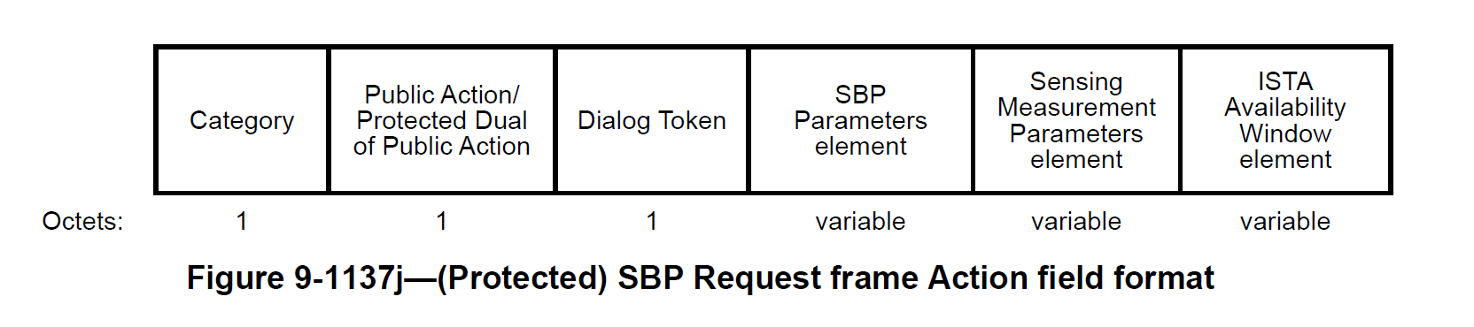

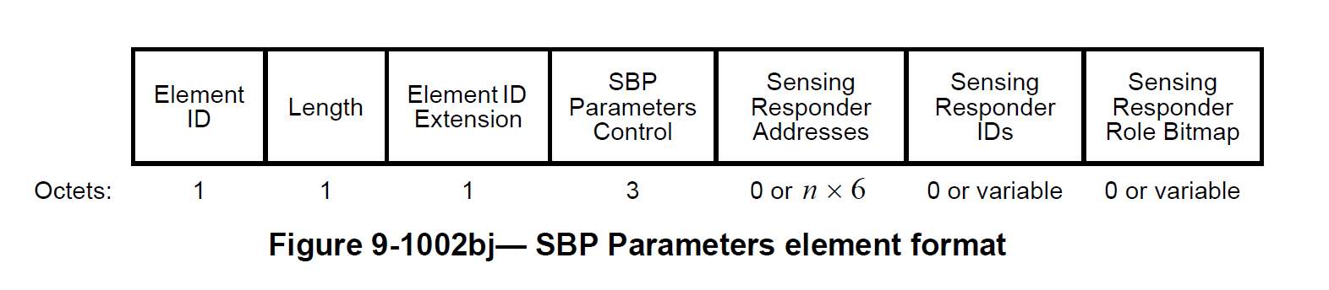

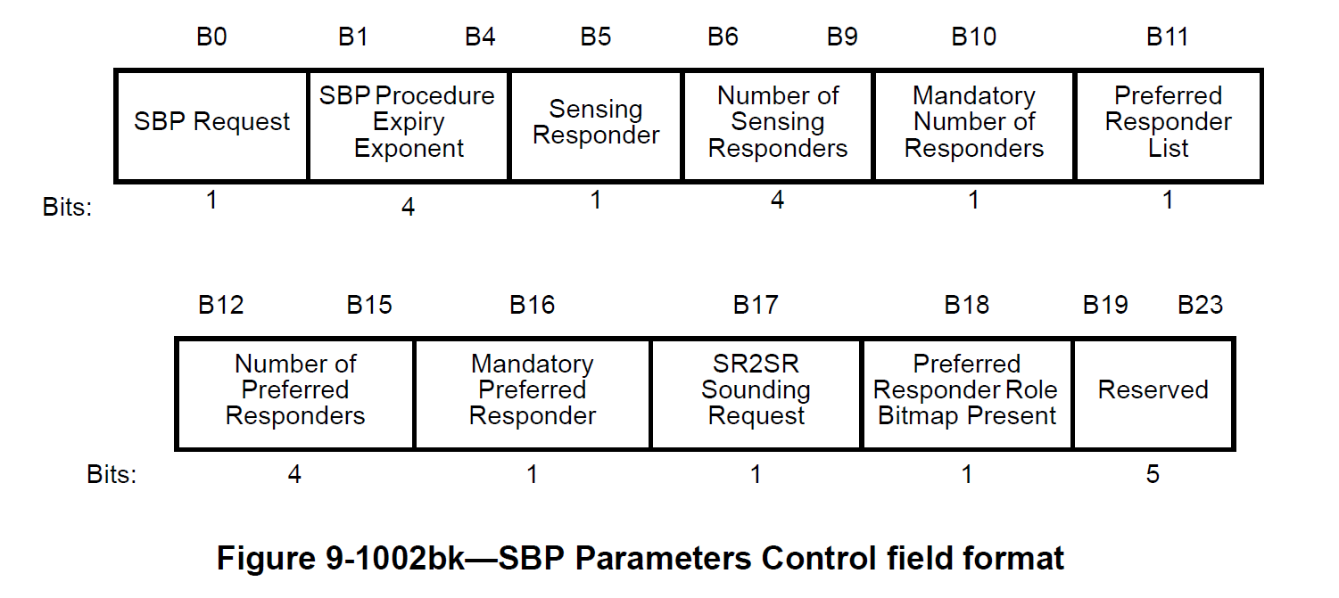

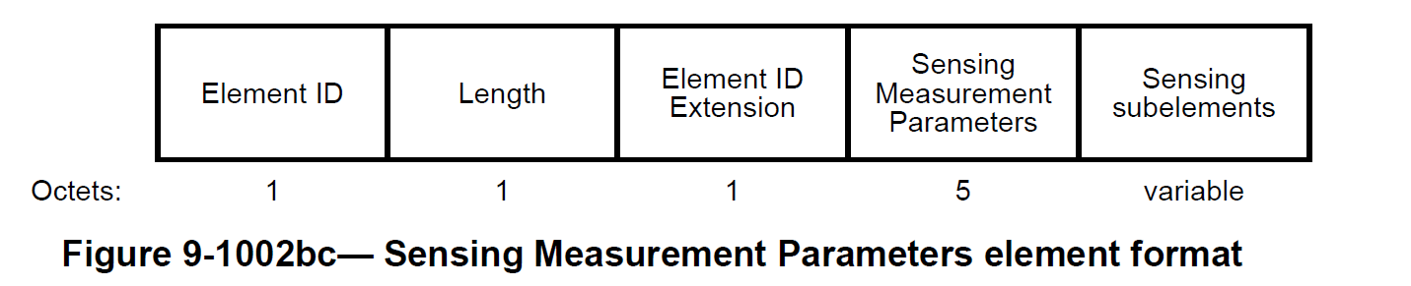

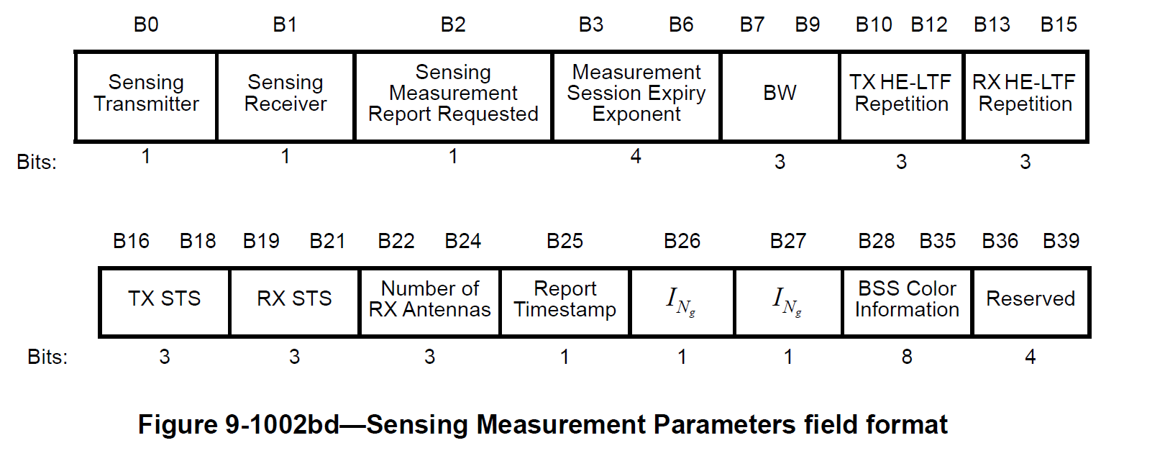
DISCUSSION END

TGbf editor: please make the following change in subclause 9.4.2.320, P72L1 in 11bf D2.1.

The Sensing Transmitter field is set to 1 to indicate a sensing transmitter role for the sensing responder; and is set to 0 otherwise. The Sensing Transmitter field is reserved in the Sensing Measurement Parameters element included in the SBP Request frame when the Preferred Responder Role Bitmap Present field is set to 1 in the SBP Parameters Control field of the SBP Parameters element in the same SBP Request frame(#3303).

The Sensing Receiver field is set to 1 to indicate a sensing receiver role for the sensing responder; and is set to 0 otherwise. The Sensing Receiver field is reserved in the Sensing Measurement Parameters element included in the SBP Request frame when the Preferred Responder Role Bitmap Present field is set to 1 in the SBP Parameters Control field of the SBP Parameters element in the same SBP Request frame(#3303).

Option 1:

TGbf editor: please insert the following paragraph in subclause 9.4.2.320, P72L27 in 11bf D2.1.
If the Sensing Receiver field is reserved in the Sensing Measurement Parameters element included in the SBP Request frame, the Sensing Measurement Report Requested field in the Sensing Measurement Parameters element included in the same SBP Request frame is set to
- 1 to indicate that all sensing responders with the sensing receiver role (i.e., value 01 or 11 in the Preferred Responder Role Bitmap in the SBP Parameters element) send the Sensing Measurement Report frames in sensing measurement exchanges that result from the sensing measurement session(s) initiated by the SBP responder (#3303)
- 0 to indicate that all sensing responders with the sensing receiver role (i.e., value 01 or 11 in the Preferred Responder Role Bitmap in the SBP Parameters element) do not send the Sensing Measurement Report frames in sensing measurement exchanges that result from the sensing measurement session(s) initiated by the SBP responder (#3303)

Option 2:

TGbf editor: please replace Figure 9-1002bj and Figure 9-1002bk with the figures below in 11bf D2.1.

 | SBP Request |  | SBP Procedure  Expiry  Exponent | Sensing  Responder |  | Number of  Sensing  Responders | Mandatory  Number of  Responders | Preferred  Responder  List
Bits: | 1 | 4 |  | 1 | 4 |  | 1 |  | 1

 | Number of  Preferred  Responders | Mandatory  Preferred  Responder |  | SR2SR  Sounding  Request | Preferred  Responder Role  Bitmap Present |  | Report Requested Bitmap Present | Reserved
Bits: | 4 |  | 1 | 1 |  | 1 | 1 |  | 4

Figure 9-1002bj— SBP Parameters element format

 | Element  ID | Length | Element ID  Extension | SBP  Parameters  Control | Sensing  Responder  Addresses | Sensing  Responder  IDs | Sensing  Responder  Role Bitmap | Report Requested Bitmap
Octets: | 1 | 1 | 1 | 3 | 0 or n x 6 | 0 or variable | 0 or variable | 0 or variable

Figure 9-1002bk—SBP Parameters Control field format

TGbf editor: please insert the following paragraph in subclause 9.4.2.322, P79L49 in 11bf D2.1

- The Report Requested Bitmap Present field is set to 1 to indicate that the Report Requested Bitmap field is present. Otherwise, it is set to 0. It is reserved if the Preferred Responder List field is set to 0.

TGbf editor: please insert the following paragraph in subclause 9.4.2.322, P80L1 in 11bf D2.1

- The Report Requested Bitmap field is present only if Report Requested Bitmap Present field is set to 1. The Report Requested Bitmap field indicates whether each one of the preferred sensing responders which is assigned the role of receiver or the role of both transmitter and receiver is required to transmit the sensing measurement report. The Report Requested Bitmap uses m bits which are listed in the same order of the m corresponding responders listed in the Sensing Responder Addresses and are assigned the role of receiver or the role of both transmitter and receiver as indicated by the Sensing Responder Role Bitmap field. The encoding of each bit of the Report Requested Bitmap field is given in Table 9-XYZ (Encoding of each bit of the Report Requested Bitmap field).

Table 9-XYZ— Encoding of each bit of the Report Requested Bitmap field
Encoding | Meaning
0 | The sensing responder is not required to send the sensing measurement report
1 | The sensing responder is required to send the sensing measurement report

TGbf editor: please insert the following paragraph in subclause 11.55.2.2, P164L24 in 11bf D2.1

If the Report Requested Bitmap Present field within the SBP Parameters parameter in the SBP Request frame sent by the SBP initiator is set to 1, the Report Requested Bitmap field shall be present in the SBP Request frame. The Report Requested Bitmap field shall include m bits each of which is corresponding to one of the preferred responders that are assigned the role of receiver or the role of both transmitter and receiver. Each bit of The Report Requested Bitmap field shall be set to the value 1 to indicate that the corresponding responder is required to send the sensing measurement report or shall be set to 0 to indicate that the corresponding responder is not required to send the sensing measurement report.

if the Report Requested Bitmap Present field within the SBP Parameters field in the SBP Request frame sent by the SBP initiator is set to 1 and if the Status Code field in the SBP Response frame sent by the SBP Responder is set to SUCCESS, the SBP Responder shall set the Sensing Measurement Report Requested field in the Sensing Measurement Parameters field in the Sensing Measurement Request frame according to the value of the corresponding bit in the Report Requested Bitmap such that each bit is mapped to one of the preferred sensing responders as listed in the Sensing Responder Addresses field in the SBP Parameters element which is assigned the role of receiver or the role of both transmitter and receiver as indicated by the Sensing Responder Role Bitmap field in the SBP Parameters element.

