IEEE P802.11
Wireless LANs
Comment resolution for CID 3381
Date: 2023-10-23
Author(s):
Name | Affiliation | Address | Phone | email
Ning Gao | OPPO |  |  | gaoning1@oppo.com
Abstract
This submission resolves CID 3381.

Revisions:

- Rev 0: Initial version of the document.

CID 3381

CID | Clause | Page | Comment | Proposed Change | Resolution
3381 | 9.3.1.25.5 | 43.16 | the Sense Golay Index field also can be used in the parallel Coordinated Monostatic sensing type, which indicates different sensing responders use different Golay indexes to alleviate interference. | Add a sentence in this paragraph as follow: The Sense Golay Index field suggests the index of the Golays sequences to be used in the TRN field of Monostatic PPDUs if the Sensing Type is set to Coordinated Monostatic. The paragraph also needs to be reorganized. | Revised.  Agree with the commenter in principle.  TGbf Editor make changes as in doc.: 11-23/1821r0 under the CID 3381.

Discussion:

Using multiple Golay sequences to reduce sidelobes in maps with Doppler was proposed in 22/0040r1. According to this contribution, this technique is applicable to bistatic and multi-static sensing types. But actually, it also can be used in coordinated bistatic type which is very similar to bistatic sensing.

Besides, this technique is also beneficial to the coordinated monostatic sensing type especially the parallel mode shown in the following figure. Using different Golay sequences by different sensing responders could help reduce interference with each other during the sounding phase.

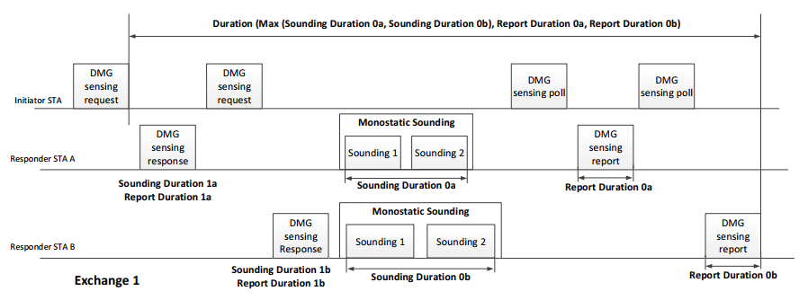

Discussion end

9.3.1.25 TDD Beamforming frame format
9.3.1.25.5 DMG Sensing Request frame
TGbf Editor: Please revise the following paragraph as below.
The EDMG TRN Length, RX TRN-Units per Each TX TRN-Unit, EDMG TRN-Unit P, EDMG TRN-Unit M, EDMG TRN-Unit N, TRN Subfield Sequence Length, BW contain the values of the corresponding header fields in the EDMG multistatic sensing PPDU. These fields are reserved if the Sensing Type is set to Coordinated Monostatic or Coordinated Bistatic.

The Sense Multiple Golays field indicates that the Golay sequences used in the TRN field of DMG monostatic sensing PPDUs, EDMG BRP PPDUs or EDMG multistatic sensing PPDUs sent in the DMG sensing measurement exchange are based on the sequence index specified in the Sense Golay Index field. The Sense Golay Index field indicates the index of the Golay sequences to be used in the TRN field.

SP
Do you support the resolution to CID 3381 and incorporate the text changes into the latest TGbf draft in 11-23/1821r0

Y/N/A

