IEEE P802.11
Wireless LANs
Proposed resolutions for editorial comments on D2.0 - Part 2
Date: 2023-10-19
Author(s):
Name | Affiliation | Address | Phone | email
Claudio da Silva | Meta Platforms
Abstract
This document contains proposed resolutions for technical comments on D2.0 (LB276). The text used as reference is D2.1.

CIDs: 3012, 3133, 3192, 3254, 3255, 3268, 3386, 3429, 3492, 3419, 3373, 3359, 3347

CID | Clause | Page | Comment | Proposed change
3012 | 9.4.2.320 | 72.39 | In this draft, "an HE" and "a HE" coexist. | Please unify the usage of the indefinite article for "HE".

Proposed resolution: Revised

Modifications: TGbf Editor – Please replace “a HE” with “an HE” throughout the draft.

CID | Clause | Page | Comment | Proposed change
3133 | 11.55.1.5.2.3 | 148.45 | Place a comma. | Change "2045 the" to "2045, the".

Proposed resolution: Rejected. Original sentence is grammatically correct.

Discussion: Text referred to by the commenter:
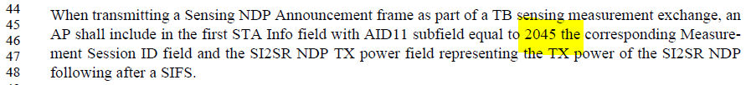

CID | Clause | Page | Comment | Proposed change
3192 | 6.4 | 21.13 | complete the name MLME-XXX throughout the subclause | as in comment

Proposed resolution: Rejected. The draft follows the convention used in the baseline.

Discussion: Text referred to by the commenter:
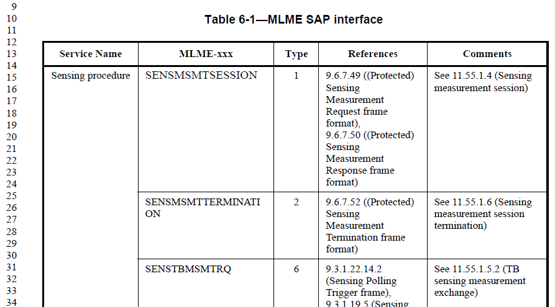

CID | Clause | Page | Comment | Proposed change
3254 | 11.55.1.5.2.2 | 148.56 | spell out WM. Wireless Medium? | As in comment

Proposed resolution: Rejected. WM is defined in the baseline as wireless medium.

Discussion: In Clause 3.1 (page 195) of REVme/D4.0, we have:

CID | Clause | Page | Comment | Proposed change
3255 | 11.55.1.5.2.6.2 | 153.17 | Looks like there is a space between [0,1] and . | Remove the extra space

Proposed resolution: Accepted

CID | Clause | Page | Comment | Proposed change
3268 | 11.55.3.1 | 167.40 | Add ", respectively" after "1,2, and3" | As in comment

Proposed resolution: Rejected. According to the writing manual of Springer (https://www.springer.com/gp/authors-editors/authorandreviewertutorials/writinginenglish/use-of-respectively/10252704#:~:text='Respectively'%20is%20an%20adverb%20that,4%20mL%2Fmin%2C%20respectively.),

“‘Respectively’ is an adverb that is often misused by non-native English speakers. It means “in the order given” and should only be used if your sentence would be unclear without it.

Example: Oxygen, nitrogen and hydrogen detector flows were set at 85, 7, and 4 mL/min, respectively.

The use of respectively here makes it clear that the first gas mentioned goes with the first number, the second gas goes with the second number, and the third gas with the third number.

More examples:
BAD: The two values were 143.2 and 21.6, respectively.
GOOD: The two values were 143.2 and 21.6.
BAD: The two tubes were labeled B and S, respectively.
GOOD: The tubes containing blood and saline were labeled B and S, respectively.””

Discussion: Text referred to by the commenter:

CID | Clause | Page | Comment | Proposed change
3386 | 28.9.3.4.2 | 203.12 | In equation 28-1a the super scripts of some line get mixed up with the subscripts of the lines above them | To be fixed by the editor, possibly by the IEEE editor.

Proposed resolution: Accepted

CID | Clause | Page | Comment | Proposed change
3429 | 11.55.3.1 | 167.01 | The bullet list type changed from the previous page "-" to a dot. Please correct | As in comment

Proposed resolution: Revised

Discussion: The text referred to by the commenter was revised by the resolution of CID 3121, and the potential issue identified by the commenter no longer exists (in D2.1).
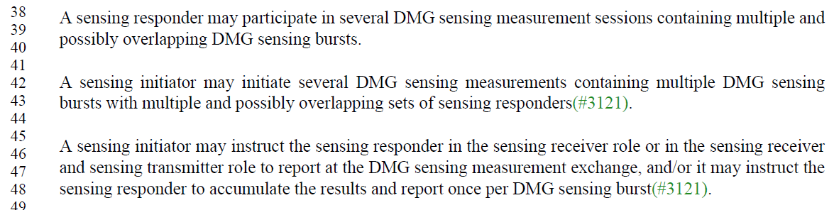

Modifications: No further changes are required.

CID | Clause | Page | Comment | Proposed change
3492 | 11.55.1.5.2.2 | 147.18 | Typo | Change "receipt" to "reception"

Proposed resolution: Rejected. Both “Upon reception of” (81 apperances) and “Upon receipt of” (161 apperances) appear in REVme/D4.0. Example of “Upon receipt of”
- “…are reset to 0 upon receipt of the MU EDCA Reset frame for affected STAs”
- “The addressed recipient takes no action upon receipt of the frame.”
- “Upon receipt of a PS-Poll frame, a STA, except for an S1G STA for which the RXVECTOR parameter RESPONSE_INDICATION of the received PS-Poll frame is NDP Response, shall update…”

Discussion: Text referred to by the commenter is:

CID | Clause | Page | Comment | Proposed change
3419 |  | 1.03 | As REVme D3.0 does not include 802.11az-2022 and 802.11bd-2022, the two amendments should be listed in addition to REVme D3.0 | As in comment
3373 | 11.3.3 | 133.09 | "Bad editing reference "as defined in IEEE P802.11az/D7.0"". 802.11az is published.  Also, 802.11az is not listed as a baseline doc on the 802.11bf title page. | Delete "as defined in IEEE P802.11az/D7.0". Re-sync with 802.11REVme after 802.11az is rolled in (or explicitly list 802.11az on the 802.11bf title page).
3359 | Title Page | 1.04 | "as amended by IEEE P802.11be/3.2". 802.11bf also makes changes to 802.11az. | Add "IEEE P802.11az"
3347 | 12.5.2.4.4 | 194.40 | There seems to be a base line issue in this text. 1) The base line is based on 802.11az and 802.11me D3.0 has made changes to this clause. But, 802.11me D3.0 does not include the 802.11az amendment, 802.11me will eventually include 802.11az (probably in a few months). So I understand the baseline confusion.  2) The baseline text from 802.11az is marked as change text (underlined), which it is not for 802.11bf. | Remove the underline from: ""The QMF receiver shall use the ACI encoded in the Sequence Number field of the received frame to select the replay counter to use for the received frame, and shall use the PN from the received frame to detect replays. A replayed frame occurs when the PN from the frame is less than or equal to the current value of the management frame replay counter that corresponds to the ACI of the frame.""  Note: Eventually this text needs to align with the 802.11me baseline text, but when it will be best to do so is a judgement call.

Proposed resolution: Revised

Discussion: IEEE 802.11 TGme expects to roll in the 802.11az amendment after its initial SA ballot. By the time of its publication, the 802.11bf baseline will be 802.11-2025 as amended by the 802.11be amendment, as it is currently shown in the 802.11bf amendment.

Modifications: TGbf Editor – Update the baseline text to the latest revisions of Draft P802.11REVme and Draft P802.11be. Also, update references from IEEE P802.11az/D7.0 to IEEE 802.11az-2022.

