IEEE P802.11
Wireless LANs
802.11 TGbe
LB275 CR for Misc clause 6 and 7
Date: 2023-11-16
Author(s):
Name | Affiliation | Address | Phone | email
Mark Hamilton | Ruckus/CommScope | 350 W Java Dr, Sunnyvale, CA 94089 | 303-818-8472 | mark.hamilton2152@gmail.com
Abstract
This submission proposes resolutions to the following comments received on LB275: 19223, 19470, 19485, 19490 ,19507, 19508, 19509, 19570, 19735.

Revision History

R0 – Iinitial version
R1 – Updated resolution to CID 19735.
R2 – Completed CIDs 19223, 19490, 19508, 19509, 19570, 19735. Deferred CIDs 19485, 19470, 19507.
R3 – Removed CID 19485. Added proposed resolution for CIDs 19470 and 19507.

Draft version

Changes are relative to TGbe D4.0, unless stated otherwise.

Ready for Discussion

CID | Clause Number | Page | Line | Comment | Proposed Change
19223 | 7.1 | 115 | 11 | The three upper boxes on the left side all say "Non-MLD upper MAC sublayer" but the center box is for MLD operation | Change text in center box to "MLD upper MAC sublayer"

Discussion:

Current figure:

The commenter is correct.

Proposed Resolution:
Accepted.

(Updated figure shown here – Visio source will be provided to the Editor)

CID | Clause Number | Page | Line | Comment | Proposed Change
19490 | 7.1 | 114 | 32 | [WFA-R] MUMS and MLMS are not used anywhere else in the document.  It seems very odd to introduce these for just one figure. | As in comment

Discussion:

Current Figure 7-1:

Generally agree with the commenter’s intent. However, given the squeeze to get all this information into one figure, there isn’t room to spell out the “MUMS” and “MLMS” in the boxes on the right side. The commenter doesn’t provide a suggestion for how to change the figure to remove these acronyms.

The options would be to make those boxes significantly bigger (bigger than any other boxes in the entire figure, which would look very out of place), or to separate the MLD concepts into a separate figure. While the separate figure might work, it would lose the implication that all these types of 802.11 architectures can co-exist within an ESS and a single DS, so this is not preferable to do.

Proposed Resolution:
Rejected.

While the commenter’s point about these acronyms is correct, there is not enough space to spell out these terms within the figure. The comment does not provide sufficient details to determine a change that would satisfy the commenter, and no appropriate change is immediately obvious within the size constraints of this figure.

CID | Clause Number | Page | Line | Comment | Proposed Change
19508 | 7.1 | 114 | 65 | [WFA-R] s/MLD's MLD upper MAC sublayer/MLD upper MAC sublayer/ | As in comment

Discussion:

Context:

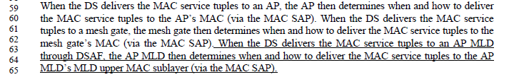

While the commenter’s intent makes sense, in context, it can be seen that this text is trying to identify the particular “MLD upper MAC sublayer” (a particular term introduced and used throughout clauses 4, 5, and 7) that is part of the AP MLD whose operation is being described by this new sentence. Thus, both terms need to be spelled out in full. If we adopt the proposed change, the sentence would then reference “the AP MLD upper MAC sublayer”, which in incorrect because an AP (that is not an AP MLD) does not have a MLD upper MAC sublayer.

So, although wordy, the existing text is correct use of the terminology.

Proposed Resolution:
Revised.

Change to “deliver to the MLD upper MAC sublayer of the AP MLD”

CID | Clause Number | Page | Line | Comment | Proposed Change
19509 | 7.2.3.2.3 | 116 | 32 | [WFA-R] s/non-AP MLD-to-AP MLD or mesh STA-to-mesh gate map/  /MLD-to-AP MLD map or mesh STA-to-mesh gate map/ Note: There is a missing "map". | As in comment

Discussion:

Context:

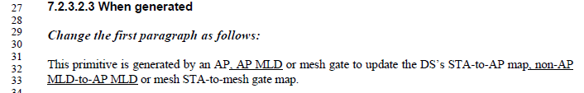

The comment is correct about the missing “map”. However, the implied change of “non-AP MLD” to just “MLD” is incorrect terminology (or at best ambiguous). Also the addition of a comma would be helpful to the reader.

Proposed Resolution:
Revised.

Replace:
“non-AP MLD-to-AP MLD”
with:
“non-AP MLD-to-AP MLD map,”

CID | Clause Number | Page | Line | Comment | Proposed Change
19570 | 6.5.4d.2 | 109 | 58 | Please clarify whether the primitive MLME-BSS-LINK-DISABLE is to disable a BSS or a link. If it can be used to disable a link, there is no link info in the primitive parameters. | Please clarify the primitive.

Discussion:

Context:

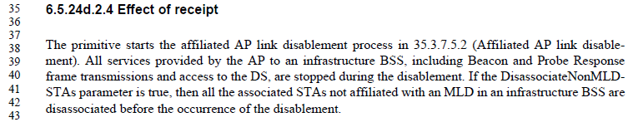

In the text quoted above, it be clearly seen that MLME-BSS-LINK-DISABLE will perform the process described in 35.3.7.5.2, upon a .request primitive.

Subclause 35.3.7.5.2 describes all actions as “each of the APs affiliated with an AP MLD shall …” language.

This includes the following:
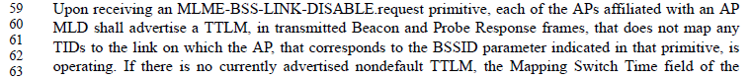
and:
with a description of how all such non-AP STAs are transitioned.

And, further, the last paragraph says:
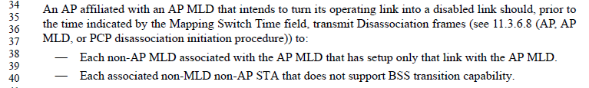
These paragraphs make it clear that all associated non-AP STAs have the link removed or are disassociated (not just a single “link” – it is clearly disabling the entire BSS for all such non-AP STAs).

So, then the question is whether the primitive is clear that this is the case. The current text for the .request primitive (shown in the quoted text above) clearly states:
- All services provided by the AP to an infrastructure BSS … are stopped. And this explicitly says it includes Beacons and Probe Responses.
- There is a parameter that allows control over the non-MLD associated non-AP STAs.
So, whether the BSS is disabled completely, or the BSS is allowed to remain but only for (non-MLD) non-AP STAs is clearly specified. Perhaps that (last) sentence could be clarified that either way, all ssociated non-AP MLDs will be disassociated.

Proposed Resolution:
Revised.

At P109.40, insert a new sentence before the sentence that starts “If the DisassociateNonMLDSTAs …”:
“All associated non-AP MLDs in the BSS will be signaled that no TIDs map to the link on which the AP is operating.”

CID | Clause Number | Page | Line | Comment | Proposed Change
19735 | 6.5.7.2.2 | 87 | 12 | Since the link where the (re)association request frame is sent must be the same as the link on which the authentication frame exchange occurs (see bugfix discussion in 11-23/743r2), the recommendation cannot be applied to association (or reassociation request frame). | Delete this parameter and make corresponding changes to the rest of clause 9.

Discussion:

The Description for this parameter clearly states that the SME provides this parameter to indicate on which link the Association Request can be transmitted.

There is no restriction in the current Standard that a non-AP STA cannot be authenticated with more than one AP at the same time. (It can only associate to one AP.) This allows flexibility in implementation and potential for optimization of the authentication step. This might not be a popular usage in actual implementations, but it is important that our Standard be consistent with mechanisms that allow it to work properly.

As such, without this parameter, the MLME may not have the information to know which link is the one performing the Association.

It is a requirement on the SME to ensure that this link matches the link on which the authentication was completed (as is clarified by the . (Note that there can be some time between the authentication and association procedures, in addition to the option to have multiple links in Authenticated state, so the SME is responsible for keeping this straight.)

Agree with commenter that there is a requirement that this Recommended Link parameter must match the Recommended Link used for a prior Authentication, and that link must be in State 2. It would be helpful to the reader/implementor to be reminded of this requirement.

Proposed Resolution:
Revised

The Recommended Link parameter serves the purpose of having the SME keep track of which links are in what state, and ensuring that the link that is appropriate for this Association Request frame is used.

TGbe Editor: Add a NOTE (in the appropriate location, to apply to the parameters to MLME-ASSOCIATE.request on P87.12 (D4.0):
NOTE: It is a requirement on the SME that the link identified by the Recommended Link parameter must match the link used in a prior successful MLME-AUTHENTICATE.request transaction, and the link must be in State 2. See 35.3.5.1.

CID | Clause Number | Page | Line | Comment | Proposed Change
19470 | 6.5.3.2.2 | 80 | 59 | The EHTCapabilities description discusses a STA, but it also applies to an MLD. | Change the text "that are supported by the STA" to "that are supported by the STA or the MLD". There are many other places in clause 6 that need to be updated and the commenter is happy to bring a submission.

Discussion:

The resolution to this CID depends on the direction to CID 19485 (above), and how the MLME SAP architecture works with respect to an MLD and its affiliated STAs.

Assuming the MLME-SCAN.request primitive can be requested of a non-AP MLD after that discussion is settled (there is an “MLD level” MLME SAP), then generally agree with the comment that the SCAN (and therefore the Probe Request(s) generated) would apply to the MLD’s capabilities for EHT (etc.?).

That said, it is noted that a Probe Request frame carries an EHT Capabilties element, which is described with reference (only) to the STA that transmits the frame, although clearly some of the capabilities information in the EHT Capabilties element are capabilities of the MLD. The MLME-SCAN primitive needs to relate to the contents of the Probe Request frame, however this gets settled.

Awaiting TG discussion on CID 19485, and any further discussion (if any) on the Probe Request’s EHT Capabilities element, and on how all these aspects of a scan request relate to the MLD and/or affiliated STAs.

The commenter notes that other places in clause 6 need to be updated, also (beyond the specific change provided). This work needs a submission. For now, adding the proposed change sentence at least clarifies that there are MLD-level capabilities in the EHT Capabilities, so we’ll start with at least that change.

Proposed Resolution:

Revised.

Change the text "that are supported by the STA" to "that are supported by the STA or the MLD".

CID | Clause Number | Page | Line | Comment | Proposed Change
19507 | 6.5.7.3 | 88 | 20 | [WFA-R] The wording is cumbersome and could be improved to cover all ofthe AP types | Change "AP or PCP, or in an AP MLD" to "AP, PCP, or AP MLD/AP, PCP, or AP MLD" at the following locations: p88/20, p89.65, p90.10, p92.30, p93.44, p93.65, p95.7, p96.25, 97.21

Discussion:

Context (p88.20):

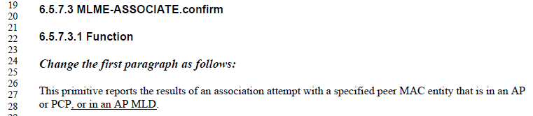

The resolution to this CID depends on the direction to CID 19485 (above), and how the MLME SAP architecture works with respect to an MLD and its affiliated STAs.

Assuming the MLME-ASSOCIATE.confirm primitive can be geneared by a non-AP MLD after that discussion is settled (there is an “MLD level” MLME SAP), then Generally agree with the comment that the list of entities that would report an Association result needs to include reporting the results of an attempt by an AP MLD.

From the changes in 11.3, it is clear the intent of TGbe is that an association can be between MLDs. Can it also be at the affiliated STA level? This would affect how this sentence is worded, as well.

That said, the Proposed Change is a bit confusing. The proposal is to say:
"AP, PCP, or AP MLD/AP, PCP, or AP MLD”
Within this:
- What is meant by “AP MLD/AP” in the list?
- Why is “PCP in the list twice? Is that just an error, or is the second PCP meant to be something else (a “PCP MLD”?)?

Awaiting TG discussion on CID 19485, and any further discussion (if any) on the Probe Request’s EHT Capabilities element, and on how all these aspects of a scan request relate to the MLD and/or affiliated STAs.

Proposed Resolution:

Revised.

Change "AP or PCP, or in an AP MLD" to "AP, PCP, or AP MLD " at the following locations: p88/20, p89.65, p90.10, p92.30, p93.44, p93.65, p95.7, p96.25, 97.21

Not ready yet

CID | Clause Number | Page | Line | Comment | Proposed Change
19485 | 6 | 79 | 1 | For an MLD, there is only one SME and only one MLME SAP which resides at the MLD (upper MAC) level, see Fig 4-30b. However there can be MLME primitives that are invoked on a specific link. Clause 6 needs to be updated to reflect this. | Add the following sentence after the first sentence of the second paragraph of 6.1:  "For MLO, there is a single SME and a single MLME for the MLD."  At the end of the paragraph preceding the table (see REVme), add the following sentence:  "The Link Specific column of Table 6-1 indicates whether the primitive is link specific. If the primitive is link specific, when invoked. the primitive includes link information.  Add a new column to the right in table 6.1 labeled "Link Specific". For each primitive that is link specific, enter a "Yes" in the new column.

Discussion:

A strict read of Figure 4-30b would say there are multiple MLMEs in an MLD. This needs to be discussed and settled by the TG.

CID 19344 also requests clarification on the number of MLME SAPs (and by implication, the number of MLMEs), as well as clarification on MIB attributes and whether they are “stored” in a per-STA or per-MLD structure. Document 11-23/1703 has some discussion on this CID and these questions.

Awaiting TG discussion on CID 19344, and any further discussion needed (if any) on how many MLMEs there are and how the MLME SAP(s) relate to the MLD and/or affiliated STAs.

19344 ready for motion. Resolution: "REVISED
There is a single SME and a single MLME for an MLD and individual affiliated STAs are identified as enumerated links. Figure 4-30b shows the MLME for each link to illustrate that MLME primitives can be called on either link.
Update clause 4 to explicitly clarify that there is a single MLME for the MLD:
At 70.31, change
“An MLD supports multiple MAC functions, coordinated by an SME.”
to
“An MLD supports multiple MAC functions, coordinated by an SME. Each affiliated STA is enumerated with a Link ID (for example, as Link 1 and Link 2 in Figure 4-30b) and MLME primitives are invoked through a single MLME SAP.”
Update Clause 6 as follows:
In 6.3.1 (see REVme D4.0, p362.50) insert the following as the second last paragraph of the clause:
“For MLO, the MLD SME invokes MLME SAP primitives through a single MLME SAP. When a primitive is invoked for an affiliated STA, the affiliated STA can be identified by its Link ID.”

Proposed Resolution:

Completed

References:

