IEEE P802.11
Wireless LANs
802.11 TGbe
LB275 CR for Subclause 6.5.24
Date: 2023-11-13
Author(s):
Name | Affiliation | Address | Phone | email
Mark Hamilton | Ruckus/CommScope | 350 W Java Dr, Sunnyvale, CA 94089 | 303-818-8472 | mark.hamilton2152@gmail.com
Abstract
This submission proposes resolutions to the following comments received on LB275: 19096, 19097, 19222, 19316, 19341, 19479, 19480, 19481, 19482, 19483, 19484, 19619.

Revision History

R0 – Iinitial version
R1 – All CIDs completed, with minor updates as shown.

Draft version

Changes are relative to TGbe D4.0, unless stated otherwise.

Ready for Discussion

CID | Clause Number | Page | Line | Comment | Proposed Change
19619 | 6.5.24a | 98 | 48 | Given Table 6-1 additions, why are subclauses 6.5.24(a-c) needed? | Delete subclauses 6.5.24a through 6.5.24c. (Note, retain 6.5.24d through 6.5.24f.)

Explanation from REVme subclause 6.5, for when primitives are detailed:
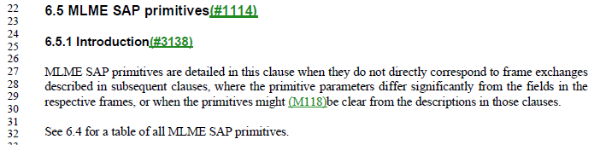

From this, we can see that the primitives should only be detailed in a subclause of 6.5, when the parameters and/or primitives do not directly correspond to the frame(s), or other aspects need to be explained to be more clear.

That is not the case here. From the example below (for EPCS Priority Access Enable, it can be seen clearly that the parameters match exactly what you’d expect based on the frame contents, and there is no “interesting” behavior described, just the expected transmission/reception of the expected frames.

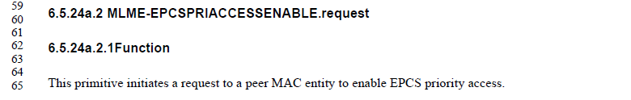
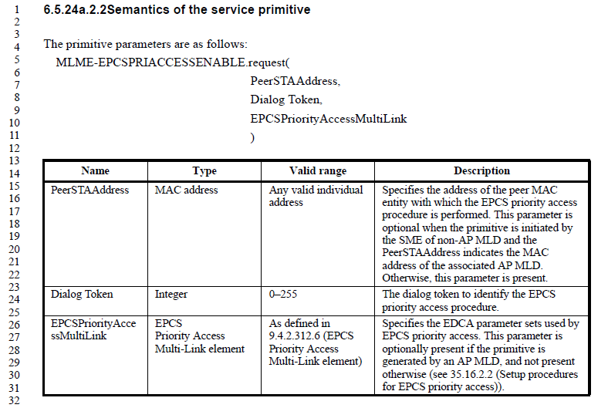
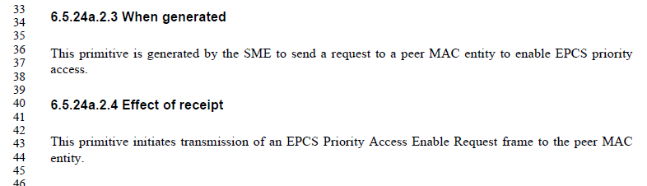

The frame format for this primitive is below, where the same fields can be clearly seen:
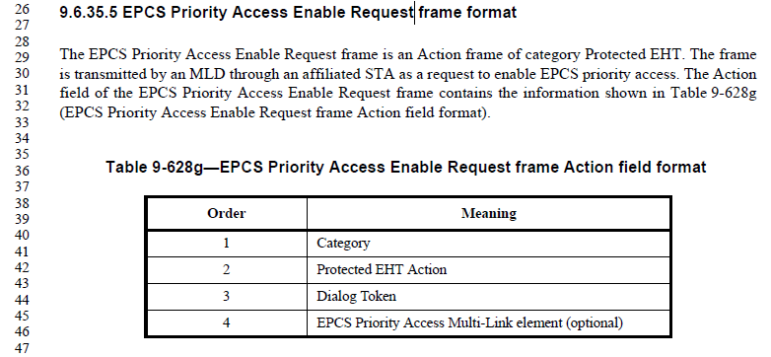

Thus, agree with the commenter, for these three subclauses (they are all very similar to this example), there is no reason to have this information detailed in 6.5.

Proposed Resolution:
Accepted.

CID | Clause Number | Page | Line | Comment | Proposed Change
19479 | 6.5.24a | 98 | 48 | As per the clause 6 changes in the baseline (read 6.5.1), EPCS primitives are redundant relative to the frames and elements documented in clause 9. Furthermore, there is already a table entry in 6.1 which references clause 9. | Remove 6.5.24a and all sub-clauses. NOTE to Editor. There are no cross-references to this clauses in the remainder of the specification.
19480 | 6.5.24b | 103 | 26 | As per the clause 6 changes in the baseline (read 6.5.1), TTLM primitives are redundant relative to the frames and elements documented in clause 9. Furthermore, there is already a table entry in 6.1 which references clause 9. | Remove 6.5.24b and all sub-clauses. NOTE to Editor. There are no cross-references to this clauses in the remainder of the specification.
19481 | 6.5.24c | 107 | 22 | As per the clause 6 changes in the baseline (read 6.5.1), EML operating mode notification primitives are redundant relative to the frames and elements documented in clause 9. Furthermore, there is already a table entry in 6.1 which references clause 9. | Remove 6.5.24c and all sub-clauses. NOTE to Editor. There are no cross-references to this clauses in the remainder of the specification.

Per discussion just above, for CID 19619, agree to remove these subclauses.

Proposed Resolution:
Accepted.

CID | Clause Number | Page | Line | Comment | Proposed Change
19482 | 6.5.24d | 108 | 58 | As per the clause 6 changes in the baseline (read 6.5.1), Link disable primitives are redundant relative to the frames and elements documented in clause 9. Furthermore, there is already a table entry in 6.1 which references clause 9. | Remove 6.5.24d and all sub-clauses. NOTE to Editor. There are no cross-references to this clauses in the remainder of the specification.
19483 | 6.5.24e | 110 | 12 | As per the clause 6 changes in the baseline (read 6.5.1), Link enable primitives are redundant relative to the frames and elements documented in clause 9. Furthermore, there is already a table entry in 6.1 which references clause 9. | Remove 6.5.24e and all sub-clauses. NOTE to Editor. There are no cross-references to this clauses in the remainder of the specification.
19484 | 6.5.24f | 111 | 34 | As per the clause 6 changes in the baseline (read 6.5.1), AP removal primitives are redundant relative to the frames and elements documented in clause 9. Furthermore, there is already a table entry in 6.1 which references clause 9. | Remove 6.5.24f and all sub-clauses. NOTE to Editor. There are no cross-references to this clauses in the remainder of the specification.

Similar to discussion just above, for CIDs 19619, 19479, 19480 and 19481, However there is an important difference for subclauses …24d, 24e and 24f.

Per below, note that these primitives do not (directly) generate an 802.11 MAC frame, which matches the primitive.
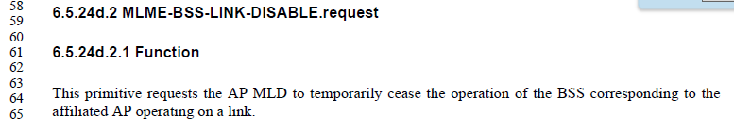

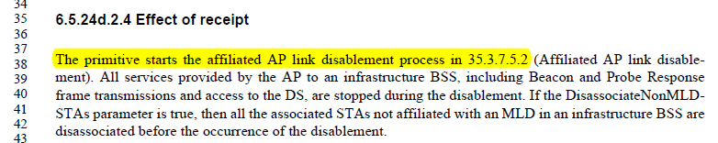

Per the introduction to 6.5, those primivites which are not obviously described based simply by looking at the frame exchange to which they relate, should be detailed as a subclause in 6.5.

The primitives in …24d, 24e and 24f are all of the type that do not map obviously to/from a simple frame transmission/reception. Thus, they are appropriate to list out in detail in subclause 6.5

However, when this is the situation, that the primitive is more complex, then the subclause of 6.5 with the primitive details should be referenced in Table 6-1, rather than just a cross-reference to some frame that happens to be a (small) part of the procedure. So, Table 6-1 entries for these primitives should be updated to cross-reference these 6.5 subclauses, similar to the entries for Event (and subclauses 6.5.18, 6.5.19, 6.5.20), or On-channel Tunneling (and subclause 6.5.21).

Proposed Resolution:
Revised.
Modify the rows in Table 6-1, as shown:
Service Name | MLME-XXX | Type | References | Comments
Link disable | BSS-LINK-DISABLE | 4 | 9.6.35.9 (Link Recommendation frame format) 6.5.24d (Link disable) | See 35.3.7.5 (Affiliated AP link disablement and enablement)
Link enable | BSS-LINK-ENABLE | 4 | 6.5.24e (Link enable)
AP removal | BSS-AP-REMOVAL | 4 | 9.6.35.12 (Link Reconfiguration Notify frame format), 9.6.35.13 (Link Reconfiguration Request frame format), 9.6.35.14 (Link Reconfiguration Response frame format) (6.5.24f (AP removal) | See 35.3.6.3 (Removing affiliated APs)

CID | Clause Number | Page | Line | Comment | Proposed Change
19096 | 6.5.24a.5.1 | 101 | 27 | The indefinite article before MLME- should be "an". | As in comment.
19097 | 6.5.24a.5.4 | 102 | 11 | The indefinite article before EPCS should be "an". | As in comment.
19222 | 6.5.24a.5.3 | 102 | 4 | The description of when the unsolicited response frame is generated is not clear. | Rephrase as "This primitive is generated by the SME as a response to an MLME-EPCSPRIACCESSENABLE.indication primitive (#16573)or as a request to transmit a response in an unsolicited mode (i.e., unsolicited response).
19316 | 6.5.24a.2.2 | 99 | 1 | No space between number of subclause and name title of subclause.  Same editorial issues are found in  p98, line62 | As in comment.

Per resolution to CIDs 19619 and 19479, above, 6.5.24a should be removed in its entirety.

Proposed Resolution:
Revised.
Remove 6.5.24a and all sub-clauses. NOTE: This matches resolution to CIDs 19619 and 19479.

CID | Clause Number | Page | Line | Comment | Proposed Change
19341 | 6.5.24e.2.2 | 110 | 50 | Style guide tends to omit "value of" in "value of <field>". | Omit "value of". Ditto P137L18 x2, P137L43x2, P143L6, etc etc. (Most efficient if editor performs a search and replace)

Context:
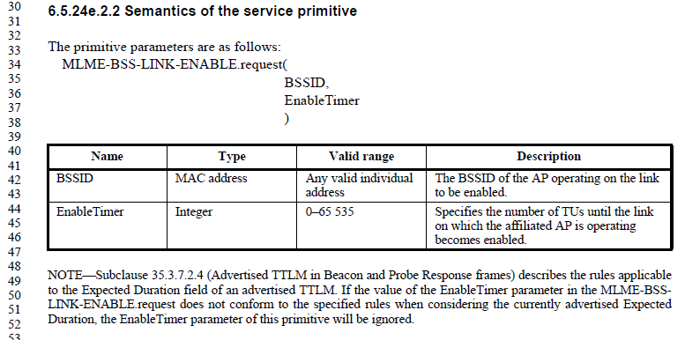

Note that Enable Timer is a parameter to an MLME primitive.

Per baseline (REVme D4.0), subclause 1.4:

So, it seems the “value of” is not necessary when referencing this scalar parameter.

In the 802.11 Style Guide (11-09/1034r19), there is no explicit discussion for this situation, other than a footnote that quotes that same text from subclause 1.4:
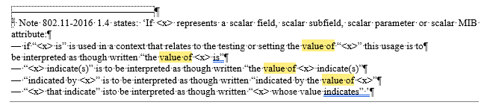

Note that 802.11 Style Guide subclause 2.13, applies to use of “value of” for fields and subfields:
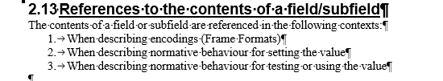

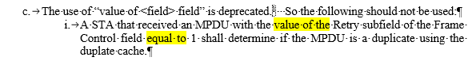

(Interestingly, the footnote copied above applies to this text (just above) which is just about fields/subfields, but the footnote text explicitly does cover other cases, including a scalar parameter.)

So, for the (first) cited location, agree with the commenter, even though this is not strictly covered by the Style Guide, it seems clear from subclause 1.4 of the baseline.

However, for the other locations, let’s look at P137L18 as an example:
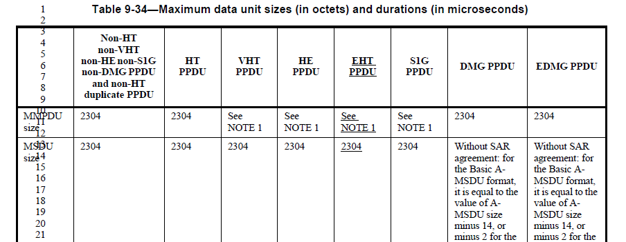

Here, this is a slightly different construct, in effect, “Maximum data unit size … is equal to the value of A-MSDU size …” and this is not any of the cases covered by either subclause 1.4 or the 802.11 Style Guide. The locations at P137L43 are similar.

For these, suggest that the proposed change be rejected, as we have no clear convention that just saying “A-MSDU size” means “the value of A-MSDU size”, which is meant to be a reference to another row in this same table, labelled “A-MSDU size”.

Finally, looking at P143L6:
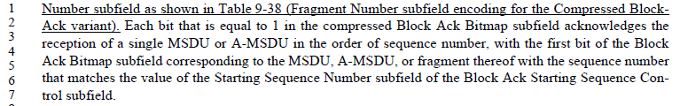

This is clearly referencing a subfield, and so it is clearly covered by the 802.11 Style Guide subclause 2.13. That said, this is baseline text, not 802.11be changed text.

Do we want to extend 802.11be updates to include “fixing” this type of editorial error in the baseline, or reject this comment (and suggest perhaps it should be filed against REVme)?

Alternative 1:
Reject this part of the comment. “This comment is not in scope of the 802.11be amendment changes.”

Alternative 2:
Accept this part of the comment, and extend the 802.11be amendment changes to fix up any such errors we notice.

Proposed Resolution:
Revised.

At P110.50, delete “value of”.

Not ready yet

CID | Clause Number | Page | Line | Comment | Proposed Change

Completed

References:

https://mentor.ieee.org/802.11/dcn/23/11-23-1152-24-00bh-ieee-802-11bh-lb274-comments.xlsx

https://mentor.ieee.org/802.11/dcn/23/11-23-1245-24-00bh-cid-resolutions-irm-1.docx

