IEEE P802.11
Wireless LANs
LB275 CR: EMLSR AAR Operation
Date: 2023-11-12
Author(s):
Name | Affiliation | Address | Phone | email
Juseong Moon | KNUT |  |  | jsmoon0211@a.ut.ac.kr
Ronny Yongho Kim | KNUT |  |  | ronnykim@ut.ac.kr
Woojin Ahn | KNUT |  |  | woojin.ahn@ut.ac.kr
Gwangho Lee | KNUT |  |  | gwangho.lee@a.ut.ac.kr
Simyoung Yang | Hyundai Motor Company |  |  | yangsimyoung@hyundai.com
Abstract
This submission proposes comment resolution for CID 19582 received in LB275.

Related Comment
CID | Commenter | Clause | P.L | Comment | Proposed Change | Resolution
19582 | Juseong Moon | 35.3.16.8.3 | 562.55 | This comment was submitted in LB271, but the comment was not properly discussed and proposed text is suggested. Similar to NSTR STA MLD, EMLSR STA MLD also suffers from lost medium synchronization problem and also applies MediumSyncDelay after returning to EMLSR listening operation. AAR can also be applied to EMLSR operation. In case of non-AP MLD's EMLSR uplink response frame transmission, the current AAR method of NSTR can be applied. In EMLSR non-AP MLD's downlink reception case, QoS Null with AAR control may be transmitted with a response frame, such as the BA frame. | Modify the text as following:  If a non-AP STA affiliated with a non-AP MLD with dot11AAROptionImplemented that is equal to true and that belongs to an NSTR link pair or EMLSR link receives a Basic Multi-Link element from its associated AP affiliated with an AP MLD, with the AAR Support subfield equal to 1 and when the other non-AP STA that belongs to the same NSTR link pair needs assistance in transmitting frames on the other link, it shall transmit the AAR Control subfield in a frame that solicits an immediate response or it shall transmit the AAR Control in an immediate response frame aggregated with a QoS Null frame with an ack policy set to No Ack. | Revised.  Agree in principle.  TGbe Editor: Apply the change tagged with #19582 to 11be D4.1.

Discussion
When a non-AP STA of a non-AP MLD that is operating in EMLSR mode receives downlink frame from an AP MLD in an EMLSR link, other non-AP STA of the non-AP MLD losts medium synchronization in EMLSR link. Therefore, the non-AP MLD may suffer from MediumSyncDelay.

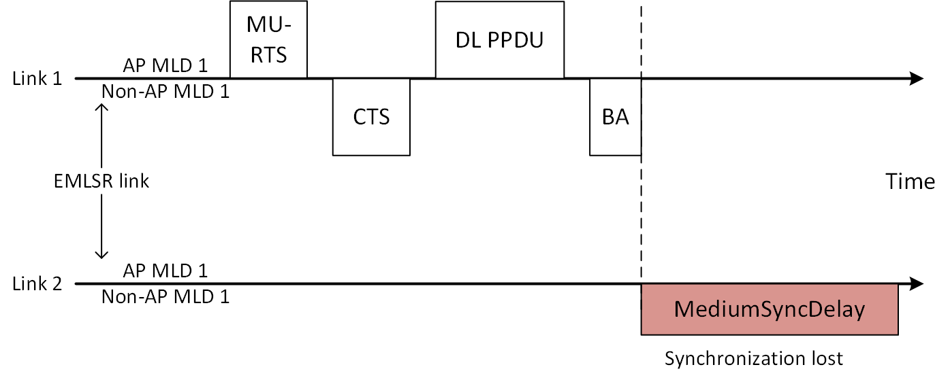

In this case, the non-AP MLD cannot use the AAR, because the current AAR Control subfield can be only included in frames soliciting an immediate response. Therefore, the non-AP MLD cannot recover medium synchronization with the AAR operation.

To address this issue, the current AAR operation should be expanded so that the AAR Control subfield can be included in immediate response frames.
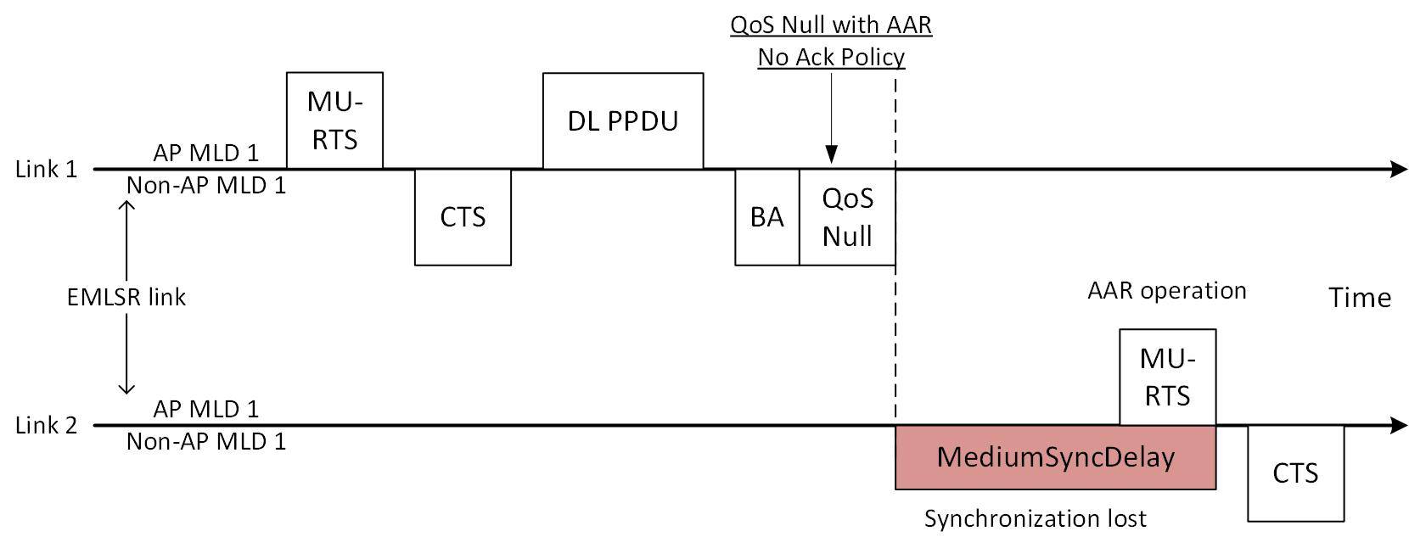

Proposed Text for 11be D4.1

35.3.16.4 AP assisted medium synchronization recovery procedure
TGbe Editor: please apply the following changes to P573L38 of 802.11be D4.1
If a non-AP STA affiliated with a non-AP MLD with dot11AAROptionImplemented that is equal to true and that belongs to an NSTR link pair(#19582) or an EMLSR link, receives a Basic Multi-Link element from its associated AP affiliated with an AP MLD, with the AAR Support subfield equal to 1 and when the other non-AP STA that belongs to the same NSTR link pair(#19582) or the same EMLSR link needs assistance in transmitting frames on the other link, it shall transmit the AAR Control subfield in a frame that solicits an immediate response(#19582) or it shall transmit a QoS Null frame with an ack policy set to No Ack, which includes the AAR Control subfield, if the AP MLD solicits an immediate response.

