IEEE P802.11
Wireless LANs
CR for overlapping R-TWTs
Date: 2023-10-17
Author(s):
Name | Affiliation | Address | Phone | email
Yunbo Li | Huawei |  |  | liyunbo@huawei.com
Ming Gan
Yuchen Guo
Guogang Huang
Zhenguo Du
Yue Zhao
Maolin Zhang
Stephen McCann
Edward Au
Abstract
This submission proposes comments resolution of the following 4 CIDs received for TGbe LB275:

CIDs:
19877
19111
19189
19190

Revisions:
- Rev 0: Initial version of the document.

TGbe editor: The baseline for this document is IEEE 802.11be D4.1

- Introduction

Interpretation of a Motion to Adopt

A motion to approve this submission means that the editing instructions and any changed or added material are actioned in the TGbe Draft. The introduction and the explanation of the proposed changes are not part of the adopted material.

CID | Commenter | Clause | P.L | Comment | Proposed Change | Resolution
19877 | Yunbo Li | 35.8.4.1 | 614.44 | Due to different traffic interval that decided by the upper traffic pattern, some times AP can not schedule several non-overlapped R-TWT.  When the SP of two R-TWT overlapps, the current spec ask a TXOP holder to end current TXOP before a coming R-TWT SP even the TXOP holder is transmitting frame for another R-TWT.  It will decrease the efficiency, and increase the delay of pending low latency traffic in current TXOP. | a TXOP holder should be allowed to continue to transmit low latency traffic of one RTWT even the SP of another R-TWT starts before the end of current TXOP. | Revised  The current TXOP and backoff procedure for R-TWT SP only covers the non-overlapped R-TWT SP case. The overlapped SPs of two different R-TWTs in the same link could happen when traffics in the two R-TWTs with different packet arrival timeintervals. When the SP of two R-TWTs overlaps, the resolution allows the TXOP holder not to terminate the TXOP in first R-TWT SP at the start of SP of another R-TWT. The resolution could increase the system efficiency and reduce the latancy of packets that intend to be delivered in the TXOP.  TGbe editor to make the changes with the CID tag 19877 in doc 11-23/1797r0
19111 | Akira Kishida | 35.8.4 | 614.46 | If multiple R-TWT SPs are overlapped on the same link, it should be clarified which operation is the correct;  (1)Transmission in R-TWT SP1 scheduled earlier than R-TWT SP2 should defer transmission scheduled in R-TWT SP2 if TXOP of the transmission of R-TWT SP1 overlaps with the start of R-TWT SP2.  (2)Transmission scheduled in R-TWT SP1 cannot execute its scheduled transmission because EHT STAs should check if the TXOP holder shall ensure the TXOP ends before the start time of R-TWT SP2. | As in comment.  And in any case, scheduling AP should limit TXOP that can be utilized in the R-TWT SP and inform to the STAs. | Revised  The current TXOP and backoff procedure for R-TWT SP only covers the non-overlapped R-TWT SP case. The overlapped SPs of two different R-TWTs in the same link could happen when traffics in the two R-TWTs with different packet arrival timeintervals. When the SP of two R-TWTs overlaps, the resolution allows the TXOP holder not to terminate the TXOP in first R-TWT SP at the start of SP of another R-TWT. The resolution could increase the system efficiency and reduce the latancy of packets that intend to be delivered in the TXOP.  TGbe editor to make the changes with the CID tag 19877 in doc 11-23/1797r0
19189 | Yusuke Asai | 35.8.4 | 614.46 | It is not clear whether R-TWT SPs are allowed to be overlapped each other when they are scheduled on the same channel. Also, if the overlap is allowed, it is not clear whether a non-AP EHT STA shall check if there is enough time for the frame exchange to complete prior to all the overlapped R-TWT SPs, respectively, or the start of the frist R-TWT SP only may be enough. | Please clarify whether the overlap is allowed or not. Also, if it is allowed, please clarify whether a non-AP EHT STA shall check if there is enough time for the frame exchange to complete prior to the start of the frist R-TWT SP only or all the R-TWT SP overlapped each other. | Revised  The current TXOP and backoff procedure for R-TWT SP only covers the non-overlapped R-TWT SP case. The overlapped SPs of two different R-TWTs in the same link could happen when traffics in the two R-TWTs with different packet arrival timeintervals. When the SP of two R-TWTs overlaps, the resolution allows the TXOP holder not to terminate the TXOP in first R-TWT SP at the start of SP of another R-TWT. The resolution could increase the system efficiency and reduce the latancy of packets that intend to be delivered in the TXOP.  TGbe editor to make the changes with the CID tag 19877 in doc 11-23/1797r0
19190 | Yusuke Asai | 35.8.4 | 615.13 | When R-TWT SP1 and R-TWT SP2 are scheduled on the same channel and they are overlapped in time, a transmission during the R-TWT SP1 might prevent a transmission during R-TWT SP2. In order to avoid this issue, the transmission during the R-TWT SP1 should be ensured to end before the start time of the R-TWT SP2. In this case an AP should notify this transmission limitation to non-AP STA. | Please add the following language.  "When more than one R-TWT SPs are overlapped in time on the same link, the transmission in the first R-TWT SPs should be ensured to end before the start time of the following R-TWT SP." | Revised  The current TXOP and backoff procedure for R-TWT SP only covers the non-overlapped R-TWT SP case. The overlapped SPs of two different R-TWTs in the same link could happen when traffics in the two R-TWTs with different packet arrival timeintervals. When the SP of two R-TWTs overlaps, the resolution allows the TXOP holder not to terminate the TXOP in first R-TWT SP at the start of SP of another R-TWT. The resolution could increase the system efficiency and reduce the latancy of packets that intend to be delivered in the TXOP.  TGbe editor to make the changes with the CID tag 19877 in doc 11-23/1797r0

Discussion:
Current spec covers the TXOP and backoff procedure for single R-TWT SP case, under which
- In all cases, a non-AP EHT STA shall terminate the current TXOP before the start time of a coming R-TWT SP
- An EHT AP shall terminate the current TXOP before the start time of a coming R-TWT SP except that the remaining TXOP is used to transmit frames of R-TWT TID of the coming R-TWT
The following two figures show the examples that follow current spec.
In Figure 1, an AP or a STA as a TXOP holder terninates TXOP before SP of R-TWT2, because the transmitting frame belongs to TID1, while R-TWT TID is TID 0 for the coming R-TWT SP.
In Figure 2, an AP as TXOP holder doesn’t terninate TXOP before SP of R-TWT2, because the transmitting frame belongs to TID0 which is the R-TWT TID of the coming R-TWT SP. It is efficient, and it will avoid the AP to terminate current TXOP and then immediately contend for another TXOP for TID 0.

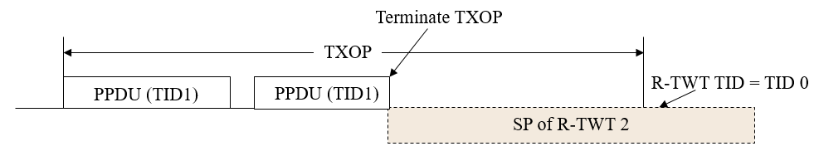
Figure 1
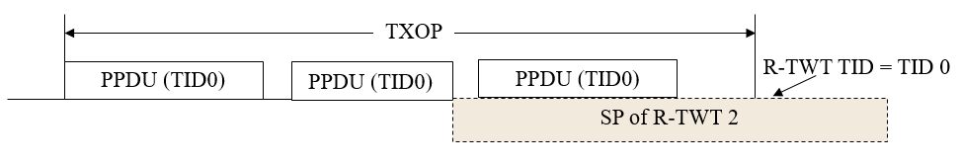
Figure 2

For the multiple R-TWT SPs overlapped cases that mentioned in the above 4 CIDs, current spec doesn’t provide a rule for TXOP and backoff operation.
Firstly, R-TWT SPs overlapped in the same link are not corner cases. As long as the TWT wake interval of one R-TWT is not an integer multiple of another R-TWT’s wake interval, partial SPs of these two R-TWT will overlap. The wake interval is decided by the upper layer traffic pattern, and AP or STA cannot change it.
Similar to the example as depicted in Figure 2, if the current TXOP is used for delivery of frames of R-TWT TID(s) in one R-TWT SP, the spec should allow the TXOP holder continue the current TXOP when the current TXOP overlapped with the start time of another R-TWT’s SP. It will make the system more efficiency.
For the example shown in Figure 3, the TXOP holder obtains a TXOP during SP of R-TWT 1, and intends to deliver frame of TID1 which is the R-TWT TID of R-TWT 1. Continue current TXOP when the start time of a SP of R-TWT 2 arrives will make the system more efficiency and reduce the delay of TID1’s traffic.

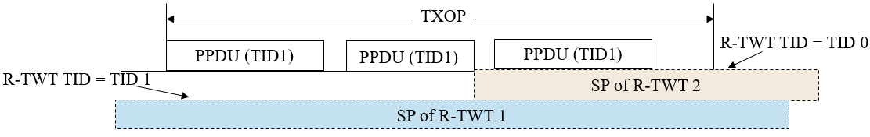
Figure 3

Editing instructions formatted like this are intended to be copied into the TGbe Draft (i.e. they are instructions to the 802.11 editor on how to merge the text with the baseline documents).

- Proposed spec text

TGbe editor: Modify the paragraphes in 35.8.4.1 (TXOP and backoff procedure rules for R-TWT SPs) as follows: (#19877)

35.8.4.1 TXOP and backoff procedure rules for R-TWT SPs
A non-AP EHT STA with dot11RestrictedTWTOptionImplemented set to true as a TXOP holder shall ensure the TXOP ends before the start time of any active R-TWT SPs that are advertised by its associated AP that does not correspond to a nontransmitted BSSID, except the non-AP EHT STA is a member of another R-TWT, the SP of another R-TWT overlaps with the start time of the active R-TWT SP and the remaining portion of TXOP is used for the delivery of UL frames of R-TWT UL TID(s) of another R-TWT.
A non-AP EHT STA with dot11RestrictedTWTOptionImplemented set to true as a TXOP holder and that is associated with an AP that corresponds to a nontransmitted BSSID not fulfill the exception conditions shall ensure the TXOP ends before the start time of any active R-TWT SPs that the AP corresponding to the transmitted BSSID in the same multiple BSSID set advertises in a broadcast TWT element carried:
—outside the Multiple BSSID element, and
—within the nontransmitted BSSID profile corresponding to its associated AP in the Multiple BSSID element.
The exception conditions include, the non-AP EHT STA is a member of another R-TWT, the SP of another R-TWT overlaps with the start time of the active R-TWT SP and the remaining portion of TXOP is used for the delivery of UL frames of R-TWT UL TID(s) of another R-TWT.
In addition, before starting transmission of any PPDU, the non-AP EHT STA with dot11RestrictedTWTOptionImplemented set to true shall check if there is enough time for the frame exchange to complete prior to the start of the R-TWT SP and, if there is not enough time, then the STA shall defer transmission by selecting a random backoff count using the present CW[AC] (without advancing to the next value of CW[AC]) , except the non-AP EHT STA is a member of another R-TWT, the SP of another R-TWT overlaps with the start time of the active R-TWT SP and the TXOP is used for the delivery of UL frames of R-TWT UL TID(s) of another R-TWT. The QSRC[AC] for the MSDU or A-MSDU is not affected.
NOTE 1—The R-TWT schedule(s) carried in a TWT element outside of a Multiple BSSID element in a Beacon or Probe Response frame include the schedule(s) for the transmitted BSSID, nontransmitted BSSID(s), and co-hosted BSSID(s), if any, as specified in 35.8.3 (R-TWT announcement).
An EHT AP with dot11RestrictedTWTOptionImplemented set to true as a TXOP holder shall ensure the TXOP ends before the start time of any active R-TWT SP advertised by itself as specified in 35.8.3 (R-TWT announcement) unless one of the following conditions are true:
— the remaining portion of TXOP falling within the R-TWT SP is used for the delivery of DL frames of R-TWT DL TID(s) or to solicit the UL frames of R-TWT UL TID(s).
- —the SP of another R-TWT overlaps with the start time of the active R-TWT SP, the remaining portion of TXOP that is fallen within the R-TWT SP is used for the delivery of DL frames of R-TWT DL TID(s) of another R-TWT or to solicit the UL frames of R-TWT UL TID(s) of another R-TWT.

NOTE 2—When an R-TWT SP starts, a member STA might suspend decrementing the backoff counter of any AC to which none of the R-TWT TID(s) belong until it has delivered all its frames from R-TWT TID(s), and resume the decrementing afterwards or when the SP is ended.

End of change

