IEEE P802.11
Wireless LANs
LB275 CR for CID 20088
Date: 2023-11-10
Author(s):
Name | Affiliation | Address | Phone | email
Liuming Lu | OPPO |  |  | luliuming@oppo.com

Abstract
This submission proposes resolutions for the following CIDs for TGbe LB275:
20088

Revisions:
- Rev 0: Initial version of the document

Interpretation of a Motion to Adopt

A motion to approve this submission means that the editing instructions and any changed or added material are actioned in the TGbe Draft. This introduction is not part of the adopted material.

Editing instructions formatted like this are intended to be copied into the TGbe Draft (i.e. they are instructions to the 802.11 editor on how to merge the text with the baseline documents).

TGbe Editor: Editing instructions preceded by “TGbe Editor” are instructions to the TGbe editor to modify existing material in the TGbe draft. As a result of adopting the changes, the TGbe editor will execute the instructions rather than copy them to the TGbe Draft.

TGbe editor: The baseline for this document is 11be D4.1.

CID | Commenter | Clause | Pg/Ln | Comment | Proposed Change | Resolution
20088 | Liuming Lu | 4.5.6.3 Support for predictable latency | 67.06 | The specification of "4.5.6.3 Support for predictable latency" is unclear, for example, no mechanism is provided for the advertisement of the information of current level of latency sensitive traffic and the efficiency of R-TWT operation for the BSS . | An extended BSS Load element is proposed to be defined and used to provide information on the current population of R-TWT member STAs and the level of latency sensitive traffic in the BSS. | Revised  Agree in principle. An EHT BSS R-TWT SPs Load element is specified and used to provide information on the utilization of R-TWT SPs in the BSS.  Instruction to the editor, please update the text in the subclause 9.4.2 Elements, as shown in this document (doc.: IEEE 802.11-23/1793r0).

Discussion:
R-TWT enables the STAs in a BSS to use enhanced medium access protection and resource reservation mechanisms for delivery of latency sensitive traffic. The benefit of R-TWT for the delivery of latency sensitive traffic is impacted by several factors, such as the population of R-TWT-supported STAs, and Non-R-TWT-supported STAs. For example, the enhanced medium access protection cannot be guanranteed if there exist many Non-R-TWT-supported STAs in the BSS.
An EHT BSS R-TWT SPs Load element is proposed to be specified and used to provide information on the utilization of R-TWT SPs in the BSS. A STA receiving the element reported by the AP might use the information it conveys in an implementation specific AP selection algorithm. For example, if there exist many non-R-TWT-supported STAs in the BSS or its R-TWT SPs Utilization is low in some case, the STA would consider that the BSS is not appropriate for the delivery of latency sensitive traffic by R-TWT. 11ax has specified an HE BSS Load element, which can be taken as a reference.

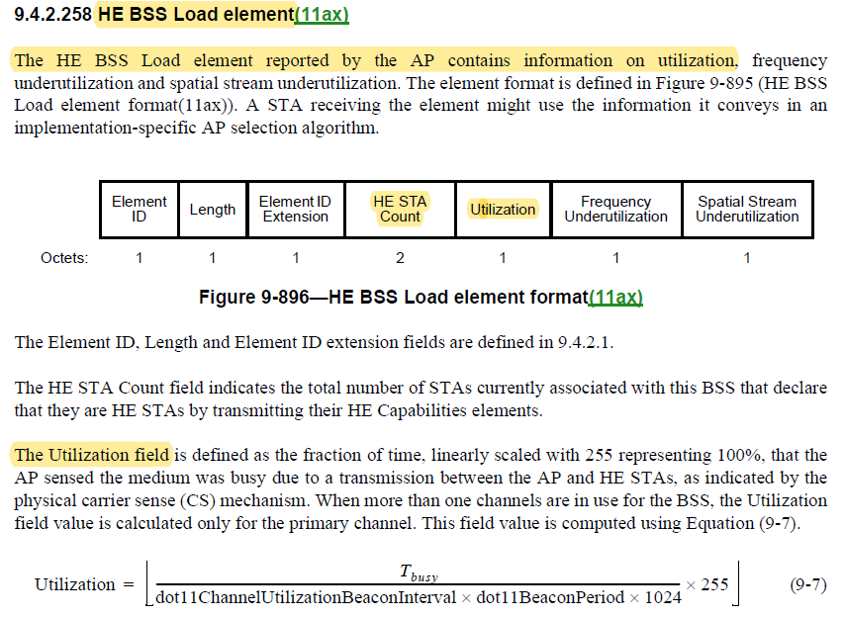
Proposed Text Change:

9.4.2 Elements
TGbe editor: please insert the following text:
9.4.2.xxx EHT BSS R-TWT SPs Load element
The EHT BSS R-TWT SPs Load element reported by the AP contains information on the utilization of R-TWT SPs. The element format is defined in Figure 9-xxx (EHT BSS R-TWT SPs Load element format). A STA receiving the element might use the information it conveys in an implementation specific AP selection algorithm.
.
 | Element ID | Length | Element ID Extension | EHT R-TWT-supported STA Count | EHT Non-R-TWT-supported STA Count
Octets: | 1 | 1 | 1 | 2 | 2
.
 | RR-TWT SPs Percentage | R-TWT SPs UtilizationUtilizati
Octets: | 1 | 1
Figure 9-xxx EHT BSS R-TWT SPs Load element format
The Element ID, Length and Element ID extension fields are defined in 9.4.2.1 (General).
The EHT R-TWT-supported STA Count field indicates the total number of STAs currently associated with this BSS that declare that they are EHT STAs by transmitting their EHT Capabilities element with the Restricted TWT Support subfield set to 1.
The EHT Non-R-TWT-supported STA Count field indicates the total number of STAs currently associated with this BSS that declare that they are EHT STAs by transmitting their EHT Capabilities element with the Restricted TWT Support subfield set to 0.
The R-TWT SPs Percentage field is defined as the fraction of R-TWT SPs duration, linearly scaled with 255 representing 100%. This field value is computed using Equation.
$$R-TWT SPs Percentage=[\frac{T_{RTWTSPsDuration}}{dot11ChannelUtilizationBeaconIntervals×dot11BeaconPeriod×1024}×255]$$
where
dot11ChannelUtilizationBeaconIntervals represents the number of consecutive beacon intervals during which the R-TWT SPs duration is measured.
$T_{RTWTSPsDuration}$ is the number of microseconds for the sum of the R-TWT SPs duration during the measure time, which is $dot11ChannelUtilizationBeaconIntervals×dot11BeaconPeriod×1024$.
The R-TWT SPs Utilization field is defined as the fraction of time, linearly scaled with 255 representing 100%, that the AP sensed the medium was busy due to a transmission between the AP and member STAs of their corresponding R-TWT SPs during R-TWT SPs, as indicated by the physical carrier sense (CS) mechanism. When more than one channels are in use for the BSS, the R-TWT SPs Utilization field value is calculated only for the primary channel. This field value is computed using Equation
$$R-TWT SPs Utilization=[\frac{T_{busyDuringRTWTSPs}}{T_{RTWTSPsDuration}}×255]$$
where
$T_{busyDuringRTWTSPs}$ is the number of microseconds during which CCA indicated the channel was busy due to a transmission between the AP and member STAs of their corresponding R-TWT SPs during the R-TWT SPs duration. The resolution of the CCA busy measurement is in microseconds.
If $T_{RTWTSPsDuration}$ is 0, the R-TWT SPs Utilization field is reserved.

References:

- https://mentor.ieee.org/802.11/dcn/23/11-23-1792-01-00be-lb275-cr-for-cid-20090-on-channel-access-rules-for-r-twt-sps.docx

