IEEE P802.11
Wireless LANs
LB275 CR: PPDU End Time Alignment
Date: 2023-11-14
Author(s):
Name | Affiliation | Address | Phone | email
Juseong Moon | KNUT |  |  | jsmoon0211@a.ut.ac.kr
Ronny Yongho Kim | KNUT |  |  | ronnykim@ut.ac.kr
Woojin Ahn | KNUT |  |  | woojin.ahn@ut.ac.kr
Gwangho Lee | KNUT |  |  | gwangho.lee@a.ut.ac.kr
Simyoung Yang | Hyundai Motor Company |  |  | yangsimyoung@hyundai.com
Abstract
This submission proposes comment resolution for CID 19583 received in LB275.

R0: Initial version.
R1: Revised texts.
R2: Revised texts and typos.

Related Comment
CID | Commenter | Clause | P.L | Comment | Proposed Change | Resolution
19583 | Juseong Moon | 35.3.16.5.1 | 557.38 | When an AP MLD transmits PPDUs of different ACs with a different TXOP limit over multiple links, even with a PPDU padding, it may be impossible to align the PPDU end time due to the different TXOP limits. For instance, while transmitting an AC_VI PPDU of 4ms length (AC_VI TXOP limit) over link 1, an AC_VO PPDU of 2ms (AC_VO TXOP limit) could be transmitted over link 2 after the success of EDCA backoff. In this case, because padding cannot be added to AC_VO PPDU with maximum TXOP limit, end time cannot be aligned. To address this issue, a rule to delay the transmission of a PPDU is needed. For example, in link 2, an EDCAF's backoff counter is maintained at 0 and the EDCAF initiates transmission at a time which makes end time alignment possible. | As in comment. | Revised.  Agree in principle.  TGbe Editor: Apply the change tagged with #19583 to 11be D4.1.

Discussion
Referring to 35.3.16.5 (PPDU end time alignment on an NSTR link pair), An AP MLD can align end times of two PPDUs by using padding on multi-link.

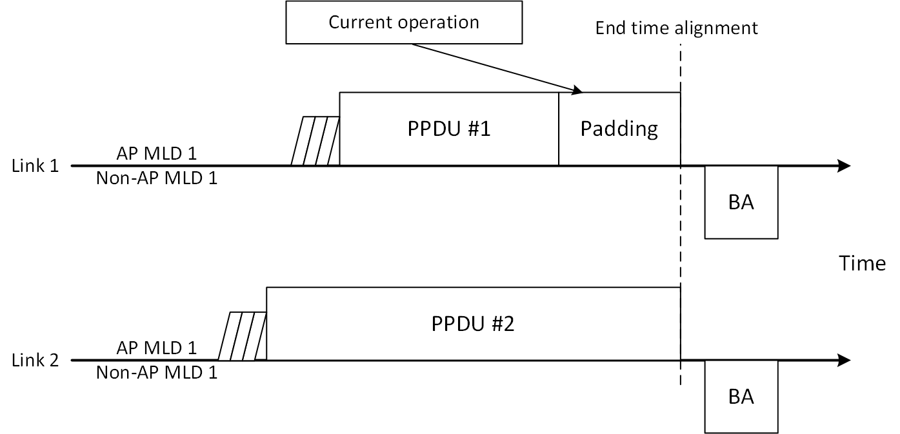
However, if two PPDU’s ACs are different each other, the AP MLD cannot align end times of two PPDUs by using padding, if the AP MLD wants to transmit a PPDU of AC_VO on the link 1 while the AP MLD is transmitting a PPDU of AC_VI on link 2. Because the TXOP limits of AC_VI and AC_VO are different (in the baseline, default TXOP limit of AC_VO is shorter than AC_VI’s.), the AP MLD cannot align end time of the PPDU of AC_VO.
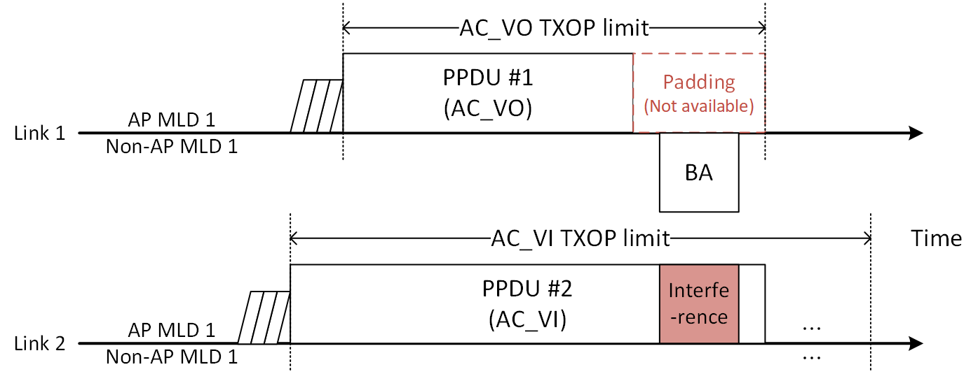
A solution for this issue is simple: defer the transmission of the AC_VO PPDU. Current 11be draft does not define this method. For AP MLD’s end time alignment, a similar method of the start time sync PPDUs medium access operation in 11be draft 35.3.16.6 can be used.
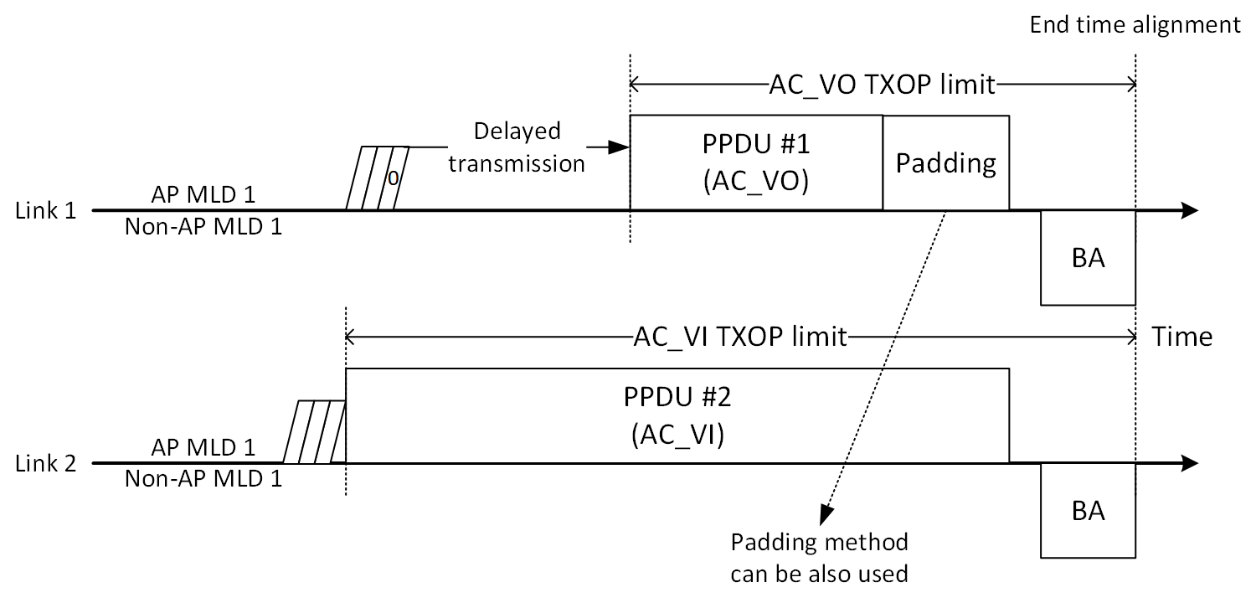

Proposed Text for 11be D4.1

35.3.16.5.1 General
TGbe Editor: please add the following change to P568L20 of 802.11be D4.1

An AP MLD may use any type of padding to align the end time of transmitted PPDUs, such as using the Padding field in a Trigger frame, post-EOF A-MPDU padding, padding in HE-SIG-B or EHT-SIG field for MU transmission, aggregating other MPDUs in the A-MPDU, or a packet extension.
(#19583)If an AP affiliated with the AP MLD that has gained the right to initiate transmission of a PPDU as described in 10.23.2.4 (Obtaining an EDCA TXOP) but chooses to defer transmission of the PPDU because it cannot align the end time of the PPDU with the end time of the PPDU being transmitted per the rules defined in this subclause using any type of padding, the AP may choose to not transmit the PPDU following the procedure defined in 35.3.16.4 (Nonsimultaneous transmit and receive (NSTR) operation).

