IEEE P802.11
Wireless LANs
Resolutions for some comments on 11me/D4.0 (initial SA ballot)
Date: 2023-11-15
Author(s):
Name | Affiliation | Address | Phone | email
Mark RISON | Samsung Cambridge Solution Centre | SJH, CB4 0DS, U.K. | +44 1223 434600 | at samsung (a global commercial entity) I'm the letter emme then dot rison
Abstract
This submission proposes resolutions for various CIDs on 11me/D4.0. Green indicates material agreed to in the group, yellow material to be discussed, red material rejected by the group and cyan material not to be overlooked. The “Final”/“No Markup” view should be selected in Word (this means Word comments can be disregarded by the Editor).

Identifiers | Comment | Proposed change
CID 6401  Mark RISON | "assumes" -- the standard should not assume, it should require | Make the changes highlighted in red under CIDs 1397/1398/1794 in 22/0353r10

Discussion:

As it says in the comment. However, there are concerns about “shall”s for entities that are not specified by 802.11.

Proposed changes:

Make the changes indicated at the following locations:

171.32: In this document, the word shall is used to indicate a mandatory requirement. The word should is used to indicate a recommendation. The word may is used to indicate a permissible action. The word can is used for statements of possibility and capability. The words need(s) to are used to indicate a requirement on an entity outside the scope of this standard.

342.16: In order for the MAC to operate properly, this standard assumes that the DS needs to meets the MSDU (“object”) reordering requirements of IEEE Std 802.1AC-2012 [B17].

2630.51: In an infrastructure BSS, the Interworking element contains signaling for HeSSs(M12). The HESSID is a (#2047)MAC address that identifies the HeSS(M12). The HESSID value shall be the universal MAC address of one of the APs(#1347) in the HeSS(M12) and all BSSs in the HeSS use the same value. Thus, it is a globally unique identifier that, in conjunction with the SSID, may be used to provide network identification for an SSPN.

NOTE 1—This standard assumes that the HESSID field in the Interworking element isneeds to be administered consistentlyto have the same value across all BSSs in an HeSS(M12).

2663.22: NOTE—This standard assumes that all APs in an ESS are configured consistently for QMF service All APs in an ESS need to have the same QMF settings when GQMF has been enabled for use by associated non-AP STAs.

2884.10: When the IEEE 802.1X authentication completes successfully, the standard assumes that the STA’s IEEE 802.1X Supplicant and the IEEE 802.1X AS share a secret, called an MSK and used to generate a PMK.

2900.41: Upon a successful authentication, the R0KH shall delete any prior PMK-R0 security association for this mobility domain pertaining to this S0KH. The R0KH shall also delete all PMK-R1 security associations derived from that prior PMK-R0 security association.

<para break>

The R0KH generates the PMK-R1s are generated by the R0KH and are assumed to be delivered from the R0KH delivers them to the R1KHs within the same mobility domain. The PMK-R1s are used for PTK generation. Upon receiving a new PMK-R1 for an S0KH, an R1KH deletes the prior PMK-R1 security association and PTKSAs derived from the prior PMK-R1.

It is assumed by this standard that the PSK is specific to a single S0KH and a single R0KH.

2901.39: The distribution of keys from the R0KH to the R1KHs is outside the scope of this standard. It is assumed that tThe PMK-R1s are distributed from the R0KH to the R1KHs following the requirements specified in 13.2.2 (Authenticator key holders).

2975.48: Each R0KH-ID and R1KH-ID is assumed to be expressed as needs to be a unique identifier within the mobility domain.

2976.24: The R0KH and the R1KH are assumedneed to have a secure channel between them that can be used to exchange cryptographic keys without exposure to any intermediate parties. The cryptographic strength of the secure channel between the R0KH and R1KH is assumedneeds to be greater than or equal to the cryptographic strength of the channels for which the keys are used. This standard assumes that the key transfer includes the PMK-R1, the PMK-R1 PMKSA, the PMK-R1 context, and the associated key authorizations.

2976.33: The PMK-R1 distribution from the R0KH to the R1KHs within the same mobility domain shall satisfy the following assumptions:

2976.45: The S0KH and S1KH are entities that are assumed to physically reside in the Supplicant.

2977.23: NOTE—It is assumed by this standard that tThe Fast BSS Transition Policy bits in the MDE are administered consistentlyneed to be the same across the mobility domain.

Proposed resolution:

REVISED

Make the changes shown under “Proposed changes” for CID 6401 in <this document URL>, which address the locations identified in the comment, using “needs to” for entities not specified by 802.11.

Identifiers | Comment | Proposed change
CID 6268  Mark RISON | There are ~16 "MAC layer"s but these should be "MAC sublayer" | As it says in the comment

Discussion:

It was discussed during LB that the MAC is a sublayer, not a layer (unlike the PHY, which is a layer).

Proposed changes:

Change as follows:

282.56: From the data delivery point of view, it appears as if all STAs in a mesh BSS are directly connected at the MAC layer the MAC service of a STA in an MBSS appears to provide the exchange of MSDUs directly to any other STA in the MBSS, even if the STAs are not within range of each other.

311.57: The deauthentication notification is provided to (#3469)IEEE Std 802.1X-2020 via the MAC layer by the MLME to the SME. The SME then notifies the 802.1X Authenticator or Supplicant, and the 802.1X entity blocks the IEEE 802.1X Controlled Port from passing any further general data traffic.

314.3: When a non-AP STA searches for, and connects to, an infrastructure BSS, IBSS, or PBSS or attempts to discover services on a network preassociation, it defines the addressing of its MAC layer selects a MAC address for the particular connection.

322.22: In 4.3.23 (Mesh BSS), the concept of the MBSS LAN was introduced. It was noted that, using the multi-hop capability it appears as if all mesh STAs are directly connected at the MAC layer, the MAC service of a STA in an MBSS appears to provide the exchange of MSDUs directly to any other STA in the MBSS, even if the STAs are not within range of each other. This is different from an IBSS, where STAs cannot communicate if they are not within range of each other.

Unlike the IBSS, an MBSS might have access to the DS. An MBSS connects through one or more mesh gates to the DS. Since in an MBSS it appears as if all mesh STAs are directly connected at the MAC layer at the MAC service interface as if all mesh STAs provide the direct exchange of MSDUs, the MBSS can be used as a DSM. APs, a portal, and mesh gates might use the MBSS as a DSM to provide the DSS. Thus, different infrastructure BSSs can unite over the MBSS to form an ESS for example.

693.28: The maximum length of the Frame Body field can be determined from the maximum MSDU length plus the length of the Mesh Control field (if present) plus any overhead from encapsulation for encryption (i.e., it is always possible to send a maximum length MSDU, with any encapsulations provided by the MAC layer within a single Data frame).

2340.43: In this example, the upper layer of the originator uses the MA-UNITDATA.request primitive to pass MSDUs to the MAC layer for delivery to the recipient.

2341.1: Delete the “Layer”s highlighted in purple in Figure 10-166:

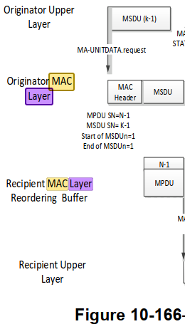

2459.50: TSPECs and DMG TSPECs are constructed at the SME, from application requirements supplied via the SME, and with information specific to the MAC layer.

2536.50: Access delay is measured by the AP’s or PCP’s MAC layer being the average medium access delay for transmitted frames

2578.13: The WNM log event report is intended to capture PHY and MAC layer events related to the operation of those layers

4450.6: The PHY layer shall issue a PHY-TXSTART.confirm primitive to the MAC in response to the PHY-TXSTART.request(TXVECTOR) primitive when it is ready to receive an MPDU/A-MPDU from the MAC layer.

5705.6: TSPECs are constructed at the SME from application requirements supplied via the SME and with information specific to the MAC layer.

5757.31: The EDCA and HCCA mechanism defined in 10.23 (HCF) provide QoS control at the MAC sublayer.

Proposed resolution:

REVISED

Make the changes shown under “Proposed changes” for CID 6268 in <this document URL>, which reword the instances of “MAC layer”.

Identifiers | Comment | Proposed change
CID 6366  Mark RISON  C.3 | dot11GroupAddressesTable should also mention the broadcast address where relevant, since this address does not appear in the table | As it says in the comment

Discussion:

In generic locations the broadcast address is explicitly covered:

1777.33: when the Address 1 field or DA field contains a group address, address filtering is performed by (#1815)comparing the value in the Address 1 field or DA field to all values in the dot11GroupAddressesTable and the broadcast address value

1827.65: the value in the Address 1 field matches any value in the dot11GroupAddressesTable or is the broadcast address(#3522)

In GCR locations not, but GCR uses non-broadcast multicast addresses, e.g.:

1922.20: When using the GCR unsolicited retry retransmission policy for a group address, an AP or mesh STA may retransmit an MPDU to increase the probability of correct reception at the STAs that are listening to this group address (i.e., the group address is in their dot11GroupAddressesTable).

Proposed resolution:

REJECTED

Where a broadcast address might be used, this is already covered. In GCR contexts the broadcast address is not mentioned since GCR does not use the broadcast address.

Identifiers | Comment | Proposed change
CID 6320  Mark RISON | CID 4114 follow-up: there are also references to PHY (or PHY SAP) sublayers, but the PHY is a layer not a sublayer. Search for "sublayer-to-sublayer", "PLME SAP sublayer", "between the two sublayers", "the ERP sublayers" and fix those | As it says in the comment

Discussion:

We agreed that the MAC is a sublayer (of the Data Link layer) but the PHY is a layer.

Proposed resolution:

REVISED

In 6.2 change “The management information specific to each layer is represented as a MIB for that layer. The MLME and PLME are viewed as “containing” the MIB for that layer. […] The invocation of a SET.request primitive might require that the layer entity perform certain defined actions.” to “The management information specific to each of the MAC sublayer and PHY layer is represented as a MIB for each. The MLME and PLME are viewed as “containing” the MIB for each. […] The invocation of a SET.request primitive might require that the entity perform certain defined actions.”

In 8.3.3 change “support sublayer-to-sublayer interactions” to “support interactions between the MAC sublayer and the PHY layer”.

In 8.3.4.2 change “the primitives for sublayer-to-sublayer interactions” to “the primitives for interactions between the MAC sublayer and the PHY layer”.

In the caption for 15.4.1, 16.3.1, 17.4.1, 19.4.1, 20.11.1, 21.4.1, 22.4.1 24.10.1, 25.14.1, change “PLME SAP sublayer management primitives” to “PLME SAP layer management primitives”.

In 17.2.3 change “The MAC and PHY use this value to determine the number of octet transfers that will occur between the two sublayers during the transfer of the received PSDU.” to “The MAC and PHY use this value to determine the number of octet transfers that will occur between them during the transfer of the received PSDU.”

In 18.4.1 change “Subclauses 18.4.2 (Regulatory requirements) to 18.4.7 (PHY transmit specifications) provide general specifications for the ERP sublayers.” to “Subclauses 18.4.2 (Regulatory requirements) to 18.4.7 (PHY transmit specifications) provide general specifications for the ERP.”

Identifiers | Comment | Proposed change
CID 6420  Mark RISON | There are references to channel "frequency index" but this is not defined | Change "frequency index" to "number" throughout. Change "ChannelCenterFrequencyIndex" to "ChannelCenterNumber" throughout, except in "dot11CurrentChannelCenterFrequencyIndex"

Discussion:

The rules for channel number are well-defined (e.g. in terms of the frequency being (for the “traditional” PHYs) some base frequency plus 5 MHz times the channel number). The “frequency index” is not so defined.

Proposed changes:

In D4.1:

Change “frequency index” to “number” in the highlighted locations:

In 6.5.3.3.2 Semantics of the service primitive:

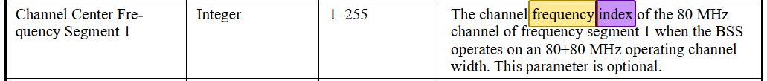

Change “channel center frequency index” to “channel number of the center frequency” in the highlighted locations:

In Table 9-214—HT/VHT Operation Information subfields:

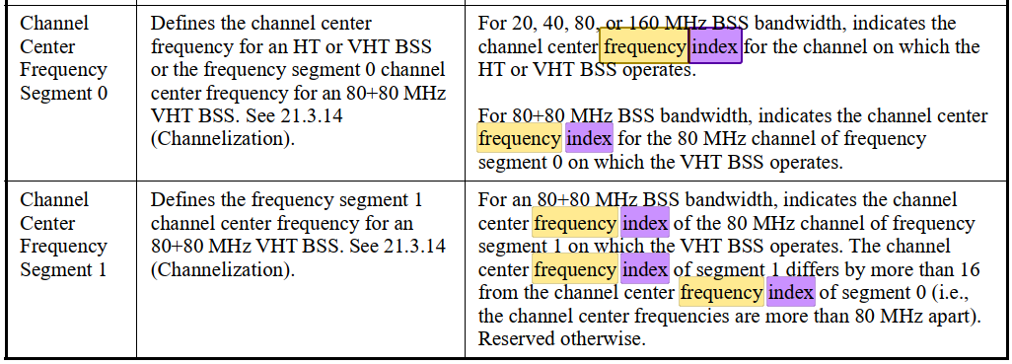

In Table 9-316—VHT Operation Information subfields:

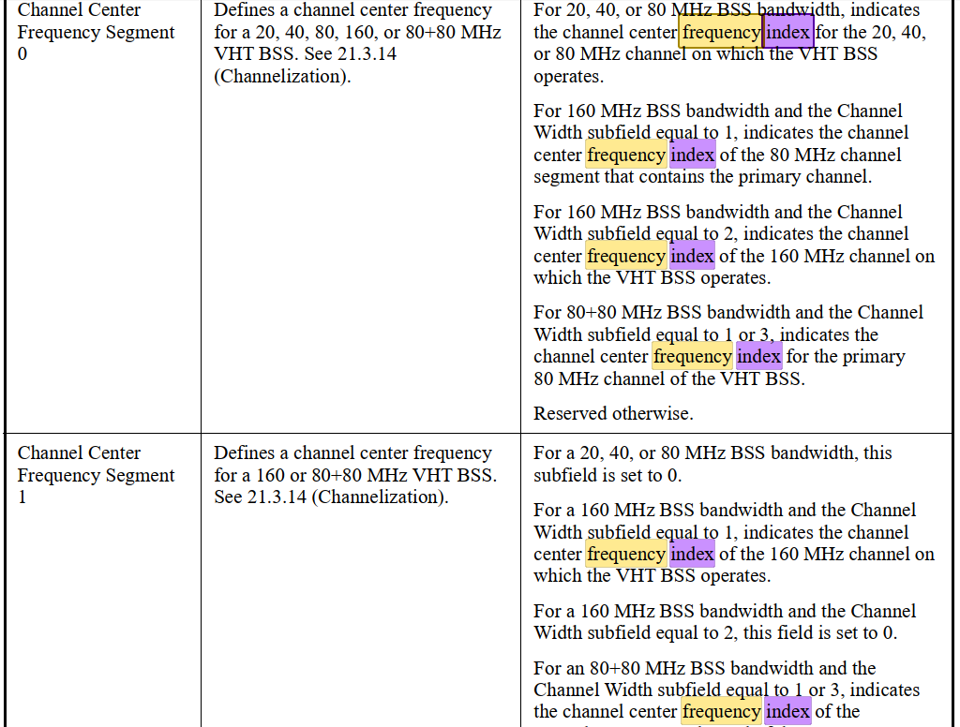

In 9.4.2.161 Channel Switch Wrapper element:

In 9.4.2.235 OCI element:

In 9.4.2.248 HE Operation element:

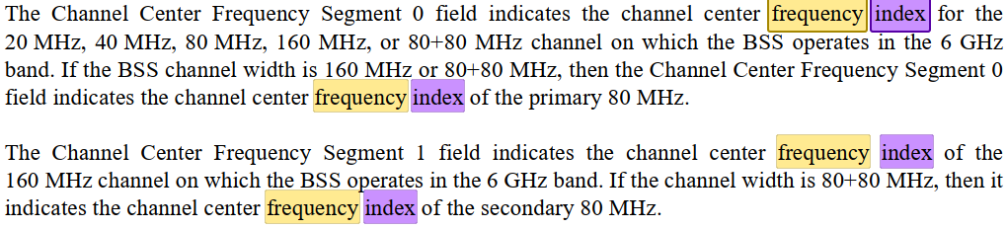

In E.1 Country information and operating classes:

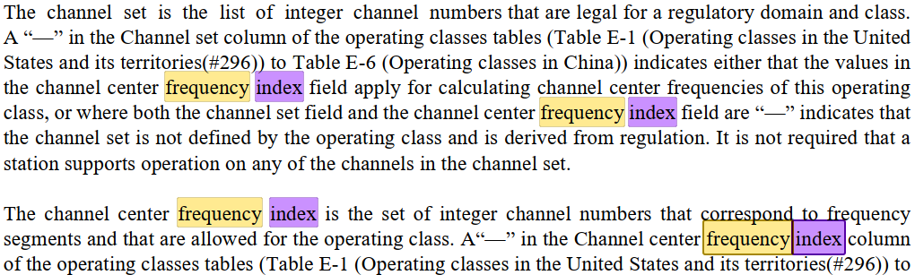
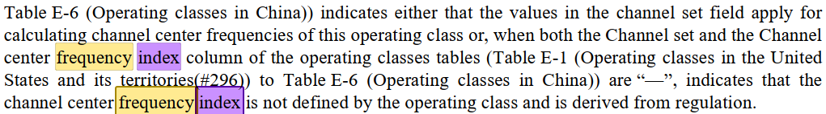

Change “Channel center frequency index” to “Channel number of the center frequency” in the highlighted locations:

In Table E-1—Operating classes in the United States and its territories(#296) to Table E-6—Operating classes in China:

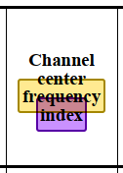

Change “center frequency index” to “channel number of the center frequency” in the highlighted locations:

In 9.4.2.65.4 Peer-to-peer link event request:

In 9.4.2.67.5 Diagnostic subelement descriptions:

Change “ChannelCenterFrequencyIndex” to “ChannelCenterChannelNumber” in the highlighted locations:

In 23.3.14 Channelization:

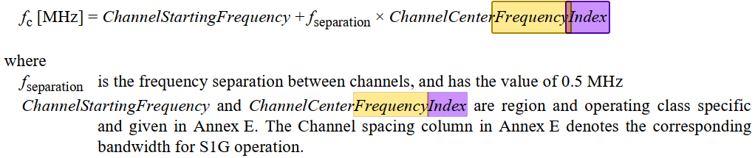

Change “CENTER_FREQUENCY_INDEX” to “CHANNEL_CENTER_CHANNEL_NUMBER” in the highlighted locations:

In 28.2.3 PHYCONFIG_VECTOR parameters:

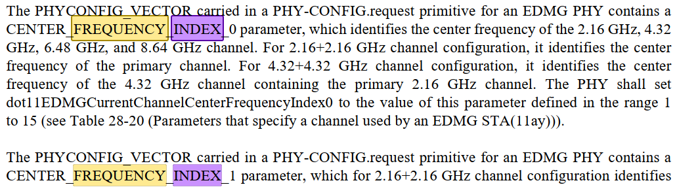

Proposed resolution:

REVISED

Make the changes shown under “Proposed changes” for CID 6420 in <this document URL>, which refer to channel numbers (of the center frequency, where appropriate).

Identifiers | Comment | Proposed change
CID 6171  Mark RISON | (Follow-up of CID 4341). It is not clear how modifying the BA timeout, the buffer size or indeed any other BA agreement parameter works. The only one that is relatively easy to deal with is modification of the BA timeout. | In 10.25.2 and 11.5.1 change "All parameters of [the/an] agreement may be modified except for the TID." to "Only the block ack agreement timeout may be modified." In 11.5.4 change "The inactivity timer at the recipient is also reset when a BlockAckReq frame with the TID for the block ack agreement is received. The inactivity timer at the originator is reset when a BlockAck frame with the TID for the block ack agreement is received." to "The inactivity timer at the recipient is also reset when a BlockAckReq or ADDBA Request frame with the TID for the block ack agreement is received. The inactivity timer at the originator is reset when a BlockAck or ADDBA Response frame with the TID for the block ack agreement is received."

Discussion:

We discussed BA modification during letter ballot, but did not reach consensus on how it worked.

During the TGme session on 2023-11-13 there seemed to be consensus that BA modification behaves, when the modification is accepted, as if there had been a DELBA immediately prior to the ADDBA exchange. This has the merit of not requiring clarification of how each parameter signalled in ADDBA is handled, since all the BA-related state is cleared by the DELBA, though it does mean that anything “in transit” is potentially lost.

However, the behaviour w.r.t. MPDUs that have been transmitted but not acked (and any MPDUs before the last MPDU that was transmitted) is not clear. There is some discussion in:

11.5.4 Error recovery upon a peer failure

When a recipient does not have an active block ack for a TID, but receives QoS Data frames with Block Ack ack policy, it shall discard them and shall send a DELBA frame within its own TXOP. If such a STA receives a BlockAckReq frame, it may respond with an Ack frame and shall respond with a DELBA frame within its own TXOP. The originator may attempt to set up the use of block ack or may send the MPDUs using an alternative acknowledgment mechanism. When the recipient transmits a DELBA frame, it shall set the last sequence number received value to the sequence number of the last received MPDU, regardless of the ack policy used in that frame. When the originator receives a DELBA frame, it shall

a) Discard any MPDU that has been transmitted and not acknowledged, with the possible exception if it was the last MPDU to be sent and it was not a retransmission, and

b) Set the sequence number to either that of the last MPDU that is sent if it intends to retransmit or one beyond the last MPDU sent.

which clarifies some points (though it’s a bit unhelpful to bury generic DELBA behaviour under a “Error recovery”/“peer failure” heading), but:

- The first 3 sentences seem to be about Block Ack ack policy (which is generally not used) and it’s not entirely clear how they relate to the rest

- This describes what happens if the recipient sends the DELBA, but not what happens if the originator sends the DELBA (which is what’s important if we consider BA modification to have an implicit DELBA beforehand)

- This doesn’t cover the (admittedly obscure) case where the originator sent say SN 1, 2 and 4 but not 3 and all the three MPDUs were acked -- in this case the third MPDU has to be discarded too (note “MPDU that has been transmitted and not acknowledged” doesn’t cover such an MPDU)

- “that of the last MPDU that is sent” should presumably be “that of the last MPDU that it sent”

- “Set the sequence number” of what? Presumably the next MPDU it transmits

- It is not clear why the last MPDU can be retained if “it was not a retransmission” but not if it was a retx

Proposed changes:

Modify Subclauses 10.25.2, 11.5.1, 11.5.3.2/3 and 11.5.4, and add Subclauses 11.5.3.4/5as follows:

10.25.2 Setup and modification of the block ack parameters

(#1807)A block ack agreement may be modified by the originator by sending an ADDBA Request frame ((#3174)(see 11.5.2 (Setup and modification of the block ack parameters), except that MLME-ADDBA primitives are not used by the originator(#4352)). All parameters of the agreement may be modified except for the TID. If the request is not successful, the existing agreement is not modified. If the request is successful, the behavior is as if a DELBA frame for the block ack agreement had been transmitted by the originator and received by the recipient immediately prior to the ADDBA Request frame.

11.5 Block ack operation

11.5.1 Introduction

(#3174)Block ack agreements may be set up, modified by the originator, or deleted from the MAC (see 10.25.2 (Setup and modification of the block ack parameters) (#4353)and 10.25.4 (Teardown of the block ack mechanism)) or from the SME. The setup, modification by the originator and deletion of block ack agreements from the SME is described in this subclause. All parameters of an agreement may be modified except for the TID. If the request is not successful, the existing agreement is not modified. If the request is successful, the behavior is as if a DELBA frame for the block ack agreement had been transmitted by the originator and received by the recipient immediately prior to the ADDBA Request frame.

11.5.3.2 Procedure at the initiator of the block ack agreement teardown

Upon receipt of an MLME-DELBA.request primitive, the MLME shall tear down the block ack agreement by transmitting a DELBA frame.

The encoding of ReasonCode values to Reason Code field (see 9.4.1.7 (Reason Code field)) values is defined in Table 9-79 (Reason codes).

11.5.3.3 Procedure at the recipient of the DELBA frame

A STA shall issue an MLME-DELBA.indication primitive with the parameter ReasonCode having a value of REQUESTED when a DELBA frame is received.

11.5.3.4 Procedure at the block ack originator

When a block ack agreement is torn down, the originator shall, for MPDUs under that block ack agreement (i.e. recipient and TID), irrespective of whether it transmitted or received a DELBA frame:

a) Discard all MPDUs that have not been acknowledged, up to and including the last (highest in sequence number space) MPDU transmitted, and

b) Set the sequence number of the next MPDU to be transmitted outside the block ack agreement to the sequence number immediately after that of the last (highest in sequence number space) MPDU transmitted.

11.5.3.5 Procedure at the block ack recipient

When a block ack agreement is torn down, the recipient shall, irrespective of whether it transmitted or received a DELBA frame, set the last sequence number received value for MPDUs for the block ack agreement’s originator and TID to the sequence number of the last (highest in sequence number space) MPDU received, regardless of the ack policy used in that MPDU.

11.5.4 Error recovery upon a peer failure

When a recipient does not have an active block ack agreement for a TID, but receives one or more QoS Data frames with Block Ack ack policy, it shall discard them and shall send a DELBA frame within its own TXOP. If such a STA receives a BlockAckReq frame, When a recipient does not have an active block ack agreement for a TID, but receives a BlockAckReq frame, it may respond with an Ack frame and shall respond with send a DELBA frame within its own TXOP. The originator may attempt to set up the use of a block ack agreement again or may send the MPDUs using an alternative acknowledgment mechanism. When the recipient transmits a DELBA frame, it shall set the last sequence number received value to the sequence number of the last received MPDU, regardless of the ack policy used in that frame. When the originator receives a DELBA frame, it shall

a) Discard any MPDU that has been transmitted and not acknowledged, with the possible exception if it was the last MPDU to be sent and it was not a retransmission, and

b) Set the sequence number to either that of the last MPDU that is sent if it intends to retransmit or one beyond the last MPDU sent.

Add “agreement” after “the block ack” in the quoted body text of the following subclauses:

9.3.1.8.8 EDMG Compressed BlockAck variant: “The size of the Block Ack Bitmap subfield is negotiated during the block ack establishment”

9.4.1.16 DELBA Parameter Set field: “UP for which the block ack has been originally set up”

9.6.4.4 DELBA frame format: “to terminate the block ack participation” [also delete “participation”]

10.25.2 Setup and modification of the block ack parameters: “The ADDBA Request and Response frames exchanged to set up the block ack”

10.25.2 Setup and modification of the block ack parameters: “Once the block ack exchange has been setup” [also delete “exchange”]

10.25.4 Teardown of the block ack mechanism [title itself; also delete “mechanism”]

10.25.4 Teardown of the block ack mechanism: “for the block ack’s TID”

10.25.4 Teardown of the block ack mechanism: “explicit teardown of the block ack mechanism”

11.5.2.2 Procedure at the originator: “modified the block ack mechanism with the recipient STA” (2x) [also delete “mechanism”]

11.5.3 Teardown of the block ack mechanism [title itself; also delete “mechanism”]

In 9.3.1.8.9 EDMG Multi-TID BlockAck variant change “negotiated during the Block Ack establishment” to “negotiated during the block ack agreement establishment” (2x).

Change “it implies that the originator of the block ack has no information” to “it implies that the block ack originator has no information” in 9.4.1.13 Block Ack Parameter Set field.

Change “which is equal to twice the Block Ack reorder window” to “which is equal to twice the block ack agreement reordering buffer” in 12.5.2.3.6 Construct CCMP header for PV1 MPDUs.

Proposed resolution:

REVISED

Make the changes shown under “Proposed changes” for CID 6171 in <this document URL>, which cause BA modification, if successful, to be handled as if the block ack agreement had been deleted immediately prior to the modification, and clarify the behaviour w.r.t. MPDUs that have not been acknowledged.

Identifiers | Comment | Proposed change
CID 6173  Mark RISON  10.25.4 | 11.5.4 requires the BA agreement to be torn down on timeout ("When a timeout of BlockAckTimeout is detected, the STA shall send a DELBA") | Change "The block ack agreement may be torn down if" to "The block ack agreement shall be torn down if"

Discussion:

10.25.4 at 1962.8 says:

The block ack agreement may be torn down if there are no BlockAck, BlockAckReq, or MPDUs received from the peer under the block ack agreement, for the block ack’s TID, within a duration of block ack timeout value (see 11.5.4 (Error recovery upon a peer failure)).

but 11.5.4 at 2482.26 says:

When a timeout of BlockAckTimeout is detected, the STA shall send a DELBA frame to the peer STA

ADACHI Tomo has suggested the apparent contradiction is because the 10.25.4 text is trying to say that the BA agreement can be torn down before the inactivity timeout expires.

Proposed resolution:

REVISED

Change the para at 1962.8 to:

The block ack agreement can be torn down if there are no BlockAck, BlockAckReq, or Data frames received from the peer under the block ack agreement, for the block ack’s TID (even before block ack agreement inactivity timeout).

Identifiers | Comment | Proposed change
CID xxx
Mark RISON

Discussion:

Proposed changes:

Proposed resolution:

REVISED

Make the changes shown under “Proposed changes” for CID xxx in <this document URL>, which xxx

References:

802.11me/D4.0 except where otherwise specified

