IEEE P802.11
Wireless LANs
Proposed Resolution for REVme SB1 Editor1 ad-hoc Comments
Date: 2023-10-11
Author:
Name | Affiliation | Address | Phone | Email
Emily Qi | Intel Corporation | 2111 NE 25th Ave.  Hillsboro OR 97124 |  | Emily.h.qi@intel.com

This submission present proposed resolutions for comments in the Editor1 ad-hoc group.

The proposed changes are based on REVme/D4.0

Revision history:

R0 – initial version
R1 – Incorporated the feedback from the discussion on 10/11/2023.

CID | Page | Clause | Resn Status | Comment | Proposed Change
6587 | 1798.00 | 10.3.2.10.1 |  | after SIFS isn't proper grammar. | Change to "after a SIFS". I counted 38 instances through the Standard. Also "after PIFS" (3 occurrences). Also, a naked PIFS or SIFS in other contexts, like P1798.38 and P1798.46.

Discussion:
38 instances: “after SIFS”
3 instances: “after PIFS”
1798.38: “PIFS shall be used as the interval between CTS1 and CTS2”
1798.46: “SIFS shall be used as the interval between CTS1 and CTS2”

Proposed Resolutions:
Revised.
Change “after SIFS” to ““after a SIFS”, thoughout the draft, 38 instanaces.
Change “after PIFS” to ““after a PIFS”, thoughout the draft, 3 instanaces.
Change “PIFS” to “A PIFS” at 1798.38
Change “SIFS” to “A SIFS” at 1708.46

CID | Page | Clause | Resn Status | Comment | Proposed Change
6568 |  |  |  | "The construction "between x and y", "x to y" or "x-y"" should have x and y in italics. Also the hyphen should be a minus or en dash (but in other places hyphens or em dashes are also sometimes used) | Change "The construction "between x and y", "x to y" or "x-y"" to have x and y in italics, and the hyphen as a minus (or en dash if that is within the available glyphs)

Discussion:
Cited text at 171.37:

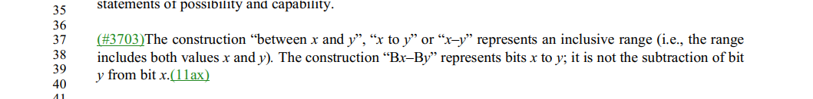

The cited text in D4.0 is shown as the comment suggested. No change is required.

Proposed Resolutions:

Rejected.
Rejected Reason: The cited text in D4.0 is shown as the commenter suggested. No change is required.

CID | Page | Clause | Resn Status | Comment | Proposed Change
6364 |  | 3 |  | Per CID 1630, "time priority Management frame:" etc. needs to become "time priority management frame:" | As it says in the comment

Discussion:
Cited text at 233.52:

Assigned to Mark R. Submission Required.

Proposed Resolutions:
Rejected.
Rejected Reason: The cited text in D4.0 is shown as the commenter suggested. No change is required.

6018 | 1125.50 | 9.4.2.84 |  | "Peer-to-peer link indication" is not only used for P2P link indication, but also used for any off-channel and off-link operation indication. The term "Peer-to-peer link indication" can be changed to a broader name. It is actually an unavailability indication (i.e., unavailable to infrastructure BSS) | Change "Peer-to-peer link indication" to "Unavailability indication".

Discussion:

Cited text:

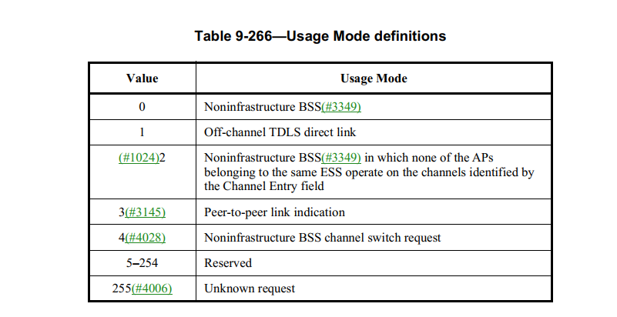

Transfered to MAC ad hoc and assigned to Emily
More work required.

Proposed resolution:
Accepted.

6029 | 993.40 | 9.4.2.24 |  | "Peer-to-peer TWT" support is not only used for P2P link indication, but also used for any off-channel and off-link operation indication (e.g., off-channel scanning). The term ""Peer-to-peer TWT" can be changed to a broader name. "Peer-to-peer TWT" is an unavailability schedule (i.e., unavailable to infrastructure BSS). | Change "Peer-to-peer TWT Support" to "Unavailability Support"; Change "Peer-to-peer TWT schedule(ing)" to "Unavailability schedule(ing)"; Change "Peer-to-peer TWT agreement" to "Unavailability notification". Change "Peer-to-peer TWT SP" to "Unavailability period", globally, clone case.

Discussion:

At 993.40, 2612.7, 2612.33:
Change "Peer-to-peer TWT Support" to "Unavailability Support"; 3 instances

At 2611.51, 2612.2, 2612.6, 2612.28, 2612.12, 2613.57:
Change "peer-to-peer TWT schedule" to "unavailability schedule", 6 instances.

At 2613.42, 2614.19,
Change "Peer-to-peer TWT scheduling" to "Unavailability scheduling", 2 instances.

At 1648.62, 1649.61,
Change "if used for the establishment of a peer-to-peer TWT agreement with a range of TWT parameter values" to " if used for the unavailability notification with a range of TWT parameter values". 2 instances

At 2611 to 2614,
Change " (a) peer-to-peer TWT agreement" to "(an) unavailability notification", 19 instances.

At 2612.63, 2614.11/12/14,
Change "peer-to-peer TWT SP" to "unavailability period", 4 instances.

Transfered to MAC ad hoc and assigned to Emily.
More work required.

Proposed Resolution:

Revised.

6028 | 1648.62 | 9.6.13.24 |  | "except if used for the establishment of a peer-to-peer TWT agreement with a range of TWT parameter values". "establishment" is redundant. Remove "the establishment of". | remove "the establishment of” at 1648.62 and 1649.49.

Discussion:

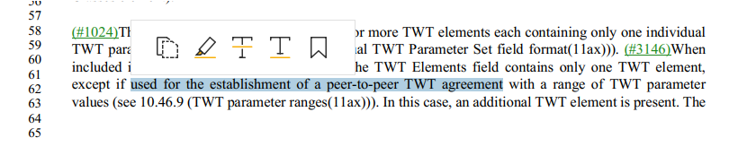
Transfered to MAC ad hoc and assigned to Emily
More work required.

Proposed Resolution:
Accepted.

CID | Page | Clause | Resn Status | Comment | Proposed Change
6322 |  | 9.6.19.17 |  | "The BA Control field is defined in 9.3.1.8 (BlockAck frame format). The (#4200)Block Ack Starting Sequence Control field is defined in 9.3.1.8 (BlockAck frame format)" should be combined, per similar text earlier for BAR (or the earlier text should be decombined) | As it says in the comment

Discussion:

Cited text:

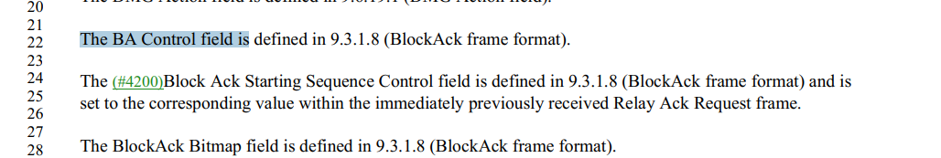

I couldn’t see anything wrong with cited tex.

Proposed Resolutions:
Revised.
Change paragraphs at 1684.22 to 1684.28 to:
“The BA Control, Block Ack Starting Sequence Control and BlockAck Bitmap fields are defined in 9.3.1.8 (BlockAck frame format). The Block Ack Starting Sequence Control field is set to the corresponding value within the immediately previously received Relay Ack Request frame.”

CID | Page | Clause | Resn Status | Comment | Proposed Change
6317 | 573.00 | 8.3.5.15.2 |  | "GROUP_ID or PARTIAL_AID filtering " should be "group ID or partial AID filtering " | As it says in the comment

Discussion:

Cited text at 573.19:
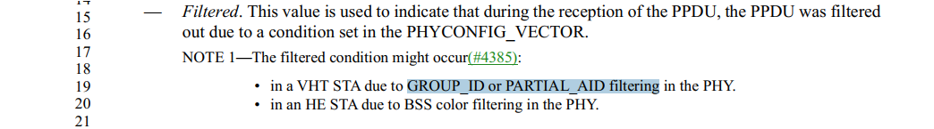

??
Proposed Resolutions:
Accepted.

CID | Page | Clause | Resn Status | Comment | Proposed Change
6316 | 331.00 | 4.10.3.3 |  | "Password or PSK" should be lowercase "password" | As it says in the comment

Discussion:

Cited text:
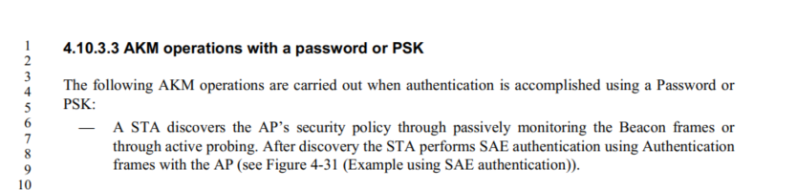

I also found other two instances on "Password or PSK" at 2882.61 and 2883.15

Proposed Resolutions:
Accepted.

CID | Page | Clause | Resn Status | Comment | Proposed Change
6295 | 367.00 | 6.4 |  | "The presence of the protected parameter " should be "The presence of the Protected parameter " | As it says in the comment
Discussion

Cited text at 367.2
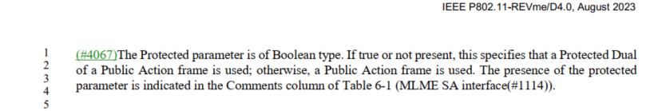

Proposed Resolutions:
Accepted.

CID | Page | Clause | Resn Status | Comment | Proposed Change
6292 |  | 9.8.5.2 |  | "The frame body of a PV1 Management frame of subtype Action is described in 9.3.3.13 (Action frame format) and the format of the Action field formats allowed is described in 9.5.7 (EDMG BRP field(11ay)). " -- broken xref (also next para) | Fix the broken xrefs
Discussion

Proposed Resolutions
Revised.
At 1753.24 and 1753.28, change “9.5.7 (EDMG BRP field(11ay))” to “9.6 (Action frame format details)”.

CID | Page | Clause | Resn Status | Comment | Proposed Change
6412 |  |  |  | The spec uses both "compliant" and "conformant" (and associated verbs, nouns, adverbs, etc.). I have a feeling these are not the same, and one is more "legal" (compliance) and the other is more "technical"/"moral" (conformance). Use "compliant" only when there is a legal requirement | Change "comply" to "conform" etc. except when this is about regulatory compliance. E.g. in 15.4.5.8 change "The transmit power ramps shall be constructed such that the DSSS PHY emissions comply with the spurious frequency product specification defined in 15.4.4.6" to "The transmit power ramps shall be constructed such that the DSSS PHY emissions conform to the spurious frequency product specification defined in 15.4.4.6"

Discussion:

CID 6412 is the same comments as CID 1472, 2144, 3548

Those three comments were rejected as:
REJECTED (ED1: 2023-03-17 10:59:50Z) - The comment fails to identify changes in sufficient detail so that the specific wording of the changes that will satisfy the commenter can be determined.

Proposed Resolution:
Rejected.
The comment fails to identify changes in sufficient detail so that the specific wording of the changes that will satisfy the commenter can be determined.

CID | Page | Clause | Resn Status | Comment | Proposed Change | Resolution | Owning Ad-hoc
6228 |  |  |  | Text in figures should be searchable (i.e. a find in a normal PDF viewer should find it). This is sometimes the case, but not always, especially for older figures | As it says in the comment |  | ED1

Discussion:

CID 6228 is the same comment as: CIDs 265, 2016, 4211,

Those three comments were rejected as:

REJECTED (ED2: 2021-11-12 16:52:03Z) The comment fails to identify changes in sufficient detail so that the specific wording of the changes that will satisfy the commenter can be determined.

Proposed Resolution:
Rejected.
The comment fails to identify changes in sufficient detail so that the specific wording of the changes that will satisfy the commenter can be determined.
6153 |  |  |  | Sometimes it's "IEEE SA", sometimes "IEEE-SA" | Use whichever of the two is the correct/preferred form |  | ED1

Discussion:

“IEEE SA” is correct form.

Proposed Resolution:
Revised.
Change “IEEE-SA” to “IEEE SA” at 6.51, 6.54, 6.56, 4791.11, 5065.26 (D 4.1).

6181 |  | 9 |  | "Operating Class and Channel Number fields" is confusing because this is a set of "Operating Class and Channel Number" fields, not a set of "Operating Class" and "Channel Number" fields | Change "and" to "And" in "Operating Class and Channel Number" throughout (in 9.4.1.22 Operating Class and Channel field, 9.4.2.69.3 Location Indication Channels subelement, 9.4.2.84 Channel Usage element, 9.9.3.3 WUR Discovery frame format, 11.21.15 Channel usage procedures) |  | ED1

Discussion:

“Operating Class and Channel Number fields" is a set of "Operating Class" and "Channel Number" fields, not a set of “Operating Class and Channel Number" fields.

“The Operating Class and Channel Number field” is not defined in 802.11. Instead, “The Operating Class and Channel field” is defined in 9.4.1.22.

I found 29 instances of “Operating Class and Channel Number fields”. They are all correct. No confusion. We should not change “and” to “And” in those instances.

The term “Operating Class and Channel Number” field(s) is not used in 9.4.1.22, 9.4.2.69.3,9.4.2.84 etc ….

Here is an example of definition:

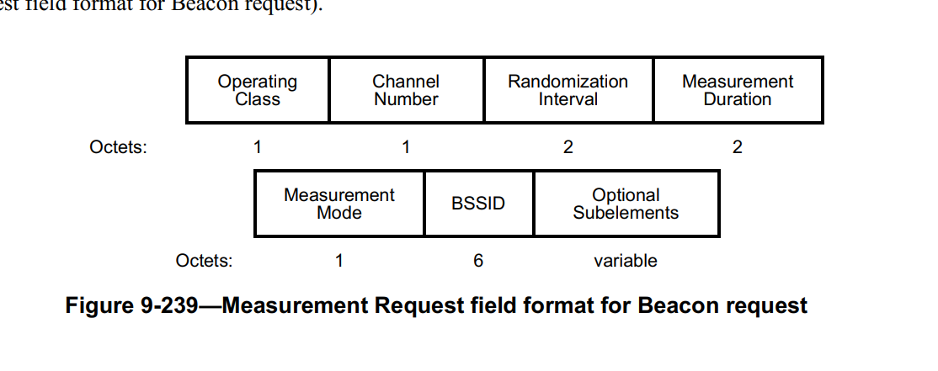

I found 29 instances of “Operating Class and Channel field”. They all state correctly.

However, I did find a typo at 1042.1:
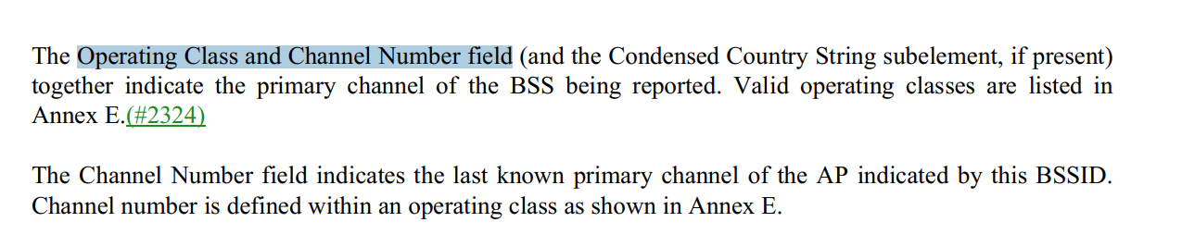
At 1042.1, change “Operating Class and Channel Number field” to ““Operating Class and Channel Number fields”

Proposed Resolution:

Revised.

At 1042.1, change “Operating Class and Channel Number field” to “Operating Class and Channel Number fields”

The current draft standard clearly defines and properly uses “Operating Class and Channel Number fields”. No confusion. No need to change “and” to “And” in either “Operating Class and Channel Number fields” or “Operating Class and Channel field”.

CID | Page | Clause | Resn Status | Comment | Proposed Change
6026 |  |  |  | MDR comment: the "Unicast" is still used in this subclause. Please review and decide whether they are appropriate. | See as comment.

Discussion:

Editorial style guide:

Unicast and Multicast
When used to describe MAC entities, the adjectives “unicast” and “directed” are deprecated in favor of “individually addressed” or “that is an individual address” and the adjective “multicast” is deprecated in favor of “group addressed” or “that is a group address.
- To modify a noun such as frame, MPDU, MSDU, PPDU, etc., or a conceptual object such MAC entity, use “individually addressed frame” or <example with MAC entity>.
- To describing a type of address, use “that is an individual address” or “that is a group address.” For example, “destination address that is an individual address” or “RA that is a group address.”

The terms “unicast” (or “directed”) and “multicast” may be used with non-MAC entities, for example:
- Unicast communication
- MIB object names
- directed multicast service
- Flexible multicast service
- Multicast parameters for FMS Request
- Multicast Diagnostic
- FMS multicast rate
- multicast integrity protocol
- Multicast Triggered Reporting
- multicast group
- multicast reception
- multicast traffic
- broadcast/multicast transmitter,

I found 7 instances in D4.0 and 15 instances in D4.1, which means 11az introduces 8 more instances.
7 instances are from ARP Proxy;
8 instances are from 11az.

Proposed Resolution:

Revised.

Makes changes as shown below:
At 287. 13:
The Proxy ARP service enables an AP to avoid forwarding to the BSS broadcast ARP frames for
IPv4 (IETF RFC 826) and IP layer multicast packets IPv6 ND messages for IPv6 (IETF RFC 4861 and IETF
RFC 4862) which target not match the address of an associated STA. If the target matches the address of an
associated non-AP STAs, the Proxy ARP service can either respond on behalf of the non-AP STA, or
preferably send the frames as individually addressed frames unicast transmissions to the target STA(s) only. As a result, an associated STA
that is not a target is not exposed to extraneous IPv4 ARP frames or IPv6 Neighbor Discovery packets. This
way, the Proxy ARP service reduces the amount of broadcast transmissions and enables associated STAs to
remain in power save for longer periods of time.

At 692.24
The RA field, and the CS Required and UL BW subfields in the Common Info field of the Ranging Trigger
frame are identical to the Basic Trigger frame described in 26.5.2 (UL MU operation) and 9.3.1.22 (Trigger
frame format(11ax)), except that the RA field in Ranging Trigger frames with only one User Info field may
be either unicast or broadcast individual address or group address.

At 2489.32:

(11az)Class 1a frames
In an infrastructure BSS when PTKSA from PASN authentication exists
1) Protected Fine Timing frames (9.6.34 (Protected Fine Timing frame details(11az)))
2) Unicast SA Query Request frames sent to an individual address (11.13 (SA Query procedures))

At 2680.37,
The Ranging NDP Announcement frame shall be unicast an individually addressed frame with the RA field set to the address of the RSTA, and contain one STA Info field with the AID11 subfield set to 0.

At 2695.44:
NOTE 1—A 6-octet parameter representing the value of the Secure HE-LTF Counter subfield is sufficient because a unicast protected individually addressed management frame that uses a 6-octet PN is used to convey the LTF sequence information that carries the counter.

At 2957.1:
In a protected unicast individually addressed management Action frame, bit 4 of the Key ID octet equals 1 if the frame is a Protected Fine Timing frame—see Table 9-51 (Category values). In other protected unicast individually addressed frames, bit 4 is reserved.

At 2972.8
(11az)In a protected unicast individually addressed management Action frame, bit 4 of the Key ID octet is set to 1 if the frame is a Protected Fine Timing frame—see Table 9-81 (Category values). In other protected unicast individually addressed frames, bit 4 reserved

11.21.14 Proxy ARP service
Implementation of the proxy ARP service is optional for a WNM STA. A STA that implements the proxy ARP
service has dot11ProxyARPImplemented equal to true. When dot11ProxyARPImplemented is true,
dot11WirelessManagementImplemented shall be true. When dot11ProxyARPActivated is true, the Proxy ARP
Service bit in the Extended Capabilities field shall be set to 1 to indicate that the AP supports the proxy ARP
service. When dot11ProxyARPActivated is false, the Proxy ARP Service bit shall be set to 0 to indicate that
the AP does not support the proxy ARP service.
(#1208)When the AP sets the Proxy ARP field to 1 in the Extended Capabilities element, the AP shall maintain
a Hardware Address to Internet Address mapping for each associated STA and for each IPv4 and IPv6 address
of the STA, and shall update the mapping when one of the addresses of the associated STA changes. A Proxy
ARP service receives and processes three types of messages: IPv4 ARP requests, IPv6 ND address lookups,
and IPv6 ND duplicate address detection (DAD) messages. These messages are all received as group
addressed. If the target address is not known, the Proxy ARP service does not forward the request to the BSS. If
the target address is known, the Proxy ARP service can either respond directly on behalf of a STA or forward
the request as an individually addressed unicast frame to the intended STA. For fixed devices in doze state, a direct response is preferable. Otherwise, forwarding as an individually addressed frame unicast is recommended, to avoid responding with misleading information.
(#1208)For IPv4, when the address being resolved in the ARP request (IETF RFC 826) is used by a non-AP
STA currently associated to the BSS, the proxy ARP service shall either respond on behalf of the STA to an
ARP request or an ARP probe (IETF RFC 5227) or preferably turn the ARP request into an individually addressed unicast frame sent to that STA.
(#1208)When an AP receives an IPv4 ARP request from one associated STA or from the DS with a target IPv4
address that corresponds to a second associated STA, the AP that decides to form a proxy ARP response frame
shall insert the second STA MAC address as the (#479)sender's MAC address in the ARP response.
(#1208)In contrast to IPv4, Stateless Address Autoconfiguration (SLAAC), which is part of IPv6 Neighbor
Discovery (ND), enables a node to form multiple addresses, some of them temporary and with a particular
attention paid to privacy. SLAAC addresses may be formed and deprecated asynchronously to the association.
Even if the knowledge of IPv6 addresses used by a STA can be obtained by snooping protocols such as IPv6
ND and DHCPv6, or by observing data traffic sourced at the STA, such methods provide only an imperfect
knowledge of the state of the STA at the AP, in particular when SLAAC is enabled. Running a Proxy ARP
service on an incomplete set of addresses may result in a loss of connectivity, in particular for addresses rarely
used and in situations of mobility.
(#1208)This nondeterministic representation of IPv6 address location and binding may also result in
undesirable state persistence in the AP when a STA ceases to use an IPv6 address. It follows that protocol
snooping is not a recommended technique and that snooping should only be used as last resort. IETF RFC 8505
defines an address registration mechanism that enables the AP to maintain a deterministic knowledge of all the
IPv6 addresses of all the associated STAs. IETF RFC 8929 defines a proxy ND service that leverages the
address registration to maintain an accurate proxy state that follows the movements of the STAs, while IETF
RFC 8928 protects the address ownership against impersonation attacks and address spoofing.
(#1208)The proxy ARP function for IPv4 and IPv6 shall support snooping of DHCPv4, DHCPv6, and IPv6
ND to discover the IPv4 and IPv6 addresses owned by the STA.
(#1208)For IPv6, since the state obtained by snooping SLAAC is unreliable, the proxy ARP function shall
support the backbone router function defined in IETF RFC 8929, which creates a binding state based on an
IETF RFC 8505 registration by the STA. The proxy ARP function should support IETF RFC 8928 to protect
the ownership of the addresses. The non-AP STA shall support the address registration mechanism defined in
IETF RFC 8505 and should support the address protection mechanism defined in IETF RFC 8928.

(#1208)IPv6 ND uses IP layer multicast Internet Control Message Protocol version 6 (ICMPv6) Neighbor
Solicitation (NS) messages (section 4.3 of IETF RFC 4861) for address resolution (section 7.2 of IETF RFC
4861), which is the equivalent of ARP request, and for duplicate address detection (DAD). The proxy ARP
function shall discard those messages if the target IP address does not correspond to an associated STA.(#3683)
NS messages are sent as IP layer unicast for neighbor unreachability detection (NUD) (section 7 of IETF RFC
4861). The proxy ARP function shall not operate on IP layer unicast NS messages.
(#1208)With the IPv6 ND proxy operation defined in IETF RFC 8929, the backbone router function at the AP
typically operates as a bridging proxy though operation as a routing proxy is also possible. As a bridging proxy,
the NS lookups are replied with the MAC address of the STA, and the packets to the STA are bridged
normally; as a routing proxy, the backbone router function replies to lookups from the wired backbone with its
own MAC address and then routes to the STA at the IP layer. The routing proxy isolates the layer-2 domains
and hides the MAC address of the STA in the wired backbone, for a better stability and scalability of the
bridged domain. The Proxy ARP function shall support the bridging proxy and may support the routing proxy
operation.
(#1208)When the target IPv6 address of a IP layer multicast NS message corresponds to an associated STA,
the Proxy ARP service may respond on behalf of an associated low-power STA with a neighbor advertisement
(NA) message (section 4.4 of IETF RFC 4861) with the override flag set to zero, to conserve energy.
Preferably, though, the Proxy ARP service should transmit the IP layer multicast NS message as an individually addressed unicast frame to the STA and let the STA respond, as recommended in IETF RFC 8929. When MAC address
mappings change, the AP may send unsolicited Neighbor Advertisement messages on behalf of a STA if the
IPv6 Neighbor Discovery function at the STA failed to do so.
(#1208)The IPv6 ND function at the STA shall register all of the IPv6 addresses on the interface (see section 10
of IETF RFC 8929) to the proxy ARP service at the AP to ensure that the proxy ARP service is aware of all
those addresses and will proxy for them. The proxy ND operation may support address mobility (section 6 of
IETF RFC 8929) to transfer a role of ND proxy for this STA to the AP with which the STA is associated
following a mobility event.

