IEEE P802.11
Wireless LANs
Proposed Resolution for REVme SB1 Editor1 ad-hoc Comments
Date: 2023-10-11
Author:
Name | Affiliation | Address | Phone | Email
Emily Qi | Intel Corporation | 2111 NE 25th Ave.  Hillsboro OR 97124 |  | Emily.h.qi@intel.com

This submission present proposed resolutions for comments in the Editor1 ad-hoc group.

The proposed changes are based on REVme/D4.0

Revision history:

R0 – initial version
R1 – Incorporated the feedback from the discussion on 10/11/2023.

CID | Page | Clause | Resn Status | Comment | Proposed Change
6587 | 1798.00 | 10.3.2.10.1 |  | after SIFS isn't proper grammar. | Change to "after a SIFS". I counted 38 instances through the Standard. Also "after PIFS" (3 occurrences). Also, a naked PIFS or SIFS in other contexts, like P1798.38 and P1798.46.

Discussion:
38 instances: “after SIFS”
3 instances: “after PIFS”
1798.38: “PIFS shall be used as the interval between CTS1 and CTS2”
1798.46: “SIFS shall be used as the interval between CTS1 and CTS2”

Proposed Resolutions:
Revised.
Change “after SIFS” to ““after a SIFS”, thoughout the draft, 38 instanaces.
Change “after PIFS” to ““after a PIFS”, thoughout the draft, 3 instanaces.
Change “PIFS” to “A PIFS” at 1798.38
Change “SIFS” to “A SIFS” at 1708.46

CID | Page | Clause | Resn Status | Comment | Proposed Change
6568 |  |  |  | "The construction "between x and y", "x to y" or "x-y"" should have x and y in italics. Also the hyphen should be a minus or en dash (but in other places hyphens or em dashes are also sometimes used) | Change "The construction "between x and y", "x to y" or "x-y"" to have x and y in italics, and the hyphen as a minus (or en dash if that is within the available glyphs)

Discussion:
Cited text at 171.37:

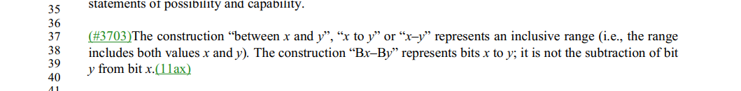

The cited text in D4.0 is shown as the comment suggested. No change is required.

Proposed Resolutions:

Rejected.
Rejected Reason: The cited text in D4.0 is shown as the commenter suggested. No change is required.

CID | Page | Clause | Resn Status | Comment | Proposed Change
6364 |  | 3 |  | Per CID 1630, "time priority Management frame:" etc. needs to become "time priority management frame:" | As it says in the comment

Discussion:
Cited text at 233.52:

Assigned to Mark R. Submission Required.

Proposed Resolutions:
Rejected.
Rejected Reason: The cited text in D4.0 is shown as the commenter suggested. No change is required.

6018 | 1125.50 | 9.4.2.84 |  | "Peer-to-peer link indication" is not only used for P2P link indication, but also used for any off-channel and off-link operation indication. The term "Peer-to-peer link indication" can be changed to a broader name. It is actually an unavailability indication (i.e., unavailable to infrastructure BSS) | Change "Peer-to-peer link indication" to "Unavailability indication".

Discussion:

Cited text:

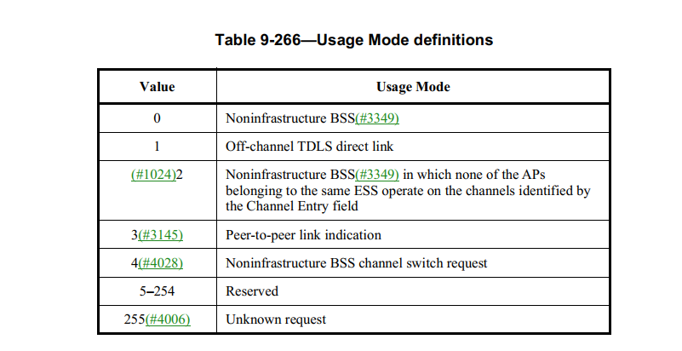

Transfered to MAC ad hoc and assigned to Emily
More work required.

Proposed resolution:
Accepted.

6029 | 993.40 | 9.4.2.24 |  | "Peer-to-peer TWT" support is not only used for P2P link indication, but also used for any off-channel and off-link operation indication (e.g., off-channel scanning). The term ""Peer-to-peer TWT" can be changed to a broader name. "Peer-to-peer TWT" is an unavailability schedule (i.e., unavailable to infrastructure BSS). | Change "Peer-to-peer TWT Support" to "Unavailability Support"; Change "Peer-to-peer TWT schedule(ing)" to "Unavailability schedule(ing)"; Change "Peer-to-peer TWT agreement" to "Unavailability notification". Change "Peer-to-peer TWT SP" to "Unavailability period", globally, clone case.

Discussion:

At 993.40, 2612.7, 2612.33:
Change "Peer-to-peer TWT Support" to "Unavailability Support"; 3 instances

At 2611.51, 2612.2, 2612.6, 2612.28, 2612.12, 2613.57:
Change "peer-to-peer TWT schedule" to "unavailability schedule", 6 instances.

At 2613.42, 2614.19,
Change "Peer-to-peer TWT scheduling" to "Unavailability scheduling", 2 instances.

At 1648.62, 1649.61,
Change "if used for the establishment of a peer-to-peer TWT agreement with a range of TWT parameter values" to " if used for the unavailability notification with a range of TWT parameter values". 2 instances

At 2611 to 2614,
Change " (a) peer-to-peer TWT agreement" to "(an) unavailability notification", 19 instances.

At 2612.63, 2614.11/12/14,
Change "peer-to-peer TWT SP" to "unavailability period", 4 instances.

Transfered to MAC ad hoc and assigned to Emily.
More work required.

Proposed Resolution:

Revised.

6028 | 1648.62 | 9.6.13.24 |  | "except if used for the establishment of a peer-to-peer TWT agreement with a range of TWT parameter values". "establishment" is redundant. Remove "the establishment of". | remove "the establishment of” at 1648.62 and 1649.49.

Discussion:

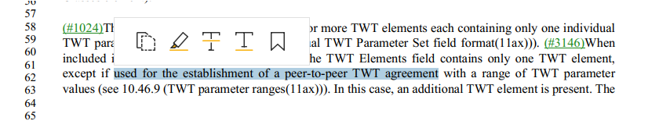
Transfered to MAC ad hoc and assigned to Emily
More work required.

Proposed Resolution:
Accepted.

CID | Page | Clause | Resn Status | Comment | Proposed Change
6322 |  | 9.6.19.17 |  | "The BA Control field is defined in 9.3.1.8 (BlockAck frame format). The (#4200)Block Ack Starting Sequence Control field is defined in 9.3.1.8 (BlockAck frame format)" should be combined, per similar text earlier for BAR (or the earlier text should be decombined) | As it says in the comment

Discussion:

Cited text:

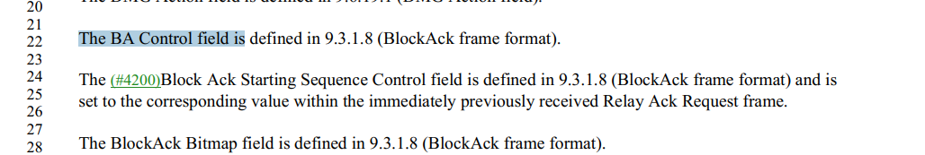

I couldn’t see anything wrong with cited tex.

Proposed Resolutions:
Revised.
Change paragraphs at 1684.22 to 1684.28 to:
“The BA Control, Block Ack Starting Sequence Control and BlockAck Bitmap fields are defined in 9.3.1.8 (BlockAck frame format). The Block Ack Starting Sequence Control field is set to the corresponding value within the immediately previously received Relay Ack Request frame.”

CID | Page | Clause | Resn Status | Comment | Proposed Change
6317 | 573.00 | 8.3.5.15.2 |  | "GROUP_ID or PARTIAL_AID filtering " should be "group ID or partial AID filtering " | As it says in the comment

Discussion:

Cited text at 573.19:
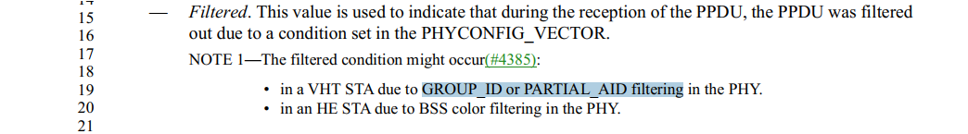

??
Proposed Resolutions:
Accepted.

CID | Page | Clause | Resn Status | Comment | Proposed Change
6316 | 331.00 | 4.10.3.3 |  | "Password or PSK" should be lowercase "password" | As it says in the comment

Discussion:

Cited text:
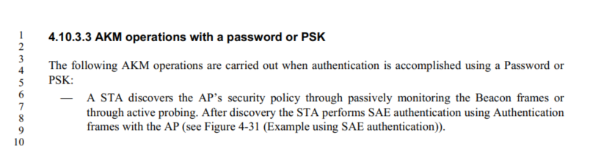

I also found other two instances on "Password or PSK" at 2882.61 and 2883.15

Proposed Resolutions:
Accepted.

CID | Page | Clause | Resn Status | Comment | Proposed Change
6295 | 367.00 | 6.4 |  | "The presence of the protected parameter " should be "The presence of the Protected parameter " | As it says in the comment
Discussion

Cited text at 367.2
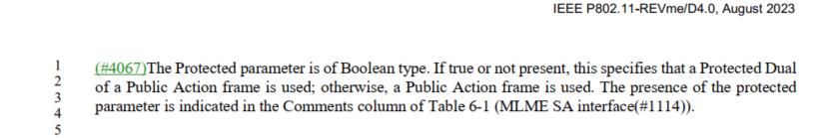

Proposed Resolutions:
Accepted.

CID | Page | Clause | Resn Status | Comment | Proposed Change
6292 |  | 9.8.5.2 |  | "The frame body of a PV1 Management frame of subtype Action is described in 9.3.3.13 (Action frame format) and the format of the Action field formats allowed is described in 9.5.7 (EDMG BRP field(11ay)). " -- broken xref (also next para) | Fix the broken xrefs
Discussion

Proposed Resolutions
Revised.
At 1753.24 and 1753.28, change “9.5.7 (EDMG BRP field(11ay))” to “9.6 (Action frame format details)”.

CID | Page | Clause | Resn Status | Comment | Proposed Change
6412 |  |  |  | The spec uses both "compliant" and "conformant" (and associated verbs, nouns, adverbs, etc.). I have a feeling these are not the same, and one is more "legal" (compliance) and the other is more "technical"/"moral" (conformance). Use "compliant" only when there is a legal requirement | Change "comply" to "conform" etc. except when this is about regulatory compliance. E.g. in 15.4.5.8 change "The transmit power ramps shall be constructed such that the DSSS PHY emissions comply with the spurious frequency product specification defined in 15.4.4.6" to "The transmit power ramps shall be constructed such that the DSSS PHY emissions conform to the spurious frequency product specification defined in 15.4.4.6"

Discussion:

CID 1472, 2144, 3548

CID | Page | Clause | Resn Status | Comment | Proposed Change
6026 |  |  |  | MDR comment: the "Unicast" is still used in this subclause. Please review and decide whether they are appropriate. | See as comment.

