IEEE P802.11
Wireless LANs
LB276 comment resolutions for measurement session
Date: 2023.10.26
Author(s):
Name | Company | Address | Phone | email
Zhuqing Tang | Huawei Technologies | Huawei Base, Shenzhen, Guangdong, China, 518129 |  | tangzhuqing@huawei.com
Rui Du
Narengerile
Mengshi Hu
Yiyan Zhang
Abstract
This submission proposes resolutions to the following comments submitted in LB276 under measurement session topic.

CIDs: 3129, 3311, 3312, 3534

Revision history:
R0: Original version

CID | Clause | Page | Comment | Proposed change | Proposed resolution
3129 | 11.55.1.4.1 | 140.26 | Figures are missing. | Figures 9-788edk, 9-788edl, and 9-788edm are missing. Put a note as in SBP description.  Editor's Note: Figure 9-788edk (Example of a bitmap with 200 TU periodicity signalled in the ISTA  Availability Window element), 9-788edl (Example of mapping of ISTA's availability bitmap to RSTA's  TSF) and 9-788edm (Example of how an RSTA assigns an Availability Window to an ISTA) are found in  IEEE P802.11az/D7.0. | Accepted

Discussion:

The location of the problem that the commenter pointed out is shown as follows:
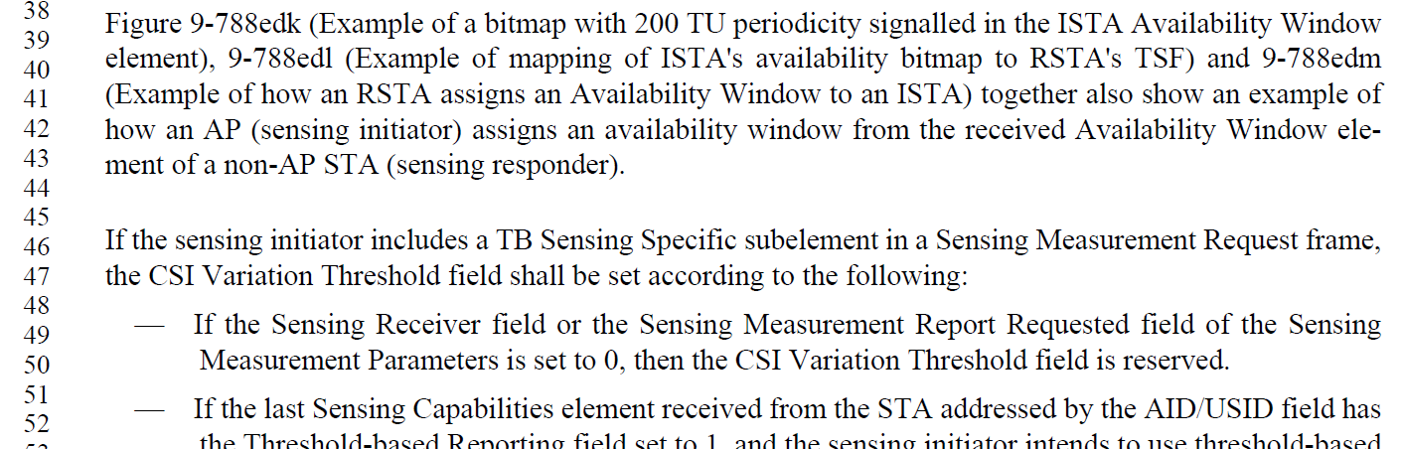

The following shows the Editor’s note in the SBP description.
It is applicable to add the same note in the indicated place describing the same figures.

CID | Clause | Page | Comment | Proposed change | Proposed resolution
3311 | 11.55.1.4.1 | 140.15 | The text needs correction. 'If the sensing responder is not available in the sensing availability window provided by the AP, ...', this rule applies only to associated STA, because U-STA has already provided it's ISTA AVW in MS-Q, no reason to provide it in MS response again. | Change to: If the sensing responder, which is associated with the AP, is not available in the sensing availability window provided by the AP, | Accepted
3312 | 11.55.1.4.1 | 140.19 | The sentence 'The TB sensing specific subelement shall include an ISTA availability window element' misses its condition, which is stated in the previous sentence. Suggest to merge the two sentences. | Change to: If the sensing responder, which is associated with the AP, is not available in the sensing availability window provided by the AP, the sensing responder shall set the STATUS CODE to REJECTED_WITH_SUGGESTED_CHANGES and include a TB sensing specific subelement, which shall include an ISTA availability window element (see 9.4.2.296 (ISTA Availability Window element)), in the Sensing Measurement Response frame. | Accepted

CID | Clause | Page | Comment | Proposed change | Proposed resolution
3534 | 11.55.1.4.1 | 141.49 | Any action constraint for the sensing initiator if a Sensing Measurement Response frame with the Status Code equals to " REJECTED_WITH_SUGGESTED_CHANGES" is received from the sensing responder? May the sensing initiator send a new Sensing Measurement Request frame including the suggested changes? If So, when can the new Sensing measurement Request frame be sent? Within the time Decline Duration field indicates or after the time Decline Duration field indicates? | Please clarify the procedure requirement for the case where the Status Code field is REJECTED_WITH_SUGGESTED_CHANGES | Revised  TGbf Editor make changes specified in 1715r0.  (https://mentor.ieee.org/802.11/dcn/23/11-23-1715-00-00bf-lb276-comment resolutions-for-measurement-session-part-1.docx)

Discussion

When the sensing initiator receives a sensing measurement response frame with a status code set to REJECTED_WITH_SUGGESTED_CHANGES, it is up to the sensing initiator whether to initiate a new session or not. The sensing initiator could refer to the suggested parameters provided by the sensing responder to increase the session setup efficiency. The new Sensing measurement Request frame can be sent whenever necessary. The Decline Duration field is only present when the status code has been set to REQUEST_DECLINED.

Resolution

Instructions to the editor: please add the following paragraph in red in P141L50 in the subclause 11.55.1.4.1 in D2.1 as shown below:

Upon reception of a Sensing Measurement Response frame with the Status Code equals to REQUEST_DECLINED, the sensing initiator should not transmit a new Sensing Measurement Request frame within the time Decline Duration field indicates.

Upon reception of a Sensing Measurement Response frame with the Status Code equals to REJECTED_WITH_SUGGESTED_CHANGES, the sensing initiator could transmit a new Sensing Measurement Request frame to the sensing responder based on its suggested changes.

Following the successful establishment of a sensing measurement session between an AP and a non-AP
STA, both STAs

SP

Do you support the proposed resolutions to the CIDs 3129, 3311, 3312, 3534 and incorporate the text changes into the latest TGbf draft?

Y/N/A

