IEEE P802.11  
Wireless LANs

|  |  |  |  |  |
| --- | --- | --- | --- | --- |
| Liaison from ITU-T SG20 re Ambient Power IoT use cases and requirements | | | | |
| Date: 2023-10-09 | | | | |
| Author(s): | | | | |
| Name | Affiliation | Address | Phone | email |
| Dorothy Stanley | Hewlett Packard Enterprise | 6280 America Center Dr  San Jose, CA 95002 | +1 630-363-1389 | [dorothy.stanley@hpe.com](mailto:dorothy.stanley@hpe.com) |
|  |  |  |  |  |

Abstract

This document contains a liaison received from ITU-T SG-20 related to an analysis of ambient power IoT requirements and use cases. The received liaison is embedded below and copied on the following pages.



|  |  |  |  |  |  |  |
| --- | --- | --- | --- | --- | --- | --- |
|  | INTERNATIONAL TELECOMMUNICATION UNION  **TELECOMMUNICATION STANDARDIZATION SECTOR**  STUDY PERIOD 2022-2024 | | | | | SG20-LS109 |
| **STUDY GROUP 20** |
| **Original: English** |
| **Question(s):** | | 2/20 | | | | Arusha, 13–22 September 2023 |
| **Ref.: SG20-TD1071** | | | | | | |
| **Source:** | | ITU-T Study Group 20 | | | | |
| **Title:** | | LS on the draft Technical Report ITU-T YSTR.Ambient IoT “Analysis on requirements and use cases of ambient power-enabled IoT” | | | | |
| **LIAISON STATEMENT** | | | | | | |
| **For action to:** | | | | - | | |
| **For information to:** | | | | ISO/IEC JTC1/SC31, GS1 EPCglobal, 3GPP SA1, IEEE 802.11 | | |
| **Approval:** | | | | ITU-T Study Group 20 meeting (Arusha, 22 September 2023) | | |
| **Deadline:** | | | | N/A | | |
| **Contact:** | | | Hyoung Jun Kim SG20 Chairman | | Tel: +82-42-860-6576 E-mail: [khj@etri.re.kr](mailto:khj@etri.re.kr) | |
| **Contact:** | | | Marco Carugi Rapporteur Q2/20 | | Tel: +33 6 64 04 74 54 E-mail: [marco.carugi@gmail.com](mailto:marco.carugi@gmail.com) | |

|  |  |
| --- | --- |
| **Abstract:** | This Liaison Statement informs that ITU-T Study Group 20 is progressing a work item on draft Technical Report ITU-T YSTR.Ambient IoT “Analysis on requirements and use cases of ambient power-enabled IoT”. |

ITU-T Study Group 20 would like to inform ISO/IEC JTC1/SC31, GS1 EPCglobal, 3GPP SA1, IEEE 802.11 that the [draft Technical Report ITU-T YSTR.Ambient IoT](https://www.itu.int/ITU-T/workprog/wp_item.aspx?isn=18752) “Analysis on requirements and use cases of ambient power-enabled IoT” was initiated at the Study Group 20 meeting, Geneva, 30 January – 10 February 2023, and was updated at the last ITU-T Study Group 20 meeting, Arusha (Tanzania), 13–22 September 2023.

This draft Technical Report studies requirements and use cases of ambient power-enabled Internet of Things, including:

* Overview of ambient power-enabled Internet of Things
* Analysis on requirements of ambient power-enabled Internet of Things
* Uses cases of ambient power-enabled Internet of Things

More information can be found in the attachment.

ITU-T Study Group 20 would appreciate receiving relevant information concerning your activities related to ambient power-enabled Internet of Things and also welcomes collaboration on this study.

**Attachment:**

* A.13 justification for proposed draft new Technical Report ITU-T YSTR.Ambient IoT “Analysis on requirements and use cases of ambient power-enabled IoT, Q2/20 meeting (Geneva, 30 January – 10 February 2023) ([SG20-TD700](https://www.itu.int/md/T22-SG20-230130-TD-GEN-0700/en))

_______________________

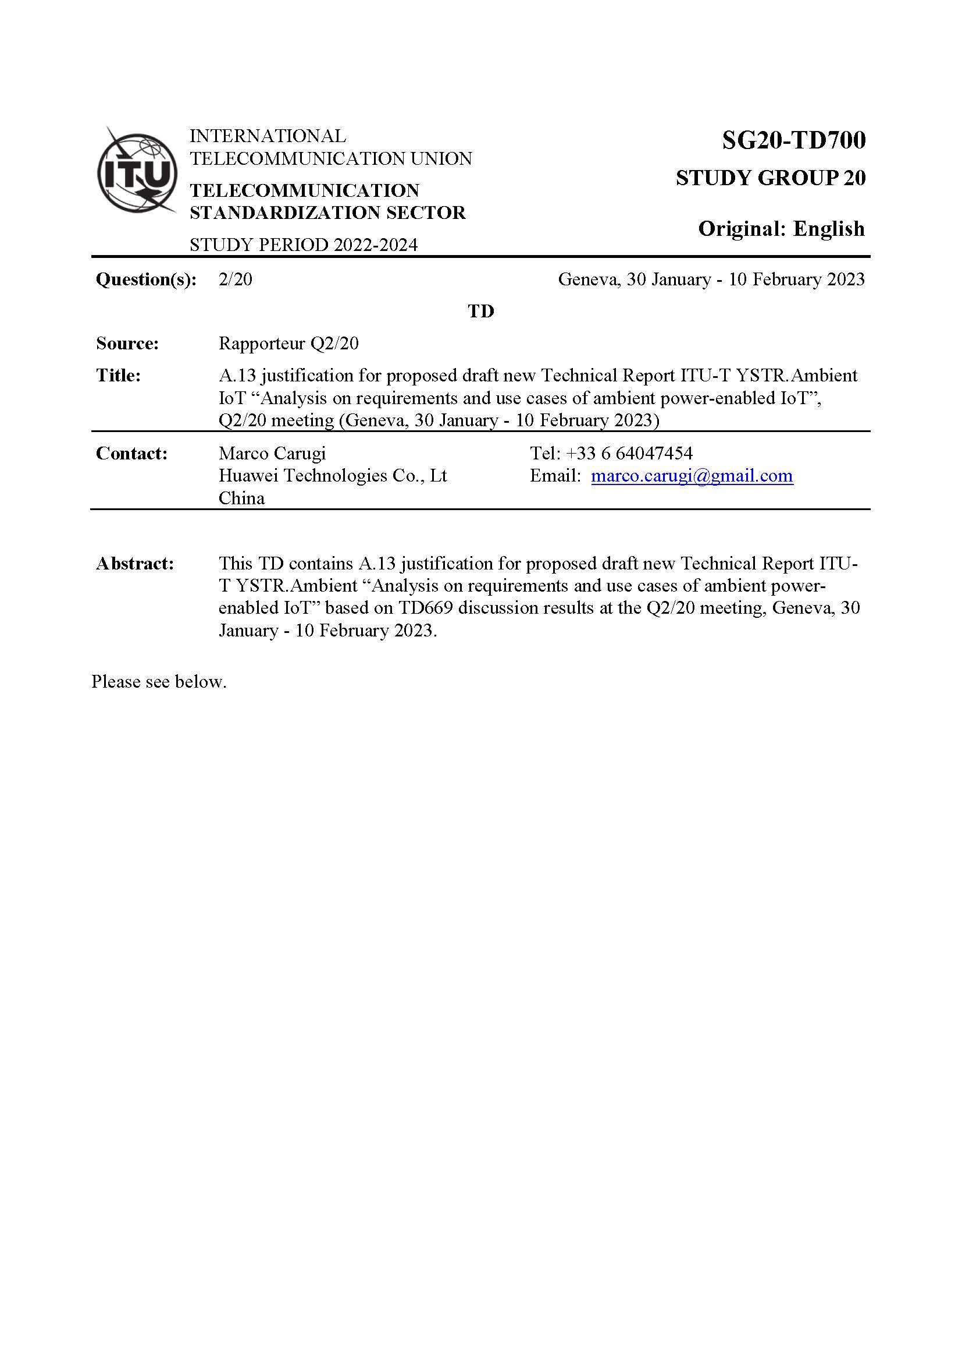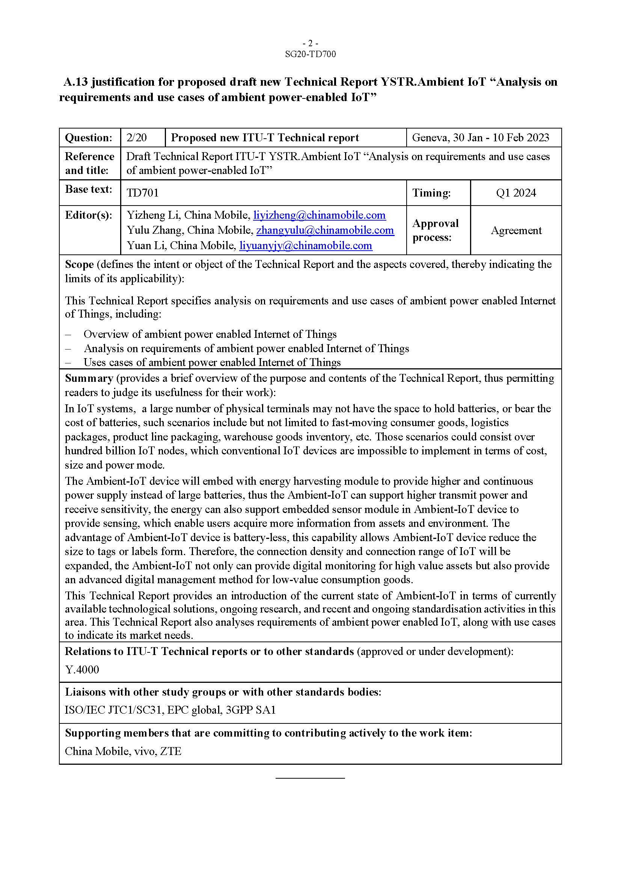

**References:**