IEEE P802.11
Wireless LANs
TGbe LB275 miscellaneous comment resolutions
Date: 2023-11-09
Author(s):
Name | Affiliation | Address | Phone | email
Michael Montemurro | Huawei |  |  | montemurro.michael@gmail.com
Background
This contribution proposes comment resolutions to TGbe comments received in LB275. The resolutions will be shown relative to D4.0.

CIDs 19128, 19485, 19485, 19344, 19389

Rev 0. Initial submission
Rev 1. Updated based on offline comments
Rev 2. Updated based on TG review
Rev 3.
Rev 4.
Rev 5.

Comment
CID | Clause | Page | Comment | Proposed Change
19128 | 4.3.8 | 63.21 | Sub-clause 4.3.8 (RSNA) should be updated to support MLD in RSNA | As comment

Discussion:
- Clause 4.3.8 from TGbe D4.1 is as follows
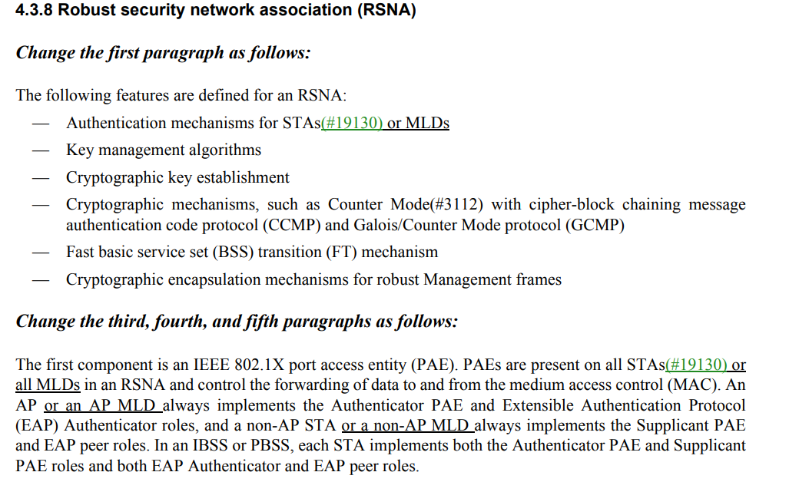
- The draft has been updated to describe RSNA for MLO as part of the resolution to CID 19130.
- The resolution to CID 19130 is
“For CID 19130, the proposed resolution is
Comment:
Besides what has been updated in this paragraph, sub-clause 4.3.8 should also be updated to support MLD in RSNA

Proposed Change:
As comment

Agree in principle with the commenter.
TGbe editor to make the changes shown in 11-23/1383r2 (https://mentor.ieee.org/802.11/dcn/23/11-23-1383-02) under all headings that include CID 19130”

Proposed Resolution: (19128)
REVISED. Clarify that Authenticator and Supplicant roles for an AP MLD and non-AP MLD are mapped to an AP and STA, respectively. Note that this change is addressed in the resolution of CID 19130:

TGbe editor to make the changes shown in 11-23/1383r2 (https://mentor.ieee.org/802.11/dcn/23/11-23-1383-02) under all headings that include CID 19130.

Comment
CID | Page | Clause | Comment | Proposed Change
19344 | 4.9.6 | 70.29 | Figure 4-30b shows two MLME-SAPs, one for the left MLME and one for the right MLME, with internal interfaces to the MLD Upper MAC sublayer. Presumably either can be used for MLME-GET/SET. However, 1) this leaves very unclear where the MIB resides and if there is one MIB per STA (the default) or per MLD (!!??) or some MIB variables have storage per STA and others have singleton storage (and apply to the whole MLD). 2) Since semantically some MIB variables are per STA and others are for the MLD, where is it documented which is which? 3) If there is one MIB per STA, how are MLD-level variables prevented from becoming mismatched? 4) If there is one MIB for MLD-level variables, does it have its own MLME-SET/GET iterface, or is this shared with every MLE's MLME-GET/SET method? 5) If there is one MIB for MLD-level variables, this MLD-level MIB should support discoverability via some exposed enumeration of its affiiliated STAs. | Do the required architectural work, perhaps in consultation with ARCH. We might start with one MIB per STA. Since some parameters were STA-level and are MLD-level in EHT, then having them duplicated in each MIB is easy BUT is surely not allowed since a) by default this permits two MLD-level variables to be mismatched and b) I kinda assume ASN.1 doesn't support the semantics for two variables in two MIBs to be tied together via singleton storage let alone typical MIB implementations (maybe research is warranted?). If this path fails (as I expect) then instead and cleaner, we should continue to have 1 MIB per STA but also define a new MLD-level MIB (with its own GET/SET interface) that contains *all* MLD-level parameters (copied from the per-STA MIB for old ones, moved from one place in the 11be draft to another for new ones). Any per-STA copies of these MLD-level variables in each per-STA MIB must be marked as disabled for EHT. Add a figure to express this.
19346 | 4.9.6 | 70.39 | Very unclear if an MLD has one MLME or one MLME per STA. P70L39 suggests one ("The SME is responsible for coordinating the MLD and each of the affiliated STAs through the MLME") but Fig 4-30b suggests one per STA given the duplicate MLME SAPs and two instances of "MAC Sublayer Mgmt Entity". | Be explicit how many MLMEs a MLD has. Update the text/figure accordingly. Given many MIB parameters need to be per STA (e.g., Dot11EDCAEntry) and fig 6-1 shows one MIB per MLME (and per PLME) the natural answer is one MLME per STA, and perhaps an extra super-MLME for the upper MAC.
19485 | 6 | 79.01 | For an MLD, there is only one SME and only one MLME SAP which resides at the MLD (upper MAC) level, see Fig 4-30b. However there can be MLME primitives that are invoked on a specific link. Clause 6 needs to be updated to reflect this. | Add the following sentence after the first sentence of the second paragraph of 6.1:  "For MLO, there is a single SME and a single MLME for the MLD."  At the end of the paragraph preceding the table (see REVme), add the following sentence:  "The Link Specific column of Table 6-1 indicates whether the primitive is link specific. If the primitive is link specific, when invoked. the primitive includes link information.  Add a new column to the right in table 6.1 labeled "Link Specific". For each primitive that is link specific, enter a "Yes" in the new column.

Discussion:
- The referenced figure in this comment is given below:
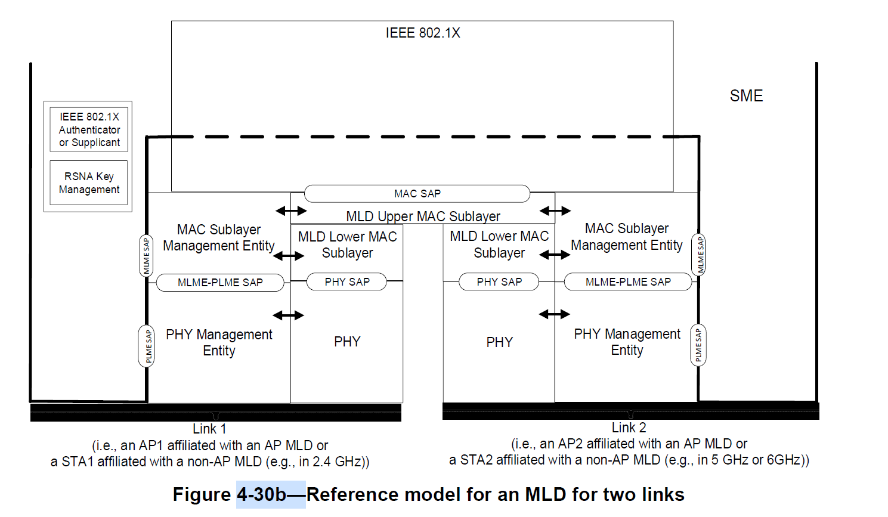
- The figure is consistent with the baseline figures 4-24, 4-25, 4-28, 4-29, and 4-30 in that none of the figures, nor the clauses that describe reference models describe how MIB variables are stored. The affiliated STAs are enumerated with links as shown in the figure.
- There is a single SME and MLME per MLD. However in the figure it is impossible to depict a single MLME and show links at the same time.
- The architecture could be clarified by adding a sentence in clause 4 and clarifying at the beginning of clause 6 that there is a single MLME for an MLD.
- REVme D4.0 (p362.50) provides a description of the MLME SAP interface:
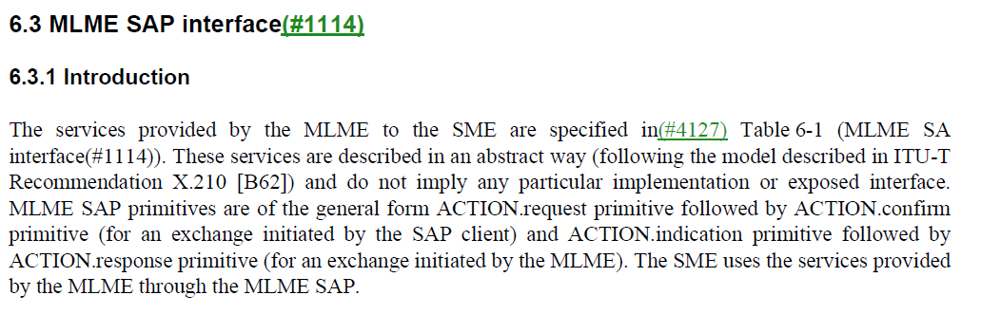
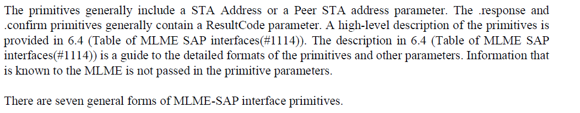
- It would be good to provide a statement before the last paragraph describing the MLME SAP interface for MLO.

Proposed Resolution: (19485, 19485, 19344)
REVISED. There is a single SME and a single MLME for an MLD and individual affiliated STAs are identified as enumerated links. Figure 4-30b shows the MLME for each link to illustrate that MLME primitives can be called on either link.

Update clause 4 to explicitly clarify that there is a single MLME for the MLD:
At 70.31, change
“An MLD supports multiple MAC functions, coordinated by an SME.”
to
“An MLD supports multiple MAC functions, coordinated by an SME. Each affiliated STA is enumerated with a Link ID (for example, as Link 1 and Link 2 in Figure 4-30b) and MLME primitives are invoked through a single MLME SAP.”

Update Clause 6 as follows:
In 6.3.1 (see REVme D4.0, p362.50) insert the following as the second last paragraph of the clause:
“For MLO, the MLD SME invokes MLME SAP primitives through a single MLME SAP. When a primitive is invoked for an affiliated STA, the affiliated STA can be identified by its Link ID.”

Comment
CID | Clause | Page | Comment | Proposed Change
19389 | 12.7.6.1 | 426.35 | "OCV requires a STA to drop a received frame if that frame is not on the same channel it expects and validated in OCI (see 12.2.9 of REVme).  With the current OCV design with EHT, only the link on which the OCI is sent is validated, hence frames received on the other link(s) would be required to be dropped.  OCV must validate all links in order to mitigate multi-channel attacks" | Extend OCV design to validate all links

Discussion:
- No progress was made to provide text changes to the draft to resolve this comment.

Proposed Resolution: (19389)
REJECTED. The comment fails to identify changes in sufficient detail so that the specific wording of the changes that will satisfy the commenter can be determined.

