IEEE P802.11
Wireless LANs
Power management terminology clean-up
Date: 2023-10-10
Author(s):
Name | Affiliation | Address | Phone | email
Michael Montemurro | Huawei |  |  | montemurro.michael@gmail.com
Background
This contribution addresses issues describing power management behavior in the 802.11 baseline.

CID 6287 and 6038

Discussion:
In clause 11.2.1, Power Management modes and states are described. However, the text describing requirements related to the use of these modes uses terminology like “wake up”, “sleep”. This document suggests changes to text in the standard to align with mode and state definitions for power management.

Here is the text in the standard:
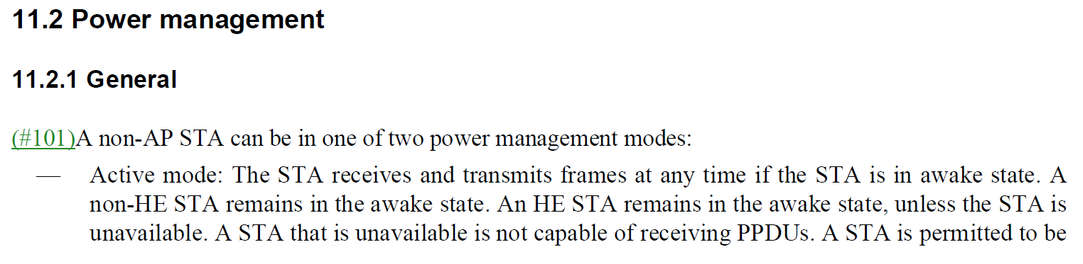
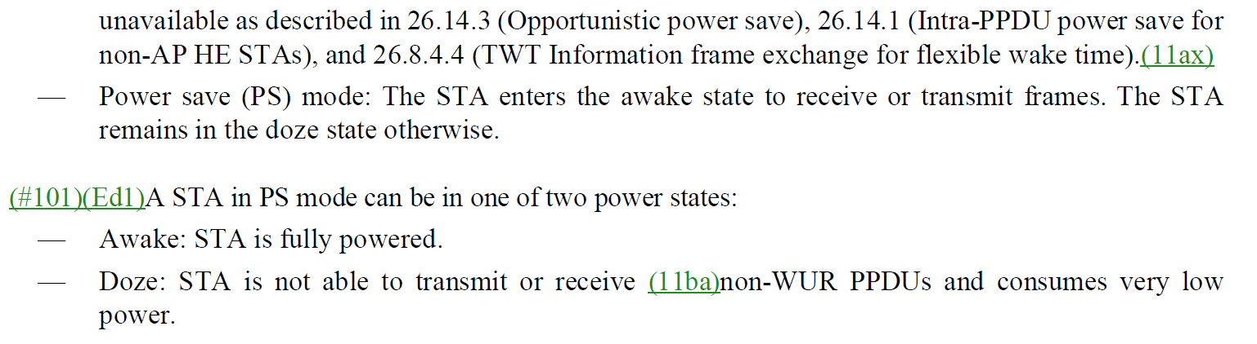

Use of “wake up”
Based on the context in the draft, the term “wake up” seems to be used to refer to a transition between doze and awake states in PS mode.

The following text proposes changes to the usage of “wake up” when it refers to a transition from doze state to awake state.

NOTE: No changes were made to WUR terminology, which uses “wake-up” in various operational descriptions.

Proposed changes for “wake up” usage (as mark up):

233.61: "if the station (STA) were to periodically transition to awake state to receive a Beacon frame"

279.30: "This enables the non-AP STA to transition to awake state at the alternate DTIM"

1941.62: "An intended STA identified by the RPS element should transition to awake state before the RAW start time indicated"

1121.43: "The value set to 0 indicates that the requesting non-AP STA does not transition to awake state at any specific interval

1282.36: "following the DTIM beacon(#3309) as described in 11.2.3 and can avoid transitioning to awake state for the assigned TIM

1285.19: "during which the non-AP STA is required to transition to awake state for receiving the S1G Beacon frames that signal the presence of group addressed BUs

1298.49: Table 9-342:
Table 9-342—Action field
Action | Options
0 | Send a PS-Poll or uplink trigger frame
1 | Transition to awake stateat the time indicated by the Min Sleep Duration field
2 | Transition to awake state to receive the beacon
3 | Transition to awake state to receive the DTIM beacon
4 | Transition to awake state at the time indicated by the sum of the Min Sleep Duration field and the ASD subfield in the APDI field of the NDP Paging frame
5–7 | Reserved

1314.62: "...estimate the clock accuracy of the transmitting STA and to schedule the time to transition to awake state for Beacon frame reception by taking this clock accuracy into account."

1756.43: "

1941.62: "An intended STA identified by the RPS element should transition to awake state before the RAW start time indicated in the RAW start time subfield of the RAW assignment subfield"

2285.43: "the Duration field value in the responding control frame from the S1G AP, the non-TIM S1G STA shall transition to awake state to receive a Beacon frame."

2292.43: "The Page slice element indicates assignment of STAs in page slices corresponding to their assigned TIMs. STAs within the assigned page slice transition to awake state at a corresponding TIM sequentially to receive buffered data from AP. In order to transition to awake state at the appropriate TBTT to receive the Page Slice element, a STA may compute the page slice assignment to the TIMs using the length of the Page Bitmap field and the value in the Page Slice Length and Page Slice Count subfields of the Page Slice element."

2293.7: "... they compute the length of the page slice and the corresponding TIM to
transition to awake state."

2300.28: "A non-AP STA that is associated to the AP and is group sectorized capable shall transition to awake state to read the sectorized Beacon frame if it intends to access the medium during the sectorized beacon interval."

2318.49: "An S1G STA that has negotiated a group AID and has not negotiated TWTs (see 10.46 (Target wake time (TWT))) shall transition to awake state every group listen interval that corresponds ..."

2318.60: "The S1G STAs that detect this indication will transition to awake state at the assigned beacon interval to determine the TIM and extract the assigned time slots that carry the buffered group data."

2356.6: "An EMA AP shall include a nontransmitted BSSID profile in the DTIM beacon of that BSS so that STAs associated to that AP can receive the profile (and any updates to the BSS configuration) without having to transition to awake state to receive additional beacons."

2358.8: "so that STAs associated to that AP can receive the changes in the DTIM beacon without having to transition to awake state for additional Beacon frames or S1G Beacon frames between the DTIM beacons"

2385.58: "STAs in WNM sleep mode can transition to awake state as infrequently as once every WNM sleep interval to check whether the corresponding TIM bit is set or group addressed traffic is pending."

2391.27: "If the SI is nonzero, a STA using scheduled SP shall first transition to awake state at the service start time to receive downlink individually addressed and/or GCR-SP group addressed BUs buffered and/or to receive polls from the AP or HC. The STA shall transition to awake state subsequently at a fixed time interval equal to the SI."

2391.44: "If the SI is nonzero, the STA shall transition to awake state at a subsequent time when the following is true:"

2394.35: "If a STA has set up a scheduled SP, it shall automatically transition to awake state at each SP."

2397.60: "STA with dot11NonTIMModeActivated equal to false shall transition to awake state early enough to be able to receive the first Beacon frame”

2398.1: “STA with dot11NonTIMModeActivated equal to true is not required to transition to awake state to receive a Beacon frame and shall transmit…"

2398.26: "When dot11FMSActivated is false and ReceiveDTIMBeacons(#4221) is true, the STA shall transition to awake state early enough to be able to receive either every non-STBC DTIM or every STBC DTIM sent by the AP of the BSS."

2398.30: "When dot11FMSActivated is true and ReceiveDTIMBeacons(#4221) is true and the STA has been granted by the AP an alternate delivery interval for a multicast stream, the STA shall transition to awake state before the non-STBC DTIM or STBC DTIM having Current Count of FMS Counter field set to 0 for that particular FMS stream."

2398.64: "If a scheduled SP has been set up, the STA transitions from doze to awake state at its scheduled start time. (The STA shall wake up early enough to receive transmissions at the scheduled SP.)"

2401.49: "i.e., the TDLS peer STA no longer has to transition to awake state during this period) and that a wakeup schedule no longer exists for this link. When traffic..."

2406.16: "Once synchronized with the FMS Current Count, the non-AP STA need not transition to awake state at every DTIM interval to receive group addressed BUs."

2407.9: "Once synchronized with the FMS Current Count, the non-AP STA need not transition to awake state at every DTIM interval to receive group addressed BUs."

2410.40: "Once synchronized with the FMS Current Count, the non-AP STA need not transition to awake state at every DTIM interval to receive group addressed BUs."

4595.36: "In any of the above actions, if the WUR AP does not have a pending WUR frame intended for WUR non-AP STAs on the WUR primary channel, then the WUR AP shall transmit a WUR frame on the WUR primary channel, which may be any WUR frame that does not cause a WUR non-AP STA to transition to awake state on the primary channel."

5773.31: "The mesh STA does not need to transition to awake state to receive a beacon from the peer mesh STA to which it is in deep sleep mode."

Use of “sleep”
Based on the context in the draft, the term “sleep” seems to be used to refer to a transition between awake and doze states in PS mode.

The following text for replacing the use of sleep when it refers to a transition between doze state and awake state in PS mode.

Proposed changes for “sleep” usage (as mark up):

2094.43: "A CDMG PCP may transition to doze state if it is in a truncatable SP that has time left in this SP that is released as a CBAP by the CDMG STA by setting the Truncation Type subfield to 1 and the PCP Active field to 0."

2420.09: "The non-AP and non-PCP STA power save mechanisms defined in 11.2.7.2 (Non-AP and non-PCP STA power management mode) enable a non-AP and non-PCP STA to transition to doze state after signaling the AP or PCP, or to to remain in doze state according to a periodic schedule that is negotiated with the AP or PCP.

2420.15: "Similarly, the PCP power save mechanisms defined in 11.2.7.3 (PCP power management mode) enable a PCP to transition to doze state after signaling at least one non-AP and non-PCP STA, or to remain in doze state according to a wakeup schedule that is available to all STAs associated with the PCP."

2420.31: "For scheduled power save, the DMG Wakeup Schedule element (9.4.2.129 (DMG Wakeup Schedule element)) is used to communicate the transitions between doze and awake states of a DMG STA, referred to as the STA wakeup schedule (WS)."
2430.6: "(i.e., PCP is in doze state every other beacon interval)"

2430.18: "... in non-TIM mode that have been previously scheduled within the RAW such as TWT STAs or doze awake cycle rescheduled STAs. The PCP remains in doze state through the remainder of the first beacon interval and through the entire second beacon interval, and transitions to awake state at the start of the third beacon interval in Figure 11-18 (Example operation of PPS mode)."

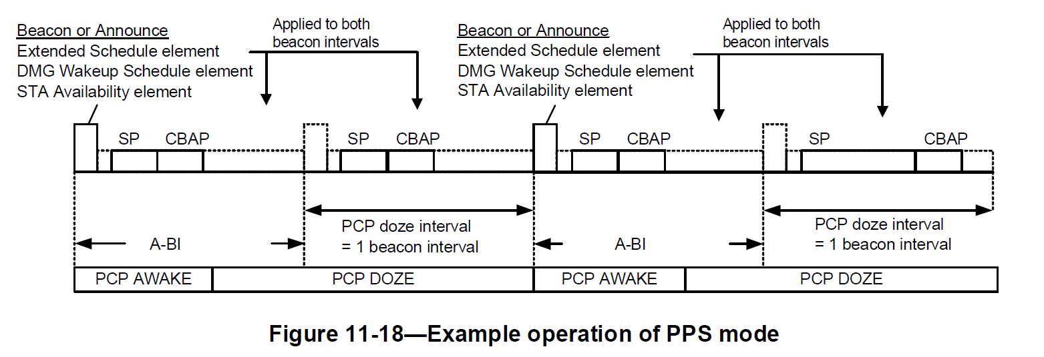

Awake/Doze cycle
In the course of going through this analysis of power management. There was one location where “awake/doze cycle” was incorrectly referenced. It looks like a typo.

Proposed changes for “awake/doze cycle” usage (as mark up):

AP may designate a RAW for S1G STAs in non-TIM mode by setting the RAW Type to Simplex RAW and setting the RAW Type Options to Non-TIM RAW in the RPS element. In a non-TIM RAW, only S1G STAs in non-TIM mode that have been previously scheduled within the RAW such as TWT STAs or awake/doze cycle rescheduled STAs (as described in 10.47.2 (Rescheduling of awake/doze cycle)) are allowed to access the medium.

At 271.20 and 2284.36, change “doze/awake” to “awake/doze”

At 1277.3, 1937.45, change “doze awake cycle” to “awake/doze cycle”

