IEEE P802.11
Wireless LANs
Comment Resolutions for 11bf D2.0 Sensing Measurement Report Container field CIDs
Date: 2023-09-21
Author(s):
Name | Affiliation | Address | Phone | email
Rojan Chitrakar | Huawei |  |  | Rojan.chitrakar@huawei.com
Abstract
This submission proposes resolutions of comments received from TGbf LB276 (TGbf Draft 2.0).
- CIDs: 3011, 3031, 3223, 3301 (4 CIDs)

Revisions:

- Rev 0: Initial version of the document.

- Introduction

Interpretation of a Motion to Adopt

A motion to approve this submission means that the editing instructions and any changed or added material are actioned in the TGbf Draft. The introduction and the explanation of the proposed changes are not part of the adopted material.

Editing instructions formatted like this are intended to be copied into the TGbf Draft (i.e. they are instructions to the 802.11bf editor on how to merge the text with the baseline documents).

TGbf Editor: Editing instructions preceded by “TGbf Editor” are instructions to the TGbf editor to modify existing material in the TGbf draft. As a result of adopting the changes, the TGbf editor will execute the instructions rather than copy them to the TGbf Draft.

CID | Commenter | Clause | Page.line | Comment | Proposed Change | Resolution
3011 | Kazuto Yano | 9.4.1.73.3 | 53.18 | A period is missing at the end of the sentence in the "Meaning" column. | Please add a period at the end of this sentence. | ACCEPTED.
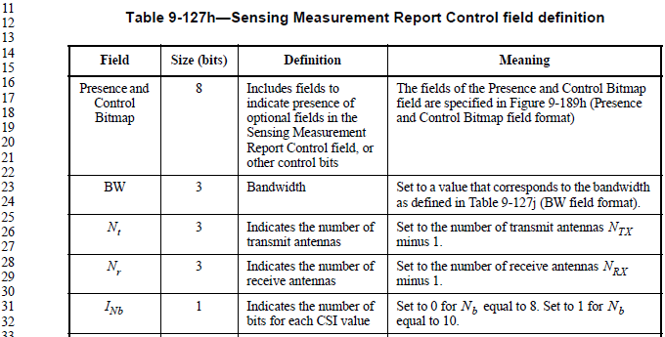
3031 | Robert Stacey |  | 53.31 | Use equations when referencing variables. | Change "N_b equal to 8" to "N_b = 8" and change "N_b equal to 10" to "N_b = 10" | ACCEPTED.
3223 | Assaf Kasher | 9.4.1.73.3 | 54.04 | "The value between 0 and 10 reflects the CSI  variation value obtained by the sensing receiver  in the case of the Invalid Indication field set to  0, and indicates an invalid CSI variation  feedback in the case of the Invalid Indication  field set to 1." - this text is confusing. When the Invalid Indication field is se tto 1, this field does not indicate an invalid CSI variation. In this case the field should be ignored. | Replace with "A value between 0 and 10 reflects the CSI variation value obtained by the sensing receiver. When the Invalid Indication field is set to 1, this field is reserved." | REVISED.  Agree with the comment. When the Invalid Indication field is set to 1, the Sensing Measurement Report Control field itself is not present. The cited text is simplified accordingly.  TGbf editor to make the changes shown in IEEE 802.11-23/1662r0 under all headings that include CID 3223.
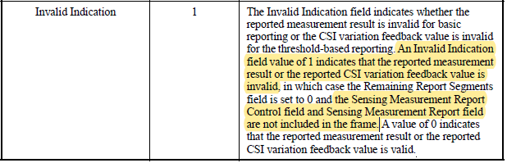
3301 | Chaoming Luo | 9.4.1.73.4 | 56.28 | It's confusing to use the word 'Sensing Measurement Report information', while it is not equal to 'Sensing Measurement Report field'.  Suggest to change it to 'measured CSI information'.  And the structure of the text should be improved. | Change to:  The Sensing Measurement Report field contains the measured CSI information or successive segments of the measured CSI information in the case of segmented sensing measurement report (see 11.55.1.5.3.4 (Rules for generating segmented  sensing measurement reports)).  The measured CSI information contains scaled and quantized CSI values. The size of the measured CSI information depends on the values in the Sensing Measurement Report Control field.  The fields of the measured CSI information are specified in Table 9-127k (measured CSI information). | REVISED.  Agree with the comment to replace the term 'Sensing Measurement Report information' with ‘measured CSI’. Since CSI already includes the word Information, it is not repeated.  TGbf editor to make the changes shown in IEEE 802.11-23/1662r0 under all headings that include CID 3301.
SP: Do you agree to incorporate the changes proposed in IEEE 802.11-23/1662r0 to the latest 11bf draft for the following CIDs?
3011, 3031, 3223, 3301 (4 CIDs)

Baseline text: P802.11bf_D2.1

- Sensing Measurement Report Container field
- Sensing Measurement Report Control field

TGbf editor: Modify the subclause as the following (Track Changes ON):

…
- Sensing Measurement Report Control field definition
Field | Size (bits) | Definition | Meaning
…
CSI Variation  Feedback | 4 | Indicates the CSI  variation feedback | (#3223) The value between 0 and 10 reflects the CSI variation value obtained by the sensing receiver. The above values are used for the feedback of CSI variation triggered by the Sensing Threshold-based Reporting Trigger frame. In this case, the Remaining Report Segments field is set to 0 to indicate this is the last segment with no Sensing Measurement Report Control and Sensing Measurement Report fields within the frame.  The value equal to 15 indicates that the CSI  variation feedback is not used and the  corresponding frame is used for the feedback of  sensing measurement result transmitted in the  measurement reporting phase of the thresholdbased reporting phase or in the basic reporting phase.  See Table 9-127i (CSI Variation Feedback  field).
9.4.1.75.4 Sensing Measurement Report field (#3301)

TGbf editor: Modify the subclause as the following (Track Changes ON):
The size of the measured CSI depends on the values in the Sensing Measurement Report Control field. The
Sensing Measurement Report field contains the measured CSI or successive segments of the measured CSI
in the case of segmented sensing measurement report (see 11.55.1.5.3.4 (Rules for generating segmented
sensing measurement reports)).

The Sensing Measurement Report field is not included in a Sensing Measurement Report Container in which
the Invalid Indication field in the Segmentation Control field is equal to 1.

The measured CSI consist of the scaled and quantized CSI values.

The fields of the measured CSI are specified in Table 9-127k (measured CSI ).

Table 9-127k— Measured CSI

…

TGbf editor: Modify the paragraph in Page 58 Line 33 of D2.1 as the following (Track Changes ON):

For each RX/TX antenna pair the in-phase (real) component of the CSI is entered first and followed by the
quadrature (imaginary) component of the CSI. This begins with the lowest frequency subcarrier, and is
repeated for each subcarrier. The number of subcarriers included in the measured CSI is defined in Table 9-127l (Number of subcarriers as a function of bandwidth, puncturing, and
Ng).

…

TGbf editor: Modify the paragraph in Page 65 Line 45 of D2.1 as the following (Track Changes ON):

The measured CSI (see Table 9-127k (measured CSI
includes the RSSI for each receive antenna. The format of each RSSI field is defined in Table 9-127r
(RSSI field format).
…

TGbf editor: Modify the paragraph in Page 66 Line 48 of D2.1 as the following (Track Changes ON):

NOTE—The size of the measured CSI, in octets, is given by Equation (9-5f).
…

TGbf editor: Modify the paragraph in Page 66 Line 56 of D2.1 as the following (Track Changes ON):

NOTE—The size of the measured CSI increases with the number of transmit antennas, …

11.55.1.5.3.4 Rules for generating segmented sensing measurement reports (#3301)

TGbf editor: Modify the subclause as the following (Track Changes ON):

If a measured CSI exceeds aSensingReportSegmentSize, then the measured CSI shall be divided into up to 32 report segments.

aSensingReportSegmentSize shall be 3 750 octets.

Each report segment shall be included in a separate Sensing Measurement Report Container and shall contain
successive portions of the measured CSI.

