IEEE P802.11
Wireless LANs
LB276 CR for OST CID 3068
Date: 2023-09-13
Author(s):
Name | Affiliation | Address | Phone | email
Atsushi Shirakawa | Sharp Corporation |  |  | shirakawa.atsushi@ieee.org
Abstract
This submission proposes resolutions for CID 3068 received for TGbf LB276

Revisions:
- Rev 0: Initial version of the document.
- Rev 1:
- Rev 2:
- Rev 3:

TGbf editor: The baseline for this document is basically 11bf D2.0

CID | Commenter | Page | Comment | Proposed Change | Resolution
3068 | Rojan Chitrakar | 112.15 | Is the 5-bits reserved field also part of the Measurement Session ID or just the 3 bits Measurement Session ID? If its the latter, this needs to be clarified and the Measurement Session ID field defined separately. | Define the Measurement Session ID field. | Revised  Measurement Sesstion ID field is defined as one (sub)field in Measurement Session ID indication field.  TGbf editor: Please make changes as Option2 in doc.: 11-23/1657r0

Discussion:

Reference:

Below is cited from 11bf D2.0

(1) Measurement Session ID indication field format
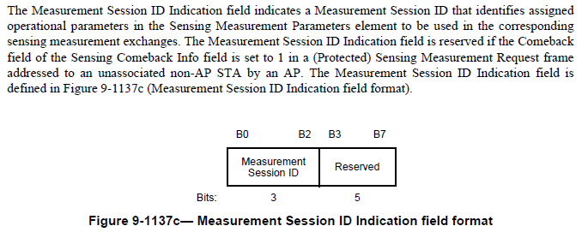

(2) Measurement Session ID field format
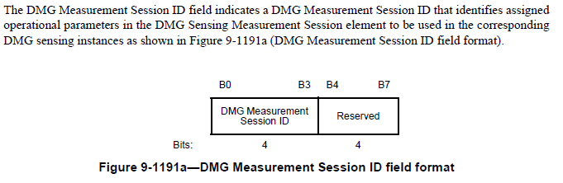

Option1: Aligne with way of DMG Measurement Session ID field format

In the case of DMG Measurement Session ID, Field DMG Measurement Session ID includes (Sub)field DMG Measurement Session ID, both names are same. But if anyone say “Measrurement Session ID field”, someone does not understand whether it means (Sub)field B0-B2 or Field B0-B7, it may be problem.

If Measuremtn Session ID is aligned with the way of DMG Measurement Session ID field format, replace “Measurement Session ID Indication field” with “Measurement Session ID field” thoruhgout 11bf D2.0.
Below is an example for the part commenter indicated (P112L15).

The Measurement Session ID Indication field indicates a Measurement Session ID that identifies assigned
operational parameters in the Sensing Measurement Parameters element to be used in the corresponding
sensing measurement exchanges. The Measurement Session ID Indication field is reserved if the Comeback
field of the Sensing Comeback Info field is set to 1 in a (Protected) Sensing Measurement Request frame
addressed to an unassociated non-AP STA by an AP. The Measurement Session ID Indication field is
defined in Figure 9-1137c (Measurement Session ID Indication field format).

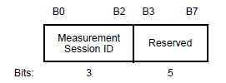
Figure 9-1137c— Measurement Session ID Indication field format

Option2: Keep field name “Measurement Session ID Indication field”

It’s better to have different names between Field and (Sub)field to distinguish those.
Now Field name is “Measurement Session ID Indication” and (Sub)field name is “Measurement Session ID” in Figure 9-1137c in Draft2.0. Keeping Figure 9-1137c as it is and make some slight change in the sentence is better to keep aligning with other figures like Figure9-75n and Figure 9-98b (see below) because those figures also use 3bit Measurement Session ID (Sub)field.

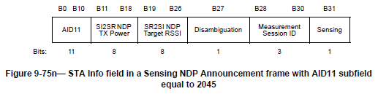

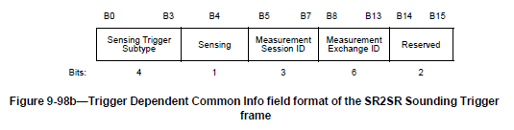

TGbf Editor: Please modify P136L16 as follows: The baseline for this document is 11bf D2.0
The Measurement Session ID Indication field is defined in Figure 9-1137c (Measurement Session ID Indication field format). The Measurement Session ID Indication field indicates a Measurement Session ID that identifies assigned
operational parameters in the Sensing Measurement Parameters element to be used in the corresponding
sensing measurement exchanges. The Measurement Session ID Indication field is reserved if the Comeback
field of the Sensing Comeback Info field is set to 1 in a (Protected) Sensing Measurement Request frame
addressed to an unassociated non-AP STA by an AP. The Measurement Session ID Indication field is
defined in Figure 9-1137c (Measurement Session ID Indication field format).

Figure 9-1137c— Measurement Session ID Indication field format

SP
Do you agree to the resolution provided for following CIDs 3068 to be included in the latest 11bf Draft?

