IEEE P802.11
Wireless LANs
Proposed resolutions for technical comments on D2.0 - Part 1
Date: 2023-09-25
Author(s):
Name | Affiliation | Address | Phone | email
Claudio da Silva | Meta Platforms
Abstract
This document contains proposed resolutions for technical comments on D2.0 (LB276). The text used as reference is D2.1.

CIDs: 3442, 3369, 3443, 3444, 3445, 3446, 3447, 3448, 3449, 3450, 3451, 3452, 3453, 3454, 3455, 3456, 3457, 3458, 3459, 3460, 3461, 3462, 3463, 3464, 3018, 3019, 3020

CID | Clause | Page | Comment | Proposed change
3442 | B.4.4.1 | 208.51 | There exists no PC65, PC67, PC64, PC66. | PC65 should be replaced with PC57, PC67 with PC59, PC64 with PC56, PC66 with PC58, PC66.2 with PC58.2, PC66.1 with PC58.1 on P207 and P208.

Proposed resolution: Accepted

Discussion: For reference, in D2.0,
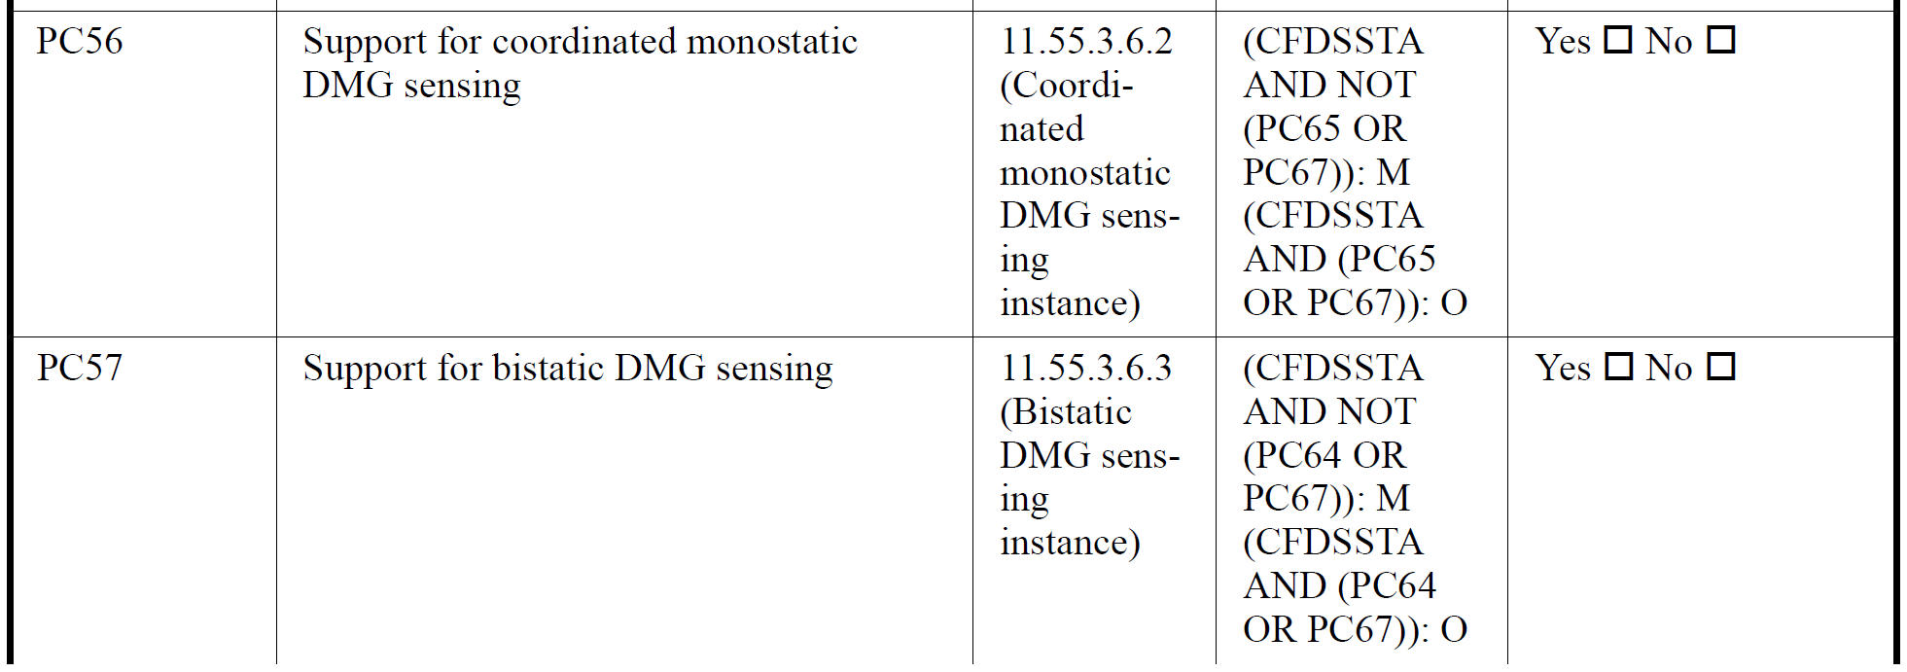
References were correct in D1.0,
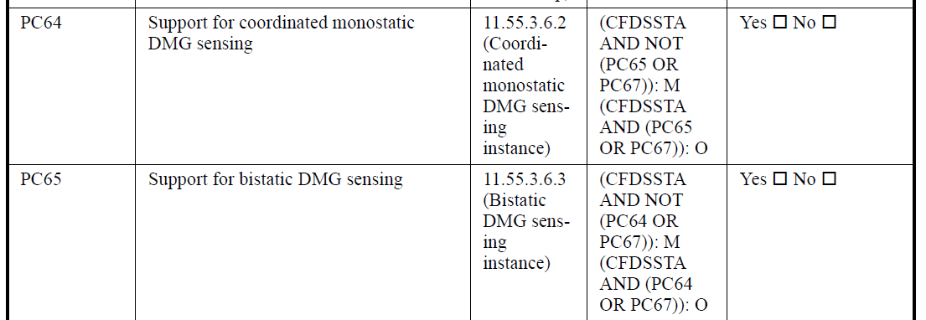
Summary D1.0 and D2.0:
 | D1.0 | D2.0
Support for coordinated monostatic DMG sensing | PC64 | PC56
Support for bistatic DMG sensing | PC65 | PC57
Support for coordinated bistatic DMG sensing  … as a sensing transmitter  … as a sensing receiver | PC66  PC66.1  PC66.2 | PC58  PC58.1  PC58.2
Support for EDMG multistatic sensing | PC67 | PC59

CID | Clause | Page | Comment | Proposed change
3369 | B.4.4.1 | 208.39 | Can't find "PC64", "PC65" or "PC66" in this draft or in 802.11az, 802.11be or REVme. | Define missing requirements. Several occurrences throughout this appendix.

Proposed resolution: Revised

Modifications: TGbf Editor – In pages 207 and 208, replace PC65 with PC57, PC67 with PC59, PC64 with PC56, PC66 with PC58, PC66.2 with PC58.2, and PC66.1 with PC58.1.
Note: Same resolution as that for CID3442.

CID | Clause | Page | Comment | Proposed change
3443 | B.4.4.2 | 209.58 | Wrong reference to PC58. | Please replace PC58 with PC52
3444 | B.4.4.2 | 210.04 | Wrong reference to PC59. | Please replace PC59 with PC53
3445 | B.4.4.2 | 210.10 | Wrong reference to PC58 and PC59 | Please replace PC58 with PC52 and PC59 with PC53

Proposed resolution: Accepted

Discussion: Summary D1.0 and D2.0:
 | D1.0 | D2.0
Support for the role of SBP initiator in an SBP procedure | PC58 | PC52
Support for the role of SBP responder in an SBP procedure | PC59 | PC53

CID | Clause | Page | Comment | Proposed change
3446 | B.4.4.2 | 210.17 | Wrong reference to PC58 and PC59 | Please replace PC58 with PC52 and PC59 with PC53

Proposed resolution: Revised

Discussion: Comment is on FT85,
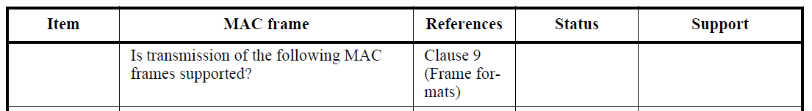
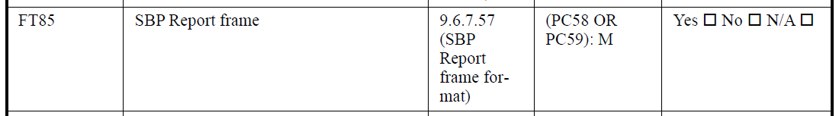
In D1.0, PC58 is “Support for the role of the SBP initiator in an SBP procedure” and PC59 is “Support for the role of the SBP responder in an SBP procedure”.
In D2.0, “Support for the role of the SBP responder in an SBP procedure” is PC53.

Modifications: TGbf Editor – In 210.16 replace “(PC58 OR PC59): M” with “PC53: M”.

CID | Clause | Page | Comment | Proposed change
3447 | B.4.4.2 | 210.56 | Wrong reference to PC60 | Please replace PC60 with PC54
3448 | B.4.4.2 | 211.03 | Wrong reference to PC61 | Please replace PC61 with PC55
3449 | B.4.4.2 | 211.09 | Wrong reference to PC60 and PC61 | Please replace PC60 with PC54 and PC61 with PC55
3450 | B.4.4.2 | 211.15 | Wrong reference to PC60 and PC61 | Please replace PC60 with PC54 and PC61 with PC55

Proposed resolution: Revised

Discussion: Comments are on FT90, FT91, FT92, and FT93:
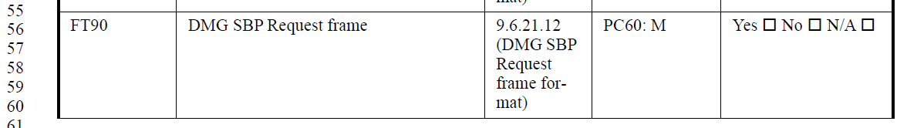
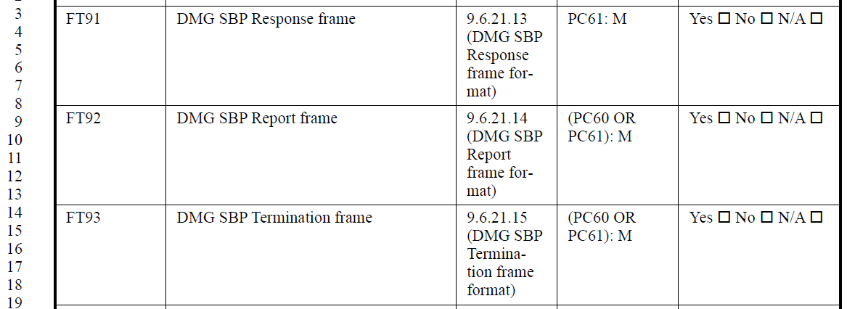

Summary D1.0 and D2.0:
 | D1.0 | D2.0
Support for the role of sensing initiator in a DMG sensing procedure | PC60 | PC54
Support for the role of sensing responder in a DMG sensing procedure | PC61 | PC55
Support for the role of SBP initiator in a DMG SBP procedure | PC70 | PC62
Support for the role of SBP responder in a DMG SBP procedure | PC71 | PC63

Modifications: TGbf Editor –
- In 210.56, replace “PC60: M” with “PC62: M”.
- In 211.03, replace “PC61: M” with “PC63: M”.
- In 211.09, replace “(PC60 OR PC61): M” with “PC63: M”.
- In 211.15, replace “(PC60 OR PC61): M” with “(PC62 OR PC63): M”.

CID | Clause | Page | Comment | Proposed change
3451 | B.4.4.2 | 212.29 | Wrong reference to PC58 | Please replace PC58 with PC52
3452 | B.4.4.2 | 212.35 | Wrong reference to PC59. | Please replace PC59 with PC53
3453 | B.4.4.2 | 212.42 | Wrong reference to PC58 and PC59 | Please replace PC58 with PC52 and PC59 with PC53
3454 | B.4.4.2 | 212.49 | Wrong reference to PC58 and PC59 | Please replace PC58 with PC52 and PC59 with PC53

Proposed resolution: Revised

Discussion: Comments are on FR82, FR83, FR84, and FR85:
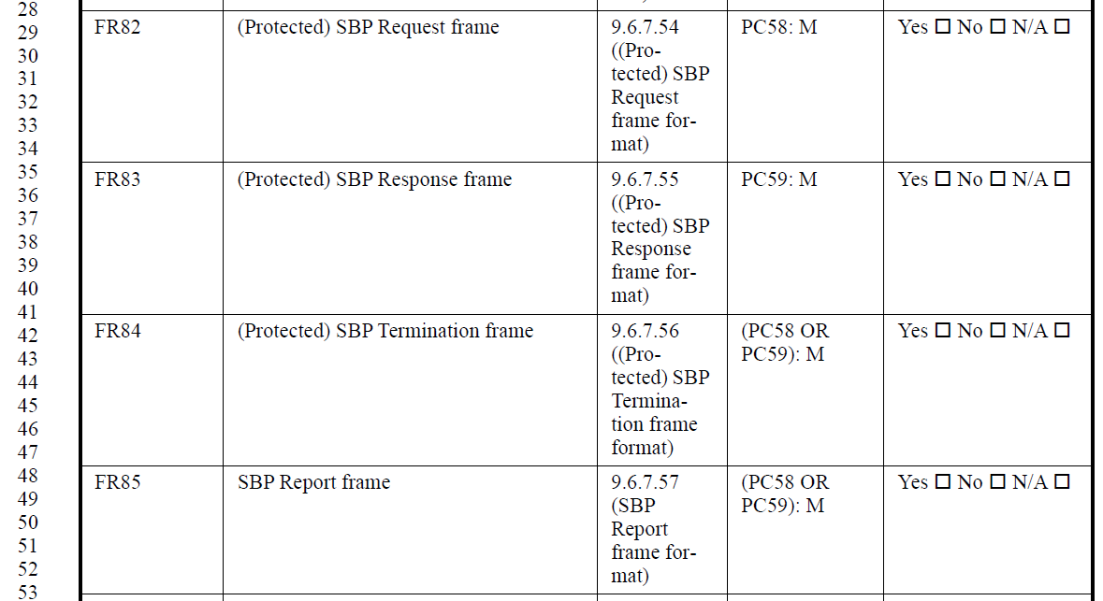

Summary D1.0 and D2.0:
 | D1.0 | D2.0
Support for the role of SBP initiator in an SBP procedure | PC58 | PC52
Support for the role of SBP responder in an SBP procedure | PC59 | PC53

Modifications: TGbf Editor –
- In 212.29, replace “PC58: M” with “PC53: M”.
- In 212.35, replace “PC59: M” with “PC52: M”.
- In 212.42, replace “(PC58 OR PC59): M” with “(PC52 OR PC53): M”.
- In 212.49, replace “(PC58 OR PC59): M” with “PC52: M”.

CID | Clause | Page | Comment | Proposed change
3455 | B.4.4.2 | 213.29 | Wrong reference to PC60 | Please replace PC60 with PC62
3456 | B.4.4.2 | 213.34 | Wrong reference to PC61 | Please replace PC61 with PC63
3457 | B.4.4.2 | 213.40 | Wrong reference to PC60 and PC61 | Please replace PC60 with PC62 and PC61 with PC63
3458 | B.4.4.2 | 213.46 | Wrong reference to PC60 and PC61 | Please replace PC60 with PC62 and PC61 with PC63

Proposed resolution: Revised

Discussion: Comments are on FR90, FR91, FR92, and FR93:
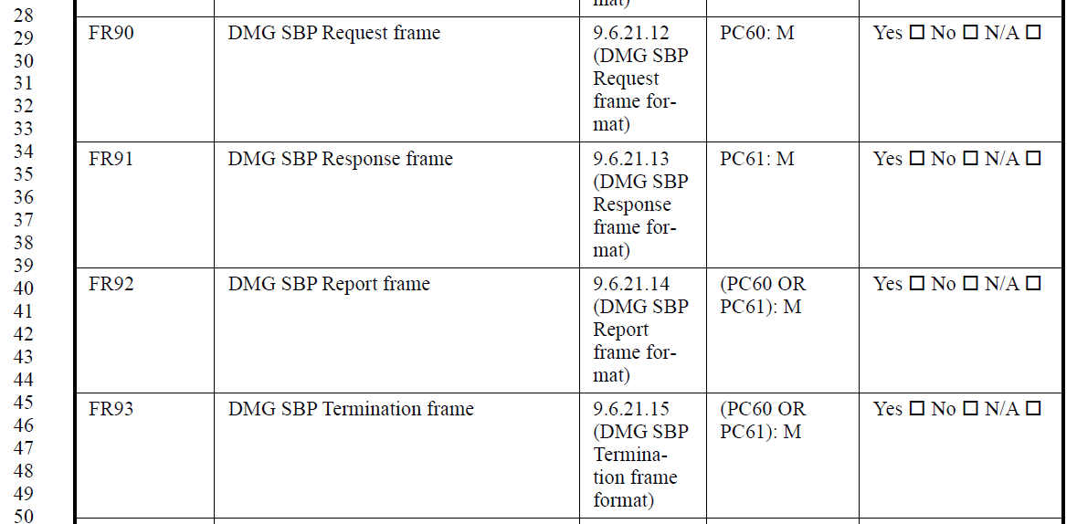

Summary D1.0 and D2.0:
 | D1.0 | D2.0
Support for the role of sensing initiator in a DMG sensing procedure | PC60 | PC54
Support for the role of sensing responder in a DMG sensing procedure | PC61 | PC55
Support for the role of SBP initiator in a DMG SBP procedure | PC70 | PC62
Support for the role of SBP responder in a DMG SBP procedure | PC71 | PC63

Modifications: TGbf Editor –
- In 213.29, replace “PC60: M” with “PC63: M”.
- In 213.34, replace “PC61: M” with “PC62: M”.
- In 213.40, replace “(PC60 OR PC61): M” with “PC62: M”.
- In 213.46, replace “(PC60 OR PC61): M” with “(PC62 OR PC63): M”.

CID | Clause | Page | Comment | Proposed change
3459 | B.4.41.1 | 214.40 | Wrong reference to PC52 | Please replace PC52 with PC49
3460 | B.4.41.1 | 214.55 | Wrong reference to PC54 | Please replace PC54 with PC50
3461 | B.4.41.1 | 215.36 | Wrong reference to PC64 | Please replace PC64 with PC56
3462 | B.4.41.1 | 215.44 | Wrong reference to PC65 | Please replace PC65 with PC57
3463 | B.4.41.1 | 215.50 | Wrong reference to PC66 | Please replace PC66 with PC58

Proposed resolution: Accepted

Discussion:
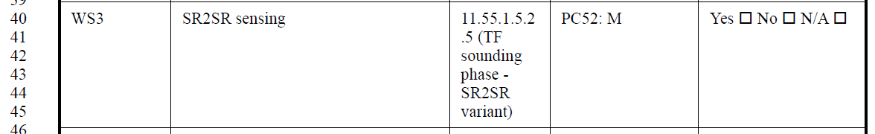
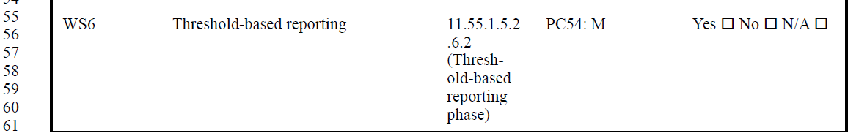
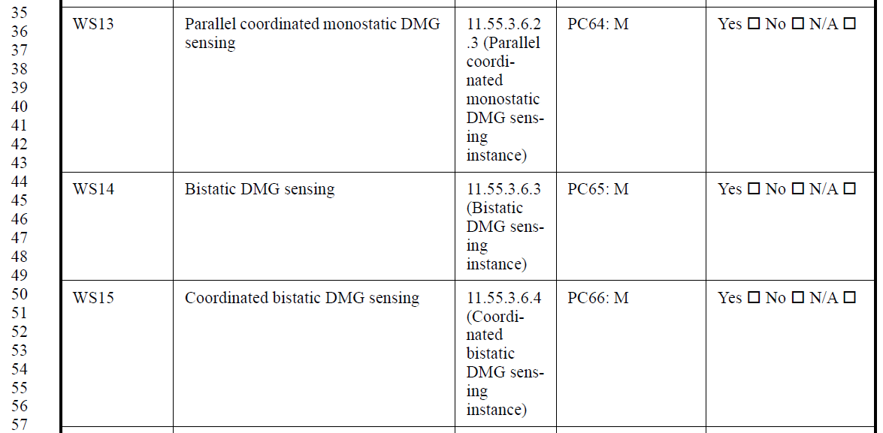

Summary D1.0 and D2.0:
 | D1.0 | D2.0
Support for the SR2SR variant of a TF sounding phase | PC52 | PC49
Support for threshold-based reporting phase | PC54 | PC50
Support for coordinated monostatic DMG sensing | PC64 | PC56
Support for bistatic DMG sensing | PC65 | PC57
Support for coordinated bistatic DMG sensing | PC66 | PC58

CID | Clause | Page | Comment | Proposed change
3464 | B.4.41.1 | 215.58 | Wrong reference to PC69 | Please replace PC69 with PC59

Proposed resolution: Accepted

Discussion:
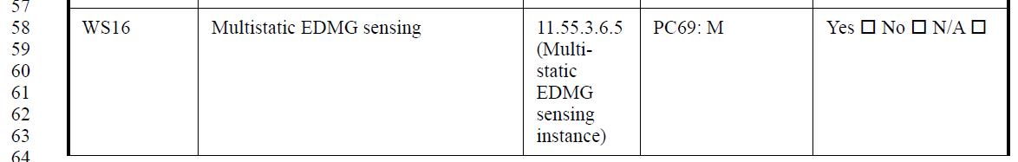

Discussion: Summary D1.0 and D2.0:
 | D1.0 | D2.0
Support for DMG passive sensing | PC69 | PC61
Support for EDMG multistatic sensing | PC67 | PC59

CID | Clause | Page | Comment | Proposed change
3018 | B.4.41.1 | 209.55 | "Incorrectly conditional on PC54 (Support for the role of sensing initiator in a DMG sensing procedure). Should be PC50 (Support for threshold-based reporting phase) instead?" | Change the Status to: PC50: M

Proposed resolution: Revised

Discussion: Summary D1.0 and D2.0:
 | D1.0 | D2.0
Support for threshold-based reporting phase | PC54 | PC50

Modifications: TGbf Editor – In 214.56, replace PC54 with PC50.
Note: Wrong page number given by the commenter.
Note: Same resolution as that proposed for CID 3460.

CID | Clause | Page | Comment | Proposed change
3019 | B.4.41.1 | 215.15 | Circular conditional on WS9! | Change the Status to the correct condition: WS8: M

Proposed resolution: Revised

Discussion: Comment is on WS9,
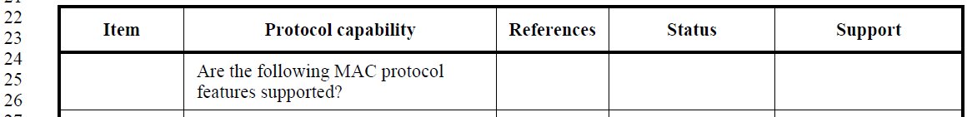
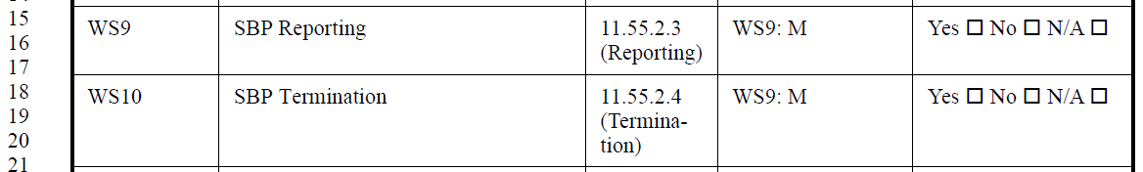

Summary D1.0 and D2.0:
 | D1.0 | D2.0
SBP | WS9 | WS8

Modifications: TGbf Editor – In 215.15 and 215.18, replace “WS9: M” with “WS8: M”.

CID | Clause | Page | Comment | Proposed change
3020 | B.4.4 | 207.32 | Should the status be "WS8: O" instead? Same for PC53. | Change the status of PC52 and PC53 to "WS8: O"

Proposed resolution: Rejected

Justification: Current text correctly reflects the fact that, in D2.0, “Support for the role of SBP initiator in an SBP procedure” and “Support for the role of SBP responder in an SBP procedure” are optional MAC protocol capabilities of a sensing STA.

Discussion: In 207.32, in B.4.4 (MAC protocol) -> B.4.4.1 (MAC protocol capabilities),
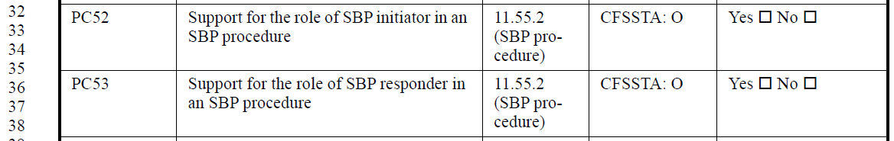
In 206.35,
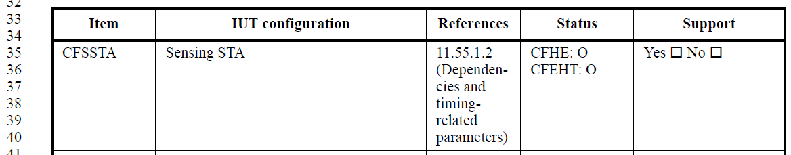

Also, in B.4.41 (Wireless sensing (WS) features) -> B.4.41.1 (WS MAC features),
