IEEE P802.11
Wireless LANs
TGbe LB275 Security comment resolutions – Part 1
Date: 2023-09-29
Author(s):
Name | Affiliation | Address | Phone | email
Michael Montemurro | Huawei |  |  | montemurro.michael@gmail.com
Background
This contribution proposes comment resolutions to TGbe comments received in LB275, mainly on Clause 12, of P802.11be D3.0. The resolutions will be shown relative to D4.0.

CIDs 19121, 19124, 19385, 19383, 19524, 19230, 19491, 19516, 19517, 19635, 19636, 19101, 19068, 19492, 19493, 19637, 19638, 19494, 19639, 19518, 19495, 19384, 19326, 19067, 19496, 20071, 19500

Rev 0. Initial submission
Rev 1. Updates based on offline feedback
Rev 2.
Rev 3.
Rev 4.
Rev 5.

Comment
CID | Clause | Page | Comment | Proposed Change
19121 | 3.1 | 53.20 | It's confusing to say "IEEE 802.1X Authenticator's station" since the correct relation between an authenticator and a STA is "an IEEE 802.1X Authenticator on an IEEE 802.11 STA" as defined in sub-clause 4.3.8 | Change to "The medium access control (MAC) address of the station (STA) or the multi-link device (MLD) that contains the IEEE 802.1X Authenticator."
19124 | 3.1 | 53.47 | It's confusing to say "IEEE 802.1X Supplicant's station" since the correct relation between an supplicant and a STA is similar to "an IEEE 802.1X Authenticator on an IEEE 802.11 STA" as defined in sub-clause 4.3.8 | Change to "The medium access control (MAC) address of the station (STA) or the multi-link device (MLD) that contains the IEEE 802.1X Supplicant."
19385 | 3.1 | 59.21 | The definition for Authenticator address, is not very clear. The authenticator address is the MAC address of the Authenticator's STA or the Authenticators MLD, the way it is currently stated is confusing. | Change the definition to: Authenticator address: [AA] The medium access control (MAC) address of the IEEE 802.1X Authenticator's station (STA) or the IEEE 802.1X Authenticator's multi-link device.

Discussion:
- The cited text (at 51.20) for 19121 and 19385 is:
- The cited text at
- With respect to CIDs 19121 and 19124, the Authenticator and Supplicant are IEEE 802.1X entities that provide authentication on behalf of the 802.11 MAC. They are separate entities. The cited wording is from the baseline and demonstrates this relationship in the definition.
- With respect to CID 19385, the commenter provides clearer wording for the definition. However, a similar wording change should be applied for the Supplicant as well.
(51.47) “Supplicant address: [SPA] The medium access control (MAC) address of the IEEE 802.1X Supplicant’s station (STA) or the IEEE 802.1X Supplicant’s multi-link device (MLD).”

Proposed Resolution:
(19121, 19124) REJECTED. The Authenticator and Supplicant are IEEE 802.1X entities that provide authentication on behalf of the 802.11 MAC. They are separate entities from the 802.11 MAC. The cited wording has not changed from the baseline and demonstrates this relationship in the definition.

(19385) REVISED. Make the change in the “Proposed Change” and update the definition for the Supplicant address as follows:
At 51.47, replace the definition with the following:
“Supplicant address: [SPA] The medium access control (MAC) address of the IEEE 802.1X Supplicant’s station (STA) or the IEEE 802.1X Supplicant’s multi-link device (MLD).”

Comment
CID | Page | Clause | Comment | Proposed Change
19383 | 12.4 | 0.00 | "SAE entity" is undefined and should not be defined anyway. | Get rid of all the "SAE entity" edits in 12.4. Add a sentence in 12.4.1 that states that what "STA" means in 12.4 for an MLO.

Discussion:
- The current definition of SAE entity is (60.7):
simultaneous authentication of equals (SAE) entity: An entity that is a station (STA) or a multi-link device (MLD) that participates in SAE authentication (see 12.4 (Authentication using a password)).
- SAE entity is defined and refers to a STA or MLD.

Proposed Resolution: (19383)
REJECTED. The definition of an SAE entity is already given in clause 3.2 (see D4.0 p60.7) and describes which architectural components can be an SAE entity (a STA or MLD). The term entity is used throughout the baseline and the cited definition is consistent with this usage of the term entity.

Comment
CID | Page | Clause | Comment | Proposed Change
19524 | 12.12.3 | 439.10 | AKM suite selector value of 00-0F-AC:24 or 00-0F-AC:25 are not specified anywhere in the 11be specification. | Include new AKMs 00-0F-AC:24 and 00-0F-AC:25 in Section 9.4.2.23 RSNE

Discussion:
- AKM suite selectors 24 and 25 are specified in REVme in table 9-188 (p982.30 in D4.0). Since P802.11be is an amendment to this baseline document, these AKMs are not specified in this amendment.

Proposed Resolution: (19524)
REJECTED. AKM suite selectors 00-0F-AC:24 and 00-0F-AC:25 are specified in the baseline (see REVme D4.0 table 9-188 on p982.30) and are not modified by P802.11be. Therefore, they are inherited from the IEEE 802.11 baseline document and there is no need to include this text in the P802.11be amendment.

Comment
CID | Page | Clause | Comment | Proposed Change
19230 | 12.2.10 | 401.48 | The text describes how the MLD transitioning to becoming a STA manages the selection of the "MLD MAC address", but during the transition the device is determining a STA MAC address. While the NOTE below clarifies that the selection of the STA MAC address is contrained, the result is still not a clear description of the requirements. | Change to "When a non-AP MLD with MAC privacy enhancements enabled becomes a non-AP STA for the purposes of BSS transition to an AP, the non-AP STA assumes the non-AP MLD MAC address, which shall adhere to the requirements above and 35.3.1 (General) for managing and selecting the MLD MAC address" and delete the subsequent NOTE.

Discussion:
- Cited text in context:
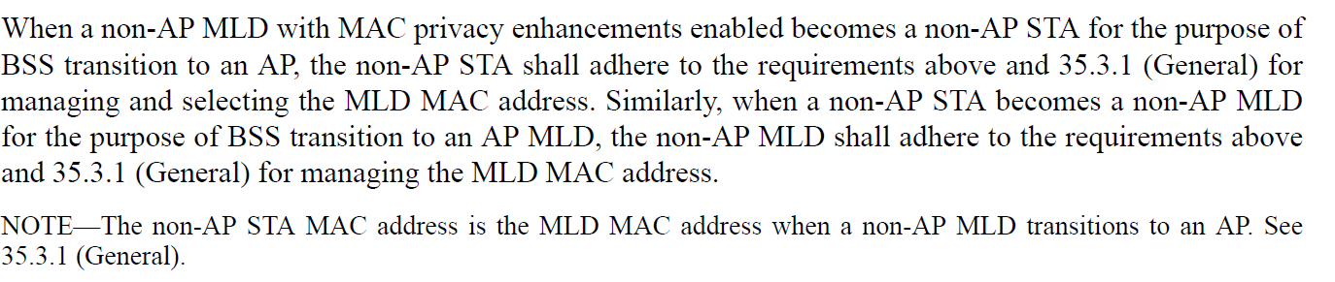
- The cited text describes the requirements for the case where an MLD with privacy enabled performs BSS transition between and AP MLD and a AP. The privacy requirements are defined in 12.2.10, but the addressing requirements for the MLD are defined in 35.3.1. The note clarifies the behavior that is required by 35.3.1.
- The proposed text duplicates the requirement in 35.3.1.

Proposed Resolution: (19230)
REJECTED. The proposed change duplicates behavior that is already defined in 35.3.1. The current text clearly describes the case for privacy requirements for BSS transition between an AP MLD and an AP.

Comment
CID | Page | Clause | Comment | Proposed Change
19491 | 12.2.4 | 401.23 | [WFA-R] The text should be clear that the MLD MAC Address is the MAC  address used by the MLD upper MAC sublayer. | As in comment

Discussion:
- Cited text in context:
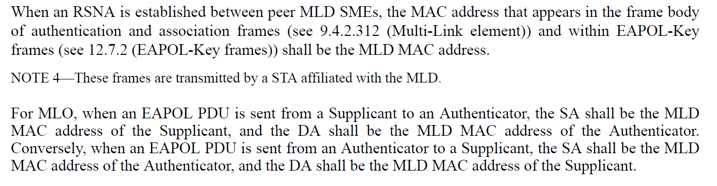
- The first sentence of 35.3.2 clearly specifies that the MLD MAC address identifies the MLD. In the cited text, note 4 could be expanded to clarify this.

Proposed Resolution: (19491)
REVISED. Clarify that the MLD MAC address identifies the MLD at the cited location

At 402.27 change
“NOTE 4—These frames are transmitted by a STA affiliated with the MLD.”
to
“NOTE 4— The MLD MAC address included in the frame body identifies an MLD while the frames are transmitted by a STA affiliated with the MLD.”

Comment:
CID | Page | Clause | Comment | Proposed Change
19516 | 12.4.4.1 | 61.04 | [WFA-R] Can you reference RFC 4306 (IKEv2) instead of RFC 2409 (IKEv1)? | As in comment

Discussion:
- Cited text in context:
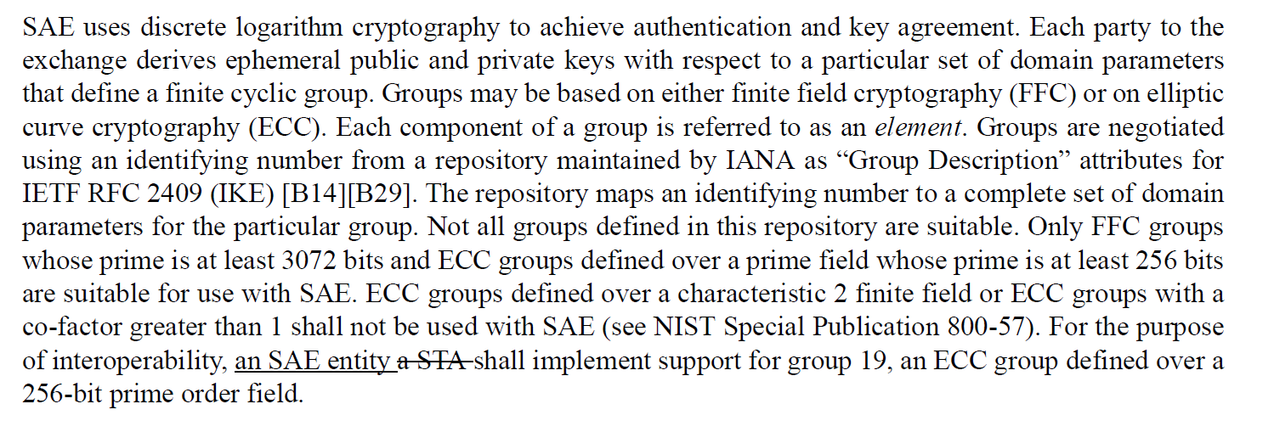
- The commenter is correct in that RFC 4306 obsoletes RFC 2409.
- [B14] is a reference to the IANA IKE registry. [B29] provides a reference to the Differentiated Services field. The cross reference to [B29] is not applicable to RFC 4306.

Proposed Resolution: (19516)
REVISED. Make the proposed change. Delete the reference to “[B29]” at the cited location. Update the normative reference in clause 2 (REVme D4.0 p176.20) as follows:
Change
“IETF RFC 2409, The Internet Key Exchange (IKE), Harkins, D., and D. Carrel, Nov. 1998 (status: Standards Track).”
to
“IETF RFC 4306, Internet Key Exchange (IKEv2) Protocol, C. Kaufman, Ed., Dec. 2005”

Comment
CID | Page | Clause | Comment | Proposed Change
19517 | 12.5.2.3.3 | 26.10 | [WFA-R] To be parallel in the structure, this should begin with: "A3 is set as follows:" | As in comment
19636 | 12.5.2.3.4 | 410.58 | The sentence should start with an "If" | Replace "The" at the beginning of the sentence with "If the".
19635 | 12.5.2.3.1 | 0.00 | Add'If" at the beginning of the sentences in line 10, 17, 22, and 35. | As in the comment

Discussion:
- The page is 410 and the references appear to be incorrect. After discussion with the commenter for CID 19635, the text is:
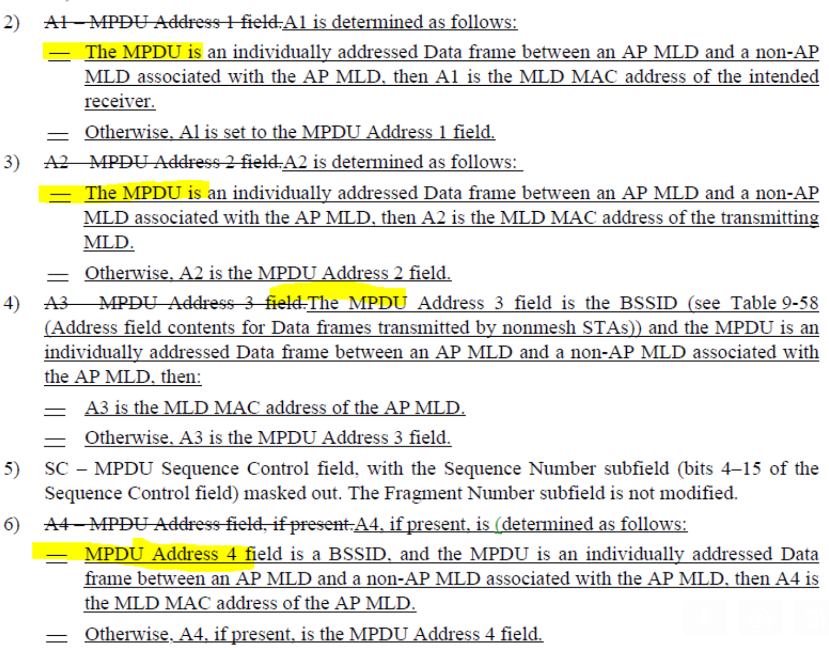
- The first sentence of 35.3.2 clearly specifies that the MLD MAC address identifies the MLD. In the cited text, note 4 could be expanded to clarify this.

Proposed Resolution: (19517, 19635, 19636)
REVISED. Make the changes shown in under document <this> to clarify the AAD behavior.

2)A1 – MPDU Address 1 field.A1 is determined as follows:
— If the MPDU is an individually addressed Data frame between an AP MLD and a non-AP MLD associated with the AP MLD, then A1 is the MLD MAC address of the intended receiver.
—Otherwise, Al is set to the MPDU Address 1 field.
3)A2 – MPDU Address 2 field.A2 is determined as follows:
— If the MPDU is an individually addressed Data frame between an AP MLD and a non-AP MLD associated with the AP MLD, then A2 is the MLD MAC address of the transmitting MLD.
—Otherwise, A2 is the MPDU Address 2 field.
4)A3 – MPDU Address 3 field.A3 is determined as follows:
— If the MPDU Address 3 field is the BSSID (see Table 9-58 (Address field contents for Data frames transmitted by nonmesh STAs)) and the MPDU is an individually addressed Data frame between an AP MLD and a non-AP MLD associated with the AP MLD, then:
—A3 is the MLD MAC address of the AP MLD.
—Otherwise, A3 is the MPDU Address 3 field.
5)SC – MPDU Sequence Control field, with the Sequence Number subfield (bits 4–15 of the Sequence Control field) masked out. The Fragment Number subfield is not modified.
6)A4 – MPDU Address field, if present.A4, if present, is (determined as follows:
—If the MPDU Address 4 field is a BSSID, and the MPDU is an individually addressed Data frame between an AP MLD and a non-AP MLD associated with the AP MLD, then A4 is the MLD MAC address of the AP MLD.
Otherwise, A4, if present, is the MPDU Address 4 field.

Comment
CID | Page | Clause | Comment | Proposed Change
19068 | 12.5.2.3.1 | 408.63 | The note "For MLO, this also applies for  retransmission on another link.." is not entirely correct for management frame. Note that MPDU includes data and management frame. A management frame like multi-link probe request may change contents during retransmission. For example, the link that the multi-link probe request is transmtited is always requested and the per-sta profile Probe Request Multi-Link element specifies the additional link to be requested if retransmitted in another link, then contents may need to be changed to make sure that the requested links remain the same. Probe Reqeust can not be encrypted, so the situation may not matter. However, for other frames like WNM sleep mode response, there are OCI element and the indication of the OCI element may change based on the link that is transmtited. Chaning content is essentially fine because AAD swap is not used, and STA MAC address is different in each link, so nonce is essentially different in each link even if the PN is the same. As a result, the original sentence in D3.1 is better rather than the revised note. | Suggest to delete "For MLO, this also applies for  retransmission on another link.." and simply say "For MLO, MPDUs are  encapsulated with the same PN when retransmitted on another link."
19101 | 12.5.2.3.1 | 408.63 | Periods are duplicated at the end of this sentence. | Please delete one of them.
19492 | 12.5.2.3.1 | 408.62 | [WFA-R] Please state the positive. We suggest: "For MLO, MPDUs are  encapsulated with the same PN when retransmitted on another link.". | As in comment

Discussion:
- Cited text in context:
- The proposed text modifies the second sentence and would make the note clearer.
- The change would need to be made for GCMP in 12.5.4.3.1 as well.

Proposed Resolution:
(19101) ACCEPTED.

(19492, 19068) REVISED. Make the change for both CCMP and GCMP
At 408.61 and 413.35, change
“For MLO, this also applies for retransmission on another link.”
to
“For MLO, MPDUs are encapsulated with the same PN when retransmitted on another link.”

Comment
CID | Page | Clause | Comment | Proposed Change
19493 | 12.5.4.3.1 | 413.06 | [WFA-R] In Draft P802.11REVme_D3.0, Figure 12-26 shows GCMP encapsulation block diagram, and Figure 12-27 shows the nonce format. These instructions ask the editor to replace Figure 12-27 with the GCMP encapsulation block diagram. Please correct. | As in comment

Discussion:
- The figures and editing instructions in P802.11be D4.0 are aligned with REVme D4.0.

Proposed Resolution: (19493)
REJECTED. Upon review of the cited figures and editing instructions in P802.11be D4.0 against REVme D4.0, the instructions and labels are now aligned. No additional changes are required.

Comment
CID | Page | Clause | Comment | Proposed Change
19638 | 12.5.4.4.1 | 414.58 | The sentence should start with an "If" | Replace "The" at the beginning of the sentence with "If the".
19637 | 12.5.4.3.4 | 414.06 | The sentence should start with an "If" | Replace "The" at the beginning of the sentence with "If the".

Discussion:
- Cited text in context:
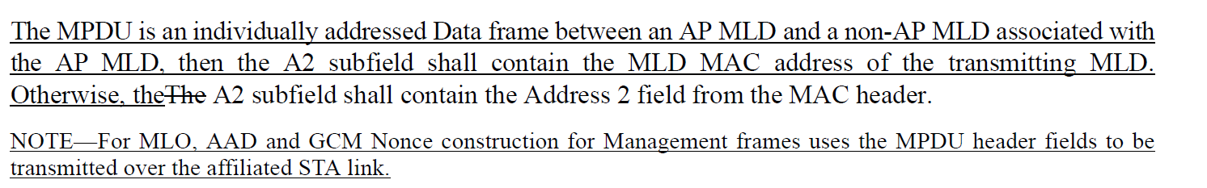

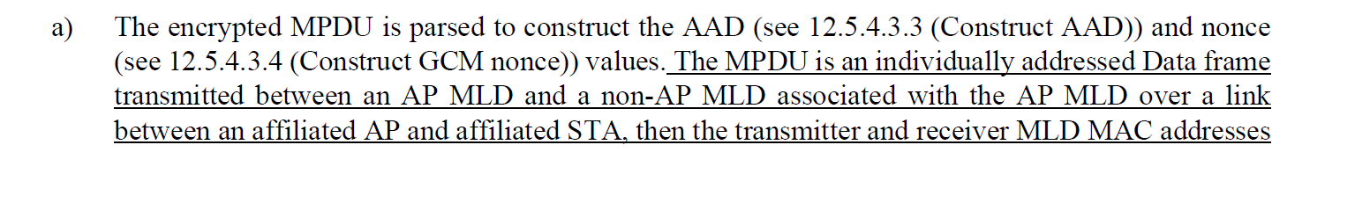
- The proposed change is to replace “The MPDU is an …” to “If the MPDU is an …”
- The proposal is consistent with proposed text for CCMP clause.

Proposed Resolution: (19637, 19638)
ACCEPTED.

Comment
CID | Page | Clause | Comment | Proposed Change
19494 | 12.5.4.3.4 | 414.10 | [WFA-R] Based on Figure 5-2a, we expect all GCMP encryption processing to use the addresses associated with the MLD upper MAC sublayer. This note seems to contradict that understanding. | As in comment

Discussion:
- Cited text in context:
- The comment references the note above.
- In TGbe D4.0 clause 12.5.2.3.1, item 3 on CCMP AAD and Nonce construction, the following note was added:
“NOTE 2—For MLO, AAD and CCM Nonce construction for Management frames follows 12.5.2.3.4 (Construct CCM nonce) and uses the MPDU header fields to be transmitted over the affiliated STA link."
- In clause 12.5.4.3.1 for GCMP, the text is:
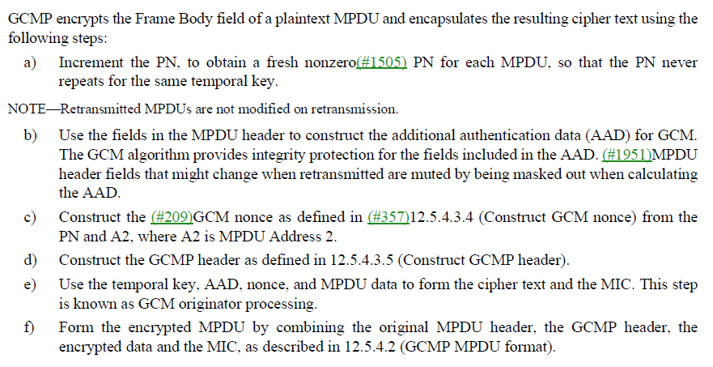
- It would be better to delete the cited note and used a similar “NOTE 2” under item C.

Proposed Resolution: (19494)
REVISED. Although the encapsulation is done at the MLD upper MAC, the AAD construction for management frames uses the MPDU header field values transmitted over the affiliated STA link. However to be consistent with CCMP, the note should be moved to the general description clause.

Move the cited note to 413.44 after item c), and re-number notes as appropriate.

Comment
CID | Page | Clause | Comment | Proposed Change
19639 | 12.5.4.4.4 | 415.40 | It's not clear what it means by "a single set of replay counters" | Please clarify.

Discussion:
- Cited text in context:

- The requirement is on the receiving MLD, so it would be better to word the bullet as follows:
“For individually addressed MPDUs received by an MLD through an affiliated STA from a transmitting MLD, the receiving MLD shall maintain a single set of replay counters for the PTKSA.”

Proposed Resolution: (19639)
REVISED. Clarify the replay counter behavior for an MLD when it receives an individually addressed MPDU.

At the cited location, change:
“For individually addressed MPDUs received by an affiliated STA from a transmitting MLD, the receiving MLD shall maintain a single set of replay counters for the PTKSA for all affiliated STAs.”
To
“For individually addressed MPDUs received through any STA affiliated with the receiving MLD from a transmitting MLD, the receiving MLD shall maintain a single set of replay counters for the PTKSA.”

Comment
CID | Page | Clause | Comment | Proposed Change
19518 | 12.7.2 | 50.22 | There is an Editors note: Editor's Note: The discussion on Key Data field is removed in REVme D3.0. Do we still need the above underlined sentence?" Resolve editor notes in this subclause | The commenter will bring a submission.

Discussion:
- Cited text in context:
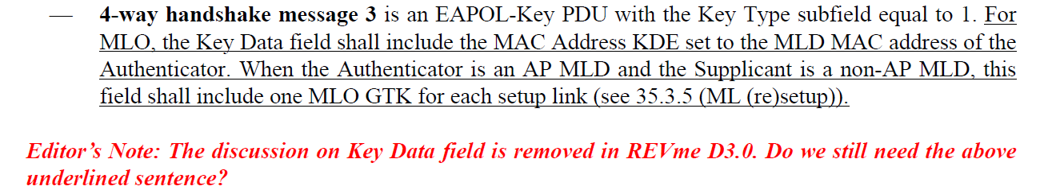

- The text in IEEE 802.11-2020 at the cited location is
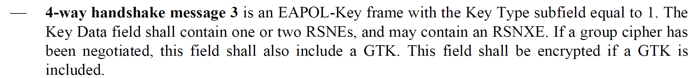
- The text in REVme D4.0 is
- In the baseline, there is description for the contents of the key data field that is duplicated from 12.7.6.4.4. For equivalent text in REVme, this text was removed. Therefore we should move similar duplication from the TGbe draft.
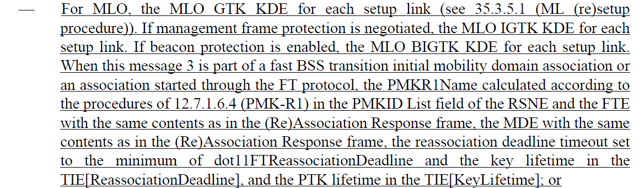
- There are also similar “Editor’s Note” at 423.21 (4-way handshake message 4) and 423.31 in the same subclause.

Proposed Resolution: (19518)
REVISED. As suggested by the Editor’s note, remove the additional MLO text at the following locations to align P802.11be with the 802.11 baseline.
At 422.39 and 423.17, remove the sentence that starts with “For MLO, …”
At 423.25, remove the two sentences of the paragraph starting with “For non-MLO, …”

Comment
CID | Page | Clause | Comment | Proposed Change
19495 | 12.7.2 | 421.43 | [WFA-R] Related to the major concern raised in the previous section, the approach used for replay detection in CCMP and GCMP can be adapted to MLD operation by accepting a fairly small window of packet number values. | As in comment
19384 | 12.7.2 | 421.43 | why is replay disabled for MLO? | If there is a reason to not send the RSC in an MLO say why, if not here then somewhere and put a note pointing back to that reasoning. If there is no reason to not send the RSC in an MLO then get rid of this line.

Discussion:
- Cited text in context:
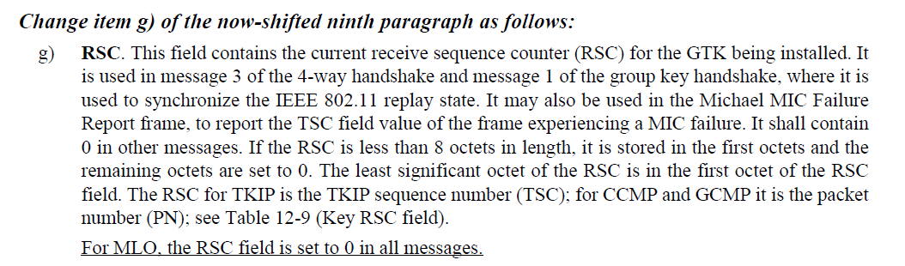
- The commenter points out that the RSC field is needed. However for MLO, there are multiple GTKs installed, one for each affiliated STA. It would be helpful to modify the cited text to explain this.

Proposed Resolution: (19495, 19384)
REVISED. Group-addressed traffic and GTKs are installed for each affiliated STA. Each GTK has a corresponding RSC. Clarify that for MLO there are multiple RSCs. One for each affiliated STA.

Add the following note after the cited sentence:
“NOTE – For MLO, a GTK is installed for each STA affiliated with an MLD. The GTK and the RSC for an affiliated STA are included in the MLO GTK KDE.”

Comment
CID | Page | Clause | Comment | Proposed Change
19326 | 12.7.5 | 426.19 | There are a couple of inconsistent "MLD address" uses in the draft while most locations use the "MLD MAC address" term. It would be clearer to use the same term in all locations. | At P116 L15, replace "the MLD address of the non-AP MLD" with "the MLD MAC address of the non-AP MLD".  At P426 L19, replace "the MLD address of the non-AP MLD" with "the MLD MAC address of the non-AP MLD".  At P442 L2, replace "the MLD address for the respective MLD" with "the MLD MAC address for the respective MLD".  At P1017 L45, replace "the non-AP MLD Address" with "the MLD MAC address of the non-AP MLD".  At P1019 L32, replace "to non-AP MLD address" with "to the MLD MAC address of the non-AP MLD".  At P1019 L33, replace "to non-AP MLD's MAC address" to "to the MLD MAC address of the the non-AP MLD"

Discussion:
- Agree with the commenter that the appropriate term is “MLD MAC address”

Proposed Resolution: (19326)
REVISED. Make the changes proposed by the commenter. Remove the “the the” from the final proposed change:
At P1019 L33, replace "to non-AP MLD's MAC address" to "to the MLD MAC address of the non-AP MLD"

Comment
CID | Page | Clause | Comment | Proposed Change
19496 | 12.7.6.4.4 | 432.24 | [WFA-R] The text is unclear what verification takes place if information is not available. People could be frustrated if MLD devices connect in one case and fail to connect in the other case. | As in comment
19067 | 12.7.6.4 | 432.34 | put Parentheses around "if information is available" | change "The affiliated AP MAC address and all fields in the RSNE and the RSNXE (if present), of other  discovered links, if information is available are identical to those received for the affiliated APs  of the AP MLD." to "The affiliated AP MAC address and all fields in the RSNE and the RSNXE (if present), of other  discovered links (if information is available), are identical to those received for the affiliated APs  of the AP MLD."
20071 | 12.7.6.4 | 432.25 | AP's RSNE/RSNXE are only included in per-STA profile in Link Reconfiguration Response frame for accepted link addition in a link reconfiguration procedure on p518 L22,  However, in initial setup 4 way handshake message 3, all links'(including those not accepted) RSNE/RSNXE must be in MLO link KDEs for non-AP to check  Should make two cases consistent | as in comment

Discussion:
- Cited text in context:
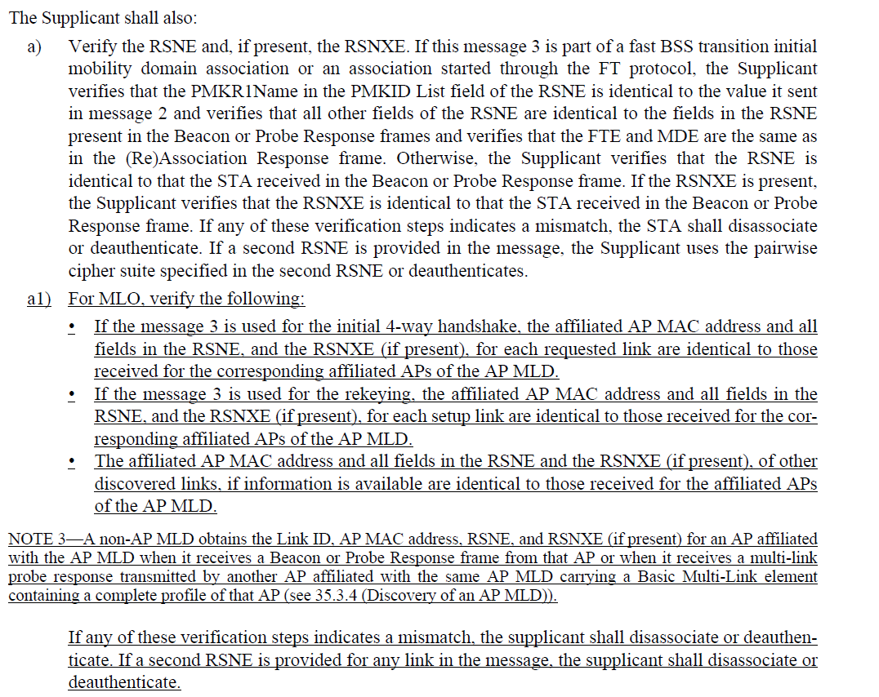

- For 20071, the text is validating message 3 of the 4-way handshake, in which the non-AP MLD verifies that the Authenticator that sent message 3 is the same entity that advertised the RSNE and RSNXE in Beacons and Probe Responses. The text could be clearer on what is verified and work was done in REVme to improve bullet a)

Proposed Resolution: (19496, 20071, 19067)
REVISED. Incorporate the changes under “Proposed Resolution: (19496, 20071, 19067) in <this> document. Align with the updated baseline item a) and make the verification steps clearer.

At 432.24, update the text as follows:

a1) For MLO, verify that the RSNE and if present, the RSNXE for each setup link:

- If this message 3 is part of a fast BSS transition initial mobility domain association or an association started through the FT protocol, the Supplicant verifies that the PMKR1Name in the PMKID List field of the RSNE is identical to the value it sent in message 2 and verifies that the affiliated AP MAC address and all other fields in the RSNE, and the RSNXE (if present), for each requested link are identical to those received for the corresponding affiliated APs of the AP MLD and verifies that the FTE and MDE are the same as in the (Re)Association Response frame.
- Otherwise, the Supplicant verifies that the affiliated AP MAC address and all fields in the RSNE, and the RSNXE (if present), for each requested link are identical to those received for the corresponding affiliated APs of the AP MLD.
- If the message 3 is used for rekeying, the Supplicant verifies that the affiliated AP MAC address and all fields in the RSNE, and the RSNXE (if present), for each setup link are identical to those received for the corresponding affiliated APs of the AP MLD.
- The Supplicant verifies that the affiliated AP MAC address and all fields in the RSNE and the RSNXE (if present), of other discovered links (if information is available), are identical to those received for the affiliated APs of the AP MLD..

NOTE 3—A non-AP MLD obtains the Link ID, AP MAC address, RSNE, and RSNXE (if present) for an AP affiliated with the AP MLD when it receives a Beacon or Probe Response frame from that AP or when it receives a multi-link probe response transmitted by another AP affiliated with the same AP MLD carrying a Basic Multi-Link element containing a complete profile of that AP (see 35.3.4 (Discovery of an AP MLD)).

If any of these verification steps indicates a mismatch, the supplicant shall disassociate or deauthenticate. If a second RSNE is provided for any link in the message, the supplicant shall disassociate or deauthenticate.

Comment
CID | Page | Clause | Comment | Proposed Change
19500 | 12.7.8.2 | 430.36 | [WFA-R] There is inconsistent formatting throughout the document regarding whether "see 35.3.21" is surrounded by parentheses or not. Two examples demonstrate the different styles:  - P436.14: (optionally included if the transmitting STA is affiliated with a non-AP MLD (see 35.3.21 (TDLS procedure in multi-link operation)))  - P438.13: TDLS Multi-Link element (when present for TDLS setup procedures with multi-link operation, see 35.3.21 (TDLS procedure in multi-link operation)) | As in comment

Discussion:
- Cited text in at 430.46, 436.14, and 438.13

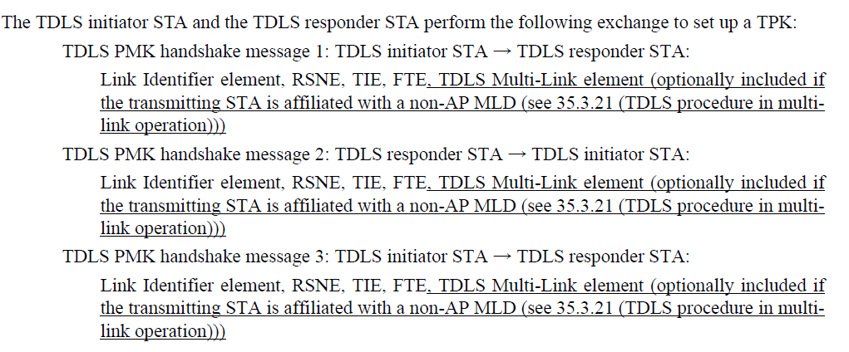

- Looking through both REVme and P802.11be, the use of parenthesis seems to depend on context and varies throughout both drafts.
- For this particular case, the text on 436 could be aligned with the baseline text quoted at 430 and 438

Proposed Resolution: (19500)
REVISED. Make the cited text on page 436 consistent with the cited text at 430 and 438

At 436.16. 436.21, and 436.27, change
“D (see 35.3.21 (TDLS procedure in multi-link operation))”
to
“D; see 35.3.21 (TDLS procedure in multi-link operation)”

