IEEE P802.11
Wireless LANs
LB276 CR for CIDs on Exchange and Reporting
Date: 2023-09-20
Author(s):
Name | Affiliation | Address | Phone | email
Zhanjing Bao | TCL New Technology | TCL International E City, Shenzhen, China 518052 |  | baozhanjing@gmail.com
Abstract
This document proposes resolutions to the following comments submitted in LB276.
CIDs: 3084, 3089, 3105, 3108, 3109, 3132, 3218, 3321
The proposed changes are based on 802.11bf/D2.0.

Revision history:
R0: Original version
R1: The proposed changes are based on 802.11bf/D2.1.
R2: supplementary modification
R3: typo correction

Exchange CIDs: 3084, 3089, 3105, 3109, 3142, 3218

CID | Clause Number | Page | Comment | Proposed Change | Resolution
3084 | 11.55.1.5.2.1 | 144.28 | The term "sensing availability window" occurs in the note before its definition in the next paragraph. | Move the note after its definition. | Accept
3089 | 11.55.1.5.2.1 | 144.28 | "Sensing Availability Window" definition | Define "Sensing Availability Window" before it is used in text | Revised  Agree with the commenter. The note is moved to the position after its related definition.  TGbf Editor: please incorporate changes as in doc.: 11-23/1651r3.
3105 | 11.55.1.5.2.1 | 144.28 | The term "sensing availability window" is not defined before its usage. The term "sensing availability window" occurs in the note before its definition in the next paragraph. | Move the note after its definition. | Accept
3142 | 11.55.1.5.2.6.2 | 144.28 | In the preceding note, the term "sensing availability window" appears just before its definition in the subsequent paragraph. | Shift the note to a position after its definition. | Accept

TGbf Editor: Please revise clause 11.55.1.5.2.1 (General) as below.
If the TF sounding phase is the only sounding phase present in a TB sensing measurement exchange, and if the polling phase is also present, the TF sounding phase shall start a SIFS after the polling phase. If both NDPA sounding phase and TF sounding phase are present in a TB sensing measurement exchange, the TF sounding phase shall start a SIFS after the NDPA sounding phase.

NOTE—A TB sensing measurement exchange that starts with polling phase and receives no CTS-to-self frame from any of the non-AP STAs does not proceed with NDPA and/or TF sounding phase if all STAs are assigned to be polled in the current sensing availability window. In this case, the AP can also start a new back off to access the channel and send another Sensing Polling Trigger frame.

A sensing availability window is a period of time during which an AP and one or more STAs are assigned to participate in TB sensing measurement exchange(s). All TB sensing measurement exchanges shall take place within a sensing availability window. Each sensing availability window may consist of one or more TXOPs, and each TXOP may consist of one or more TB sensing measurement exchanges.

NOTE—A TB sensing measurement exchange that starts with polling phase and receives no CTS-to-self frame from any of the non-AP STAs does not proceed with an NDPA sounding phase or a TF sounding phase(#3083) if all STAs are assigned to be polled in the current sensing availability window. In this case, the AP can also start a new back off to access the channel and send another Sensing Polling Trigger frame.

Within each sensing availability window, the sensing initiator and sensing responder(s) should not transmit
or trigger transmission of any Data frames and instead should only perform sensing activities related to polling, NDPA sounding, TF sounding, reporting, and SBP reporting(#3206).

CID | Clause Number | Page | Comment | Proposed Change | Resolution
3109 | 11.55.1.5.2.4 | 149.40 | Referring to Figure 11-75i and modifying Figure 11-75f, adding roles such as sensing initiator, responder, transmitter, and receiver would be better | As in comment | Revised  Agree with the commenter.  TGbf Editor: please incorporate changes as in doc.: 11-23/1651r3.
3218 | 11.55.1.5.3.3 | 156.22 | If Figure 11-75i is a representative figure for non-TB sensing measurement, similar apperance like Figure 11-75c (which is representative figure for TB sensing measurement) is prefered. Further, move this figure and related explanation to section "11.55.1.5.3.1 General" | As in comment | Revised  Agree with the commenter.  TGbf Editor: please incorporate changes as in doc.: 11-23/1651r3.

TGbf editor: please make the following change in subclause 11.55.1.5.2.4(TF sounding phase).

An AP may perform the frame exchange of transmitting an SR2SI Sounding Trigger frame and soliciting the SR2SI NDP transmission(s) multiple times during the TF sounding phase (see Figure 11-75f (Example of a TF sounding phase that contains multiple SR2SI Sounding Trigger frames)).
Figure 11-75f—Example of a TF sounding phase that contains multiple SR2SI Sounding Trigger frames

TGbf editor: please make the following change in subclause 11.55.1.5.3.1(General).

The SME of the non-AP STA shall issue an MLME-SENSNONTBMSMTRQ.request primitive to request a
non-TB sensing measurement exchange to be performed with the intended AP(#3027). A non-TB sensing
measurement exchange shall always include(#3185) a measurement sounding phase (see 11.55.1.5.3.2
(Measurement sounding phase)). It shall also include(#3185) a reporting phase if the Sensing Measurement
Report Requested field within the Sensing Measurement Request frame that resulted in the non-TB sensing
measurement exchange is set to 1.

Figure 11-75i (A non-TB sensing measurement exchange consisting of a measurement sounding phase and a reporting phase) shows a non-TB sensing measurement exchange consisting of a measurement sounding phase and a reporting phase.
Figure 11-75i—A non-TB sensing measurement exchange consisting of a measurement sounding phase and a reporting phase

The non-AP STA shall set the Min Time Between Measurements field in the Sensing Measurement Request frame taking into account the measurement exchange duration and the AP’s capability indicated in the Min Time Between Measurements field carried in the Sensing Capabilities element.

TGbf editor: please make the following change in subclause 11.55.1.5.3.3 (Reporting phase).

If the reporting phase is present, the AP shall send a Sensing Measurement Report frame to the non-AP STA SIFS after transmitting the SR2SI NDP (see Figure 11-75i (A non-TB sensing measurement exchange consisting of a measurement sounding phase and a reporting phase)).

Figure 11-75i (A non-TB sensing measurement exchange consisting of a measurement sounding phase and a reporting phase) shows a non-TB sensing measurement exchange consisting of a measurement sounding phase and a reporting phase.
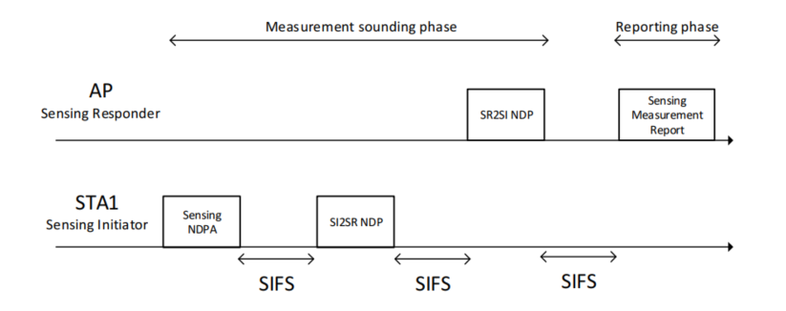

Figure 11-75i—A non-TB sensing measurement exchange consisting of a measurement sounding phase and a reporting phase
The AP shall transmit a Sensing Measurement Report frame corresponding to the sensing measurement results of the SI2SR NDP for either the current non-TB sensing measurement exchange (see Figure 11-75j (Reported sensing measurement results correspond to current sensing measurement exchange)) or for the previous non-TB sensing measurement exchange (see Figure 11-75k (Reported sensing measurement results correspond to previous sensing measurement exchange)) consistently throughout all the subsequent non-TB sensing measurement exchanges associated with the same sensing measurement session. In the latter case, in the first non-TB sensing measurement exchange for a given sensing measurement session, the AP shall set the Invalid Measurement field in the Sensing Measurement Report frame to 1.

Reporting CIDs： 3108, 3321

CID | Clause Number | Page | Comment | Proposed Change | Resolution
3108 | 11.55.1.5.2.6.2 | 153.47 | Based on Figure 11-75h and the definition of the Sending Measurement Report frame, the CSI variation feedback value should be included in the Sending Measurement Report frame and reported in the CSI variation reporting sub-phase | change " Sensing CSI Variation Feedback frame" to "Sensing Measurement Report frame". | Accept
3321 | 11.55.1.5.2.6.2 | 153.47 | There is no such a "Sensing CSI Variation Feedback frame" defined. | Change to: Sensing Measurement Report frame | Accept

SP

Do you support the proposed resolutions to the CIDs 3084, 3089, 3105, 3108, 3109, 3142, 3218, 3321 and incorporate the changes into the latest TGbf draft?

Y/N/A

References: IEEE P802.11bf D2.1

