IEEE P802.11
Wireless LANs
Searchable definitions revisited
Date: 2023-09-13
Author(s):
Name | Affiliation | Address | Phone | email
Robert Stacey | Intel |  | +1-503-724-0893 | robert.stacey@intel.com
Abstract
Revisit the “searchable definitions” topic (REVme CID 3819)

rev: 2012-10-09 (Adrian Stephens)

Background

Minutes for REVme 2022 December AdHoc – Piscataway (11-23/2110r0)

- TGme (REVme AdHoc) Mixed-mode – Wednesday, December 7, 2022, at 9:00-12:00 ET

  - Review Doc 11-22/1993r3 – Youhan KIM (Qualcomm)
    - Document: https://mentor.ieee.org/802.11/dcn/22/11-22-1993-03-000m-definition-acronym.docx

    - CID 3819 (ED1)
      - Review Comment
      - Discussion on how the Searchable terms could be done.
      - Discussion on the alternatives
      - Discussion on process to make the changes.
      - Place “[abbreviation]” after the colon.
      - For now, make incremental change and put searchable terms on right side of colon and not
      - Schedule for Telecon after the Interim.
      - While more changes may be made in the future, we will start with this.
      - The rule in the SA manual:
        - Within text, the acronym or abbreviation should follow the first use of the full term (the first time in the introduction, then the first time in the body of the document, and then the first time in any annexes in which the acronym appears). The abbreviation or acronym should be placed in parentheses when following the full term.

Minutes for REVme 2023 January 27 (11-23/0159r0)

- TGme (REVme) Telecon –Friday, January 27, 2023, at 10:00-12:00 ET

  - CID 3819 (ED1) doc 11-22/1993 Youhan KIM (Qualcomm)
    - https://mentor.ieee.org/802.11/dcn/22/11-22-1993-04-000m-definition-acronym.docx
    - CID 3819 (ED1)
      - Review Comment
      - Review the history of how we got to this point.
      - Review the proposed changes for the definitions.
      - Discussion on the placement of the definition Acronyms.
      - Discussion on use of KCK and KEK acronym. – Do we want to move to right of colon.
      - Question on DL-MU-MIMO? Two hyphens or one. Leave with both as it is as it was. Referencing CID 3367, on "DL-" or "DL<sp>"
        - From database: CID 3367: REVISED (ED1: 2023-01-06 20:48:00Z) -
        - Change “DL-MU-MIMO” to “DL MU-MIMO” throughout the draft. 43 instances.
        - For now, Youhan will remove first hyphen in his doc to make incorporation easier in future.
      - Question on definition that may be deleted later today – leave it as is for now.
      - Discussion on how the choices for when the end Acronyn was moved from left to right of the colon.
      - A rule for how to explain this plan should be included in the Style Guide.
      - Proposed Resolution: CID 3819 (ED1): Revised. Incorporate the changes in 11-22/1993r5 (https://mentor.ieee.org/802.11/dcn/22/11-22-1993-05-000m-definition-acronym.docx).
      - No objection – Mark Ready for Motion

Discussion from 11-22/1993r5

IEEE publication editor was also consulted, who advised not to put acronyms ‘within’ the definition name as that affects the ‘database’ for the acronyms. While this seems to indicate that even the existing acronyms should be removed from the clause 3 definition terms, TGme decided to make incremental change:
- Add the full acronym for the definition terms (where necessary)
- Add the acronym after the colon, i.e., outside the definition “name”

What is the practise in other standards?

Example from 802.1X-2010:

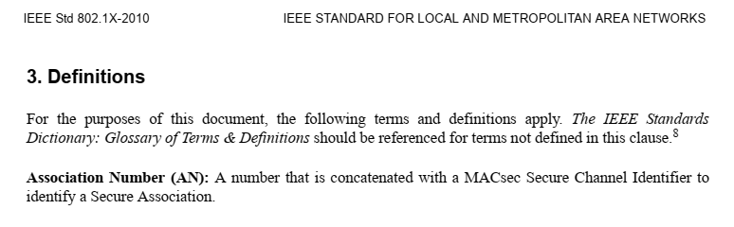

Example from 802.3-2022:
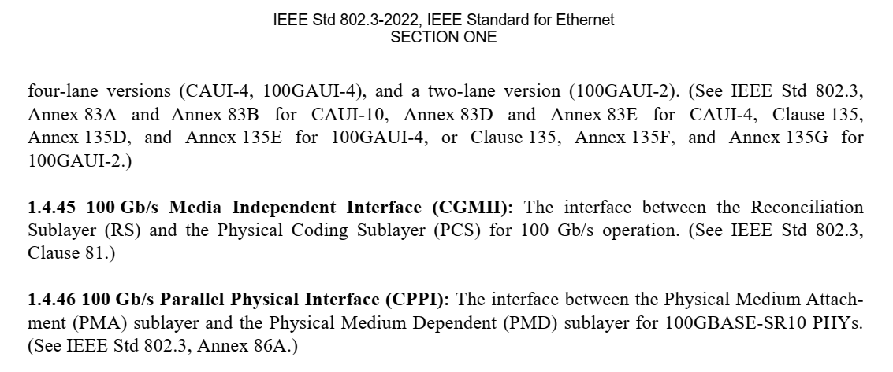

Example from P802 REVc/D0.2:

Discussion

I agree with the new practice of adding the searchable term in square brackets after the colon; this helps find instances where the term is obscured by acronym expansion.

For example,

access point (AP) reachability: [AP reachability] An AP is reachable by a station (STA) if preauthentication messages can be exchanged between the STA and the target AP via the distribution system (DS).

Allows the reader to easily find the definition with a search for “AP reachability”.

However, I disagree with the practise of moving the acronym into square brackets after the colon.

For example,
access point: [AP] An entity that contains one station (STA) and provides access to the distribution system services, via the wireless medium (WM) for associated STAs. An AP comprises a STA and a distribution system access function (DSAF).

This makes no difference at all to searchability, i.e., it is not fixing the problem identified in the original comment.

This is inconsistent with the practise in other working groups.

This is inconsistent with the practice in the rest of the standard.

Proposed practice

I propose that we adopt the following practice by updating our style guide as follows:

3.1 Definitions (Clause 3)
Subclause 3.1 contains definitions that are consolidated by IEEE into a single publication of general definitions for terms used in IEEE standards (e.g. IEEE Standards Dictionary Online). Any definition that is considered “generally applicable in the industry” should be included in 3.1. All acronyms in subclause 3.1 have to be expanded on first use within each definition.

Many definitions that appear in 802.11 are more local, and have no meaning or significance outside of this particular document. Such definitions should be included in 3.2.

For example, the term “cipher suite” (a set of one or more algorithms designed to provide data confidentiality, data authenticity or integrity, and/or replay protection) is applicable outside of the 802.11 standard, and is included in 3.1. The term “Michael” (The message integrity code for the Temporal Key Integrity Protocol) is included in 3.2.

Abbreviations used in definitions should be spelled out in full on their first use in each definition.
Example, “access point (AP): An entity that contains one station (STA) and provides access to the distribution system services, via the wireless medium (WM) for associated STAs. An AP comprises a STA and a distribution
system access function (DSAF).”

If the expansion of an acronym in the term being defined prevents a search for the term finding the definition, then the searchable term may be added in square brackets after the colon.

Example: “access point (AP) path: [AP path] Path between two tunneled direct-link setup (TDLS) peer stations (STAs) via the AP with which the STAs are currently associated.”

Definitions should appear in alphabetical order. In addition, following rules apply:
- spaces sort earlier than letters or digits
- digits sort earlier than letters (but numbers sort in numeric order, e.g. 2 is before 10)
- ignore (treat as not present) everything that is not an ASCII alphanumeric or space, including hyphens
- ignore (treat as equivalent) case of letters
- ignore (treat as not present) stuff in parentheses.

References:

