IEEE P802.11
Wireless LANs
Comment resolution for CIDs 3279 and 3346
Date: 2023-09-14
Author(s):
Name | Affiliation | Address | Phone | email
Chaoming Luo | OPPO |  |  | luochaoming@oppo.com
Abstract
This submission resolves CID 3279 and 3346.

Revisions:

- Rev 0: Initial version of the document.
- Rev 1: Change resolution for 3279 to revised.
- Rev 2: Editorial change in resolution of 3279, and defer it

CID 3279

CID | Clause | Page | Comment | Proposed Change | Resolution
3279 | 35.3.14.1 | 205.01 | Sensing procedure is a per-link basis procedure. The Sensing Report frames shall be transmitted in the measurement sequence, hence should not be transmitted in another link in an MLD. | Add Sensing Report frames into the frame list at the beginning of 35.3.14.1 of Draft P802.11be_D4.0 | Revised.  In short, the frames list at the beginning of 35.3.14.1 are not supposed to be transmitted to another STA (other than the intended STA) affiliated with the MLD.  TGbf editor to add the following into the frame list at the beginning of 35.3.14.1 of 11be D4.0:  - Public Action Sensing Measurement Report frame  - Public SBP Report frame  - Protected Sensing Measurement Report frame  - Protected SBP Report frame

Reference text (in 11be D4.0):
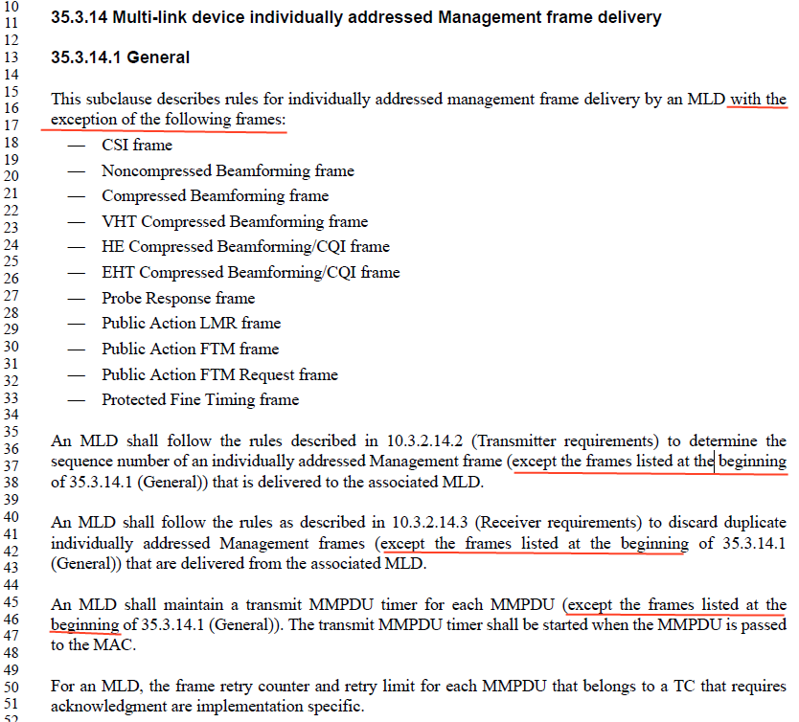
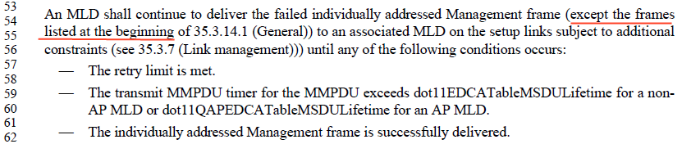

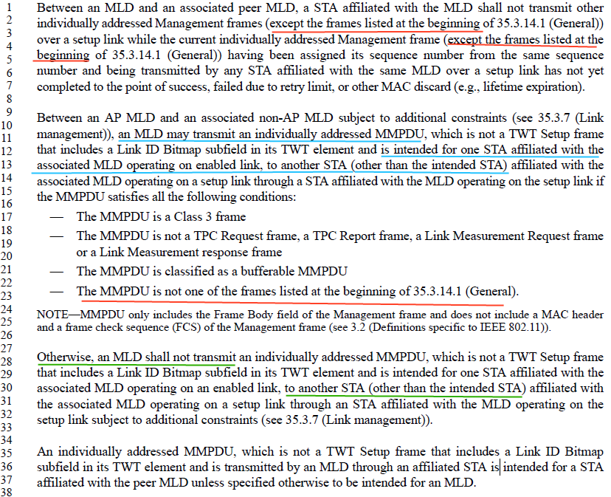
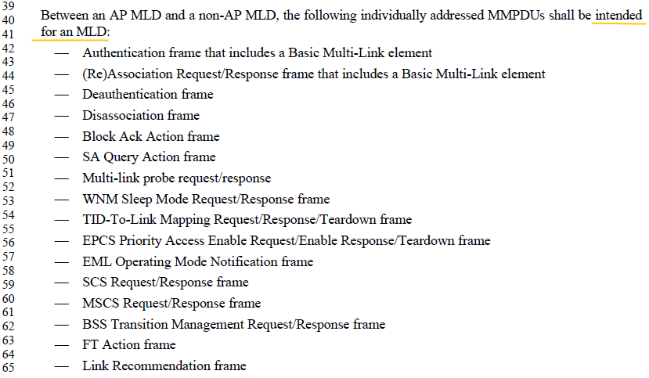

Clause 35.3.14.3 Identification of the intended STA specifies to include an MLO Link Information element that identifies the intended link of the MMPDU.

CID 3346

CID | Clause | Page | Comment | Proposed Change | Resolution
3346 | 12.5.2.4.4 | 194.40 | It is unnecessary to repeat that the To DS subfield is equal to 1, as the requirement only applies to individually addressed robust Management frames with the To DS subfield equal to 1. | Delete "that are received with the To DS subfield equal to 1" | Revised.  Agree with the commentor and apply same change in clause 12.5.4.4.4 too.  TGbf editor to make the changes shown in Https://mentor.ieee.org/802.11/dcn/23/11-23-1577-02-00bf-lb276-cids-3279-3346.docx under all headings that include CID 3346

Reference text:
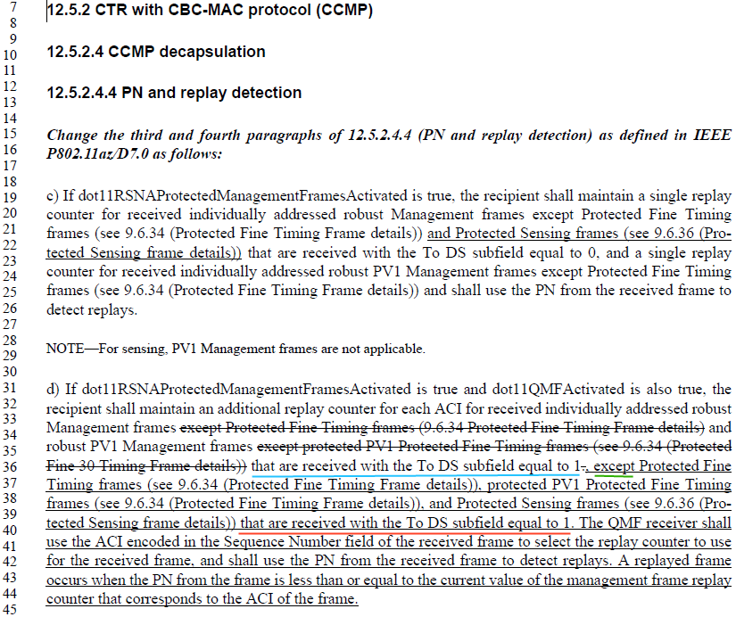

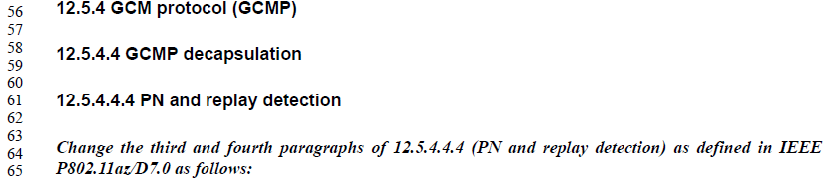
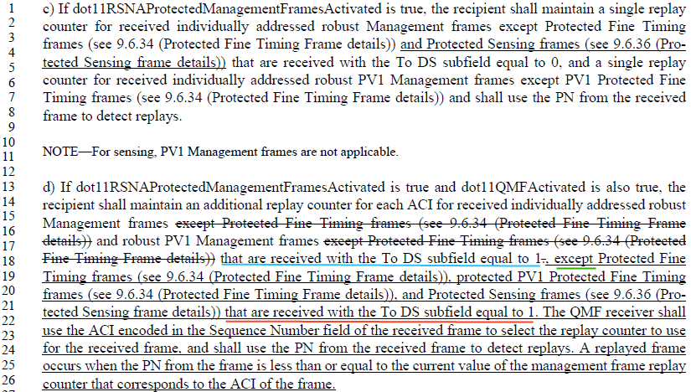

Resolution:

12.5.2.4.4 PN and replay detection
TGbf Editor: please change P194L40 in D2.0 as follows (marked in blue):
d) If dot11RSNAProtectedManagementFramesActivated is true and dot11QMFActivated is also true, the
recipient shall maintain an additional replay counter for each ACI for received individually addressed robust
Management frames except Protected Fine Timing frames (9.6.34 Protected Fine Timing Frame details) and
robust PV1 Management frames except protected PV1 Protected Fine Timing frames (see 9.6.34 (Protected
Fine 30 Timing Frame details)) that are received with the To DS subfield equal to 1., except Protected Fine
Timing frames (see 9.6.34 (Protected Fine Timing Frame details)), protected PV1 Protected Fine Timing
frames (see 9.6.34 (Protected Fine Timing Frame details)), and Protected Sensing frames (see 9.6.36 (Protected
Sensing frame details)) that are received with the To DS subfield equal to 1 (3346). The QMF receiver shall
use the ACI encoded in the Sequence Number field of the received frame to select the replay counter to use
for the received frame, and shall use the PN from the received frame to detect replays. A replayed frame
occurs when the PN from the frame is less than or equal to the current value of the management frame replay
counter that corresponds to the ACI of the frame.

12.5.4.4.4 PN and replay detection
TGbf Editor: please change P195L21 in D2.0 as follows (marked in blue):
d) If dot11RSNAProtectedManagementFramesActivated is true and dot11QMFActivated is also true, the
recipient shall maintain an additional replay counter for each ACI for received individually addressed robust
Management frames except Protected Fine Timing frames (see 9.6.34 (Protected Fine Timing Frame
details)) and robust PV1 Management frames except Protected Fine Timing frames (see 9.6.34 (Protected
Fine Timing Frame details)) that are received with the To DS subfield equal to 1., except Protected Fine
Timing frames (see 9.6.34 (Protected Fine Timing Frame details)), protected PV1 Protected Fine Timing
frames (see 9.6.34 (Protected Fine Timing Frame details)), and Protected Sensing frames (see 9.6.36 (Protected
Sensing frame details)) that are received with the To DS subfield equal to 1(3346). The QMF receiver shall
use the ACI encoded in the Sequence Number field of the received frame to select the replay counter to use
for the received frame, and shall use the PN from the received frame to detect replays. A replayed frame
occurs when the PN from the frame is less than or equal to the current value of the management frame replay
counter that corresponds to the ACI of the frame.

SP
Do you support resolutions to the following CID and incorporate the text changes into the latest TGbf draft:3346, in 11-23/1577r2

Y/N/A

