IEEE P802.11
Wireless LANs
LB275 CR for CID 19443
Date: 2023.09.11
Author(s):
Name | Company | Address | Phone | email
Mengshi Hu | Huawei Technologies | F3, Huawei Base, Bantian, Longgang, Shenzhen, Guangdong, China, 518129 |  | humengshi@huawei.com
Ming Gan
Abstract
This submission contains the proposed comment resolution for a CID in 23/1375 IEEE 802.11be LB275 comments:

CID 19443 in subclause 35.13 (Nominal packet padding values selection rules) is resolved.

.
Revision Notes
R0 | Initial revision

CID 19443
CID | Page.  Line | Clause Number | Comment | Proposed Change | Resolution
19443 | 627.64 | 35.13.4 | NSS is used on P627L64, but N_{SS} is used on P625L28L34L41. Should keep consistent because they are in same subcuase and talking about similar technical things. | As in the comment. | REVISED.  Agree with the commenter in principle.  Instructions to the editor:  Please make the changes as shown under CID 19443 in 11-23/1574r0.
Discussion (the related text is shown below):
- [P627, L64] in 802.11be D4.0 mentioned by the commenter:
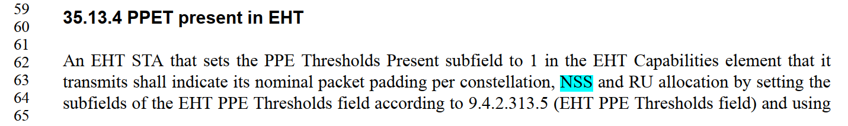
- [P625, L28 L34 L41] in 802.11be D4.0 mentioned by the commenter:
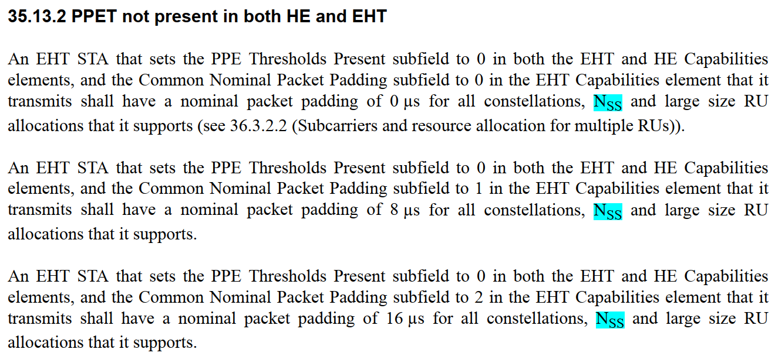
- [P3964, L7] in 802.11Revme D4.0 (Releted text in 11ax):
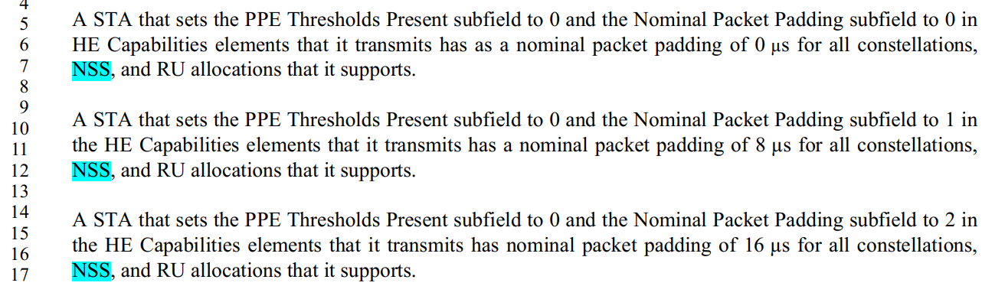

Instructions to the editor: please make the following changes to Page 625, Line 28 in the subclause 36.3.13.5 (Nominal packet padding values selection rules) in D4.0 as shown below:
An EHT STA that sets the PPE Thresholds Present subfield to 0 in both the EHT and HE Capabilities elements, and the Common Nominal Packet Padding subfield to 0 in the EHT Capabilities element that it transmits shall have a nominal packet padding of 0 µs for all constellations, NssNSS and large size RU allocations that it supports (see 36.3.2.2 (Subcarriers and resource allocation for multiple RUs)).

An EHT STA that sets the PPE Thresholds Present subfield to 0 in both the EHT and HE Capabilities elements, and the Common Nominal Packet Padding subfield to 1 in the EHT Capabilities element that it transmits shall have a nominal packet padding of 8 µs for all constellations, NssNSS and large size RU allocations that it supports.

An EHT STA that sets the PPE Thresholds Present subfield to 0 in both the EHT and HE Capabilities elements, and the Common Nominal Packet Padding subfield to 2 in the EHT Capabilities element that it transmits shall have a nominal packet padding of 16 µs for all constellations, NssNSS and large size RU allocations that it supports.

