IEEE P802.11
Wireless LANs
TGbe LB275 CR on 36.3.12.10
Date: 2023-09-11
Author(s):
Name | Affiliation | Address | Phone | Email
Jinyoung Chun | LG Electronics | 19, Yangjae-daero 11gil, Seocho-gu, Seoul 137-130, Korea |  | jiny.chun@lge.com
Dongguk Lim |  |  |  | dongguk.lim@lge.com
Eunsung Park |  |  |  | esung.park@lge.com
Insik Jung |  |  |  | insik0618.jung@lge.com
Jinsoo Choi |  |  |  | js.choi@lge.com

Abstract
This submission proposes comment resolutions for 6 CIDs: 19393, 19537, 19444, 19544, 19008, and 19007.
All the changes are based on P802.11be D4.0.

Revisions:
- Rev 0: Initial version of the document.
- Rev 1: Editorial change
- Rev 2: Modify the resolution about the deferred CID 19544

CID 19393 and 19007
CID | Commenter | Category | Page | Comment | Proposed Change | Resolution
19393 | Yapu Li | G | 810.31 | The Q matrix definition should be further referenced to subclause 36.3.11.4.  Also in P810L56, P818L27, P847L53. | As in comment | Revised  Agree with the commenter, and also suggest deleting Q_{k} in P818L27 by CID 19007.  Note to Editor:  Please modify the text in P810L31, P810L56, P818L27, P847L53 to “Q_{k,u} is defined in 36.3.11.4 (Transmitted signal)”.
19007 | Xiaogang Chen | T | 818.27 | no Q_k anymore | remove Q_k | Revised  Agree with the commenter.  Same resolution with CID 19393
Background in P810.31, P810L56, P847L53 of 11be D4.0:
Background in P818L27 of 11be D4.0:
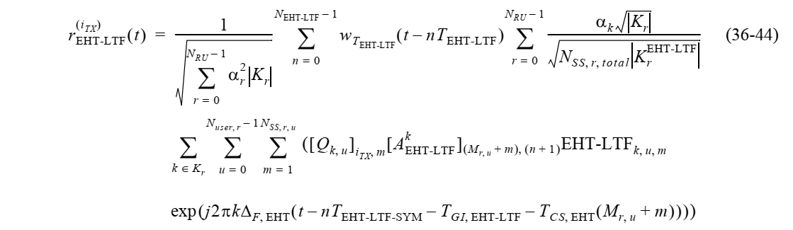
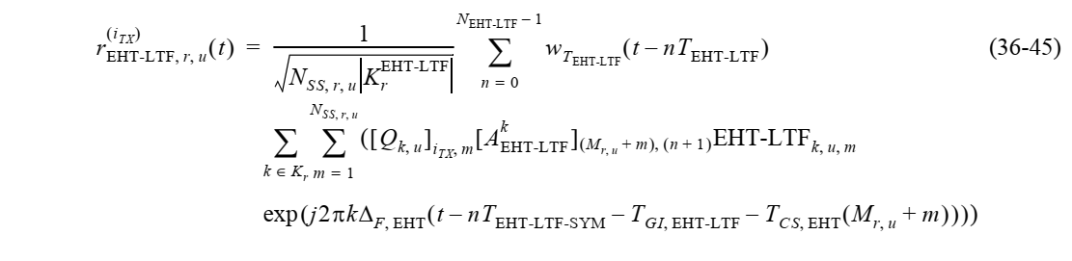
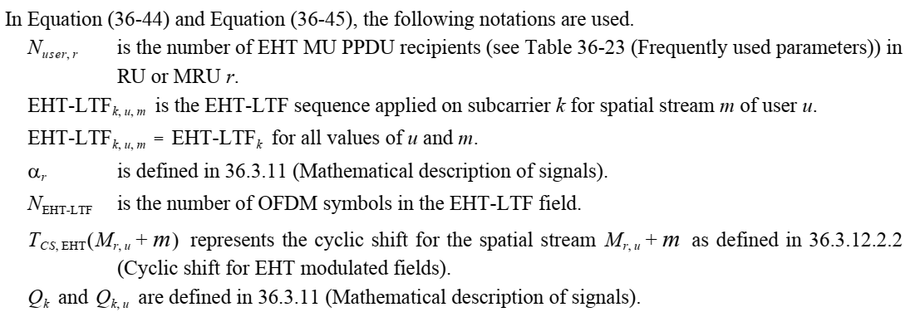
Background: Q matrix definition in subclause 36.3.11.4 (P750) of 11be D4.0:
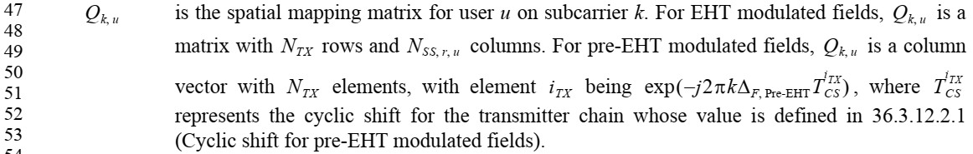

CID 19537
CID | Commenter | Category | Page | Comment | Proposed Change | Resolution
19537 | Sigurd Schelstraete | T | 812.54 | "The duration of each EHT-LTF symbol excluding GI is T_EHT-LTF, defined in Equation (36-37).".  In fact, T_EHT-LTF is already defined in Table 36-18. Why repeat it here? | Refer to Table 36-18 instead of explicitly defining T_EHT-LTF here. | Revised  Agree with the commenter and modify the sentence as below.  Note to Editor:  Please modify the text in P812L54 to “T_{EHT-LTF}, described in Table 36-18 (Timing-related constrants), is given by Equation (36-37).”
Background:
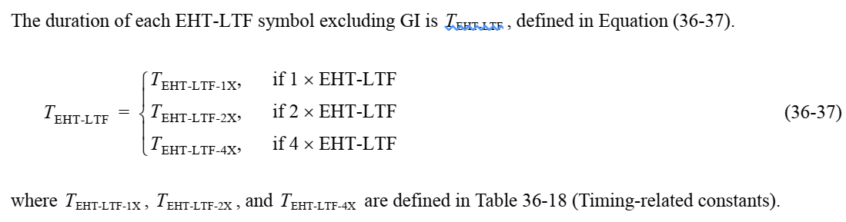
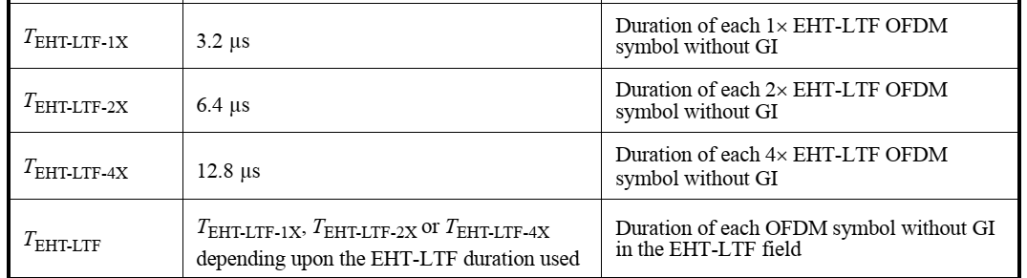

CID 19444
CID | Commenter | Category | Page | Comment | Proposed Change | Resolution
19444 | ZHI MAO | E | 814.13 | Equation of sequence LTF80MHz_2x should use "{}" rather than "[]", similar changes should be made to equations on P815L3 and P815L29. | As in the comment. | Accepted
Background:
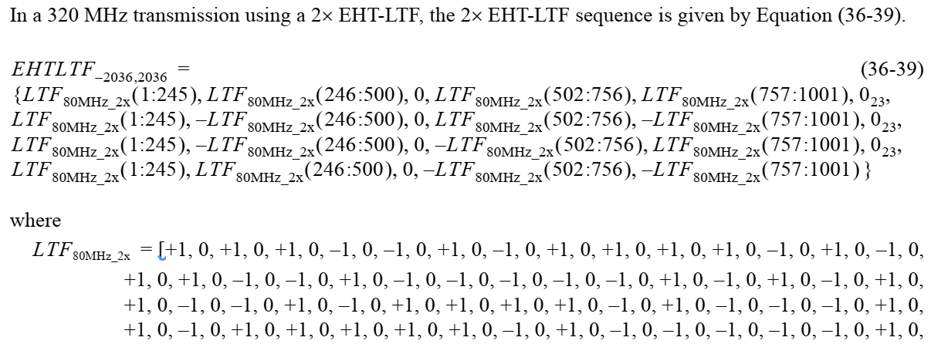
…
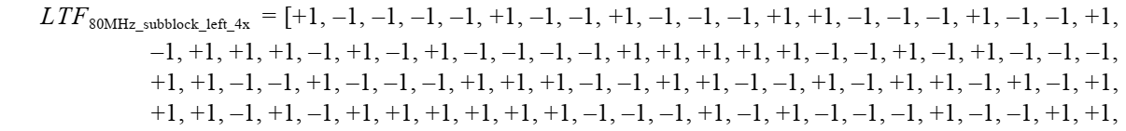
…

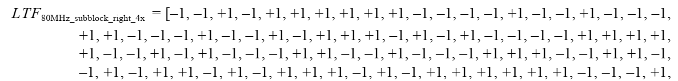
…

CID 19544
CID | Commenter | Category | Page | Comment | Proposed Change | Resolution
19544 | ron porat | E | 816.07 | There is no definition of "punctured RU" |  | Revised  Agree with the commenter.  Note to Editor:  Please modify the text in P816L07 to “~ for all subcarriers that are unassigned or punctured as well ~”
Background: text in Page 816 of 11be D4.0

CID 19008
CID | Commenter | Category | Page | Comment | Proposed Change | Resolution
19008 | Xiaogang Chen | T | 817.46 | alpha_k should be alpha_r | change to alpha_r | Revised  Agree with the commenter and add some clarification by modifying the reference to 36.3.11.4 (Transmitted signal).  Note to Editor:  Please modify “α_{k}” to “α_{r}” in equation (36-44) of P817L46. And modify the text in P818L21 to “α_{r} is defined in 36.3.11.4 (Transmitted signal)”.
Background text in P817 L46 and P818L21 of 11be D4.0:
