IEEE P802.11
Wireless LANs
LB275 CR for Segment Parser
Date: 2023.09.10
Author(s):
Name | Company | Address | Phone | email
Mengshi Hu | Huawei Technologies | F3, Huawei Base, Bantian, Longgang, Shenzhen, Guangdong, China, 518129 |  | humengshi@huawei.com
Ming Gan
Abstract
This submission contains the proposed comment resolutions of CIDs in 23/1375 IEEE 802.11be LB275 comments.

4 comments in subclause 36.3.13.5 (Segment Parser) are resolved.

Resolved CIDs: 19011, 19012, 19170, and 19171.
Revision Notes
R0 | Initial revision

CID 19011
CID | Page.  Line | Clause Number | Comment | Proposed Change | Resolution
19011 | 830.15 | 36.3.13.5 | "for fully occupied frequency subblock l with nonzero leftover bits, for  partially occupied frequency subblock l with no leftover bits needed." later on p831, last row. we have "(i.e., the frequency subblock without leftover bits)" Those text are used to differentiate different frequency subblocks either fully occupied or partially occupied but language are not quite consistent. | suggest to change text in 830.15 to: ...for  partially occupied frequency subblock l with zero leftover bits.  suggest to change text in p831 last row to: i.e. the partially occupied frequency subblock with zero leftover bits. | REVISED.  Agree with the commenter that the wording can be improved.  In addition, when resolving this CID, I found that the following case was missing in the output calculation of the segment parser: $n_{l}=0$ for fully occupied frequency subblock l with zero leftover bits (i.e., 2×996-, 3×996-, and 4×996-tone RU or MRU). This missing part is also added to enable the output calculation of these RU or MRUs.  Instructions to the editor:  Please make the changes as shown under CID 19011 in 11-23/1566r0.
Discussion 1 (the related text is shown below):
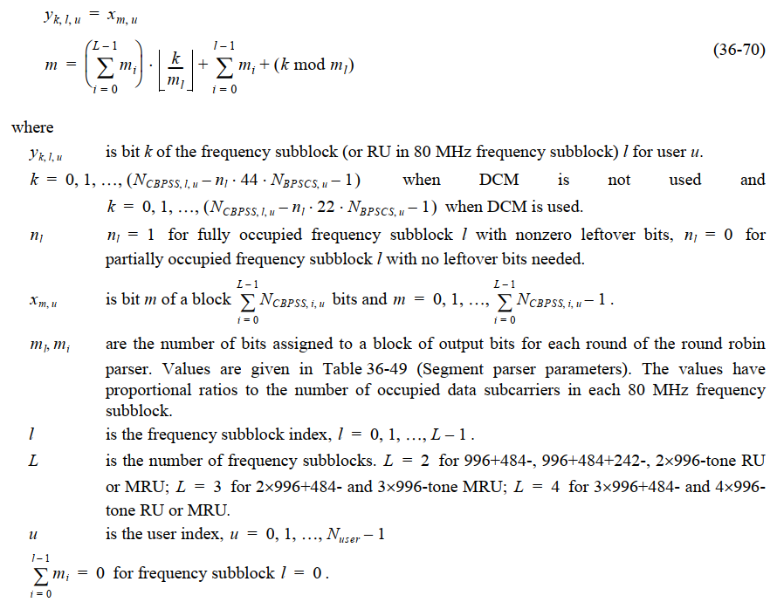
Discussion 2 (the related table is shown below):
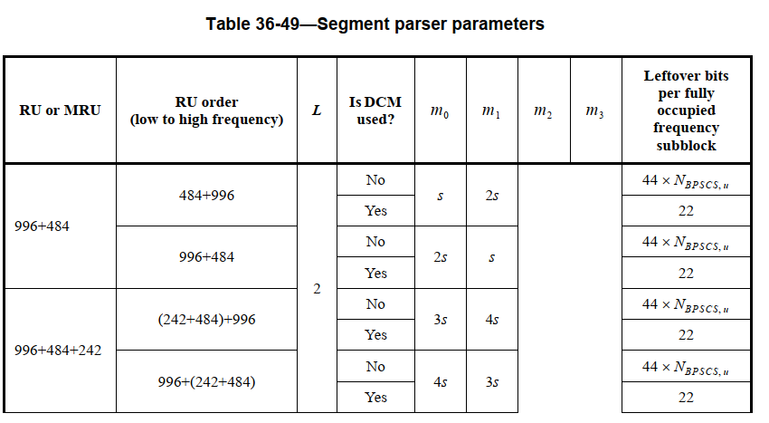
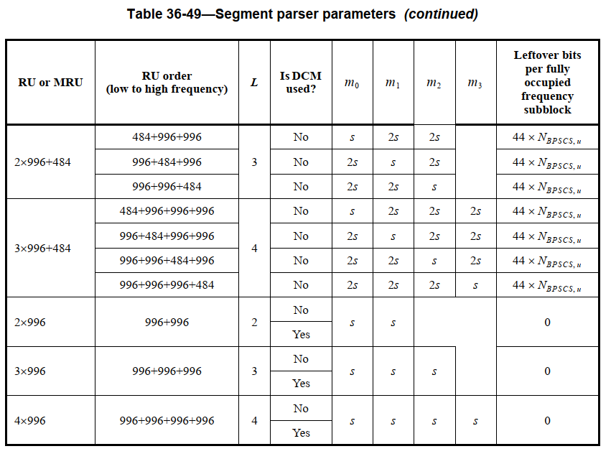
Instructions to the editor: please make the following changes to Page 830, Line 15 in the subclause 36.3.13.5 (segment parser) in D4.0 as shown below:
$n_{l}=1$ for fully occupied frequency subblock $l$ with nonzero leftover bits, $n_{l}=0$ for partially or fully occupied frequency subblock $l$ with zero leftover bits.
Instructions to the editor: please make the following changes to Page 831, Line 62 in the subclause 36.3.13.5 (segment parser) in D4.0 as shown below:
$l_{0}$ is the subblock index with $n_{l_{0}}=1$ (i.e., the partially occupied frequency subblock with zero leftover bits).

CID 19012
CID | Page.  Line | Clause Number | Comment | Proposed Change | Resolution
19012 | 831.50 | 36.3.13.5 | in equation 36-71, clarify the sigma_i=0,i!=l_0 m_i =0 for l = 0. This term is not exactly the one defined for 36-70. better to clarify to avoid misunderstanding | as proposed in the comment | REVISED.  Agree with the commenter that this term can be further clarified.  Instructions to the editor:  Please make the changes as shown under CID 19012 in 11-23/1566r0.

Discussion (the related text is shown below):
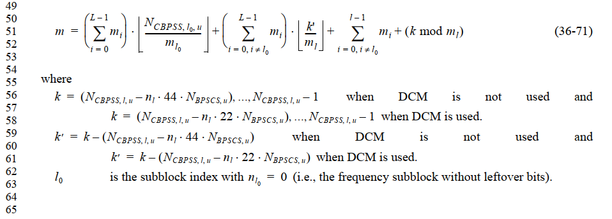
Note that for the equation (36-70), the following clairification exists:
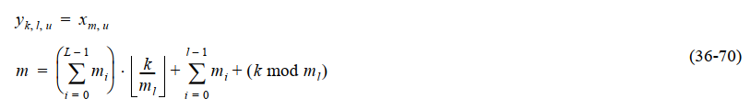
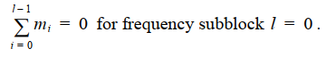
Similar to the above description, a clairification can also be added for the similar term in equation (36-71).

Instructions to the editor: please add the following part to Page 831, Line 64 in the subclause 36.3.13.5 (segment parser) in D4.0 as shown below:
i=0, i≠l0l-1mi=0 for frequency subblock $l=0$.

CID 19170
CID | Page.  Line | Clause Number | Comment | Proposed Change | Resolution
19170 | 830.23 | 36.3.13.5 | It is not accurate to state that "The values have  proportional ratios to the number of occupied data subcarriers in each 80 MHz frequency  subblock". Actually, the number of bits assigned to a block of output bits for each round of the round robin parser is not exactly proportional to the number of occupied data subcarriers in each 80 MHz frequency subblock. | Please change the original sentences to "The values are approximately proportional to the number of occupied data subcarriers in each 80 MHz frequency subblock" | REVISED.  Agree with the commenter that the wording can be improved.  Instructions to the editor:  Please make the changes as shown under CID 19170 in 11-23/1566r0.
Discussion (the related text is shown below):
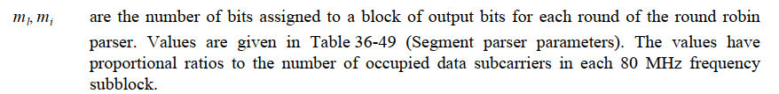

Instructions to the editor: please make the following changes to Page 830, Line 23 in the subclause 36.3.13.5 (segment parser) in D4.0 as shown below:
$m_{l}, m_{i}$ are the number of bits assigned to a block of output bits for each round of the round robin parser. Values are given in Table 36-49 (Segment parser parameters). The values are proportional or approximately proportional to the number of occupied data subcarriers in each 80 MHz frequency subblock.

CID 19171
Page.  Line | Page.  Line | Clause Number | Comment | Proposed Change | Resolution
19171 | 831.36 | 36.3.13.5 | In Table 36-49 (Segment parser parameters), the calculation of s does not consider BPSK. When it is BPSK, s is equal to 0 in one axis (real or imaginary) in a constellation point. | Please specify the calculation of s when BPSK is applied. | REJECTED.  This calculation of s is widely used in the stream parser and segment parser in many PHY versions. The case of BPSK is already considered in the calculation (s=1 in the case of BPSK).
Discussion
The case of BPSK is already considered in the calculation of $s$:
In the case of BPSK, $N_{BPSCS,u}=1$. If $\frac{N_{BPSCS,u}}{2}$ is used, $s$ is equal to a non-integer value. To avoid this, the following equation is used.

