IEEE P802.11
Wireless LANs
TGbe LB275 CR on 9.4.1.68 and 9.4.1.69
Date: 2023-09-11
Author(s):
Name | Affiliation | Address | Phone | Email
Jinyoung Chun | LG Electronics | 19, Yangjae-daero 11gil, Seocho-gu, Seoul 137-130, Korea |  | jiny.chun@lge.com
Dongguk Lim |  |  |  | dongguk.lim@lge.com
Eunsung Park |  |  |  | esung.park@lge.com
Insik Jung |  |  |  | insik0618.jung@lge.com
Jinsoo Choi |  |  |  | js.choi@lge.com

Abstract
This submission proposes comment resolutions for 2 CIDs: 19362, 19363
All the changes are based on P802.11be D4.0

Revisions:
- Rev 0: Initial version of the document.

CID 19362
CID | Commenter | Category | Page | Comment | Proposed Change | Resolution
19362 | Brian Hart | T | 205.52 | There is not a single RU edge nor a single DC tone | Pluralize these. Try "generally around the RU edges and the DC tones" | Accepted
Background in page 205 of 11be D4.0:
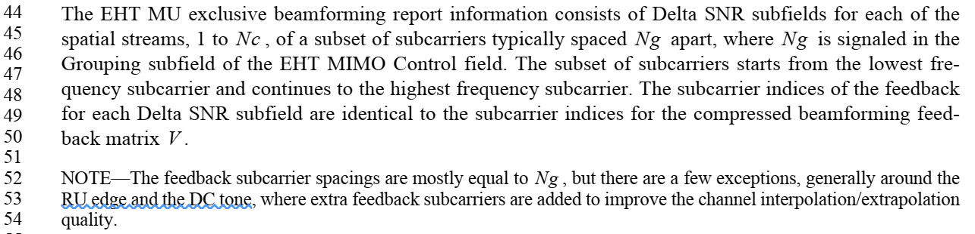

CID 19363
CID | Commenter | Category | Page | Comment | Proposed Change | Resolution
19363 | Brian Hart | T | 206.44 | "in RU index k" is misleading (probably just bad grammar). Here RU is a modifier to "k" and we don't average over subcarriers in k. This is a repeat of CID 17511 which was rejected with reason "As shown in table 9-127, k indicates the index of RU to calculate the average SNR over the subcarriers in RU index k." which is true but doesn't address the actual comment. | Try "in the RU with index k" or "in the RU indexed by k" | Rejected  The RU index k is used from 11ax, and there’s some description in REVme as the below. So it’s better to keep the wording for consistency.

Background: text in page 206 of 11be D4.0:
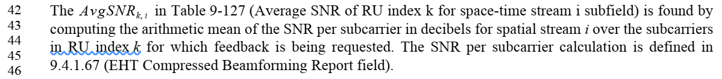
Background: the related parts in 11REVme D3.0:
