IEEE P802.11
Wireless LANs

LB275 CR for CID 19392, 19533
Date: 2023-09-11
Author(s):
Name | Affiliation | Address | Phone | email
Yapu Li | OPPO | 15F, Building A2, Central Park Plaza, Chao Yang, Beijing, China |  | liyapu1@oppo.com

Abstract
This submission contains proposed comment resolutions to the following CID based on P802.11be D4.0.

CID 19392, 19533

Revisions:

- Rev 0: Initial version of the document.
-

CID 19392, 19533

CID | Page.  Line | Clause | Comment | Proposed Change | Resolution
19392 | 746.58 | 36.3.11.4 | Figure 36-29 is missing the EHT-SIG field. | Add EHT-SIG field. | Revised  Agree with commenter. The EHT-SIG field is added in figure 36-29.  Instructions to the editor:  Please make the changes to the spec as shown in 11/23-1558r0 under CID 19392.
19533 | 746.60 | 36.3.11.4 | Figure 36-29 appears to be missing EHT-SIG. This figure is supposed to apply to both MU and TB PPDUs. | Correct figure | Revised  Agree with commenter. The EHT-SIG field is added in figure 36-29.  Instructions to the editor:  Please make the changes to the spec as shown in 11/23-1558r0 under CID 19533.

Discussion:
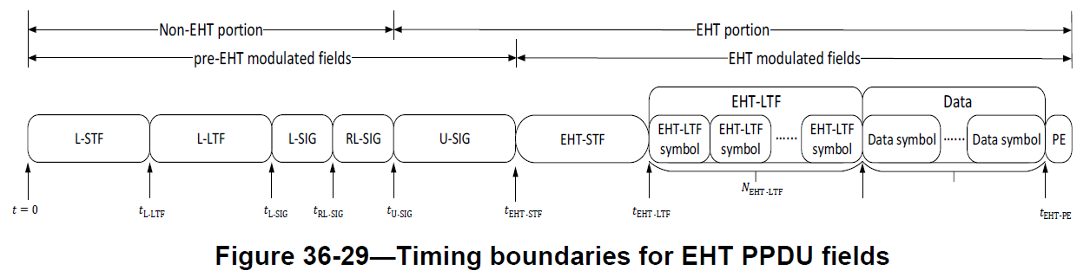

TGbe editor:
Please replace Figure 36-29 with the following figure:

Figure 36-29—Timing boundaries for EHT PPDU fields

