IEEE P802.11
Wireless LANs
LB 275 comment resolutions for CRs in EHT PHY Capabilities Information
Date: 2023-09-05
Author(s):
Name | Affiliation | Address | Phone | email
Kanke Wu | Qualcomm Inc |  |  | kankew@qti.qualcomm.com
Bin Tian | Qualcomm Inc

Abstract
This submission proposes resolutions for the following 2 comments from LB275 in P802.11be D4.0:
19083, 19376
This proposed text changes in this document are based on TGbe Draft 4.0

Revisions:

- Rev 0: Initial version of the document.

CID 19083
CID | Clause | Page.Line | Comment | Proposed Change | Resolutions
19083 | 9.4.2.313.3 | 270.06 | why specific for "non-OFDMA" ? | Remove "non-OFDMA" or modified as "for PPDU bandwidth of 320 MHz" | Rejected  Non-OFDMA is needed here because an 80MHz STA can still participate in 320MHz OFDMA transmission and reception and support 320MHz PPDU. The non-OFDMA descriptor here is to ensure that the STA can indeed support 320MHz in 6GHz.

  - Background
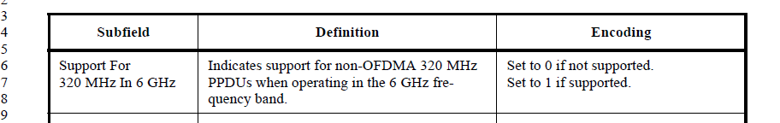

CID 19376
CID | Clause | Page.Line | Comment | Proposed Change | Resolutions
19376 | 9.4.2.313.3 | 275.31 | As written "Set to 0 if not supported" and "Set to 1 if supported" apply for the whole field not individual bits of the field, which is surely not the intent | Try "Bx: set to 0 if x not supported / Bx: set to 1 if x supported / for x = 0, 1,, 2 and 3." or similar | Revised  Agree with the commenter to clarify the language.  Instruction to the editor:  Please change the 3rd column at P275.31 to the following:  “B0:  Set to 0 if transmission and reception of EHT-MCS 15 in 52+26-tone and 105+26-tone MRUs is not supported.  Set to 1 if transmission and reception of EHT-MCS 15 in 52+26-tone and 105+26-tone MRUs is supported.  B1:  Set to 0 if transmission and reception of EHT-MCS 15 in a 484+242-tone MRU is not supported.  Set to 1 if transmission and reception of EHT-MCS 15 in a 484+242-tone MRU is not supported.  B2:  Set to 0 if transmission and reception of EHT-MCS 15 in a 996+484+242-tone MRU is not supported.  Set to 1 if transmission and reception of EHT-MCS 15 in a 996+484+242-tone MRU is supported.  B3:  Set to 0 if transmission and reception of EHT-MCS 15 in a 3x996-tone MRU is not supported.  Set to 1 if transmission and reception of EHT-MCS 15 in a 3x996-tone MRU is not supported.  If 80 MHz is not supported, then B1, B2, and B3 are set to 0.  If 160 MHz is not supported, then B2 and B3 are set to 0.  If 320 MHz is not supported, then B3 is set to 0.

  - Background
