IEEE P802.11
Wireless LANs
LB 275 comment resolutions for CRs in PHY introduction
Date: 2023-09-05
Author(s):
Name | Affiliation | Address | Phone | email
Kanke Wu | Qualcomm Inc |  |  | kankew@qti.qualcomm.com
Bin Tian | Qualcomm Inc

Abstract
This submission proposes resolutions for the following 15 comments from LB275 in P802.11be D4.0:
19118, 19883, 19884, 19531, 19732, 19084, 19885, 19174, 19886, 19082,
19887, 19085, 19119, 19120, 19175
This proposed text changes in this document are based on TGbe Draft 4.0

Revisions:

- Rev 0: Initial version of the document.

CID 19118
CID | Clause | Page.Line | Comment | Proposed Change | Resolutions
19118 | 36.1.1 | 652.59 | Description on "The EHT PHY supports a symbol duration, excluding GI, of 3.2 µs for the pre-EHT modulated fields and  12.8 µs for the Data field in an EHT PPDU" isn't clear and misaligns with that in Draft P802.11REVme_D3.1,subclause 27.1.1, Page 3996, line2 | The EHT PHY supports a symbol duration, excluding GI, a DFT period of 3.2 µs for the pre-EHT modulated fields and  12.8 µs for the Data field in an EHT PPDU | Accepted
  - Background

CID 19883, 19884
CID | Clause | Page.Line | Comment | Proposed Change | Resolutions
19883 | 36.1.1 | 653.38 | Simplify the sentence "Both DL MU-MIMO and UL MU-MIMO transmissions are supported on portions of the PPDU bandwidth (on resource units greater than or equal to 242 tones)" | Change the sentence to "Both  DL MU-MIMO and UL MU-MIMO transmissions are supported on resource units greater than or equal to 242 tones" | Revised  The original sentence emphasis support of partial-bandwidth MU-MIMO, the suggested sentence doesn’t quite reflect that.  Instruction to the editor:  Please change the sentence at P653.38:  “Both DL MU-MIMO and UL MU-MIMO transmissions are supported on portions of the PPDU bandwidth (on resource units greater than or equal to 242 tones)”To:  “Both DL MU-MIMO and UL MU-MIMO transmissions are supported on both the entire PPDU bandwidth and portions of the PPDU bandwidth, with the assigned resource unit of size greater than or equal to 242 tones.”
19884 | 36.1.1 | 653.40 | There is no such a thing called "MU-MIMO resource unit". | Change the start of the sentence to "In an MU-MIMO transmission on a resource unit, ..." | Revised  Agree with the commenter that there’s no MU-MIMO resource unit. Changed the language a little to reflect the suggested change.  Instruction to the editor:  Please change the sentence at P653.40:  “In an MU-MIMO resource unit,…” To:  “On a resource unit utilizing MU-MIMO transmission,…”
  - Background
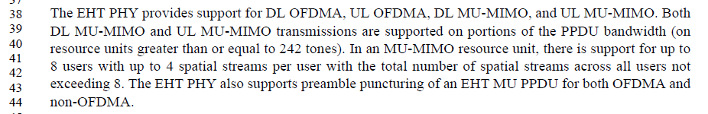

CID 19531, 19732
CID | Clause | Page.Line | Comment | Proposed Change | Resolutions
19531 | 36.1.1 | 653.63 | "data subcarrier frequency spacing that is a quarter of the VHT PHY and HT PHY data subcarrier frequency spacing". Use of which is preferred. | Change to "(...) frequency spacing, which is a quarter (...)" | Accepted
19732 | 36.1.1 | 653.63 | In "that is a quarter of the VHT PHY and HT PHY data subcarrier frequency spacing", the part "VHT PHY and" could be deleted. This doesn't bring new information, VHT and HT having the same subcarrier spacing | Replace with "that is a quarter of the HT PHY data subcarrier frequency spacing" | Rejected  Agree with the commenter that VHT and HT have the same subcarrier frequency spacing. One can delete either VHT PHY, or HT PHY in this sentence since the two are the same. However, we don’t see the need to remove reference to one or the other here, especially since language similar to the existing one has been used in 11ax spec.
  - Background

CID 19084
CID | Clause | Page.Line | Comment | Proposed Change | Resolutions
19084 | 36.1.1 | 654.02 | other QAM level does not show its the EHT MCS numbers | Remove '(EHT-MCS12 and MCS13)' | Rejected  EHT-MCS 12 and 13 are mentioned because 4096QAM is newly introduced in 11be.  Similarly we see EHT-MCS 15 is mentioned because it uses BPSK-DCM.
  - Background
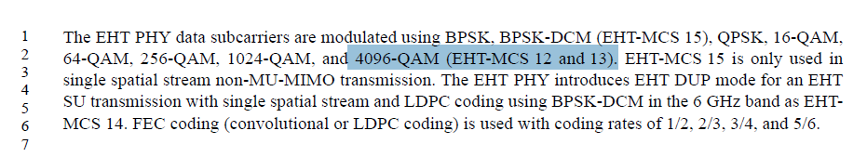

CID 19885
CID | Clause | Page.Line | Comment | Proposed Change | Resolutions
19885 | 36.1.1 | 654.10 | Confusing statement: "Transmission ... of ... transmission". | Change to "Transmission and reception of an EHT PPDU for a single user" | Revised  Agree with the commenter that the current language is repetitive.  Instruction to the editor:  Please change the sentence at P654.10:  “Transmission and reception of an EHT SU transmission.” To:  “EHT SU transmission and its reception.”
  - Background
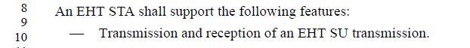

CID 19174
CID | Clause | Page.Line | Comment | Proposed Change | Resolutions
19174 | 36.1.1 | 654.24 | Typo | Remove one of the "for" as: "The STA declares support for transmitting and receiving" | Accepted
  - Background

CID 19886, 19082
CID | Clause | Page.Line | Comment | Proposed Change | Resolutions
19886 | 36.1.1 | 654.58 | This sentence can use the same structure as the following 3 sentences and remove "(transmit and receive)" | Change the sentence to "Transmission and reception using 40 MHz and 80 MHz channel widths and all RU and MRU sizes and locations applicable to the 40 MHz and 80 MHz channel widths, respectively, in the 5 GHz and 6 GHz bands if the STA is not a 20 MHz-only non-AP STA." | Accepted
19082 | 36.1.1 | 654.58 | Is it mandatory for AP to receive a MU PPDU which is not fully occupied? The following text sounds mandatory "40 MHz and 80 MHz channel widths and all RU and MRU sizes and locations applicable to the  40 MHz and 80 MHz channel widths in the 5 GHz and 6 GHz bands (transmit and receive) if the  STA is not a 20 MHz-only non-AP STA." | if mandatory, suggest to clarify with explicit text. | Rejected  This bullet is emphasising the bandwidth support requirement in the 5 GHz and 6 GHz bands, for STAs that are not 20 MHz-only non-AP STAs. It is not about partial bandwidth transmission. An AP needs to support all the RU sizes and locations in OFDMA transmissions if a bandwidth is supported.  Current signaling doesn’t support non-AP STAs transmitting MU-PPDU carrying a single user transmission that doesn’t occupy the whole bandwidth.

  - Background
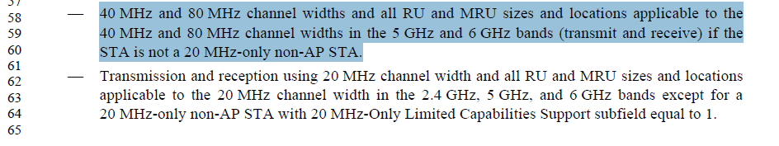

CID 19887
CID | Clause | Page.Line | Comment | Proposed Change | Resolutions
19887 | 36.1.1 | 654.64 | It is odd to mention a MAC subfield (20 MHz-Only Limited Capabilities Support subfield) in PHY introduction without any reference. | Either replace it using a statement to describe the meaning of "20 MHz-Only Limited Capabilities Support subfield equal to 1." or add a reference subclause where this subfield is defined. | Revised.  “20 MHz-Only Limited Capabilities Support” subfield is a subfield in EHT PHY capabilities information field.  We can add reference to this subfield in the sentence.  Similar changes should apply to the next bullet as well  Instruction to the editor:  Please change the sentence at P654.64 and P655.04:  “…20 MHz-Only Limited Capabilities Support subfield equal to 1.” To:  “…20 MHz-Only Limited Capabilities Support subfield in EHT PHY Capabilities Information field (9.4.2.313.3) equal to 1”.

CID 19085
CID | Clause | Page.Line | Comment | Proposed Change | Resolutions
19085 | 36.1.1 | 655.19 | P654L4 already mentioned that MCS15 is only used for single spatial stream. | Remove 'single spatial stream' | Rejected  While it is previously stated that MCS15 is only defined for single spatial stream transmissions, we find it better to clarify it here in the optional support features section to avoid any potential confusion

  - Background
“An EHT STA may support”

CID 19119
CID | Clause | Page.Line | Comment | Proposed Change | Resolutions
19119 | 36.1.1 | 657.10 | incorrect grammar | MU-MIMO reception on an RU or MRU in an EHT MU PPDU which consists of multiple RUs and/  or MRUs (DL MU-MIMO within OFDMA) with a maximum total number of spatial streams (across  all users) of at least 4. | Accepted

  - Background
A non-AP EHT STA may support: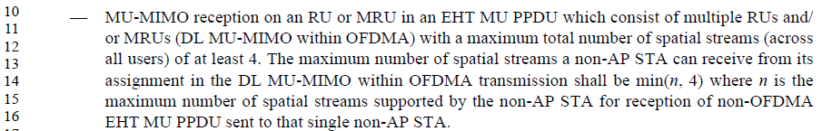

CID 19120
CID | Clause | Page.Line | Comment | Proposed Change | Resolutions
19120 | 36.1.1 | 657.28 | incorrect grammar | MU-MIMO transmission on an RU or MRU in an EHT TB PPDU which consists of multiple RUs  and/or MRUs in the entire PPDU bandwidth (UL MU-MIMO within OFDMA) | Accepted

  - Background
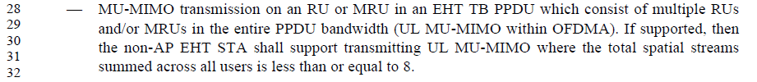

CID 19175
CID | Clause | Page.Line | Comment | Proposed Change | Resolutions
19175 | 36.1.1 | 657.24 | Case missing, for 320 MHz PPDU transmission/reception with  HE subchannel selective transmission operation support,  the assigned RU or MRU could also be in the secondary  160 MHz channel | Change the text to: "where the assigned RU or MRU is in the secondary 80 MHz  channel or secondary 160 MHz channel". | Rejected  HE SST support is only up to 160MHz channel. There’s no secondary 160MHz case.

  - Background
