IEEE P802.11
Wireless LANs
LB276-DMG-CID-set2
Date: 2023-09-12
Author(s):
Name | Affiliation | Address | Phone | email
Alecsander Eitan | Qualcomm |  |  | eitana@qti.qualcomm.com
Abstract
This document proposes resolution to LB276 CIDs:
3123, 3406, 3407, 3431, 3433, 3434, 3435, 3438 and 3441.

The changes are relative to IEEE P802.11-REVbf/D2.0, July 2023
Rev01 changes:
- 3123: document editorial
- 3406 & 3407: revised resolution
- 3431: changed “Number” to “number” as well
- Revision updated through the resolution fields

CID | Section | Page  Line | Comment | Proposed Change | Resolution
3123 | 11.55.3.5 | P173  L22 | The sentence "A DMG sensing burst is a set of scheduled DMG sensing instances so that the time difference between the DMG sensing instances within each DMG sensing burst, may be shorter than the time difference between consecutive DMG sensing bursts. One or more sensing responders may be scheduled for sensing within a DMG sensing burst."  doesn't look reasonable. | Replace with "A DMG sensing burst is a set of scheduled DMG sensing instances so that the overall time it takes to complete all DMG sensing instances within each DMG sensing burst, is less than the time difference between consecutive DMG sensing bursts. One or more sensing responders may be scheduled for sensing within a DMG sensing burst." | Accepted.

Discussion:
The commenter is pointing that the description of DMG sensing burst can be improved.

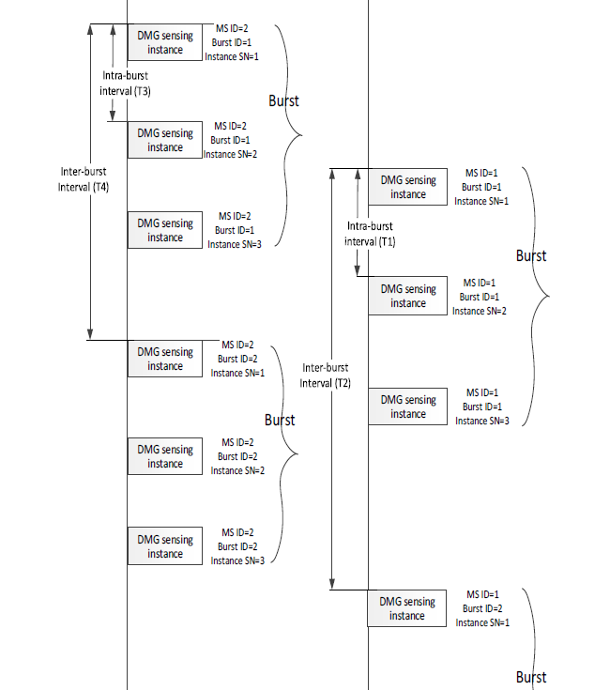

A DMG sensing burst is a set of scheduled DMG sensing instances so that the overall time it takes to complete all DMG sensing instances within each DMG sensing burst, is less than the time difference between consecutive DMG sensing bursts. One or more sensing responders may be scheduled for sensing within a DMG sensing burst.

CID | Section | Page  Line | Comment | Proposed Change | Resolution
3406 | 11.55.3.4 | P172  L59 | Change to "Sensing Measurement Request frame | As in comment | Revised:  TGbf Editor make changes as in:  https://mentor.ieee.org/802.11/dcn/23/11-23-1502-01-00bf- lb276-dmg-cid-set1.docx
3407 | 11.55.3.6.1 | P176  L2 | Change to "Sensing Measurement Request frame | As in comment | Revised:  TGbf Editor make changes as in:  https://mentor.ieee.org/802.11/dcn/23/11-23-1502-01-00bf- lb276-dmg-cid-set1.docx

Discussion:
The commenter is correct, however we need to keep the DMG.

TGbf Editor: Do the following edit in P172L5:

The sensing responder shall set the Sensing Type and RX Initiator fields to the same value that was in the
DMG Sensing Measurement Session element within the DMG Sensing Measurement Request
frame. If present:

TGbf Editor: Do the following edit in P176L2:

The sensing initiator may update the transmit beams assigned to the sensing responder in DMG Sensing
Measurement Request frame by setting the Updated TX Beam List subfield in the TDD Beamforming Information field in the DMG Sensing Request frame.

CID | Section | Page  Line | Comment | Proposed Change | Resolution
3431 | 11.55.3.5 | P174  L21 | "The Number of STAs in Instance" should read "The Number of STAs in a DMG Sensing Instance". Please change accordingly. | As in comment | Revised:  TGbf Editor make changes as in:  https://mentor.ieee.org/802.11/dcn/23/11-23-1502-01-00bf- lb276-dmg-cid-set1.docx

Discussion:
The commenter is correct.

The number of STAs in a DMG Sensing Instance may vary among the DMG sensing exchanges belonging to the same Measurement Burst ID. In this case, STA ID, EDMG TRN Length and EDMG TRN-Unit M in different DMG sensing exchanges shall vary accordlingly.

CID | Section | Page  Line | Comment | Proposed Change | Resolution
3433 | 11.55.3.6.2.2 | P177  L53 | The notation in Equation (11-8a) is confusing as the DMG Sensing Instance i is used in superscript and would mean that the number is raised to the i-th power. Please replace all occuring superscripted "i" with subscripted "i" and use for the Sounding Duration and Report Duration "n,i-1" in subscipt. Also update the subsequent occurences of superscripted "i" in the following paragraph. | As in comment | Revised:  TGbf Editor make changes as in:  https://mentor.ieee.org/802.11/dcn/23/11-23-1502-01-00bf- lb276-dmg-cid-set1.docx
3434 | 11.55.3.6.2.3 | P180  L47 | The notation in Equation (11-9b) is confusing as the DMG Sensing Instance i is used in superscript and would mean that the number is raised to the i-th power. Please replace all occuring superscripted "i" with subscripted "i" and use for the Sounding Duration and Report Duration "n,i-1" in subscipt. Also update the subsequent occurences of superscripted "i" in the following paragraph. | As in comment | Revised:  TGbf Editor make changes as in:  https://mentor.ieee.org/802.11/dcn/23/11-23-1502-01-00bf- lb276-dmg-cid-set1.docx

Discussion:
The commenter is pointing that the “i” in superscript may lead some readers to think that it is a power of “i” and not as an index.
The text explains that “i” is the instance index and not power of.
To improve the text and avoid possible misleading, we suggest changing the superscript “i” with “(i)”.
This method is used in the literature and even in 802.11: REVme D4.0 Equations: (21-11), (21-12), (21-13), … (thank you Stephan Sand)

TGbf Editor: Add a parenthesis to the superscript of variables where “i” or “i-1” which are marking the DMG sensing instance. Example: replace N^{i} with N^{(i)}.
Same change to variable “N”, “Duration “, “Sounding Duration” and “Report Duration”.

List of places:
- P177L53 – 4 instances
- P177L57 - 3 instances
- P177L62 - 1 instance
- P178L3 - 1 instance
- P178L5 - 1 instance
- P178L9 - 1 instance
- P178L10 - 1 instance
- P180L47 – 5 instances
- P180L51 - 3 instances
- P180L56 - 1 instance
- P180-L3 - 1 instance
- P180L64 - 1 instance
- P181L1 - 1 instance
- P181L5 - 1 instance
- P181L6 - 1 instance

CID | Section | Page  Line | Comment | Proposed Change | Resolution
3435 | 11.55.3.6.2.2 | P178  L5 | The definition of Sounding Duration_{n}^{0} should be for the first DMG sensing instance i=1. Hence, please add between "the Sounding Duration field of the" and "DMG Sensing Instance" "first". Similar add "first between "Report Duration field of the" and "DMG Sensing Instance Duration" on P178L12, between "Souding Duration field of the" "DMG Sensing Instance" on P181L1, and between "Report Duration field of the" "DMG Sensing Instance" on P181L8. | As in comment | Revised:  TGbf Editor make changes as in:  https://mentor.ieee.org/802.11/dcn/23/11-23-1502-01-00bf- lb276-dmg-cid-set1.docx

Discussion:
The commenter is correct. Adding the “first” is improving the text

TGbf Editor: Note that the resolution of 3433 and 3434 are included below

TGbf Editor: Do the following edit in P178L5:
${Sounding Duration}_{n}^{(i-1)}$ is the value of the Sounding Duration field of the DMG Sensing Response frame delivered by the sensing responder n in DMG sensing instance i - 1 (i > 1). ${Sounding Duration}_{n}^{(0)}$ is the value of the Sounding Duration field of the first DMG Sensing Instance Duration element within the DMG Sensing Measurement Response frame delivered by sensing responder n

TGbf Editor: Do the following edit in P178L11:
${Report Duration}_{n}^{(i-1)}$ is the value of the Report Duration field of the DMG Sensing Response frame delivered by the sensing responder n in DMG sensing instance i - 1 (i > 1). ${Report Duration}_{n}^{(0)}$ is the value of the Report Duration field of the first DMG Sensing Instance Duration element within the DMG Sensing Measurement Response frame delivered by the sensing responder n

TGbf Editor: Do the following edit in P181L1:
${Sounding Duration}_{n}^{(i-1)}$ is the value of the Sounding Duration field of the DMG Sensing Re-sponse frame delivered by the sensing responder n in DMG sensing instance i - 1 (i > 1). ${Sounding Duration}_{n}^{(0)}$ is the value of the first Sounding Duration field of the DMG Sensing Instance Duration element within the DMG Sensing Measurement Response frame delivered by the sensing responder n

TGbf Editor: Do the following edit in P181L8:
${Report Duration}_{n}^{(i-1)}$ is the value of the Report Duration field of the DMG Sensing Response frame delivered by the sensing responder n in DMG sensing instance i - 1 (i > 1). ${Report Duration}_{n}^{(0)}$ is the value of the Report Duration field of the first DMG Sensing Instance Duration element within the DMG Sensing Measurement Response frame delivered by the sensing responder n

CID | Section | Page  Line | Comment | Proposed Change | Resolution
3438 | 9.4.2.326.4 | P91  L12 | The Burst Response Delay field consists of 8 octets, i.e. 64 bit. The Burst Response Delay field contains the maximum time in milliseconds after the end of the last PPDU in the burst it takes the sensing responder to generate the report on the sensing measurements in the burst. Thus it could use up to 2^(64)-1 milliseconds. Why ss such a large delay necessary? Espescially when the aDMGSensingProcedureExpiry is 10 seconds. | Reduce the number of Octets from 8 to at most 2 for the Burst Response Delay field | Revised:  TGbf Editor make changes as in:  https://mentor.ieee.org/802.11/dcn/23/11-23-1502-01-00bf- lb276-dmg-cid-set1.docx

Discussion:
The commenter is correct. Two bytes are sufficient.

TGbf Editor: Do the following edit in P91L12:

 | Subelement  ID | Length | Burst Response  Delay
Octets: | 1 | 1 | 2

Figure 9-1002bz—Burst Response Delay subelement format

CID | Section | Page  Line | Comment | Proposed Change | Resolution
3441 | 11.55.4.4 | P193  L2 | Instead of "DMG SBP Setup Unsuccess field" it should be "DMG SBP Session Unsuccess field" see Figure 9-1191c | As in comment | Accepted.

Discussion:
The commenter is correct.

Straw Poll:
Do you agree with the proposed resolutions in revision 1 of this document?
Y/N/A

