IEEE P802.11
Wireless LANs
CRs for SBP part2 in LB 276
Date: 2023-09-06
Author(s):
Name | Affiliation | Address | Phone | email
Xiandong Dong | Xiaomi |  |  | dongxiandong@xiaomi.com
Abstract
This submission proposes resolutions for following 4 CIDs received for WG LB276:
3191 3200 3201 3208
The proposed changes are based on 802.11bf D2.0

Revisions:
- Rev 0: Initial version of the document.
- Rev1: offline discussion of CIDs3200 &3201, and withdrawing of the CID 3209

CID | Commenter | Clause | Page | Comment | Proposed Change | Resolution
3200 | Xiandong Dong | 9.4.2.322 | 78.56 | clarify the relation of the SBP Procedure Expiry Exponent value and the Measurement Session Expiry Exponent value, in the praxis the SBP Procedure Expiry Exponent value should be set larger than the Measurement Session Expiry Exponent value. | as in comment | Revise  Agree with the commenter in principle, but the proposed text is normative, so add this change in the clause 11.55.2.2 .  TGbf editor please make the changes shown in IEEE 802.11-23/1501r1 under all headings that include CID3200
3201 | Xiandong Dong | 9.6.7.56 | 117.64 | If the Terminate All SBP Procedures field is set to 1, the Measurement Session ID Indication field is reserved, add the sentence. | As in comment | Revise  Agree with the commenter in principle.  TGbf editor please make the changes shown in IEEE 802.11-23/1501r1 under all headings that include CID3201

Discussion

CID3200
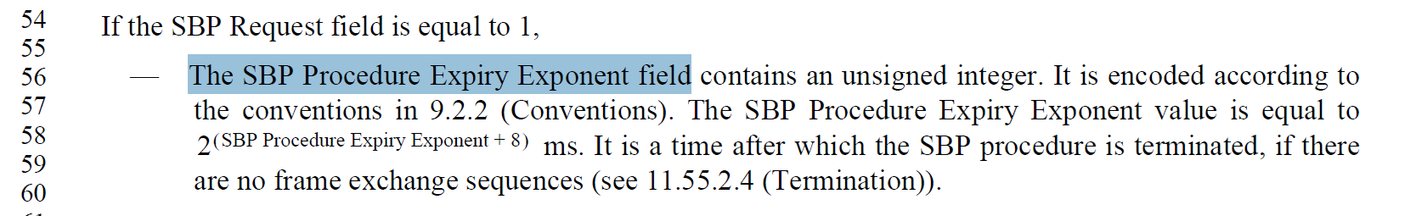

TGbf editor: please insert the following change in subclause 11.55.2.2, P160L66

If an SBP Request frame includes an SBP Procedure Expiry Exponent field and a Measurement Session Expiry Exponent field, the value indicated in the SBP Procedure Expiry Exponent field should be greater than the value indicated in the Measurement Session Expiry Exponent value. (#3200)

CID 3201
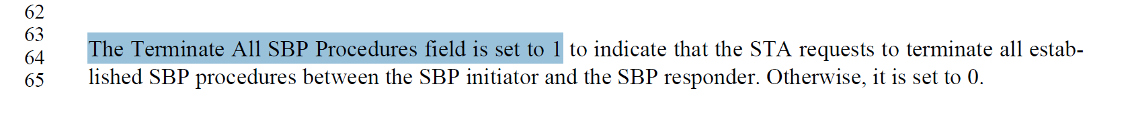
TGbf editor: please insert the following change in subclause 9.6.7.56, P117L48

The Measurement Session ID Indication field is reserved if the Terminate All SBP Procedures field is equal to 1. (#3201)

CID | commenter | Clause | Page | Comment | Proposed Change | Resolution
3191 | Alireza Raissinia | 11.55.2.3 | 165.35 | Change the text "An SBP responder which is a sensing receiver" to "The sensing receiver(s) involved in the sensing procedure for the SBP request" as this requirement should apply to all sensing receivers and not just SBP responder? | As per comment | Revise  Agree with the commenter in principle, but the SBP initiator that is also sensing receiver should not send the sensing report to the SBP responder.  TGbf editor please make the changes shown in IEEE 802.11-23/1501r1 under all headings that include CID3191
3208 | Xiandong Dong | 11.55.2.2 | 164.18 | It is better to add a reference for "initiate a new sensing procedure" | As in comment | Revise  Agree with the commenter in principle, by adding the reference makes the text more clear.  TGbf editor please make the changes shown in IEEE 802.11-23/1501r1 under all headings that include CID3208

Discussion

CID3191
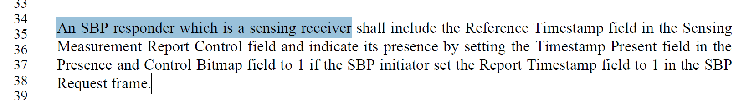

TGbf editor: please insert the following change in subclause 11.55.2.3, P165L35

The sensing receiver(s) that is not an SBP initiator involved in the sensing procedure for the SBP request(#3191) shall include the Reference Timestamp field in the Sensing
Measurement Report Control field and indicate its presence by setting the Timestamp Present field in the
Presence and Control Bitmap field to 1 if the SBP initiator set the Report Timestamp field to 1 in the SBP
Request frame.

CID3208
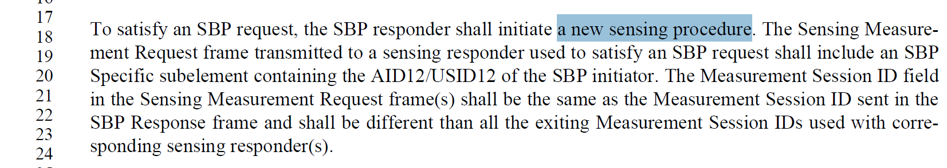

TGbf editor: please insert the following change in subclause 11.55.2.2, P164L18

To satisfy an SBP request, the SBP responder shall initiate a new sensing procedure (see 11.55.1.4 Sensing measurement session).(#3208)

SP: Do you support the resolution to the following 4CIDs and to incorporate the changes proposed in IEEE 802.11-23/1501r1 to the latest 11bf draft for the following CIDs: 3191 3200 3201 3208 1?

