IEEE P802.11
Wireless LANs
CR for 11be D4.0
Date: 2023-09-05
Author(s):
Name | Affiliation | Address | Phone | email
Xiaogang Chen | Spreadtrum Communications USA. | 2680 N 1st St. San Jose, California 95134 |  | Xiaogang.g.chen@gmail.com

Abstract
This submission proposes text changes of TGbe Draft 4.0 for CIDs:

19016
19089
19094
19110
19157
19158
19168
19371
19374
19399
19539
19540
19541
19542

Revisions:

- Rev 0: Initial version of the document.

Interpretation of a Motion to Adopt

A motion to approve this submission means that the editing instructions and any changed or added material are actioned in the TGbe Draft 4.0. This introduction is not part of the adopted material.

Editing instructions formatted like this are intended to be copied into the TGbe Draft (i.e. they are instructions to the 802.11 editor on how to merge the text with the baseline documents).

TGbe Editor: Editing instructions preceded by “TGbe Editor” are instructions to the TGbe editor to modify existing material in the TGbe draft. As a result of adopting the changes, the TGbe editor will execute the instructions rather than copy them to the TGbe Draft.

CID | Clause | Page | Comment | Proposed Change | Resolution
19016 | 36.3.13.3.6 | 800.01 | "Padding bits are appended immediately after the tail bits corresponding to the final user encoding block in  each EHT-SIG content channel to round up to the next multiple of number of data bits per EHT-SIG OFDM  symbol.  The padding bits may be set to any value. Further padding bits are appended to each EHT-SIG content  channel so that the number of OFDM symbols after encoding and modulation in different 20 MHz  subchannels is the same and equal to the number of EHT-SIG symbols signaled in the Number Of EHT-SIG  Symbol subfield in U-SIG field. For the common encoding block and each user encoding block, the  information bits, tail bits and padding bits (if present) are BCC encoded at rate using the encoder  described in 17.3.5.6 (Convolutional encoder)" sounds like there are preFEC and postFEC padding. | if the intention is to do both prefec and postfec, it's better to explicitly describe. However, it's not necessary IMO. | Revised.  11be editor please make changes under CID 19016 in DCN 23/1491r0
19089 | 36.3.6 | 725.45 | The pre-FEC phy padding doesn't match the descriptions on padding in EHT-SIG subclause | Clarify on either side and align both | Revised.  11be editor please make changes under CID 19089 in DCN 23/1491r0
19094 | 36.3.23 | 896.11 | there are two dots. 'The PHY entity shall not process the Disregard field..' | remove one dot. | Accepted
19110 | 36.3.23 | 896.11 | Periods are duplicated at the end of this sentence. | Please delete one of them. | Accepted
19157 | 36.3.21.6.3 | 888.31 | Wrong reference "aCCATime (see 21.4.4 (VHT PHY))" | Point to the correct subclause | Revised.  11be editor please change the reference in the concerned sentence from 21.4.4(VHT PHY) to  10.3.7 (DCF timing relations)
19158 | 36.3.21.6.4 | 889.14 | OBSS_PD is only present in the per20MHz CCA. However, in the SR subclause  "The value of the OBSS_PDlevel is applicable to the start of a 20 MHz PPDU received on the primary 20 MHz  channel." OBSSPD is applicable to P20 but no matched text in CCA.  In addition, start of PPDU is usually refered as PD but "The received signal strength level, which is measured from the L-STF or L-LTF fields of the PPDU  or the PHY SYNC field, shortSYNC field or Long PHY SYNC field, whichever exists and which is  used to determine PHY-CCA.indication, is below the SRG OBSS PD level." This is energy detection. Thirdly, why an energy detection needs aCCAMid time instead of aCCATime? | There are a few mismatch between CCA and OBSS_PD based SR. Let's discuss how to fix it... | Rejected  “The CCA signal shall be held busy (not issue a PHY-CCA.indication primitive with the STATUS  parameter set to IDLE) for the duration of the PPDU, unless it receives a CCARESET.request primitive  before the end of the PPDU for instance during spatial reuse operation as described in 35.10 (EHT Spatial  reuse operation).” This sentence should address the concern.
19168 |  | 862.39 | there seems to be an extra 'hows' in the following sentence: "Figure  36-63 (Example transmit spectral mask for a 320 MHz mask PPDU)  shows hows an example of the resulting overall spectral mask when the -40  dBr spectrum level is above -39 dBm/MHz" | remove 'hows' between 'shows' and 'an example' as follows:  "Figure  36-63 (Example transmit spectral mask for a 320 MHz mask PPDU)  shows an example of the resulting overall spectral mask when the -40  dBr spectrum level is above -39 dBm/MHz" | Accepted
19371 | 36.3.23 | 896.59 | "may" undermines the entire RX procedure. While there continues to be a valid PPDU that could be intended for the receiver, the receiver *shall* continue to receive it. Otherwise the receiver could use this exception to selectively ignore any frame in an EHT MU PPDU that the receiver doesn't like by pointing to this gaping exception. This is a repeat of CID 17625 which was rejected for the reason "The current specification has clarified the behaviour of receiving UL PPDU." which is non-responsive to this "may" issue. | Append something along the lines of "If the STA-ID field is checked and equals the intended STA-ID or if the STA_ID field is not checked, the receiver shall continue receiving the EHT-STF right after the EHT-SIG" | Revised.  11be editor please make changes under CID 19371 in DCN 23/1491r0
19374 | 36.3.23 | 899.25 | A very short non-HT/HT/VHT/etc PPDU cannot be an 11be PPDU because the 11be preamble is just too long. SIG rotations (e.g., Q-BPSK) and repetitions (e.g., RLSIG) are probabistic determinations which are usually conducted by comparing a statistic to a threshold, and such determinations have some non-zero probability of performing a false detection.  This is an update to CID 17632 which was rejected with a rich explanation (many thanks) which however included some flaws:  - "(1) Once Rx evaluates LENGTH, the parity and RATE check are passed. The RL-SIG is detected, and the received signal can only be HE or EHT. Non-HT is impossible." is untrue with additive noise etc. There is always a non-zero false detection rate. Shall's should not be included to preclude better implementations: e.g. one that entertains multiple PPDU format hypotheses and eliminates a hypothesis only when it becomes impossible to proceed.  - "(2) A long-enough LENGTH and a short-enough LENGTH can't be used to distinguish between 11a and 11be. Because in addition to 11a, other PPDU format may have ultra short length which is shorter than the shortest EHT PPDU. E.g. 11n may have 5 symbols (SIG(2 sym)+STF/LTF/Data(3sym)) after L-SIG, which is shorter than shortest EHT (RL-SIG+U-SIG(2sym)+EHT-SIG(1sym)+STF/LTF). Similar for 11ac." - true. Accordingly this comment is updated. And actually the rejeciton reason underlines the value and importance of considering length to constrain the PPDU format determination.  - 3) " Implementation is free to implement such algorithm but including in spec is not necessary." - so we agree that the spec language should not preclude such an implementation (which is what I see at L42-46) | During PPDU format determination, add LSIG LENGTH as an (optional) consideration for excluding a PPDU format from the set of remaining candidate PPDU formats; and thence allowing hte RX procedure to jump to the associated 11a/HT/VHT/etc RX procedure when the candidate set has been reduced to the PPDU format(s) defined in a single PHY clause. | Rejected.  We discussed this in the previous round of CR. The majority don’t think it’s necessary to include this optional solution in standard. In addition, implementation will not likely (AFAIK) implement this logic because it won’t save other logics which still have to be used to deal with long HT/VHT/nonHT PPDU. So this optional solution is an extra logic.
19399 | 36.3.6 | 730.13 | This figure 36-26 is related to the RU or MRU size larger than a 996-tone RU.  Thus, there should exist two, three or four 80 MHz subblocks. However, only 2 subblocks are shown here. Three or four output branches could be added to the output of the segment parser. | As in comment. Can add "..." to the output of the segment parser. | Rejected.  There are dots in the graph. The squares overlaying each other will take care the case of more than two segments.
19539 | 36.3.20.1.2 | 864.04 | "Case 1" is not descriptive as a header. | Replace with "Case 1: "preamble puncturing at the edge of the EHT PPDU bandwidth" | Accepted
19540 | 36.3.20.1.2 | 865.35 | "Case 2" is not descriptive as a header. | Replace with "Case 2: "preamble puncturing of two or more contiguous 20 MHz subchannels not at the edge of the EHT PPDU bandwidth" | Accepted
19541 | 36.3.20.1.2 | 864.04 | "Case 3" is not descriptive as a header. | Replace with "Case 3: "preamble puncturing of single 20 MHz subchannel not at the edge of the EHT PPDU bandwidth" | Accepted
19542 | 36.3.20.1.2 | 871.01 | "The rules of constructing (...) is the same as the rules defined in 36.3.20.1.2 (...)". Verb should be plural. | Change to "The rules of constructing (...) are the same as the rules defined in 36.3.20.1.2 (...)" | Accepted

Discussions on CID 19016, CID 19089:
"Padding bits are appended immediately after the tail bits corresponding to the final user encoding block in
each EHT-SIG content channel to round up to the next multiple of number of data bits per EHT-SIG OFDM
symbol.
The padding bits may be set to any value. Further padding bits are appended to each EHT-SIG content
channel so that the number of OFDM symbols after encoding and modulation in different 20 MHz
subchannels is the same and equal to the number of EHT-SIG symbols signaled in the Number Of EHT-SIG Symbol subfield in U-SIG field. For the common encoding block and each user encoding block, the
information bits, tail bits and padding bits (if present) are BCC encoded at rate using the encoder
described in 17.3.5.6 (Convolutional encoder)"

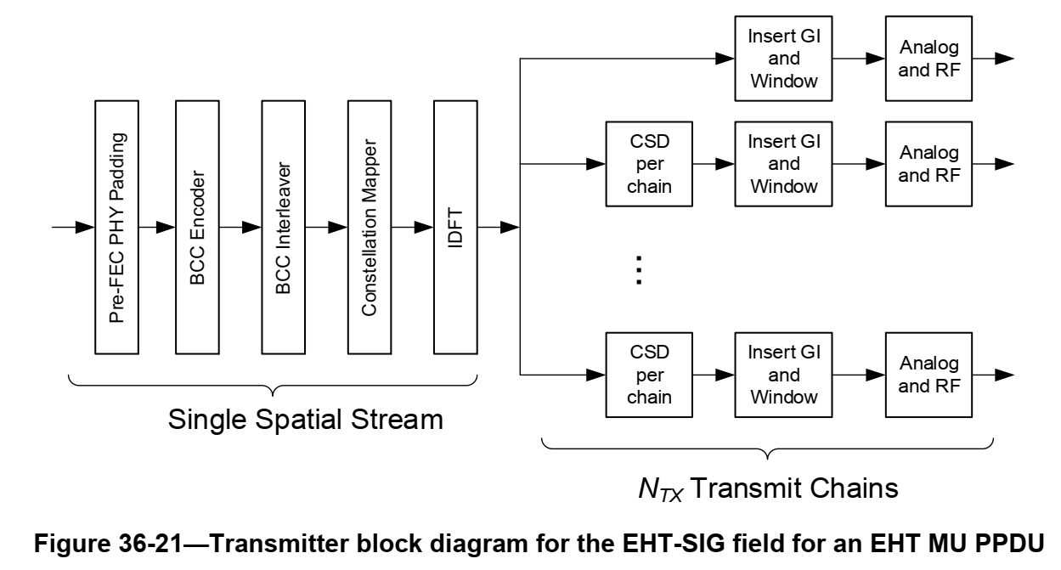
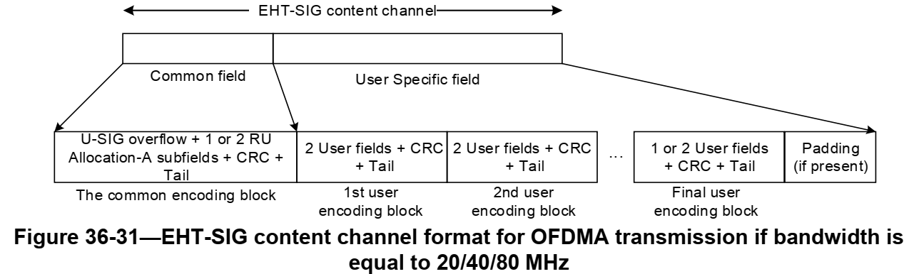

Discussions: The current text describe EHT-SIG padding as two portion of padding but it’s not clearly saying pre-FEC or post-FEC. The two portions reads like include both pre-FEC and post FEC. The current block diagram of EHT-SIG only mentioned pre-FEC. EHT-SIG coding graph only say “padding (if present)”. Although there is no performance difference for BCC regardless of pre or post FEC padding is conducted, it may cause confusion in different understanding and leads to different implementations and consequence could be calibration error. The suggestion is to clearly saying those padding are pre-FEC padding.

Proposed changes for CID 19016, CID 19089:
11be editor please make the following changes in P.L. 800.1 (36.3.12.8.6 Encoding and modulation).

Pre-FEC padding bits are appended immediately after the tail bits corresponding to the final user encoding block in each EHT-SIG content channel to round up to the next multiple of number of data bits per EHT-SIG OFDM symbol.
The padding bits may be set to any value. Further Pre-FEC padding bits are appended to each EHT-SIG content channel so that the number of OFDM symbols after encoding and modulation in different 20 MHz
subchannels is the same and equal to the number of EHT-SIG symbols signaled in the Number Of EHT-SIG Symbol subfield in U-SIG field. For the common encoding block and each user encoding block, the
information bits, tail bits and padding bits (if present) are BCC encoded at rate using the encoder
described in 17.3.5.6 (Convolutional encoder)

Proposed changes for CID 19371
If the UL/DL subfield of the U-SIG field is set to 1 and the CRC protecting the common encoding
block of the EHT-SIG is valid and an unsupported mode or a Validate EHT-SIG indication is not
indicated, the PHY entity shall continue receiving the EHT-STF after the EHT-SIG if the STA-ID field is checked and equals the intended STA-ID or if the STA_ID field is not checked.

