IEEE P802.11
Wireless LANs
New primitive for Sensing Measurement Query frame
Date: 2023-09-05
Author(s):
Name | Affiliation | Address | Phone | email
Narengerile | Huawei | Shenzhen, China |  | narengerile@huawei.com
Rui Du
Mengshi Hu
Zhuqing Tang
Yiyan Zhang

Abstract
This document proposes a new set of primitives to enable the transmission and reception of Sensing Measurement Query frame for the unassociated STAs to perform sensing as sensing responders.

R0: initial version on Sept 05, 2023.

Discussions:
- For sensing procedure, 11bf proposes a new frame that is Sensing Measurement Query frame for the unassociated STAs to participate in sensing as sensing responders. But the MLME service access point (SAP) interface that provides such a functionality is missing in the protocol.
- So, this contribution proposes a new set of primitives: MLME-SENSMSMTQUERY. This set of primitives assumes Type 3, which contains a .request primitive and a .indication primitive.
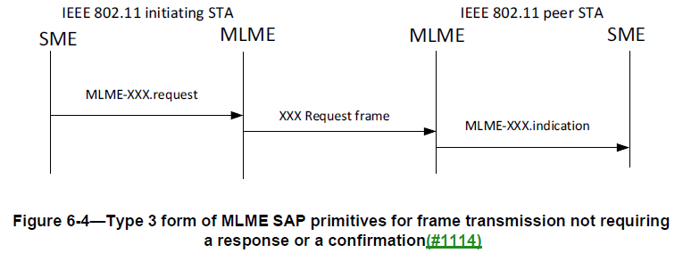
Modifications:
To TGbf editor: Please add a row in Table 6-1 as follows.
Service Name | MLME-xxx | Type | References | Comments
Sensing procedure | SENSMSMTSETUP | 1 | 9.6.7.49 ((Protected) Sensing Measurement Setup Request frame format), 9.6.7.50 ((Protected) Sensing Measurement Setup Response frame format) | See 11.55.1.4 (Sensing measurement setup)
 | SENSMSMTQUERY | 3 | 9.6.7.53 ((Protected Sensing Measurement Query frame format)) | See 11.55.1.4.2 (Sensing measurement session for unassociated STAs)
 | SENSMSMTTERMINATION | 2 | 9.6.7.52 ((Protected) Sensing Measurement Setup Termination frame format) | See 11.55.1.6 (Sensing measurement setup termination)
 | SENSTBMSMTRQ | 6 | 9.3.1.22.14.2 (Sensing Polling Trigger frame),  9.3.1.19.5 (Sensing NDP Announcement frame format),  9.3.1.22.14.3 (SR2SI Sounding Trigger frame),  9.3.1.22.14.6 (SR2SR Sounding Trigger frame),  9.3.1.22.14.4 (Sensing Report Trigger frame),  9.3.1.22.14.5 (Sensing Threshold-based Report Trigger frame) | See 11.55.1.5.2 (TB sensing measurement instance)
 | SENSNONTBMSMTRQ | 6 | 9.3.1.19.5 (Sensing NDP Announcement frame format),  9.3.1.22.14.4 (Sensing Report Trigger frame) | See 11.55.1.5.3 (Non-TB sensing measurement instance)
 | SENSREPORT | 7 | 9.4.1.75 (Sensing Measurement Report Container field) | See 11.55.1.5.2.6 (Reporting phase), 11.55.1.5.3.3 (Reporting phase)
 | SENSREPORTRQ | N/A | 6.5.25 (Sensing procedure)

To TGbf editor: Please modify the text in 11.55.1.4.2 on P142 as follows.
11.55.1.4.2 Sensing measurement session for unassociated STAs
If an unassociated non-AP STA intends to establish a sensing measurement session for a non-TB sensing measurement exchange, it shall transmit a Sensing Measurement Request frame to the AP and include a non-TB Specific subelement to set the parameters of the sensing measurement session.

If an unassociated non-AP STA intends to participate in a sensing measurement session initiated by an AP, it shall issue an MLME-SENSMSMTQUERY.request primitive that results in the transmission of a Sensing Measurement Query frame to the AP to solicit a Sensing Measurement Request frame from the AP. Upon reception of a Sensing Measurement Query frame from an unassociated STA, the MLME of the AP shall issue an MLME-SENSMSMTQUERY.indication primitive. Upon receipt of the MLME-SENSMSMTQUERY.indication primitive, the SME of the AP should issue an MLME-SENSMSMTSESSION.request primitive to cause the transmission of a Sensing Measurement Request frame to the unassociated STA within a aSensingFrameExchangeExpiry (see Table 11-30a (Sensing procedure timing-related parameters)) timeout period to initiate a sensing measurement session. If the unassociated non-AP STA does not receive a Sensing Measurement Request frame from the AP within a aSensingFrameExchangeExpiry (see Table 11-30a (Sensing procedure timing-related parameters)) timeout period, then it shall consider the solicitation to the AP to initiate a sensing measurement session unsuccessful.

SP:
Do you agree to include the proposed draft text in DCN 23/1486r0 in the latest 11bf Draft?
Y/N/A

