IEEE P802.11
Wireless LANs
LB276 Resolutions on primitive-related comments – Part 1
Date: 2023-09-05
Author(s):
Name | Affiliation | Address | Phone | email
Narengerile | Huawei | Shenzhen, China |  | narengerile@huawei.com
Rui Du
Mengshi Hu
Zhuqing Tang
Yiyan Zhang

Abstract
This document proposes the comment resolution for CID 3026, 3027, 3024, 3028.

R0: initial version on Sept 05, 2023.

3026 (Sensing measurement session)
CID | Clause | Page | Comment | Proposed change
3026 | 6.4 | 21.15 | The use of MLME-SENSMSMTSESSION is not defined in subclause 11.55.1. | Define the use of MLME-SENSMSMTSESSION in 11.55.1. As an example, the use of MLME-SENSTBMSMTRQ is defined in 144.63-65.
Proposed resolution: REVISED.
Please refer to the modifications labelled with #3026 in DCN 23/1484r0.
Discussions:
- Primitive parameters are no longer defined in Clause 6, which will be defined in Clause 11 to complete the normative text. Not only MLME-SENSMSMTSESSION primitives need to be defined in Clause 11, but also other primitives given in Table 6-1.
- Basically, we need to reflect the function, the when-generated and the effects of the primitives in Clause 11.
- The set of MLME-SENSMSMTSESSION primitives is of Type 1.
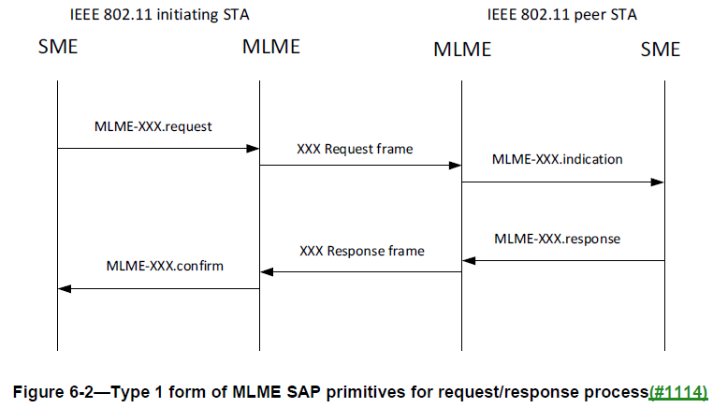
Modifications:
To TGbf editor: Please modify the text in 11.55.1.4.1 on P138 as follows.
11.55.1.4 Sensing measurement session
11.55.1.4.1 General
A sensing measurement session is an agreement between a sensing initiator and a sensing responder on operational parameters associated with sensing measurement exchanges of a given Measurement Session ID.
P138L9
To establish a sensing measurement session, the SME of a sensing initiator shall issue an MLME-SENSMSMTSESSION.request primitive that results in the transmission of a Sensing Measurement Request frame to a sensing responder with which it intends to establish a sensing measurement session. A sensing initiator shall not attempt to establish more sensing measurement sessions than the value of the Max Number of Supported Sessions as Responder field in the last Sensing Capabilities element received from the sensing responder. (#3026)
…

P138L40
Upon reception of a Sensing Measurement Request frame, the sensing responder shall validate the frame and issue an MLME-SENSMSMTSESSION.indication primitive. If the Comeback field of the Sensing Comeback Info field within the Sensing Measurement Request frame is set to 0, the SME of the sensing responder shall issue an MLME-SENSMSMTSESSION.response primitive to cause the transmission of a Sensing Measurement Response frame to the sensing initiator which transmitted the Sensing Measurement Request frame, according to the following rules: (#3026)
…

P138L60
The sensing responder should transmit the Sensing Measurement Response frame within aSensingFrameExchangeExpiry (see Table 11-30a (Sensing procedure timing-related parameters)) timeout period in response to the Sensing Measurement Request frame. The sensing responder shall set the Measurement Session ID field in the Sensing Measurement Response frame to the value set in this field in the Sensing Measurement Request frame sent by the sensing initiator. Upon reception of a Sensing Measurement Response frame, the sensing initiator shall validate the frame and issue an MLME-SENSMSMTSESSION.confirm primitive. If the sensing initiator does not receive the Sensing Measurement Response frame within this timeout period, or if a Sensing Measurement Response frame is received with a status code other than SUCCESS, the sensing measurement session shall be considered unsuccessful. (#3026)

3027 (non-TB sensing measurement exchange)
CID | Clause | Page | Comment | Proposed change | Proposed resolution
3027 | 6.4 | 21.51 | The use of MLME-SENSNONTBMSMTRQ is not defined in subclause 11.55.1. | Define the use of MLME-SENSNONTBMSMTRQ in 11.55.1. As an example, the use of MLME-SENSTBMSMTRQ is defined in 144.63-65. | REVISED.  Agree with the commenter.  Please refer to the modifications labelled with #3027 in DCN 23/1484r0.
Modifications:
To TGbf editor: Please modify the text in 11.55.1.5.3.1 on P154 as follows.
P154L38
The SME of the non-AP STA shall issue an MLME-SENSNONTBMSMTRQ.request primitive to request a non-TB sensing measurement exchange to be performed with the intended AP. (#3027) A non-TB sensing measurement exchange shall always consist of a measurement sounding phase (see 11.55.1.5.3.2 (Measurement sounding phase)). It shall also consist of a reporting phase if the Sensing Measurement Report Requested field within the Sensing Measurement Request frame that resulted in the non-TB sensing measurement exchange is set to 1.

3024 3028 (reporting phase)
CID | Clause | Page | Comment | Proposed change | Proposed resolution
3024 | 11.55.1.5.1 | 143.29 | The sentence "The SENSREPORT.indication primitive includes sensing measurements." should be moved to the previous paragraph. | Delete "The SENSREPORT.indication primitive includes sensing measurements." from 143.28-33. Add "that includes sensing measurements obtained with the correspoding NDP." to the end of 143.25-27. | REVISED.  Agree with the commenter.  Please refer to the modifications labelled with #3024 in DCN 23/1484r0.
3028 | 6.4 | 21.58 | The use of MLME-SENSREPORT is not defined in subclause 11.55.1. | Define the use of MLME-SENSREPORT in 11.55.1. As an example, the use of MLME-SENSTBMSMTRQ is defined in 144.63-65. | REVISED.  The use of this primitive is already defined in 11.55.1.5.1.  Please refer to the modifications labelled with #3028 in DCN 23/1484r0.
Modifications:
To TGbf editor: Please modify the text in 11.55.1.5.1 on P143 as follows.
P143L25
Upon receiving an SI2SR, SR2SI or SR2SR NDP, the sensing receiver’s MAC shall issue a SENSREPORT.indication primitive that includes sensing measurements obtained with the corresponding NDP. (#3024, #3028)

NOTE—If the NDP is preceded by a Sensing NDP Announcement frame, the SENSREPORT.indication primitive also includes operational parameters carried in the Sensing NDP Announcement frame. If the NDP is triggered by an SR2SI Sounding Trigger frame or SR2SR Sounding Trigger frame, the SENSREPORT.indication primitive also includes operational parameters carried in the SR2SI Sounding Trigger frame or SR2SR Sounding Trigger frame.

SP:
Do you agree to the resolution provided for CIDs 3026, 3027, 3024, 3028 to be included in the latest 11bf Draft?
Y/N/A

