IEEE P802.11
Wireless LANs
LB276 comment resolutions for reporting
Date: 2023.09.xx
Author(s):
Name | Company | Address | Phone | email
Rui Du | Huawei Technologies | F3, Huawei Base, Shenzhen, Guangdong, China, 518129 |  | Ray.du@huawei.com
Ali Raissinia | Qualcomm Inc. |  |  | alirezar@qti.qualcomm.com
Narengerile | Huawei Technologies | F3, Huawei Base, Shenzhen, Guangdong, China, 518129
Mengshi Hu
Zhuqing Tang
Yiyan Zhang
Abstract
This submission contains the proposed comment resolutions for the CIDs 3077, 3078, 3087, 3378 and 3380.

R0: initial document
R1: revise the document based on offline discussions
R2: revise the docuemtn based on online discussions

CID 3077, 3078, 3087, 3380 and 3378

CID | Page.  Line | Clause Number | Comment | Proposed Change | Resolution
3077 | 52.4 | 9.4.1.73.2.2 | In the baseline document, N_{RX} is defined as the number of receive chains. | Define N_{RX} as the number of receive chains throughout the entire document. | Revised.  TGbf Editor make changes specified in 1476r2.  (https://mentor.ieee.org/802.11/dcn/23/11-23-1476-02-00bf-lb276-comment-resolutions-for-reporting.docx)
3078 | 52.5 | 9.4.1.73.2.2 | In the baseline document, N_{TX} is defined as the number of transmit chains. | Define N_{TX} as the number of transmit chains throughout the entire document. | Revised.  TGbf Editor make changes specified in 1476r2.  (https://mentor.ieee.org/802.11/dcn/23/11-23-1476-02-00bf-lb276-comment-resolutions-for-reporting.docx)
3087 | 52.5 | 9.4.1.73.2.2 | N_{RX} and N_{TX} definitions are not clear | Explicitly clarify definitions of N_{RX} and N_{TX} (also other places in document) | Revised.  TGbf Editor make changes specified in 1476r2.  (https://mentor.ieee.org/802.11/dcn/23/11-23-1476-02-00bf-lb276-comment-resolutions-for-reporting.docx)
3380 | 52.4 | 9.4.1.73.2.2 | In the baseline document, N_{RX} is defined as the number of receive chains. | Define N_{RX} as the number of receive chains | Revised.  TGbf Editor make changes specified in 1476r2.  (https://mentor.ieee.org/802.11/dcn/23/11-23-1476-02-00bf-lb276-comment-resolutions-for-reporting.docx)
3378 | 197.26 | 27.2.2 | "transmit antennas" and "Receive antennas" should be "transmit chains" and "receive chains", which are clearly defined in REVme D4.0. | As in comment | Revised.  TGbf Editor make changes specified in 1476r2.  (https://mentor.ieee.org/802.11/dcn/23/11-23-1476-02-00bf-lb276-comment-resolutions-for-reporting.docx)

Disucssion

As all the commentors pointed out, N_{RX} and N_{TX} are defined as the number of receive chains and number of transmit chains in the REVme_D4.0.
A few examples are shown as follows.

- HT
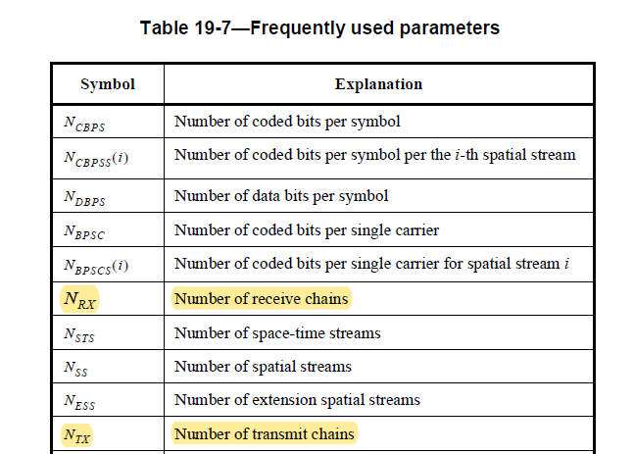

- VHT

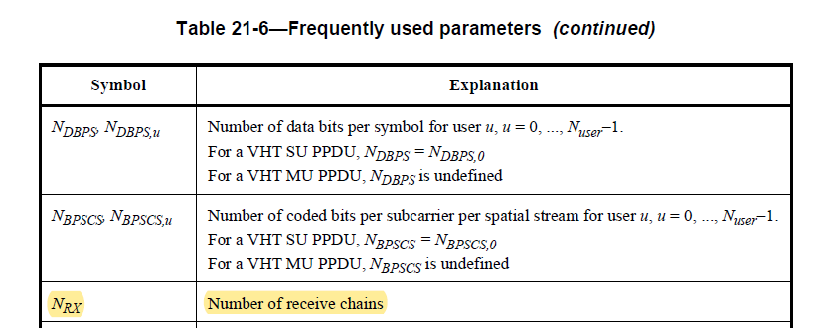

- HE

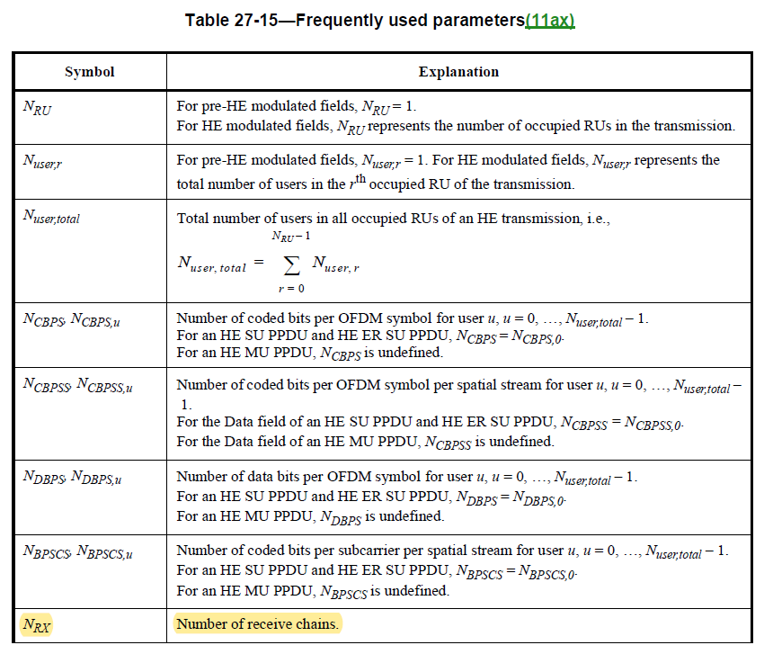

Discussion end

Instructions to the editor: please make the following changes to the paragraph from P51L54 to P51L63 in the subclause 9.4.1.73.2.1 General in D2.0 as shown below:

The measured CSI for the $r^{th}$ receive chain, the $t^{th}$ transmit chain, and the $k^{th}$ subcarrier is the complex value indicated by $H\left(r,t,k\right)$. The real part of the CSI is indicated by $H^{\left(R\right)}\left(r,t,k\right)$, and the imaginary part of the CSI is indicated by $H^{\left(I\right)}\left(r,t,k\right)$. The real and imaginary parts of the CSI are represented as 2s complement binary integers.

Instructions to the editor: please make the following changes to the paragraph from P52L4 to P52L5, P52L13 to P52L15, P52L16 to P52L21 and P56L30 in the subclause 9.4.1.73.2.2 CSI encoding procedure in D2.0 as shown below:

The number of receive chains is indicated by N_{RX} and the number of transmit chains is indicated by N_{TX}.

This calculation is performed for each tuple of receive and transmit chains, (r, t), with r=1, 2, …, N_{RX} and t = 1, 2, …, N_{TX} .

For a given tuple of receive and transmit chains, (r, t), the positive scaling factor $γ(r, t)$ (see 9.4.1.73 (Sensing Measurement Report Container field)) is selected to avoid overflow when scaling and quantizing the measured CSI using Equation (9-5c) and Equation (9-5d). The value of $m(r, t)$ may be used in the selection of the $γ(r, t)$ to avoid an overflow. The sensing receiver selects the exact value of the scaling factor.

This calculation is performed for each tuple of receive and transmit chains, (r, t).

Instructions to the editor: please make the following changes to Table 9-127h – Sensing Measurement Report Control field definition in the subclause 9.4.1.73.3 Sensing Measurement Report Control field in D2.0 as shown below:

N_{t} | 3 | Indicates the number of transmit chains. | Set to the number of transmit chainsNTX minus 1.
N_{r} | 3 | Indicates the number of receive chains. | Set to the number of receive chainsNRX minus 1.

Instructions to the editor: please make the following changes to Table 9-127k – Sensing Measurement Report information in the subclause 9.4.1.73.4 Sensing Measurement Report field in D2.0 as shown below:

- receive antenna -> receive chain
- transmit antenna -> transmit chain

Instructions to the editor: please make the following changes to the paragraph from P58L24 to P58L30 in the subclause 9.4.1.73.4 Sensing Measurement Report field in D2.0 as shown below:

Since the scaling and quantization is performed for each RX/TX chain pair, the scaled and quantized CSI values are ordered by RX/TX chain pair. The Sensing Measurement field begins with the set of scaling factors for each RX/TX chain pair. For each RX/TX chain pair there is a 12-bit positive scaling factor. If there is an odd number of scaling factors, then the set of scaling factors is followed by a 4-bit padding field.

Instructions to the editor: please make the following changes to the paragraph from P66L55 to P66L59 in the subclause 9.4.1.73.4 Sensing Measurement Report field in D2.0 as shown below:

NOTE—The size of the Sensing Measurement Report information increases with the number of transmit chains, the number of receive chains, the bandwidth, the smaller subcarrier grouping size, and the larger number of quantization bits for each real and imaginary component of CSI. The smallest Sensing Measurement Report field is 44 octets, and the largest Sensing Measurement Report field is 80752 octets.

Instructions to the editor: please make the following changes to Table 27-1 – TXVECTOR and RXVECTOR parameters in the subclause 27.2.2 TXVECTOR and RXVECTOR parameters in D2.0 as shown below:

- receive antennas -> receive chains
- transmit antennas -> transmit chains

Instructions to the editor: please make the following changes to Table 36-1— TXVECTOR and RXVECTOR parameters in the subclause 36.2.2 TXVECTOR and RXVECTOR parameters in D2.0 as shown below:

- receive antennas -> receive chains
- transmit antennas -> transmit chains

Instructions to the editor: please make the following changes to the paragraph from P135L1 to P135L5 in the subclause 11.55.1.1 Overview in D2.0 as shown below:

If the bandwidth of an SI2SR NDP is equal to 320 MHz, for transmission of EHT-STFs and EHT-LTFs, if $N_{STS}=N_{TX}$, the spatial mapping matrix, Q matrix, shall be an Identity matrix, which maps the first stream to the first RF chain and the first antenna element, the second stream to the second RF chain and the second antenna element, so on so forth. If $N_{STS}<N_{TX}$, the Q matrix shall be based on a RF chain/antenna element selection with no RF chain/antenna element swapping such that the Q matrix becomes an Identity matrix when all 0 rows are removed. In both $N_{STS}=N_{TX}$ and $N_{STS}<N_{TX}$ cases the stream to RF chain and physical antenna mapping shall be the same across all the measurement exchanges.

Instructions to the editor: please add the NOTE in P135L7 in the subclause 11.55.1.1 Overview in D2.0 as shown below:
NOTE—For example, if $N_{STS}=2$ and $N_{TX}=4$, one Q matrix that is compliant with the spec is 1 0 0 0 0100, which selects the first RF chain and the first antenna element to transmit the first stream, and the second RF chain and the second antenna element to transmit the second stream. Besides, these Q matrices are also compliant with the spec: 1 0 0 0 0010, 1 0 0 0 0001, 0 1 0 0 0010, 0 1 0 0 0001, and 0 0 1 0 0001. When all 0 rows are removed, these Q matrices all become an Identity matrix $\left[\begin{aligned}1 0 \\ 0 1\end{aligned}\right]$. One example of Q matrix that is not compliant with the spec is $\left[\begin{aligned}0 \\ 1 \\ 0 \\ 0 \end{aligned}\begin{aligned}1 \\ 0 \\ 0 \\ 0\end{aligned}\right]$, which selects the second RF chain and the second antenna element to transmit the first stream, and the first RF chain and the first antenna element to transmit the second stream. When all 0 rows are removed, the $Q$ matrix becomes 0 11 0 which is not an Identity matrix.

SP
Do you support resolutions to the following CIDs and incorporate the text changes into the latest TGbf draft: 3077, 3078, 3087, 3378 and 3380 in 11-23/1476r2 ?

Y/N/A

