IEEE P802.11
Wireless LANs
LB276 CR for Termination CIDs
Date: September 05, 2023
Author(s):
Name | Affiliation | Address | Phone | Email
Pei Zhou | TCL |  |  | zhoupei36@gmail.com

Abstract
This submission proposes resolutions to the following LB276 CIDs.
- 3169, 3490, 3508, 3065.
The text used as reference is 802.11bf D2.0.

Revisions:
- Rev 0: Initial version of the document.
- Rev 1: Reject CID 3508 according to offline discussions.

Comments:
CID | Clause | Page | Comment | Proposed Change | Resolution
3169 | 11.55.1.4.1 | 141.52 | The paragraph between L52-56 and L58-61 can perhaps be combined/cleaned-up so that redundant text are avoided. | One possible suggested text can be:  Following the successful establishment of a sensing measurement session between an AP and a non-AP STA, both STAs  ---shall start a sensing measurement session expiry timer  ---shall set the sensing measurement session expiry timer to aMeasurementSessionExpiry (see Table 11-30a (Sensing procedure timing related parameters))  ---shall reset the sensing measurement session expiry timer upon participation in TB and/or non-TB sensing measurement exchange(s) | Revised.  Agree with the commenter.  The paragraph between L52-56 and L58-61 are combined to avoid redundant text.  TGbf Editor make changes as in doc.: 11-23/1475r1.
3490 | 11.55.1.4.1 | 141.64 | There isn't any condition given in this paragraph for the case "A sensing measurement session established between an AP and a non-AP STA shall be terminated explicitly." This paragraph mentions only the expiry timer. | change " terminated explicitly or implicitly" to "considered terminated" | Revised.  Agree in principle with the commenter.  This paragraph mentions only the expiry timer, which talks about the implicit termination. Therefore, “explicitly” is deleted.  TGbf Editor make changes as in doc.: 11-23/1475r1.
3508 | 9.6.7.52 (Protected) Sensing Measurement Termination frame format | 114.50 | If Terminate All TB Measurement Sessions field is set to 1, all TB sessions (including the TB sessions solicited by SBP procedures) will be terminated. If AP do not want to be a sensing proxy and want to terminate all TB sessions solicited by SBP procedures, AP cannot directly use the Terminated All TB Measurement Sessions field. | If it is the case, decriminate the termination of all TB measurement sessions and all TB measurement sessions solicited by SBP. | Rejected.  The group reach consensus that Terminate All TB Measurement Sessions field = 1 is used to terminate the all sensing measurement sessions established in the TB case (including all TB measurement sessions solicited by SBP).
3065 | 11.55.1.6 | 159.37 | For SME initiated termination, there is a MLME-TERMINATE.request. This results in a Termiantion frame being sent (on next channel access). Once transmitted, but before the ack, the MLME-TERMINATE.confirm is issued. What happens if a timeout occurs between the .request and the .confirm? Are there two .confirms - one for the timeout and then one for transmission? Or just one? Also, typically a timeout would result in a .indication (since a .confirm is typically not sent by iteself, but in response to a .request). | Fix the identified problems with the termination procedure. Sepcifically, require that the timer be cancelled on receipt of the MLME-Terminate.request (so that it can't fire). And then make timeout issue a .indication (not a .confirm). Also, I'm not sure there is benefit in waiting for transmission, maybe just schedule transmission and send .indication. There might be a number of retries anyway and that way you free up resources with the .request and don't maintain some intermediate state while waiting for transmission -- become a pure upper MAC issue. | Rejected.  MLME-SENSMSMTTERMINATION is Type 2 form of MLME SAP primitive. The .confirm can indicate timeout or success. The identified condition was already considered and solved by the existing Type 2 form.  Please refer to the discission shown in page 5 and page 6 in doc.: 11-23/1475r1 for more details.

11.55.1.4 Sensing measurement session
11.55.1.4.1 General
TGbf Editor: Please revise clause 11.55.1.4.1 (General) as below.
Following the successful establishment of a sensing measurement session between an AP and a non-AP STA, both STAs
—shall start a sensing measurement session expiry timer
—shall set the sensing measurement session expiry timer to aMeasurementSessionExpiry (see Table 11-30a (Sensing procedure timing related parameters))
—shall reset the sensing measurement session expiry timer upon participating in TB and/or non-TB sensing measurement exchange(s).(#3169)
A sensing measurement session established between an AP and a non-AP STA shall be terminated implicitly if the corresponding sensing measurement session expiry timer expires at either STA. (#3490)

Discussion on CID 3065:
This CID is related to the following paragraph in subclause 11.55.1.6:
11.55.1.6 Sensing measurement session termination
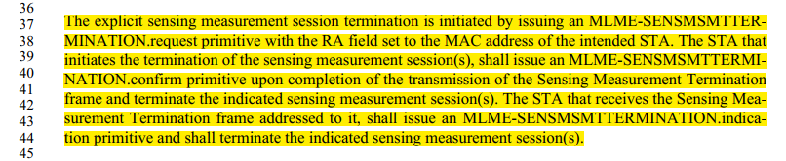

From the following Table 6-1, we can see that MLME-SENSMSMTTERMINATION is Type 2 form of MLME SAP primitive.
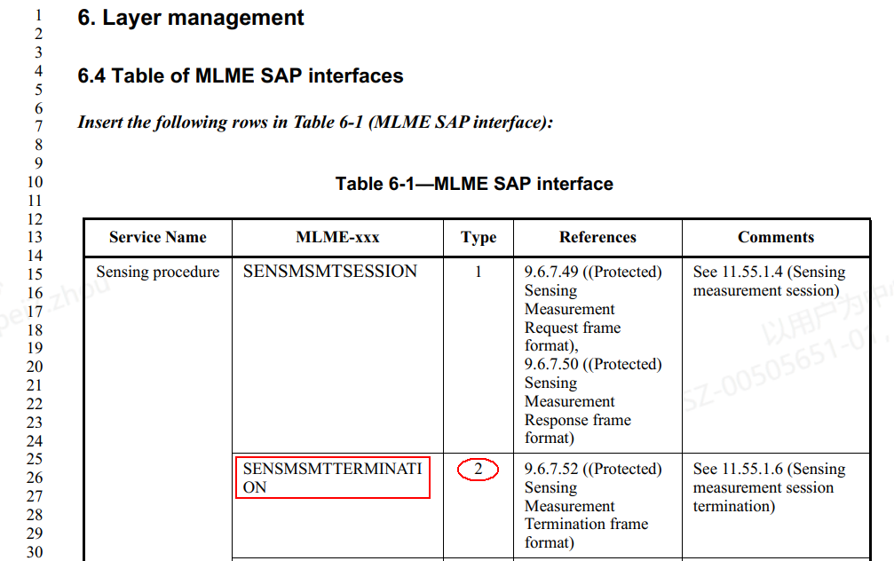

The definition of Type 2 form is shown below.
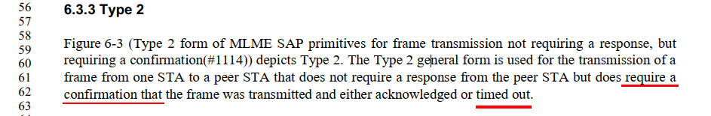
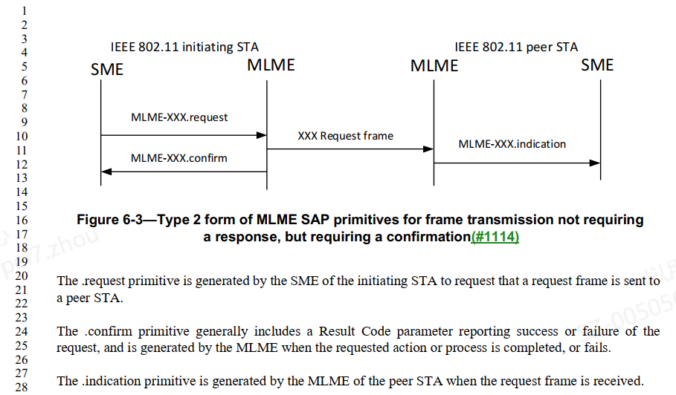
We can see that “if a timeout occurs between the .request and the .confirm”, there will be one .confirm for the timeout (by including a Result Code parameter reporting failure of the request, and is generated by the MLME when the requested action or process fails.)

To sum up, the mentioned text in draft 2.0 works well.

SP: Move to approve resolutions to CIDs 3169, 3490, 3508, 3065,
as specified in doc.: 11-23/1475r1 and incorporate the text changes into the latest TGbf draft.

