IEEE P802.11
Wireless LANs
CRs for SBP part1 in LB 276
Date: 2023-09-04
Author(s):
Name | Affiliation | Address | Phone | email
Xiandong Dong | Xiaomi |  |  | dongxiandong@xiaomi.com
Abstract
This submission proposes resolutions for following 10 CIDs received for WG LB276:
3153 3154 3187 3190 3258 3261 3308 3427
The proposed changes are based on 802.11bf D2.0

Revisions:
- Rev 0: Initial version of the document.
- Rev1: offline discussion of the CIDs 3258 and 3261

CID | Commenter | Clause | Page | Comment | Proposed Change | Resolution
3153 | Alireza Raissinia | 9.4.2.322 | 78.63 | Change "....requests to not participate in  the sensing procedure used by the SBP responder to satisfy the SBP request" to | requests to not participate in  the sensing procedure as a sensing responder used by the SBP responder to satisfy the SBP request | Accept
3154 | Alireza Raissinia | 9.4.2.322 | 79.35 | Change "may" to "can" as section 9 cannot have normative text | As per comment | Accept
3308 | Chaoming Luo | 9.6.7.56 | 118.02 | The two paragraphs should be restructured. And better to clarify what is an SBP error condition. | Change to:  The SBP Error Status field is set to 1 to indicate that the SBP procedure is terminated due to SBP error conditions; otherwise it is set to 0. The SBP Error Status field is reserved if Terminate All SBP Procedures field is set to 1.  The SBP Parameters element is defined in 9.4.2.322 (SBP Parameters element). The SBP Parameters element is present if the SBP Error Status field is set to 1; otherwise, it is not  present. | Accept

Discussion

CID3153
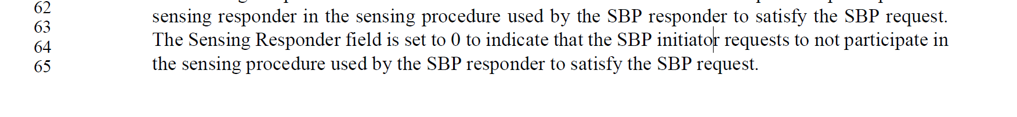
CID 3154
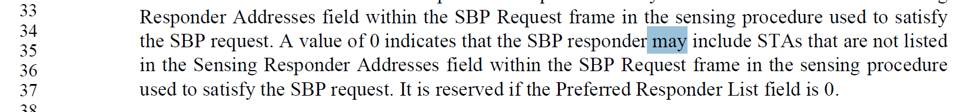

CID3308
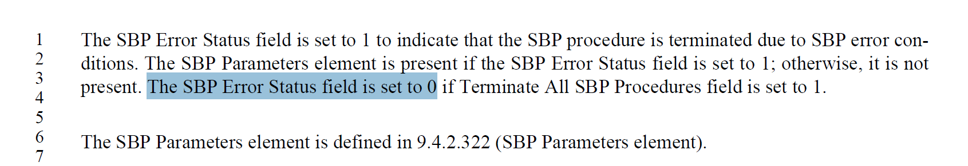

CID | commenter | Clause | Page | Comment | Proposed Change | Resolution
 |  |  |  |  |  | accept
3187 | Alireza Raissinia | 11.55.2.2 | 160.62 | Change "indicated" to "included" | As per comment | Accept
3190 | Alireza Raissinia | 11.55.2.2 | 164.41 | Delete "for SBP" (two places) as SBP is already implied in the text | As per comment | Accept
3258 | Leif Wilhelmsson | 11.55.2.1 | 160.17 | Reading the sentence it seems that it is possible to have dot11SBPImplemented = true and dot11SensingImplemented = false. If this is not possible, but in fact SBP implies sensing, I suggest explicitly stating that dot11SensingImplemented must be true as it in that case would be implicitly required. | As in comment | reject  The intent of “A STA in which both dot11SensingImplemented and dot11SBPImplemented are equal to true is defined as a STA that supports SBP” is partially to define that a STA that supports SBP shall be a sensing STA. Without such a definition, the case stated by the commenter could, at least in principle, be true.
3261 | Leif Wilhelmsson | 11.55.2.2 | 161.45 | "used to satisfy an SBP request" does not seem necessary to spell out and just makes the sentence harder to read. | remove "used to satisfy an SBP request" | Reject  “used to satisfy an SBP request” is needed because an AP may issue an MLME-SENSMSMTSESSION.request primitive to initiate a sensing procedure that is *not* used to satisfy an SBP request; that is, to initiate a sensing procedure in response to a request from a local application.
3427 | Stephan Sand | 11.55.2.2 | 161.55 | In this paragraph the SBP Request field is once refered to SBP Request subfield. Please change subfield to field. | As in comment | Accept

Discussion

CID 3187
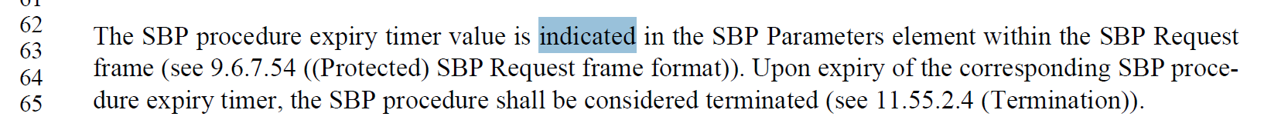

CID 3190
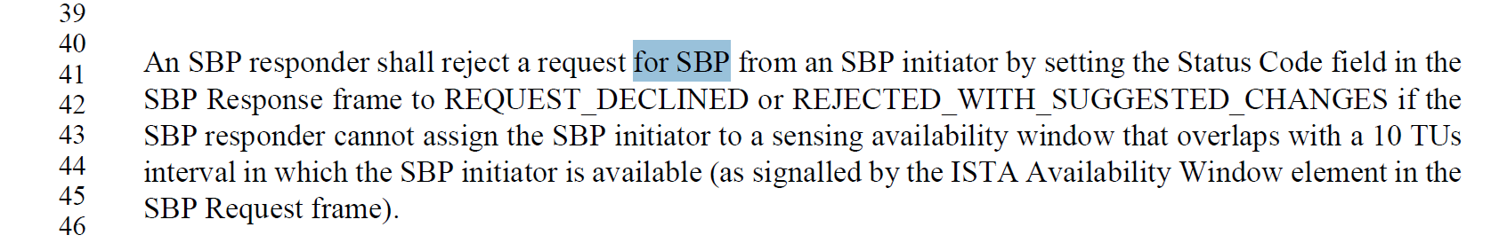

CID 3258

CID 3261
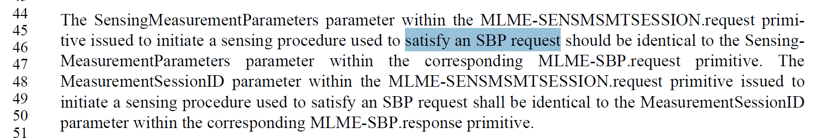

CID 3427
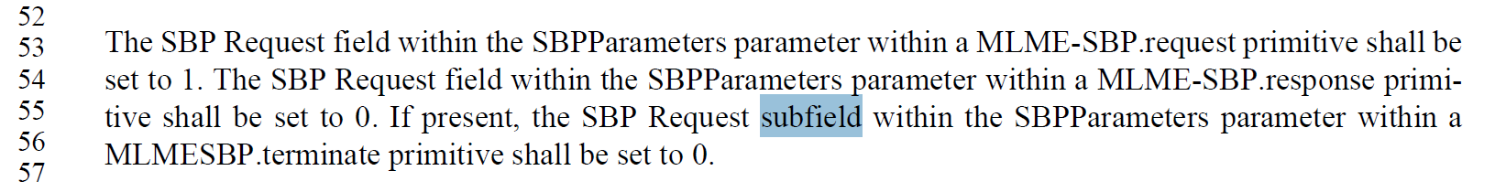

SP: Do you support the resolution to the following 10 CIDs and to incorporate the changes proposed in IEEE 802.11-23/1473r0 to the latest 11bf draft for the following CIDs: 3153 3154 3187 3190 3258 3261 3308 3427?

