IEEE P802.11
Wireless LANs
11bk Spec Text for MLD handling
Date: 2023-08-25
Author(s):
Name | Affiliation | Address | Phone | Email
Yanjun Sun | Qualcomm
Ali Raissinia
George Cherian

Abstract
We propose the draft specification skeleton for MLD to help the creation of TGbk draft.

Revisions:

- Rev 0: Initial version of the document.

Interpretation of a Motion to Adopt

A motion to approve this submission means that the editing instructions and any changed or added material are actioned in the TGbk Draft. This introduction is not part of the adopted material.

Editing instructions formatted like this are intended to be copied into the TGbk Draft (i.e. they are instructions to the 802.11 editor on how to merge the text with the baseline documents).

TGbk Editor: Editing instructions preceded by “TGbk Editor” are instructions to the TGbk editor to modify existing material in the TGbk draft. As a result of adopting the changes, the TGbk editor will execute the instructions rather than copy them to the TGbk Draft.

Discussion:
There were some brief discussions on MLD handling in the July meeting, a few key points are:
- MLD handling is not in PAR at the moment
- If needed, the solution needs to be kept simple, e.g., FTM negotiation should be per-link based

Two topics to discuss in this PDT:
- Questoin1: Without any MLD specific rules, could there be potential interop issues?
- Question2: If so, what would be a simple solution?

Questoin1: Without any MLD specific rules, could there be potential interop issues?
Findings: the latest 802.11beD4.0 (P548L29) has clarified that FTM, FTMR and LMR are not at the MLD level, instead, they’re at per-link level.
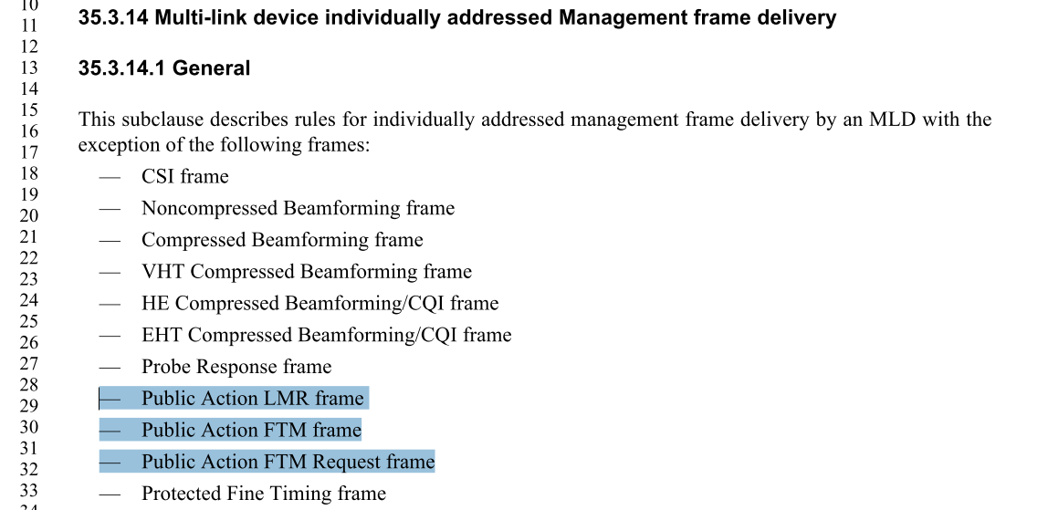

Such clarification in 11beD4.0 allows existing 11bk procedures to work on a STR link pair (example from 11beD4.0 P1024 below). An MLD in this case can perform FTM negotiation on each of the link at a per-link basis. We only need to make sure an FTM is transmitted on the same link where the corresponding IFTMR frame is received.
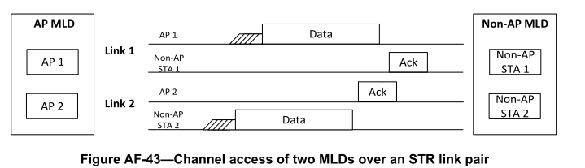

Issue: For an MLD in the EMLSR mode ((example from 11beD4.0 P1026 below), the existing 11bk procedures can have interop issues, as the non-AP MLD is expecting an initial Control frame before receiving any other frame and such initial Control frame is not present in any existing 11bk frame exchange sequences.
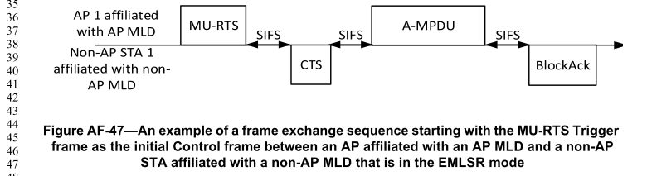
Related rules (11beD4.0P566L9):
“An AP affiliated with the AP MLD that initiates frame exchanges that are neither group addressed Data nor group addressed Management frames with the non-AP MLD on one of the EMLSR links shall begin the frame exchanges by transmitting the initial Control frame to the non-AP MLD with the limitations specified below.
… …
The initial Control frame shall be an MU-RTS Trigger frame or a BSRP Trigger frame.”

Candidate solution: one simple solution is to require an MLD be ready during a meansurement window neigotiated on a link so that the initial Control frame is not needed anymore on the link for any 11bk measurement sequences. This only requires a simple rule change instead of additional signalling so that existing 11bk sequences can remain as is. This solution is also similar to the baseline behavior which requires an ISTA to prioritize ranging measurement over other DATA exchange based on the following text from 11az (D7.0P151L27).
“Within each availability window the RSTA and ISTAs shall not transmit or trigger transmission of any Data frames; they shall only perform ranging activities related to Polling, Measurement Sounding and Measurement Reporting phases, as well as signaling of modification of availability window parameters”

Proposed spec text:

TGbk editor: Please note Baseline is REVme_D4.0, 11az D7.0, 11be4.0 and 11bk D0.2

TGbk editor: Please insert the following to the end of subclause 11.21.6.3.1 (track change enabled):

11.21.6.3 FTM procedure negotiation

11.21.6.3.1 General

… …
An MLD shall transmit an IFTM frame or an FTM frame on a link on which the corresponding IFTMR frame is received. The negotiated FTM session by the IFTMR, IFTM or FTM frames shall be applied to the link and shall not be applied to another link of the MLD.

Within each availability window a RSTA has negotiated with an ISTA that is an MLD operating in the EMLSR mode, the RSTA shall not transmit the initial Control frame that initiates frame exchanges defined in 35.3.17 (Enhanced multi-link single radio operation).

