IEEE P802.11
Wireless LANs
TGbe July September Teleconference Minutes
Date: 2023-08-23
Author(s):
Name | Affiliation | Address | Phone | email
Jason Yuchen Guo | Huawei |  |  | guoyuchen@huawei.com
Abstract
This document contains the minutes for the IEEE 802.11 TGbe teleconferences from July 2023 to September 2023.

Revision history:
- Rev0: initial version of the document
- Rev1: add attendee list for the joint meeting on August 23.

Abbreviations:
- C: Comment.
- A: Answer.

1st Conf. Call: August 23 (10:00–12:00 ET)–JOINT
- The Chair, Alfred Asterjadhi (Qualcomm), calls the meeting to order
- Jason Yuchen Guo (Huawei) is serving as the Secretary
- IEEE 802 and 802.11 IPR policy and procedure
  - Patent Policy: Ways to inform IEEE:
    - Cause an LOA to be submitted to the IEEE-SA (patcom@ieee.org); or
    - Provide the chair of this group with the identity of the holder(s) of any and all such claims as soon as possible; or
    - Speak up now and respond to this Call for Potentially Essential Patents
If anyone in this meeting is personally aware of the holder of any patent claims that are potentially essential to implementation of the proposed standard(s) under consideration by this group and that are not already the subject of an Accepted Letter of Assurance, please respond at this time by providing relevant information to the WG Chair. Nobody speaks/writes up.
  - Copyright Policy: Participants are advised that
    - IEEE SA’s copyright policy is described in Clause 7 of the IEEE SA Standards Board Bylaws and Clause 6.1 of the IEEE SA Standards Board Operations Manual;
    - Any material submitted during standards development, whether verbal, recorded, or in written form, is a Contribution and shall comply with the IEEE SA Copyright Policy
    - Copyright Policy was presented.
  - Patent, Participation, Copyright and policy related subclause: Please refer to Patent And Procedures
- Attendance reminder.
  - Participation slide: https://mentor.ieee.org/802-ec/dcn/16/ec-16-0180-05-00EC-ieee-802-participation-slide.pptx
  - Please record your attendance during the conference call by using the IMAT system:
    - 1) login to imat, 2) select “802.11 Telecons (<Month>)” entry, 3) select “C/LM/WG802.11 Attendance” entry, 4) click “<Joint TGbe > conference call that you are attending.
  - If you are unable to record the attendance via IMAT then please send an e-mail to Jason Y. Guo (guoyuchen@huawei.com) and Alfred Asterjadhi (asterjadhi@gmail.com)
  - Please ensure that the following information is listed correctly when joining the call:
    - "[voter status] First Name Last Name (Affiliation)"
  - Attendee List
Breakout | Timestamp | Name | Affiliation
TGbe (Joint) | 8/23 | Ajami, Abdel Karim | Qualcomm Technologies, Inc
TGbe (Joint) | 8/23 | Au, Kwok Shum | Huawei Technologies Co., Ltd
TGbe (Joint) | 8/23 | Baek, SunHee | LG ELECTRONICS
TGbe (Joint) | 8/23 | Bahn, Christy | IEEE STAFF
TGbe (Joint) | 8/23 | Cha, Dongju | LG ELECTRONICS
TGbe (Joint) | 8/23 | Chen, You-Wei | MediaTek Inc.
TGbe (Joint) | 8/23 | Chu, Liwen | NXP Semiconductors
TGbe (Joint) | 8/23 | CHUN, JINYOUNG | LG ELECTRONICS
TGbe (Joint) | 8/23 | Cui, Yaoshen | TP-Link Corporation Limited
TGbe (Joint) | 8/23 | Das, Subir | Peraton Labs
TGbe (Joint) | 8/23 | Dong, Xiandong | Xiaomi Communications Co., Ltd.
TGbe (Joint) | 8/23 | Erkucuk, Serhat | Ofinno
TGbe (Joint) | 8/23 | Fang, Yonggang | Mediatek
TGbe (Joint) | 8/23 | Fujimori, Yuki | Canon Research Centre France
TGbe (Joint) | 8/23 | Gu, Xiangxin | Spreadtrum Communications (Shanghai) Co., Ltd.
TGbe (Joint) | 8/23 | GUIGNARD, Romain | Canon Research Centre France
TGbe (Joint) | 8/23 | Guo, Yuchen | Huawei Technologies Co., Ltd
TGbe (Joint) | 8/23 | Gupta, Binita | Meta Platforms, Inc.
TGbe (Joint) | 8/23 | Ho, Duncan | Qualcomm Incorporated
TGbe (Joint) | 8/23 | Huang, Po-Kai | Intel
TGbe (Joint) | 8/23 | Jang, Insun | LG ELECTRONICS
TGbe (Joint) | 8/23 | Kakani, Naveen | Qualcomm Incorporated
TGbe (Joint) | 8/23 | Kim, Geon Hwan | LG ELECTRONICS
TGbe (Joint) | 8/23 | Kim, Jeongki | Ofinno
TGbe (Joint) | 8/23 | Kim, Sang Gook | LG ELECTRONICS
TGbe (Joint) | 8/23 | Kim, Sanghyun | WILUS Inc
TGbe (Joint) | 8/23 | Kim, Youhan | Qualcomm Technologies, Inc.
TGbe (Joint) | 8/23 | Klein, Arik | Huawei Technologies Co., Ltd
TGbe (Joint) | 8/23 | Lanante, Leonardo | Ofinno
TGbe (Joint) | 8/23 | Li, Weiyi | Spreadtrum Communication USA, Inc
TGbe (Joint) | 8/23 | Li, Yapu | Guangdong OPPO Mobile Telecommunications Corp.,Ltd
TGbe (Joint) | 8/23 | Lim, Dong Guk | LG ELECTRONICS
TGbe (Joint) | 8/23 | McCann, Stephen | Huawei Technologies Co., Ltd
TGbe (Joint) | 8/23 | Ouchi, Masatomo | Canon
TGbe (Joint) | 8/23 | Patil, Abhishek | Qualcomm Incorporated
TGbe (Joint) | 8/23 | Patwardhan, Gaurav | Hewlett Packard Enterprise
TGbe (Joint) | 8/23 | Petrick, Albert | InterDigital, Inc.
TGbe (Joint) | 8/23 | Quan, Yingqiao | Spreadtrum
TGbe (Joint) | 8/23 | Ryu, Kiseon | NXP Semiconductors
TGbe (Joint) | 8/23 | Schelstraete, Sigurd | MaxLinear
TGbe (Joint) | 8/23 | Sun, Yanjun | Qualcomm Incorporated
TGbe (Joint) | 8/23 | Tian, Bin | Qualcomm Incorporated
TGbe (Joint) | 8/23 | Wang, Qi | Apple, Inc.
TGbe (Joint) | 8/23 | Yano, Kazuto | Advanced Telecommunications Research Institute International (ATR)
TGbe (Joint) | 8/23 | Yee, James | MediaTek Inc.
TGbe (Joint) | 8/23 | Yi, Yongjiang | Spreadtrum Communication USA, Inc
TGbe (Joint) | 8/23 | Yoon, Yelin | LG ELECTRONICS
TGbe (Joint) | 8/23 | Zhao, Yue | Huawei Technologies Co., Ltd
TGbe (Joint) | 8/23 | Zhou, Pei | TCL

- Announcements:
  - LB275 closed on August 13th, 2023 with an approval rate of ~90%.
- LB275 Results, Plan and (updated) CR Guidelines:
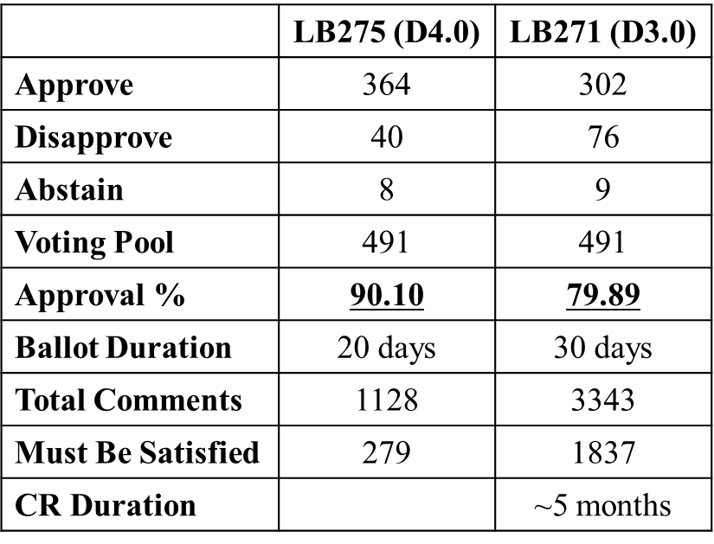

  - Updated CR Guidelines: 23/984r16
- 1376r2 Editor’s Report on LB275 Edward Au
- Agenda
  - CR Submissions:
    - 1383r0 CR for some subclauses in 4, 10, and 11 Po-Kai Huang [17C]
    - 1385r0 CR for 35.3.14 Po-Kai Huang [11C]
    - 1409r0 CR for Trigger frame Yanjun Sun [7C]
    - 1406r0 Resolution for comments assigned to Abhi - Part 6 Abhishek Patil [10C]
    - 1405r0 Resolution for comments assigned to Abhi - Part 5 Abhishek Patil [10C]
    - 1404r0 Resolution for comments assigned to Abhi - Part 4 Abhishek Patil [10C]
  - Discussions
    - None
  - Agenda approved with unanimous consent

- Technical contributions

  - 1383r0 CR for some subclauses in 4, 10, and 11 Po-Kai Huang

C: I’ve made a search and find there are still some occurences of “non-AP STA affiliated with a non-AP MLD”.
C: the document number is missing in the heading of this document.
C: missing “e” in “subelement”, duplicate of “non-”
C: we should use the IEEE document template.
C: Rubayet requested to defer CID 19593 for further discussion

SP: Do you agree to resolve the following CIDs listed in 11-23/1383r1 and incorporate the text changes into the latest TGbe draft?
• 19589, 19066, 19489, 19499, 19130, 19063, 19224, 19062, 19003, 19052, 19054, 19050, 19053, 19593, 19229, 19514, 19515
Discussion: None.
Result: No objection.

  - 1385r0 CR for 35.3.14 Po-Kai Huang

C: CID 19640, the proposed resolution has a typo. You can change “Accept” to “Revised”. Same for CID 19644.
C: CID 19064, Link ID Bitmap and Aligned TWT Bitmap always appear at the same time. The presenter rejected this CID after checking with Ming.

SP: Do you agree to resolve the following CIDs listed in 11-23/1385r1 and incorporate the text changes into the latest TGbe draft?
• 19064, 19284, 19640, 19641, 19642, 19643, 19644, 19285, 19286, 19287, 19857
Discussion: None.
Result: No objection.

  - 1409r0 CR for Trigger frame Yanjun Sun

Discussion: None.

SP: Do you agree to resolve the following CIDs listed in 11-23/1409r0 and incorporate the text changes into the latest TGbe draft?
• 19000,19469,19646,19647,19467,19648,19162
Discussion: None.
Result: No objection.

  - 1406r0 Resolution for comments assigned to Abhi - Part 6 Abhishek Patil

Discussion: None.

SP: Do you agree to resolve the following CIDs listed in 11-23/xxxxr0 and incorporate the text changes into the latest TGbe draft?
• 19070 19811 19812 19813 19814 19815 19816 19601 19602 19806
Discussion: None.
Result: No objection.

  - 1405r0 Resolution for comments assigned to Abhi - Part 5 Abhishek Patil

C: 19792, Qi requested to defer it for offline discussion.
C: 19802, Po-Kai asked to defer it for further check.
C: Ming asked to defer 19794

SP: Do you agree to resolve the following CIDs listed in 11-23/1405r0 and incorporate the text changes into the latest TGbe draft?
• 19780 19275 19789 19297 19793 19298 19205
Discussion: None.
Result: No objection.

  - 1404r0 Resolution for comments assigned to Abhi - Part 4 Abhishek Patil

C: CID 19762, suggest to put the revised text in the main body of this document, rather than in the table. The reason is that the scratch out part will disappear in the comment spreadsheet.

SP: Do you agree to resolve the following CIDs listed in 11-23/1404r1 and incorporate the text changes into the latest TGbe draft?
• 19102 19202 19204 19760 19915 19762 19763 19764 20068 19242
Discussion: None.
Result: No objection.

- AoB: None
- Adjourned at 12:00

2nd Conf. Call: August 24 (10:00–12:00 ET)–MAC
Please refer to the following link for the minutes
- https://

3rd Conf. Call: August 28 (19:00–21:00 ET)–MAC
Please refer to the following link for the minutes
- https://

3rd Conf. Call: August 28 (19:00–21:00 ET)–PHY
Please refer to the following link for the minutes
- https://

4th Conf. Call: August 30 (10:00–12:00 ET)–MAC
Please refer to the following link for the minutes
- https://

5th Conf. Call: September 06 (10:00–12:00 ET)–MAC
Please refer to the following link for the minutes
- https://

6th Conf. Call: September 07 (10:00–12:00 ET)–MAC
Please refer to the following link for the minutes
- https://

