IEEE P802.11
Wireless LANs
LB 275 Resolution for CIDs assigned to Abhi – Part 7
Date: August 22, 2023
Author(s):
Name | Affiliation | Address | Phone | email
Abhishek Patil | Qualcomm Inc. |  |  | appatil@qti.qualcomm.com
Gaurang Naik
George Cherian
Alfred Asterjadhi
Duncan Ho
Yanjun Sun
Abdel Karim

Abstract
This submission proposes resolutions for following CIDs received for TGbe LB275:
19512 19761 19203 19268 19269 20062 20063 20065 19805 19332

Revisions:
- Rev 0: Initial version of the document.
- Rev 1: Includes a few changes that were made on the fly when the doc was presented during the TGbe MAC call on 8/28/23

TGbe editor: Baseline for this document is 11be D4.0

Interpretation of a Motion to Adopt

A motion to approve this submission means that the editing instructions and any changed or added material are actioned in the TGbe Draft. This introduction is not part of the adopted material.

TGbe Editor: Editing instructions preceded by “TGbe Editor” are instructions to the TGbe editor to modify existing material in the TGbe draft. As a result of adopting the changes, the TGbe editor will execute the instructions rather than copy them to the TGbe Draft.

CID | Commenter | Category | Clause | Page | Comment | Proposed Change | Resolution
19512 | Michael Montemurro | E | 9.4.312.1 | 252.65 | [WFA-R] s/below/below./ Note: There is a missing period. | As in comment | Revised  The comment applies to page 243 (not 252).  TGbe editor, please add a ‘.’ After ‘below’ on the last line of page 243.
19761 | Abhishek Patil | T | 35.3.3.1 | 492.05 | Generalize the NOTE 5 or add a similar NOTE for AP side. | As in comment | Revised  The test in subclause 35.3.3.1 is reorganized to remove redundant text. The first paragraph is broadly written and covers the case of an ML IE being advertisement by an AP or a non-AP MLD. The 6th paragraph does not provide much value and is deleted. The NOTEs following the 6th paragraph are deleted and the technical content is covered in a new sentence added to the 1st paragraph and a new NOTE 2.  TGbe editor, please make changes as shown in 11-23/1407r0 tagged 19761
19203 | Rubayet Shafin | E | 35.3.3.1 | 491.56 | This sentence is a bit hard to read | add a comma after "Basic Multi-Link element" in line 55; replace "carrying" with "which carries" in line 55; add a comma after "affiliated" in line 56, | Revised  The NOTE cited by the comment is deleted as a resolution to CID 19761 and the issue pointed by the comment no longer applies.  TGbe editor, please make changes as shown in 11-23/1407r0 tagged 19761
19268 | John Wullert | E | 35.3.8 | 531.01 | Sentence is missing an article and has unnecessary trailing "on" | Revise as "A STA affiliated with a recipient MLD shall provide, to the STA affiliated with the originator MLD that is operating on the same link, the reception status for any MPDU, with an ack policy other than No Ack, that is received on the link on which the STA affiliated with the recipient MLD is operating." | Revised  The commenter provided the wrong page number. The comment applies to P533L1.  TGbe editor, please make changes as proposed by the comment to the correct sentence (P533L1-L3).
19269 | John Wullert | G | 35.3.8 | 531.03 | Belonging to TID and having ack policy are necessary conditions and thus should be set off with "that" rather than "which". Also, order of some of the clauses makes sentence hard to parse. | Replace with "When a TID is mapped to more than one link, a STA affiliated with a recipient MLD may provide reception status (if available) to the STA affiliated with the originator MLD that is operating on the same link, indicating successful reception of any MPDU that belongs to that TID and has an ack policy other than No Ack and that is received by a STA affiliated with the recipient MLD that is operating on a different link." | Revised  The commenter provided the wrong page number. The comment applies to P533L3.  TGbe editor, please make changes as proposed by the comment to the correct sentence (P533L3-L8).
20062 | Binita Gupta | T | AF.2.3 | 1000.51 | The name of the element in the figure should be 'EHT Operation' (without the plural *s*) as per clause 9.4.2.311 | Fix in the figure as per comment. Also fix this in other applicable figures in clause AF.2 and AF.3 | Revised  The extra ‘s’ in EHT Operations is deleted from multiple figures in clause AF. The modified figures are shown in this document.  TGbe editor, please replace the respective figures in clause AF with the ones shown in document 11-23/1407r1.
20063 | Binita Gupta | T | AF.2.3 | 1001.12 | In Figures AF-5, AF-6 and AF-7, the AP entries need to also point to the first entry in RNR. It only points to the last three AP entries. | Modify figure as per comment. | Revised  The cited figures are updated as indicated by the comment. The modified figures are shown in this document.  TGbe editor, please replace the respective figures in clause AF with the ones shown in document 11-23/1407r1
20065 | Binita Gupta | T | AF.2.3 | 1001.63 | Figure AF-8 implies that MLD ID is carried in the Common Info of the Reconfig ML element, which is not the case. Move the arrow to the Index field for the Nontransmitted BSSID profile.  Also replace 'MLD ID' with 'AP MLD ID' for consistent use of terminology. | Modify figure as per comment. | Revised  The arrow is moved to point to the nonTxBSSID profile, and the field name is fixed to AP MLD ID. The modified figure is shown in this document.  TGbe editor, please replace the respective figures in clause AF with the ones shown in document 11-23/1407r1
19805 | Abhishek Patil | T | AF.10 | 1018.59 | For brevity, replace with non-MLD non-AP STA. Same comment at P1020L53 | As in comment | Revised  Agree with the comment. A non-AP STA that is not affiliated with a non-AP MLD can be referred to as a non-MLD non-AP STA. The change on P1020L53 is made as part of another comment and not addressed here.  TGbe editor, please make the following replacements:  - P1018L59: “STA3 is not affiliated with a non-AP MLD” with “STA3 is a non-MLD non-AP STA”  - P1022L40: “which is a STA that is not affiliated with a non-AP MLD” with “which is a non-MLD non-AP STA”
19332 | Yingqiao Quan | E | AF.10 | 1024.06 | In Figure AF-39--TDLS direct link involving a STA affiliated with a non-AP MLD and a non-AP STA that is not affiliated with a non-AP MLD, the marker of the non-AP STA that is not affiliated with a non-AP MLD in the right of the figure is missing. | Add a marker (it might be "STA3") for the the non-AP STA that is not affiliated with a non-AP MLD | Revised  STA 3 was added to the figure to identify the device on the right. The updated figure is shown in this document.  TGbe editor, please replace the respective figures in clause AF with the ones shown in document 11-23/1407r1

35.3.3 Advertisement of multi-link information in Multi-Link element
35.3.3.1 General
TGbe editor: Please modify the following paragraphs in this subclause as shown below:
[19761]The rules for including a Basic Multi-Link element in a Beacon frame or in a Probe Response frame are described in 35.3.4 (Discovery of an AP MLD). The rules for including a Basic Multi-Link element in an Authentication frame, in a (Re)Association Request frame, or in a (Re)Association Response frame are described in 35.3.5 (ML (re)setup). The subclauses also define the conditions for presence of the Link Info field in the Basic Multi-Link element and when present, whether the Link Info field carries complete or partial profile of a reported STA.
The requirements for including a Reconfiguration Multi-Link element in a Beacon frame and Probe Response frame are described in 35.3.6.3 (Removing affiliated APs).
NOTE 1—The Probe Response frame referred in the above paragraphs can be a multi-link probe response.
[19761]NOTE 2— The rules related to inclusion and location of a Multi-Link element in a frame when an affiliated AP corresponds to a nontransmitted BSSID in a multiple BSSID set can be found in 35.3.20 (Multi-link operation in a multiple BSSID set or co-hosted BSSID set)), 35.3.4.2 (Use of multi-link probe request and response)) and 35.3.6 (ML reconfiguration). The subclauses also define the conditions for presence of the Link Info field in the Basic Multi-Link element and when present, whether the Link Info field carries complete or partial profile of a reported STA.
The requirements for including a EPCS Priority Access Multi-Link element in EPCS Priority Access Enable Request/Response frames are described in 35.16 (EPCS priority access).
The requirements for including a Probe Request Multi-Link element in a Probe Request frame are described in 35.3.4.2 (Use of multi-link probe request and response).
The requirements for including a TDLS Multi-Link element in frames exchanged during TDLS discovery and setup are described in 35.3.21 (TDLS procedure in multi-link operation).
[19761]

Annex AF
TGbe editor: Please replace Figure AF-4 with the one shown below:
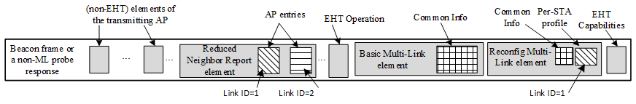
[20062]Figure AF-4—Contents of a Beacon frame or a non-multi-link probe response during ML reconfiguration AP removal procedure (non-multiple BSSID scenario)

TGbe editor: Please replace Figure AF-5 with the one shown below:
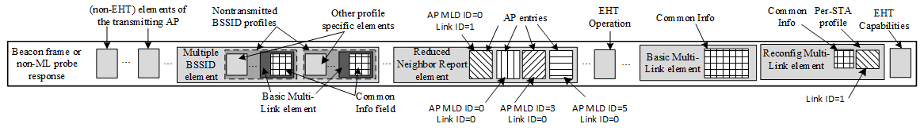
[20062, 20063]Figure AF-5—Contents of a Beacon frame or a non-multi-link probe response during ML reconfiguration AP removal procedure for an AP affiliated with the AP MLD of the transmitted BSSID

TGbe editor: Please replace Figure AF-6 with the one shown below:
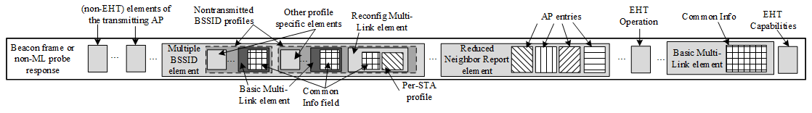
[20062, 20063]Figure AF-6—Contents of a Beacon frame or a non-multi-link probe response during ML reconfiguration AP removal procedure for an AP affiliated with the AP MLD of a nontransmitted BSSID

TGbe editor: Please replace Figure AF-7 with the one shown below:
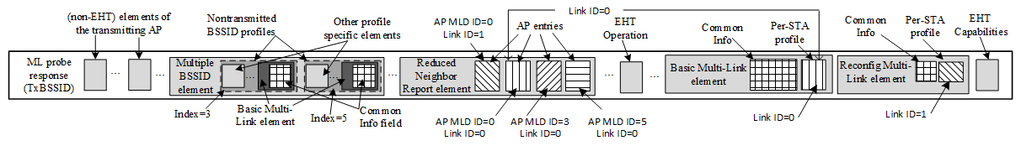
[20062, 20063]Figure AF-7—Contents of a multi-link probe response during ML reconfiguration AP removal procedure for an AP affiliated with the AP MLD of the transmitted BSSID

TGbe editor: Please replace Figure AF-8 with the one shown below:
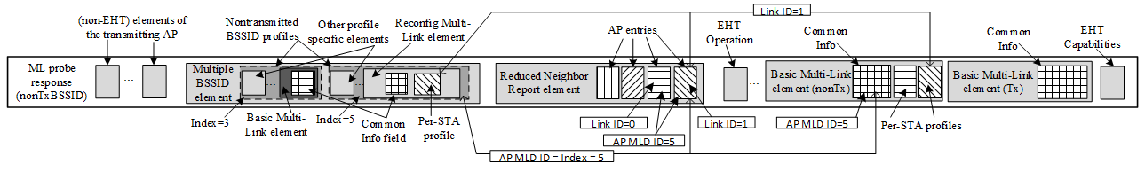
[20062, 20065]Figure AF-8—Contents of a multi-link probe response during ML reconfiguration AP removal procedure for an AP affiliated with the AP MLD of a nontransmitted BSSID

TGbe editor: Please replace Figure AF-13 with the one shown below:
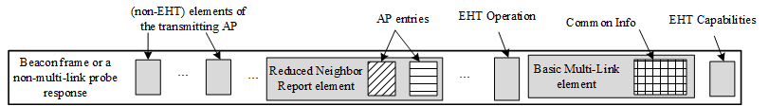
[20062]Figure AF-13—Contents of a Beacon frame or Probe Response frame that is not a multi-link probe response transmitted by an affiliated AP that is not a member of a multiple BSSID set during MLO discovery

TGbe editor: Please replace Figure AF-14 with the one shown below:
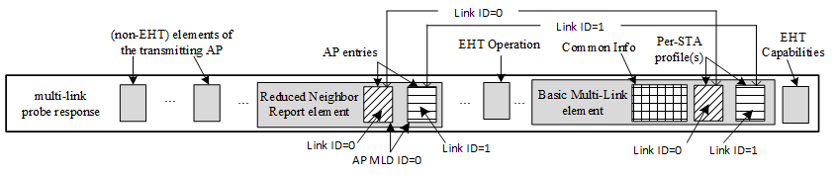
[20062]Figure AF-14—Contents of a multi-link probe response transmitted by an affiliated AP that is not a member of a multiple BSSID set during MLO discovery

TGbe editor: Please replace Figure AF-16 with the one shown below:
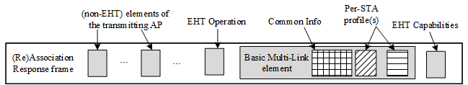
[20062]Figure AF-16—Contents of a (Re)Association Response frame transmitted by an affiliated AP that is not a member of a multiple BSSID set during MLO discovery

TGbe editor: Please replace Figure AF-17 with the one shown below:
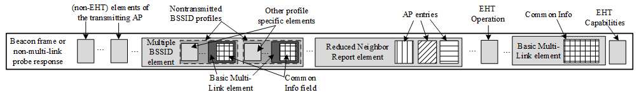
[20062]Figure AF-17—Contents of a Beacon frame or Probe Response frame that is not a multi-link probe response transmitted by an AP corresponding to transmitted BSSID during MLO discovery

TGbe editor: Please replace Figure AF-18 with the one shown below:
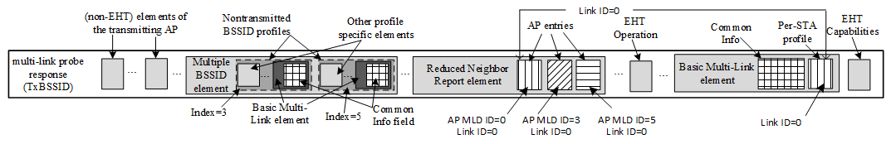
[20062]Figure AF-18—Contents of a multi-link probe response, when soliciting frame was directed to transmitted BSSID, transmitted by an AP affiliated with an AP MLD that is a member of multiple BSSID set during MLO discovery

TGbe editor: Please replace Figure AF-19 with the one shown below:
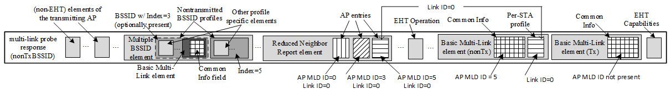
[20062]Figure AF-19—Contents of a multi-link probe response, when soliciting frame was directed to nontransmitted BSSID corresponding to index 5, transmitted by an AP affiliated with an AP MLD that is a member of multiple BSSID set during MLO discovery

TGbe editor: Please replace Figure AF-21 with the one shown below:
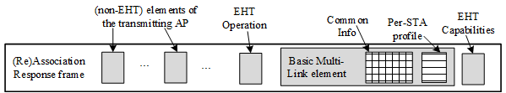
[20062]Figure AF-21—Contents of a (Re)Association Response frame transmitted by nontransmitted BSSID corresponding to index 5 during ML setup

TGbe editor: Please replace Figure AF-39 with the one shown below:
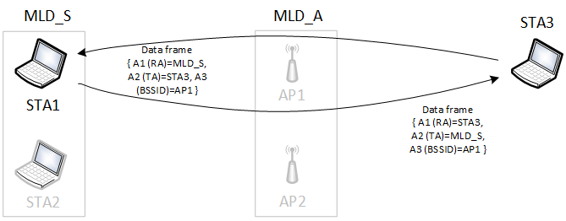
[19332]Figure AF-39—TDLS direct link involving a STA affiliated with a non-AP MLD and a non-AP STA that is not affiliated with a non-AP MLD

