IEEE P802.11
Wireless LANs
LB 275 CR for Annex Z
Date: Aug 17, 2023
Author(s):
Name | Affiliation | Address | Phone | email
Ross Jian Yu | Huawei |  |  | ross.yujian@huawei.com
Ming Gan | Huawei
Edward Au | Huawei
Stephen McCann | Huawei

Abstract
This submission proposes resolutions for following 7 CIDs received for TGbe LB275:
CID 19036, 19037, 19038, 19039, 19040, 19041, 20117
Revisions:
- Rev 0: Initial version of the document.

CID 19036
CID | Page | Clause | Comment | Proposed Change | Resolution
19036 | 975.22 | Z.6 | The 5th octet should be 00010100 (28) and not 01010000 (0A) for both content channels 1 and 2 | As in comment | REVISED  Reflect the changes in detail  Instructions to the editor:  Please make the changes as shown in 11/23-1378r0 tagged with #CID19036.

Discussion
The typo was made when handling CID 11971 in 11/22-1360r0.
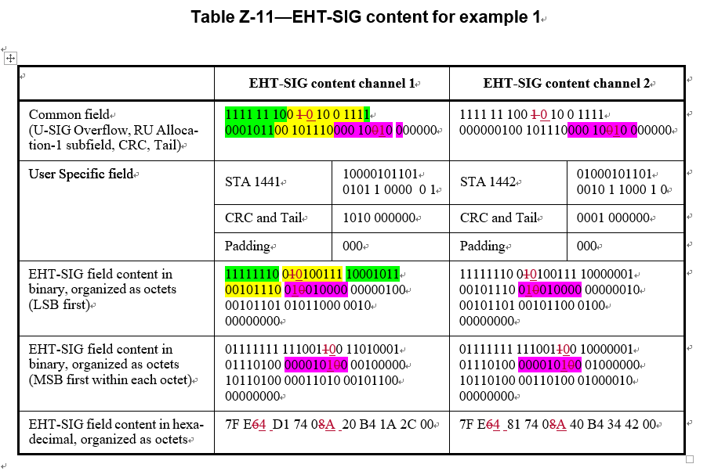
Discussion ends
TGbe editor, please make the following changes to P975, line 22 of P802.11be D4.0 as shown below:
Table Z-11—EHT-SIG content for example 1
 | EHT-SIG content channel 1 |  | EHT-SIG content channel 2
Common field  (U-SIG Overflow, RU Alloca- tion-A subfield, CRC, Tail) | 1111 11 100 0 10 0 1111  000101100 101110000 1010 000000 |  | 1111 11 100 0 10 0 1111  000000100 101110000 1010 000000
User Specific field | STA 1441 | 10000101101  0101 1 0000 0 1 | STA 1442 | 01000101101  0010 1 1000 1 0
 | CRC and Tail | 1010 000000 | CRC and Tail | 0001 000000
 | Padding | 000 | Padding | 000
EHT-SIG field content in binary, organized as octets (LSB first) | 11111110 00100111 10001011  00101110 000 1010 0 (#19036) 00000100  00101101 01011000 00110100  00000000 |  | 11111110 00100111 10000001  00101110 000 1010 0 (#19036) 00000010  00101101 00101100 01000010  00000000
EHT-SIG field content in binary, organized as octets (MSB first within each octet) | 01111111 11100110 10010001  01110100 00101000 (#19036) 00100000  10110100 00011010 00101100  00000000 |  | 01111111 11100100 10000001  01110100 00101000(#19036) 01000000  10110100 00110100 01000010  00000000
EHT-SIG field content in hexa- decimal, organized as octets | 7F E4 D1 74 28(#19036) 20 B4 1A 2C 00 |  | 7F E4 81 74 28(#19036) 40 B4 34 42 00

CID 19037
CID | Page | Clause | Comment | Proposed Change | Resolution
19037 | 975.31 | Z.6 | The 5th octet should be 28 and not 0A for content channels 1 and 2. | As in comment | REVISED  Reflect the changes in detail  Instructions to the editor:  Please make the changes as shown in 11/23-1378r0 tagged with #CID19036.  Note to the commenter and editor: It is the same proposed change as part of CID 19036.

CID 19038
CID | Page | Clause | Comment | Proposed Change | Resolution
19038 | 980.18 | 36.3.12.8 | The 5th octet should be 68 and not 16 for content channels 1 and 2. | As in comment | REVISED  Reflect the changes in detail  Instructions to the editor:  Please make the changes as shown in 11/23-1378r0 tagged with #CID19038.

TGbe editor, please make the following changes to P980, line 18 of P802.11be D4.0 as shown below:
Table Z-21—EHT-SIG content in the upper 80 MHz for example 3
 | EHT-SIG content channel 1 |  | EHT-SIG content channel 2
Common field | 1111 11 100 1 10 0 1111 |  | 1111 11 100 1 10 0 1111
(U-SIG Overflow, 2 RU Allo- | 101110000 101110000 1011 |  | 101110000 101110000 1011
cation-A subfields, CRC, Tail, | 000000 011110000 011110000 |  | 000000 011110000 011110000
2 RU-Allocation-B subfields, CRC, Tail) | 0101 000000 |  | 0101 000000
User Specific field | Padding | 00000000 | Padding | 00000000
 |  | 00000000 |  | 00000000
 |  | 00000000 |  | 00000000
 |  | 00000000 000 |  | 00000000 000
EHT-SIG field content in binary, organized as octets (LSB first) | 11111110 01100111 11011100  00101110 00010110 00000011  11000001 11100000 10100000  00000000 00000000 00000000  00000000 0000 |  | 11111110 01100111 11011100  00101110 00010110 00000011  11000001 11100000 10100000  00000000 00000000 00000000  00000000 0000
EHT-SIG field content in binary, organized as octets (MSB first within each octet) | 01111111 11100110 00111011  01110100 01101000 11000000  10000011 00000111 00000101  00000000 00000000 00000000  00000000 0000 |  | 01111111 11100110 00111011  01110100 01101000 11000000  10000011 00000111 00000101  00000000 00000000 00000000  00000000 0000
EHT-SIG field content in hexa- decimal, organized as octets | 7F E6 3B 74 68(#19038) C0 83 07 05 00 00  00 00 00 |  | 7F E6 3B 74 68(#19038) C0 83 07 05 00 00  00 00 00

CID 19039
CID | Page | Clause | Comment | Proposed Change | Resolution
19039 | 983.50 | Z.9 | The 3rd and 4th octets should be 39 and 74 respectively for both content channels. Not 9C and 2E. | As in comment | REVISED  Reflect the changes in detail  Instructions to the editor:  Please make the changes as shown in 11/23-1378r0 tagged with #CID19039.

TGbe editor, please make the following changes to P983, line 50 of P802.11be D4.0 as shown below:

Table Z-27—EHT-SIG content in the upper 80 MHz for example 4

 | EHT-SIG content channel 1 |  | EHT-SIG content channel 2
Common field | 1111 11 110 1 10 0 1111 001110000 |  | 1111 11 110 1 10 0 1111 001110000
(U-SIG Overflow, 2 RU Allo- | 1011100001101 000000 101110000 |  | 101110000 1101 000000 000011100
cation-A subfields, CRC, Tail, | 110000100 1011 000000 |  | 001110000 1010 000000
2 RU-Allocation-B subfields,
CRC, Tail)
User Specific field | STA 1448 | 00010101101  1110 1 000000 | STA 1447 | 11100101101  0010 1 1000 1 1
 | STA 1449 | 10010101101 | CRC and Tail | 0000 000000
 |  | 0110 1 000000
 | CRC and Tail | 1110 000000 | Padding | 00000000  00000000  00000000  00000000  00000000  00000000  00000000  00000000  00000000  0000000
 | STA 1450 | 01010101101
 |  | 1010 1 000000
 | STA 1451 | 11010101101  1010 1 000000
 | CRC and Tail | 1010 000000
 | Padding | 000
EHT-SIG field content in | 11111111 01100111 10011100 |  | 11111111 01100111 10011100
binary, organized as octets | 00101110 00011010 00000101 |  | 00101110 00011010 00000000
(LSB first) | 11000011 00001001 01100000 |  | 01110000 11100001 01000000
 | 00001010 11011110 10000001 |  | 01110010 11010010 11000110
 | 00101011 01011010 00000111 |  | 00000000 00000000 00000000
 | 00000000 10101011 01101010 |  | 00000000 00000000 00000000
 | 00000110 10101101 10101000 |  | 00000000 00000000 00000000
 | 00010100 00000000 |  | 00000000 00000000
EHT-SIG field content in | 11111111 11100110 00111001 |  | 11111111 11100110 00111001
binary, organized as octets | 01110100 01011000 10100000 |  | 01110100 01011000 00000000
(MSB first within each octet) | 11000011 10010000 00000110 |  | 00001110 10000111 00000010
 | 01010000 01111011 10000001 |  | 01001110 01001011 01100011
 | 11010100 01011010 11100000 |  | 00000000 00000000 00000000
 | 00000000 11010101 01010110 |  | 00000000 00000000 00000000
 | 01100000 10110101 00010101 |  | 00000000 00000000 00000000
 | 00101000 00000000 |  | 00000000 00000000
EHT-SIG field content in hexa- | FF E6 39 74(#19039) 58 A0 C3 90 06 50 7B |  | FF E6 39 74(#19039) 58 00 0E 87 02 4E 4B
decimal, organized as octets | 81 D4 5A E0 00 D5 56 60 B5 15 28 |  | 63 00 00 00 00 00 00 00 00 00 00 00
 | 00

CID 19040
CID | Page | Clause | Comment | Proposed Change | Resolution
19040 | 985.32 | Z.10 | The second content channel should be BF E6 55 DA 1A 28 00 00 00 00 0 | As in comment | REVISED  Reflect the changes in detail  Instructions to the editor:  Please make the changes as shown in 11/23-1378r0 tagged with #CID19040.
TGbe editor, please make the following changes to P985, line 32 of P802.11be D4.0 as shown below:
Table Z-30—EHT-SIG content for example 5

 | EHT-SIG content channel 1 |  | EHT-SIG content channel 2
Common encoding block (U- SIG Overflow, Number Of Non-OFDMA Users, 1st User Field, CRC, Tail) | 1111 11 010 1 10 0 1111 010  10000101101 0101 1 100000  1110 000000 |  | 1111 11 010 1 10 0 1111 010  10100101101 1010 1 100000  0101 000000
User Specific field  except for the 1st User field | STA 1443 | 11000101101  1110 1 100000 | Padding | 0000 0000 0000  0000 0000 0000  000 0000
 | CRC and Tail | 0010 000000
 | Padding | N/A
EHT-SIG field content in binary, organized as octets (LSB first) | 11111101 01100111 10101000  01011010 10111000 00111000  00001100 01011011 11011000  00001000 0000 |  | 11111101 01100111 10101010  01011011 01011000 00010100  00000000 00000000 00000000  0000000 0000
EHT-SIG field content in binary, organized as octets (MSB first within each octet) | 10111111 11100110 00010101  01011010 00011101 00011100  00110000 11011010 00011011  00010000 0000 |  | 10111111 11100110 01010101  11011010 00011010 00101000  00000000 00000000 00000000  0000000 000
EHT-SIG field content in hexa- decimal, organized as octets | BF E6 15 5A 1D 1C 30 DA 1B 10 0 |  | BF E6 55 DA 1A 28 00 00 00 00 0(#19040)

CID 19041
CID | Page | Clause | Comment | Proposed Change | Resolution
19041 | 991.24 | Z.13 | The 12th octet of content channel 1 should be E3 and not 73 | As in comment | REVISED  Reflect the changes in detail  Instructions to the editor:  Please make the changes as shown in 11/23-1378r0 tagged with #CID19041.
TGbe editor, please make the following changes to P991, line 24 of P802.11be D4.0 as shown below:
Table Z-41—EHT-SIG content in each 80 MHz frequency subblock for example 8

 | EHT-SIG content channel 1 |  | EHT-SIG content channel 2
Common encoding block (U- | 1111 11 010 1 10 0 1111 |  | 1111 11 010 1 10 0 1111
SIG Overflow, 2 RU Alloca- | 010110000 101110000 0110 000000 |  | 100001100 101110000 1101 000000
tion-A subfields, CRC, Tail, 2 | 000111100 001110000 1111 000000 |  | 101110000 010011000 1111 000000
RU Allocation-B subfields
CRC, Tail)
User Specific field | STA 1443 | 11000101101 | STA 1441 | 10000101101
 |  | 0001 1 1000 1 1 |  | 0101 1 001000
 | CRC and Tail | 1100 000000 | STA 1442 | 01000101101
 |  |  |  | 0010 1 001000
 | Padding | 00000000 | CRC and Tail | 1100 000000
00000000
00000000
00000000
 |  |  | STA 1444 | 00100101101  0010 1 0000 1 0
00000000
00000000
00000000
 |  |  | STA 1445 | 10100101101  1110 1 0000 1 0
 |  | 00000000 | CRC and Tail | 0110 000000
 |  | 00000000
 |  |  | Padding | 000
 |  | 0000000
EHT-SIG field content in binary, organized as octets (LSB first) | 11111101 01100111 10101100  00101110 00001100 00000000  11110000 11100001 11100000  01100010 11010001 11000111  10000000 00000000 00000000  00000000 00000000 00000000  00000000 00000000 00000000  00000000 00000000 |  | 11111101 01100111 11000011  00101110 00011010 00000101  11000001 00110001 11100000  01000010 11010101 10010000  10001011 01001010 01000110  00000000 01001011 01001010  00010101 00101101 11101000  01001100 00000000
EHT-SIG field content in binary, organized as octets (MSB first within each octet) | 10111111 11100110 00110101  01110100 00110000 00000000  00001111 10000111 00000111  01000110 10001011 11100011  00000001 00000000 00000000  00000000 00000000 00000000  00000000 00000000 00000000  00000000 00000000 |  | 10111111 11100110 11000011  01110100 01011000 10100000  10000011 10001100 00000111  01000010 10101011 00001001  11010001 01010010 01100010  00000000 11010010 01010010  10101000 10110100 00010111  00110010 00000000
EHT-SIG field content in hexa- decimal, organized as octets | BF E6 35 74 30 00 0F 87 07 46 8B E3(#19041)  01 00 00 00 00 00 00 00 00 00 00 |  | BF E6 C3 74 58 A0 83 8C 07 42 AB  09 D1 52 62 00 D2 52 A8 B4 17 32  00

CID 20117
CID | Page | Clause | Comment | Proposed Change | Resolution
20117 | 973.01 | Annex Z | There is no example on EHT-SIG content channel for 160/320 MHz channel bandwidth (OFDMA),  where all 20 MHz subchannels use an allocation index representing an RU/MRU tone size < 242 with some | Add an example to show how to signal no-user for an RU size < 242 for an OFDMA transmission in  160/320 MHz channel bandwidth where all 20 MHz subchannels use an allocation index representing an RU/MRU tone size < 242 | REJECTED  The suggestion proposed by the commenter is an example where the logic is simple to understand. Moreover, it is not common to use all smaller RU or MRUs in a 160/320 MHz PPDU. Therefore, adding an additional example is not necessary.

